The Battle of Glenshiel
There are settings of this tune in the following manuscript sources:

--Angus MacKay’s MS, ii, 3-4 (and also in the so-called “Kintarbert” MS ff.3-4);
--Colin Cameron’s MS, f.83;
--Duncan Campbell of Foss’s MS, ff. 89-91 (original MS is mispaginated here);
--Uilleam Ross’s MS, ff.84-6;
--D. S. MacDonald’s MS, ii,101-2;
--John MacDougall Gillies’s MS, f.38;
--David Glen’s MS, ff.64-5;
and in the following published source:

--C. S. Thomason, Ceol Mor, p.366.

Angus MacKay sets the tune as follows:

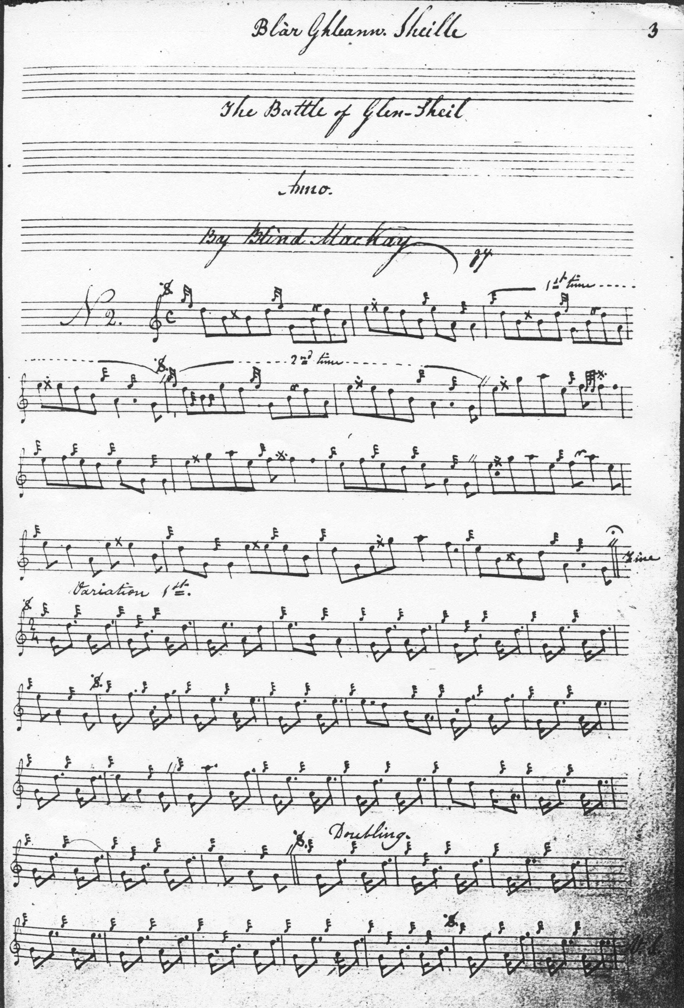
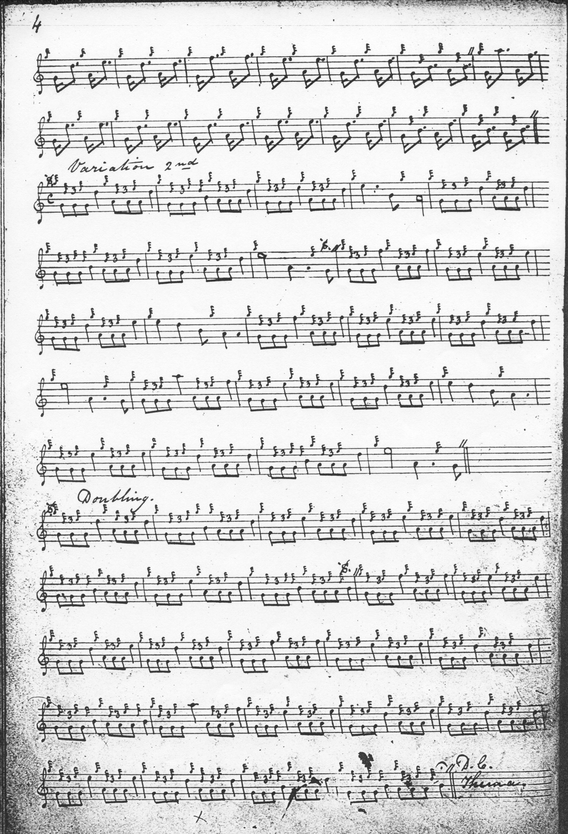

MacKay organises the tune as follows--ground, siubhal singling and doubling, and taorluath fosgailte singling and doubling, at the end of which he directs that the ground should be re-stated seemingly signaling the end of the tune. He has no crunluath. The score leaves precise details of timing open at several points. These are made more explicit in MacKay’s so-called “Kintarbert MS”. In addition, MacKay has eight bars in the first line of the ground, and nine in the second. He evens this up to eight and eight in the variations, and the tune proceeds in what would now be considered a “regular” manner thereafter. There appears to be mis-barring in the third line of the ground in both MSS. General Thomason offers a more plausible general timing for line three as we shall see below. As the minim-duration given to cadence notes in the singling of the taorluath fosgailte suggest, the four-four timing seems fully intended, and here at least it seems likely that the setter did not play this variation with the “modern” demi-semi-quaver timing.

MacKay’s so-called “Kintarbert” MS specifies more exact timings, thus:

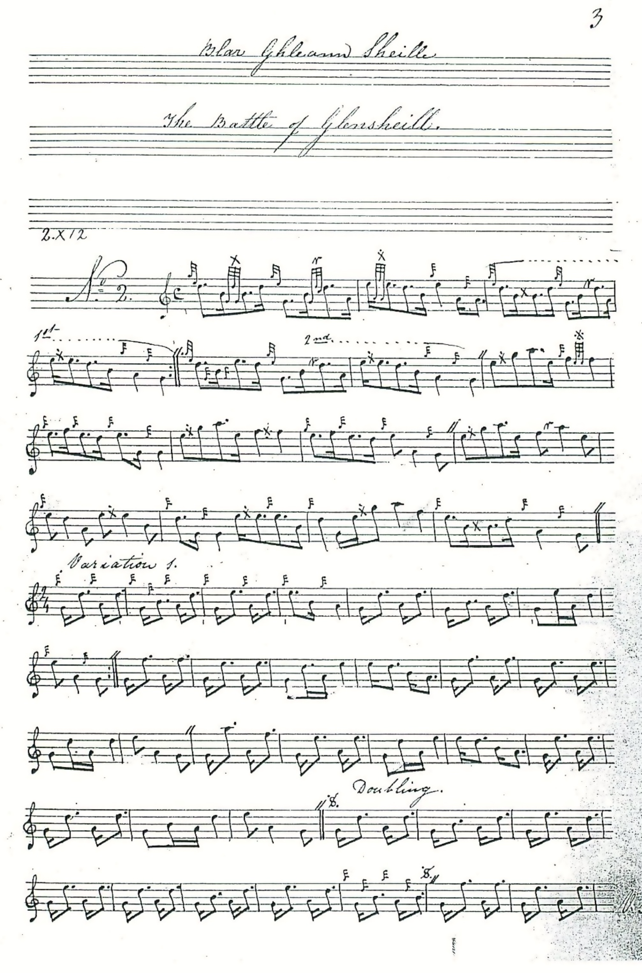

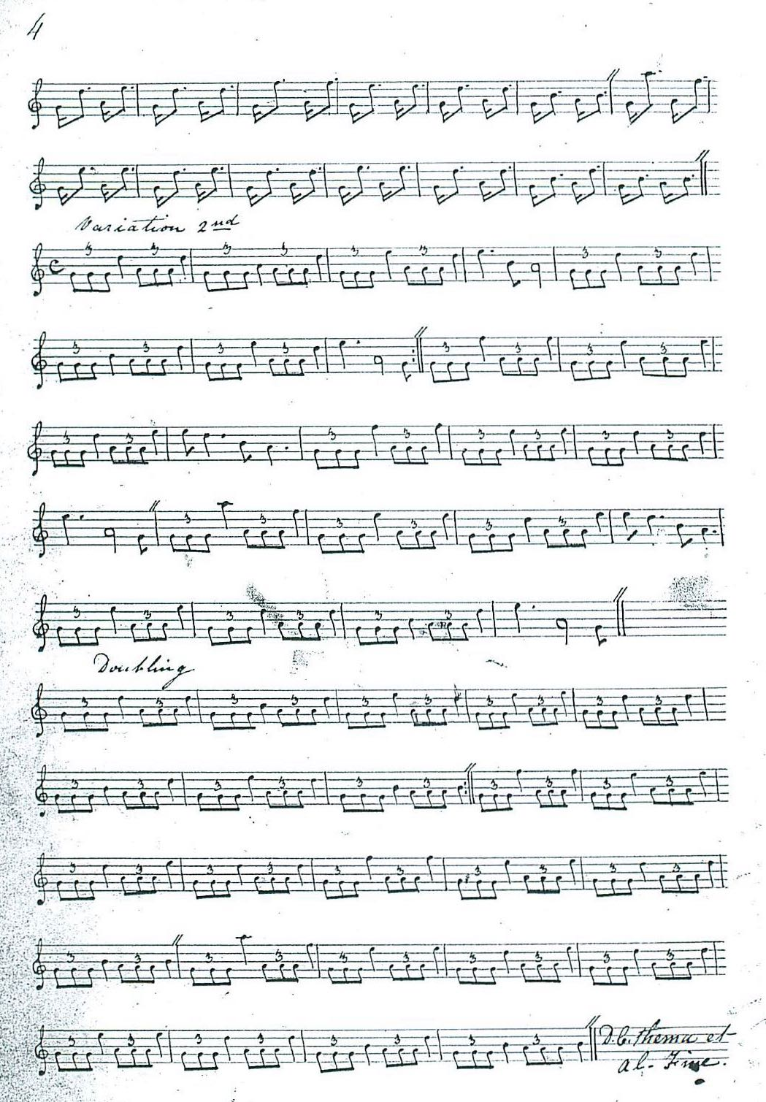

Colin Cameron’s setting has a number of interesting differences from MacKay’s, including playing on to an expressed D crotchet in the opening gesture of the ground, dropping the A quavers before throws on E from lower positions, dropping MacKay’s decorative repeat in bars 7 and 8 of the ground, plus a more idiomatic-sounding timing of the troublesome line three of that part and a number of other interesting minor touches of timing and decoration:

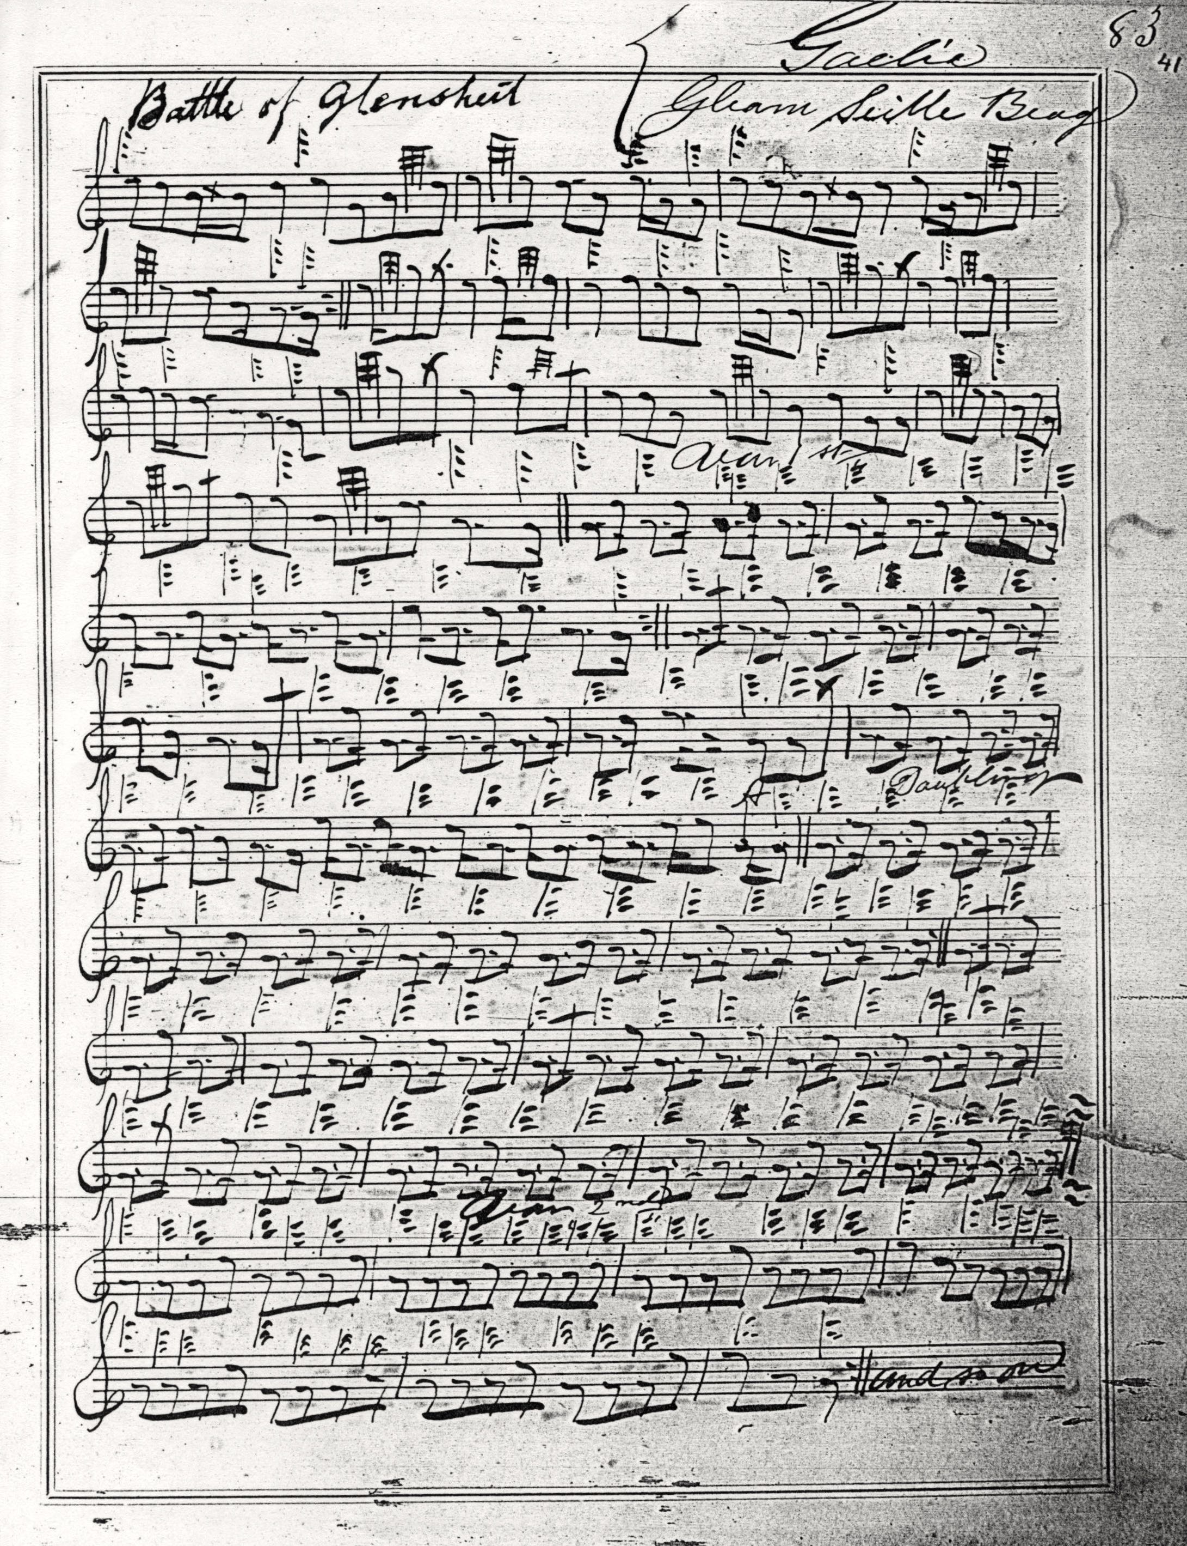

One might note the briskly cut-down E/A cadence at the end of the first phrase, for example, and in corresponding places between E and low G in the second line. We note too the “down” pointing of the siubhal, as opposed to the “up”-cut timing in MacKay. Cameron’s score is technically incomplete, ending midway through the sketchily-indicated taorluath fosgailte singling with the words “and so on”. So the possibility of completing the tune with a crunluath fosgailte, as Glen does, could remain at least theoretically open.

Duncan Campbell of Foss and Uilleam Ross add little to the expressive possibilities of the tune and their scores are not reproduced here.

John MacDougall Gillies follows MacKay style rather than Colin Cameron’s—interestingly since he was taught by Colin’s brother Sandy Cameron (the younger). His score is not reproduced here.

David Glen generally follows MacKay, but adjusts the tone row slightly in the taorluath fosgailte doubling:
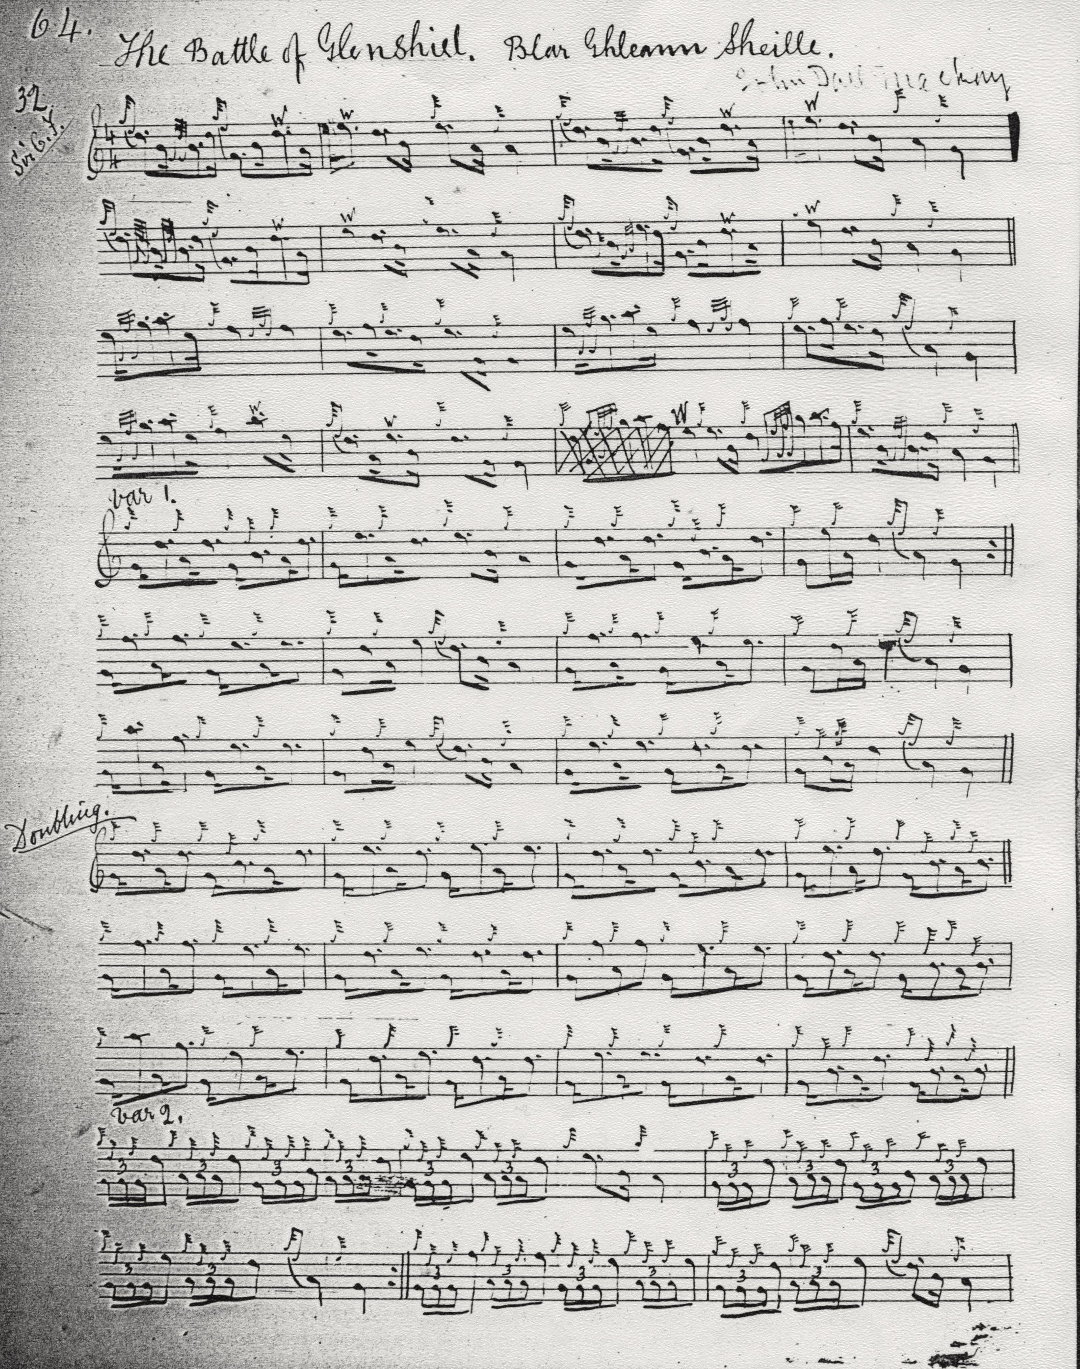

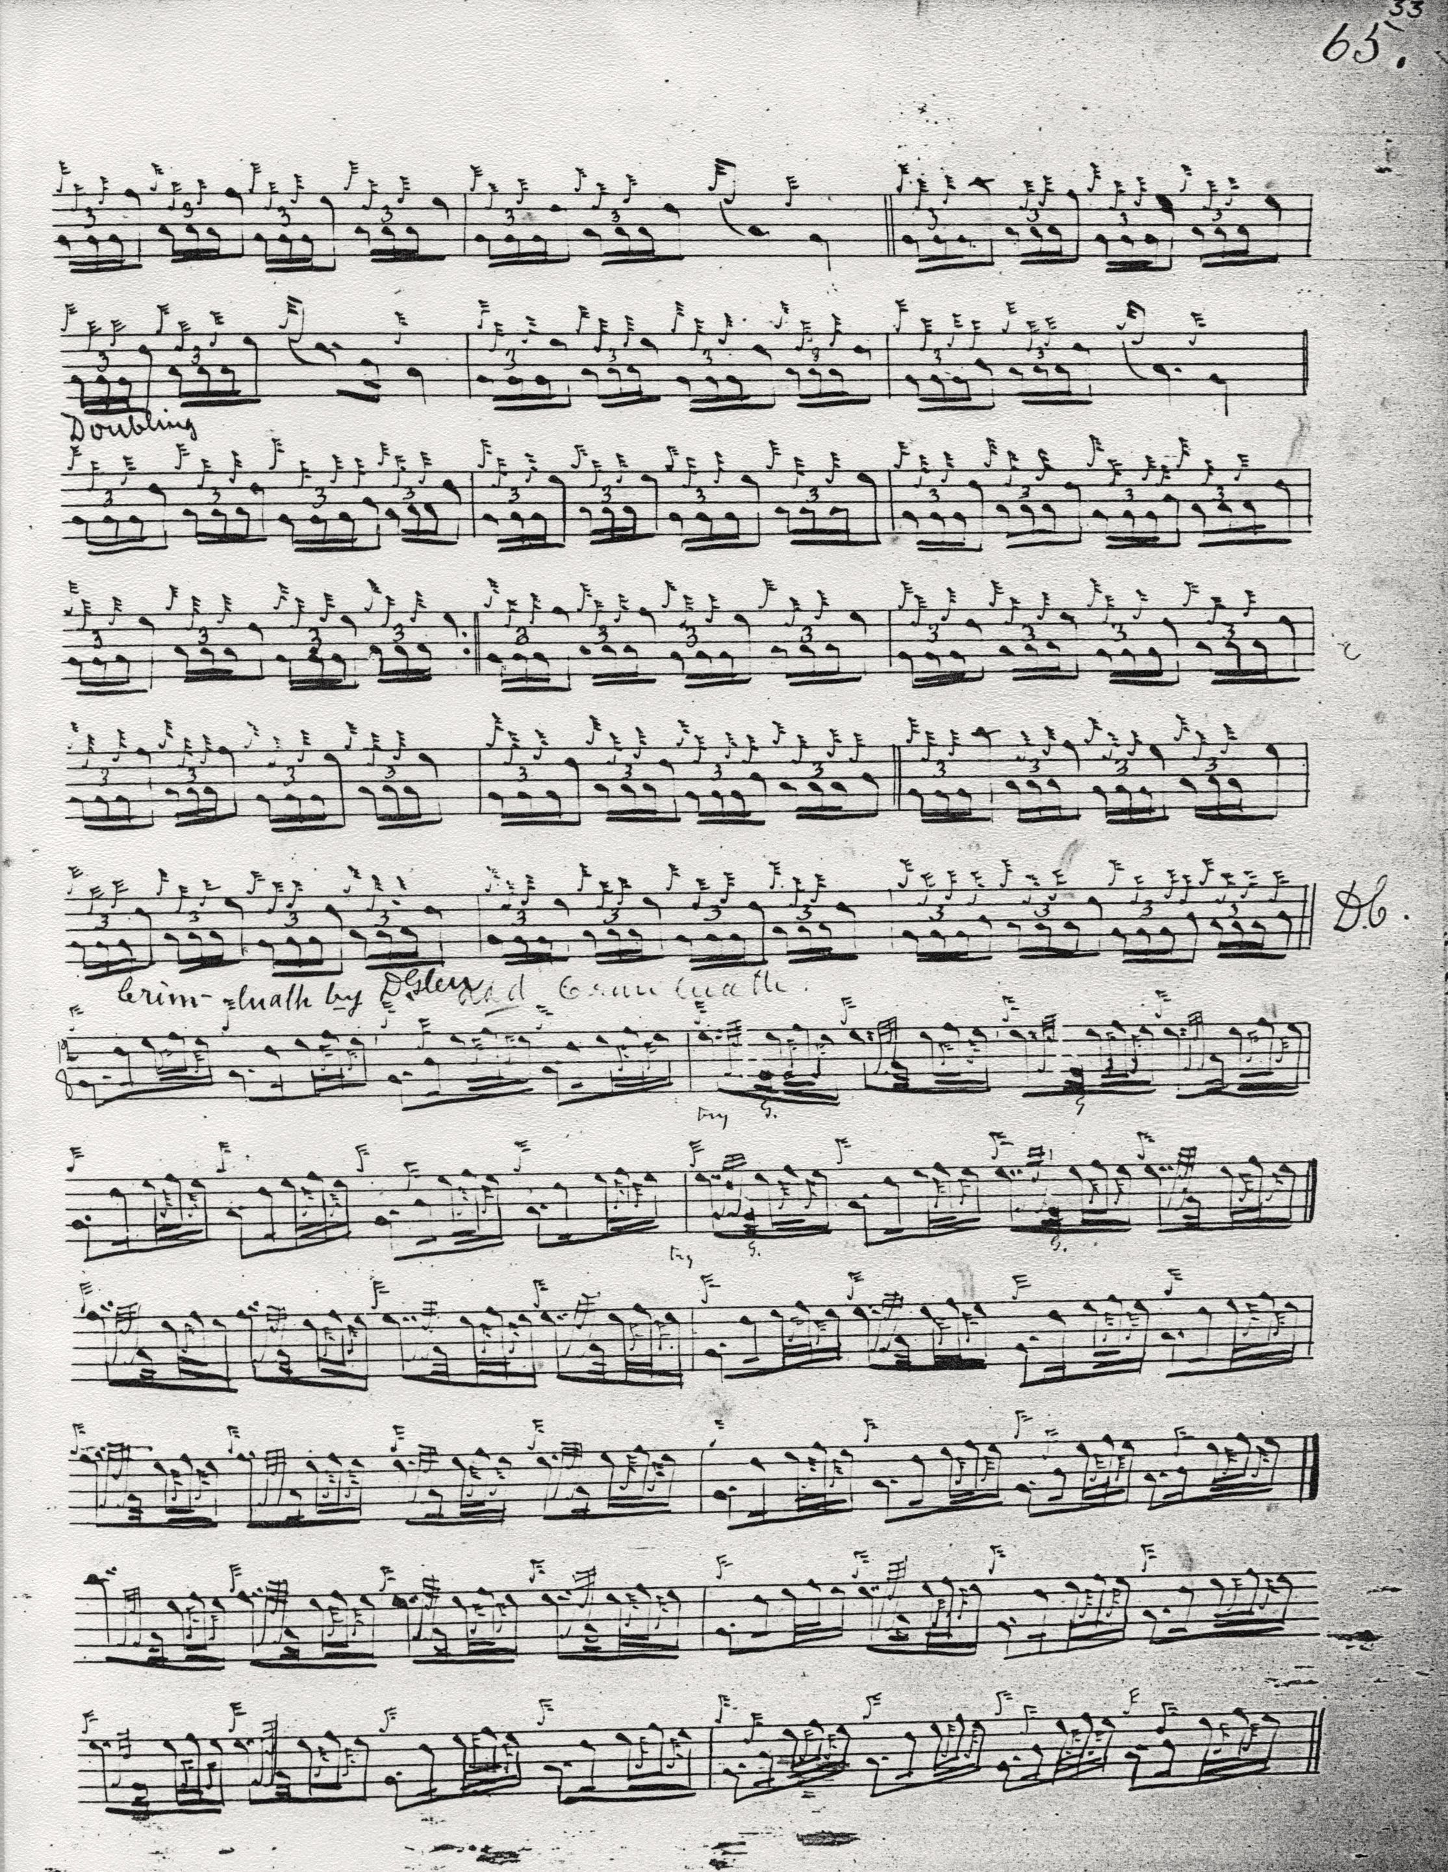

From the taorluath fosgailte doubling onwards Glen returns to E as the melody note at the end of line one (as opposed to MacKay’s more “closed” ending on B) presumably to assert the powerful forward momentum of the melody at this point. We note, too, that even Glen, usually an accomplished notator, seems to have had second thoughts about line three of the Ground, although he does succeed by dint of more sensible barring to reduce its dimensions to “regular” proportions. The taorluath fosgailte movements are timed in the “modern” manner. The crunluath fosgailte variation he framed for the tune was obviously added later.

C. S. Thomason gives his source as MacKay but indicated editorial intervention; this consists of re-barring MacKay’s ground (sensibly) and adjusting, also sensibly, the note values of the penultimate bar in the ground, and cutting up to the final D in the opening gesture of the tune (which MacKay’s even quaver timing would permit him to do). Otherwise he seems to leave the score alone; interestingly he does not go down the route of David Glen in supplying a crunluath fosgailte:

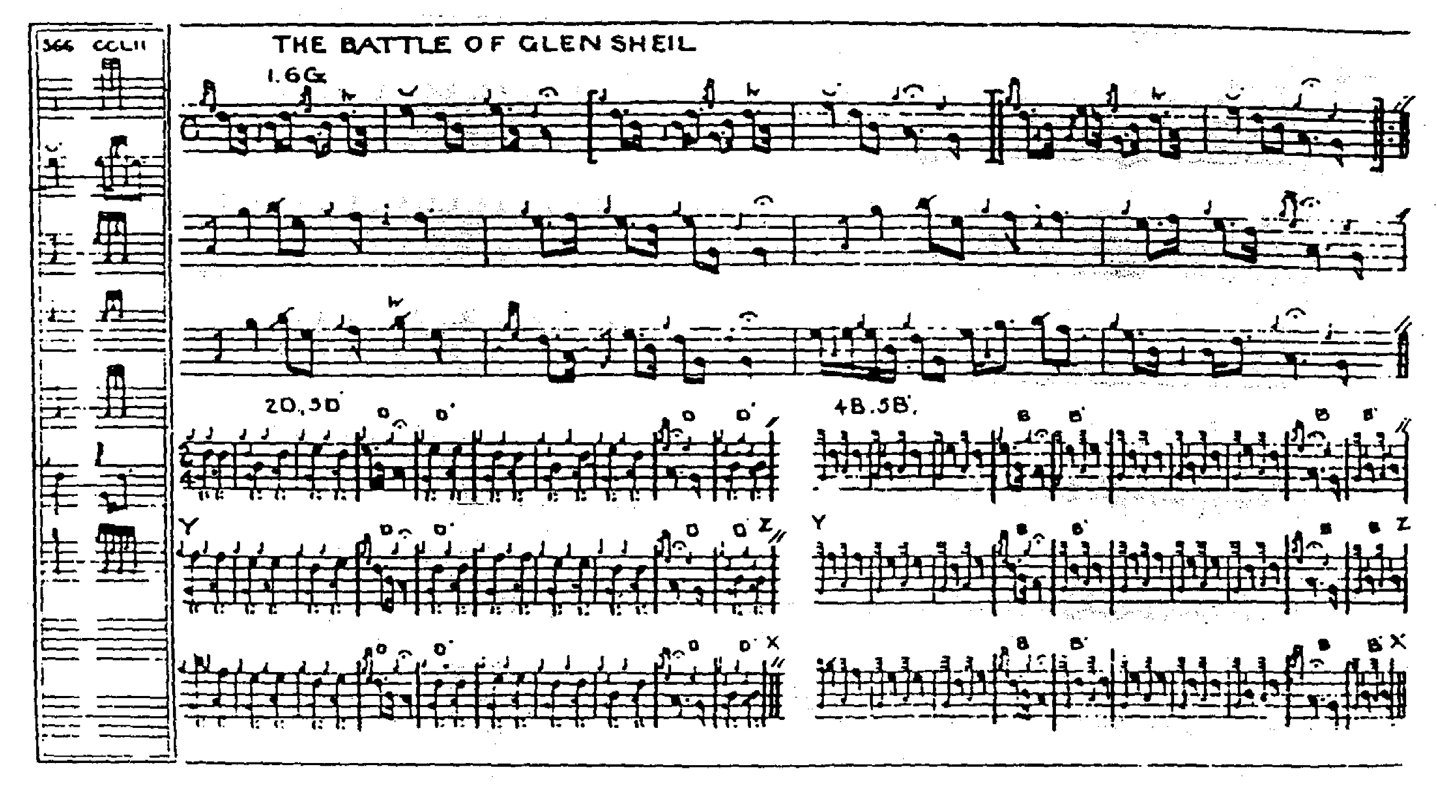

Commentary:

The battle of Glenshiel was fought in Kintail on 10th June, 1719. It formed part of the long struggle to restore the exiled house of Stuart which began with Killiecrankie and Viscount Dundee in1688-9, and broke out sporadically thereafter for a period of more than fifty years when the military phase was finally brought to a close at Culloden. The Glenshiel episode was part of a projected Spanish invasion, a northern diversion from the main landings in the south west of England. But the main fleet was scattered by storm and only the northern contingent went ahead. The clans did not rise as expected, and a skirmishing battle took place (involving little more than a thousand men on either side) in Glenshiel under the shadow of the Five Sisters of Kintail, in which the superior artillery of the government forces soon proved decisive.

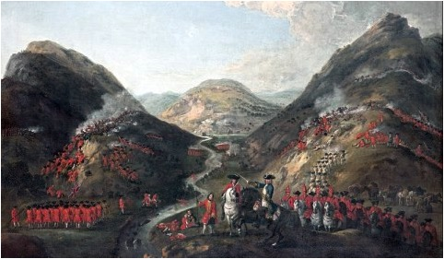

The Jacobite forces were led by the Earl of Seaforth (Uilleam Dubh, the fifth earl, commonly associated with the tune “Seaforth’s Salute”), the Marquis of Tullibardine, and the brilliant Keith brothers, the Earl Marischal and his soldier brother James, who had been obliged to seek exile after the failure of the ’15. The Keiths were a family of the first importance, with political control of much of the North East of Scotland from their twin bases of Fetteresso and Inverugie. It was said of the 9th Earl that he could ride across Scotland from end to end and never spend a night outside his own property. The family had founded the famous Marischal College, which still exists as a component of the University of Aberdeen. There was an immense amount of talent on the Jacobite side lost to Scotland in this way. The Earl Marischal became a top diplomat, Prussian ambassador at Madrid, and his brother a field marshal in the Prussian service. At Glenshiel, however, they were on the losing side. The Earl, a highly intelligent and witty man, a friend of Voltaire, much later (and now pardoned) met King George, and when asked what transpired, replied in an improvised ballad quatrain:

The king’s he’s turned him roun’ aboot,
And a laich lauch leuch he
“Gin it warna for me, Earl Marischal,
High hangit ye should be”.

* * *

Electronic text © Dr. William Donaldson, Cambridge, Massachusetts, 9th June 2016

My notes to the PS second series score say “This tune seems to come down only through the MacKays; good example of the leaden ‘squared off’ quality of their style which tends to give prominence to passing notes by misleading note-ties which spoils the rhythm and makes the melody square, cluttered and unidiomatic”. I add to the note on the adjoining page: “Thomason edits MacKay’s MS—what this amounts to is dropping some of the cadences from the ground; and re-pointing certain figures in the ground—not unpleasingly.”

