Black Wedder’s White Tail
There is a setting of this tune in the following manuscript source:
--Colin Mór Campbell’s “Nether Lorn Canntaireachd”, ii, 144-7.
It does not seem to be contained in any other written source before 1914.
Colin Mór sets the tune as follows:

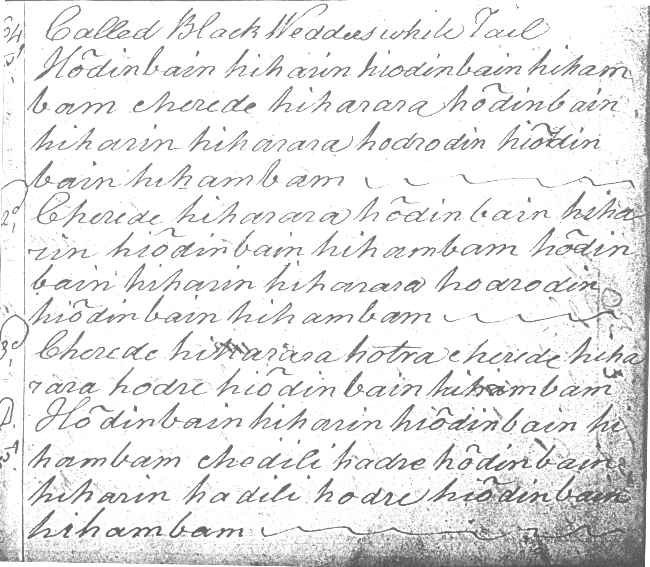

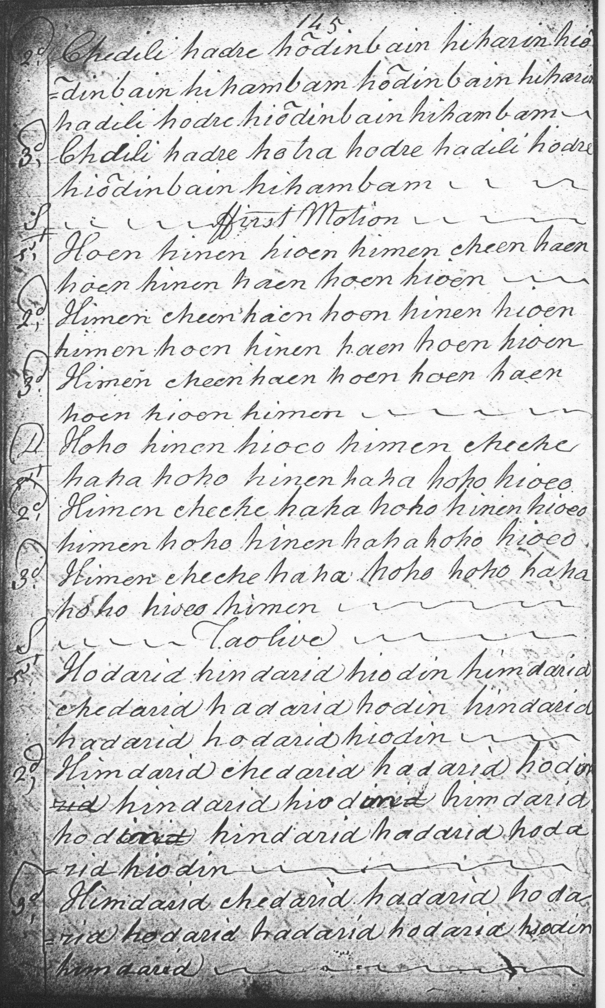
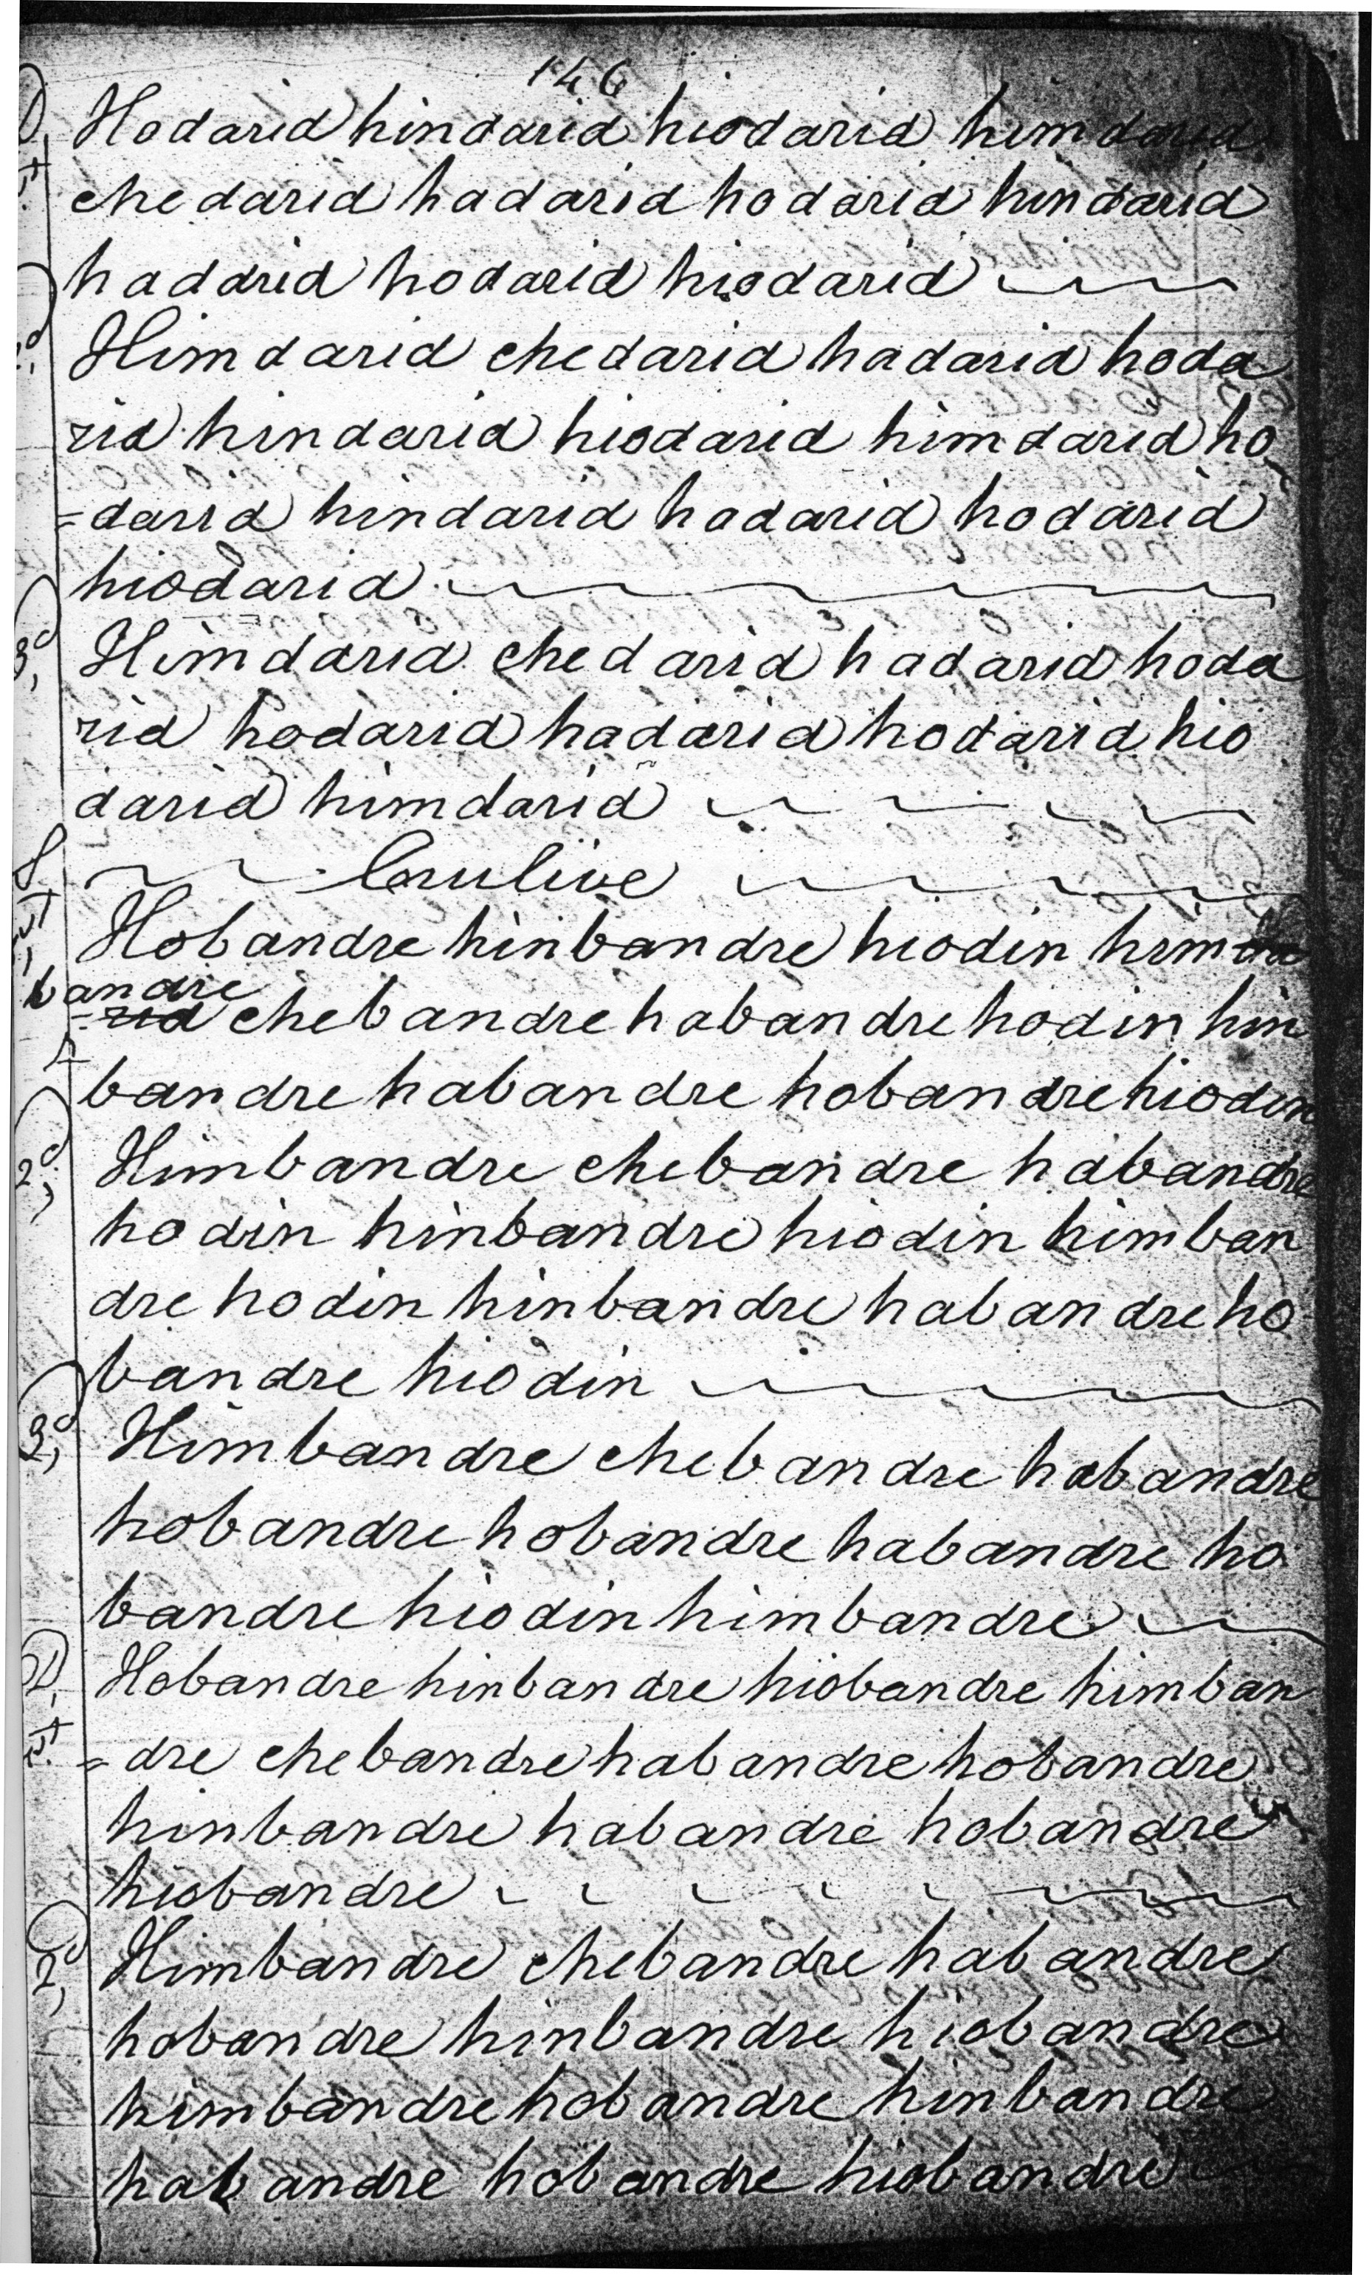
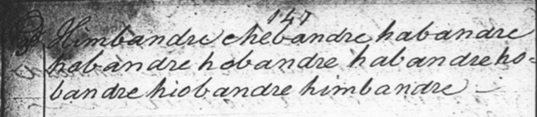

Commentary:
This curiously-named tune occurs only in the Nether Lorn Canntaireachd MS. A fine bold piece if played up to time, it offers the performer many interesting interpretational choices, as discussed in the accompanying MP3 file.
The Black Wedder with the White Tail is a semi-mythical creature who featured in the disputes between the Colquhouns and the MacGregors that culminated in the Rout of Glenfruin. The story is a well-known one; it was cited by Sir Walter Scott in Rob Roy, and there are numerous online sources which give the details, including the following:
The old castle of Bannachra, the ruin of which stands on the rising ground in the mouth of Glenfruin behind, was in 1592 the scene of a tragic incident. In one of the feuds of the time, Sir Humphrey, chief of the Colquhouns, was beset by his enemies here. His servant was induced to betray him, and in lighting him up a stair so shone a candle on him as to make him a mark for those outside, who shot him with an arrow through a loophole. The deed has been blamed upon the Macgregors and Macfarlanes, but in Birrell's Diary it is stated that on "Nov. 30 John Cachoune was beheidit at the Crosse of Edinburghe for murthering of his auen brother, the Laird of Lusse", and as it was not John Colquhoun but the next brother Alexander who succeeded Sir Humphrey, Birrell's statement seems to point to the truth.
This Sir Alexander, who succeeded, was the chief who took part, eleven years later, in the conflict with the Macgregors, known as the battle of Glenfruin, The ruin of Bannachra overlooks the scene. According to the Macgregors the feud was caused by the Colquhoun Chief hanging two Macgregors who had stolen and suppered off a sheep, though they afterwards offered to pay for it. There is evidence, however, that Clan Gregor was really set on by the Earl of Argyll, who was Colquhoun's bitter enemy. Some three hundred were engaged on each side, but Alastair Macgregor, more practised in war than his opponent, divided his forces, attacked the Colquhouns in front and rear, and soon threw them into confusion. He pursued them to the gates of Rossdhu, and slew a hundred and forty of them, while he himself lost only two followers, including his brother John. Sir Walter Scott, in his novel of Rob Roy, makes the Macgregor boatmen, as they row Bailie Nicol Jarvie down Loch Lomond, entertain him with a song of triumph on the subject:
Proudly our pibroch has thrilled in Glen Fruin,
And Baunochar's groans to our slogan replied;
Glen Luss and Rossdhu, they are smoking in ruin,
And the best of Loch Lomond lie dead on her side,
Widow and Saxon maid
Long shall lament our raid,
Think of Clan Alpin with fear and with woe;
Lennox and Leven-glen
Shake when they hear again
Roderich Vich-Alpin Dhu, ho! ieroe!
But the Macgregors themselves had, after all, the most fearful cause to lament the exploit, They followed up their victory by burning and ravishing the whole lands of Luss, and one of them, Dugald Ciar Mhor of Glengyle, set to watch a party of schoolboys who had come from Dunbarton to see the fight, cut short his charge by slaying them all, When Alastair his chief met him rushing to the plunder, and asked what he had done with the students, Dugald held up his bloody dirk and said: "Ask that!"
Such deeds were bound to bring retribution. A band of sixty Colquhoun widows paraded before James VI at Stirling with their husbands' bloody shirts on poles, and the horrified King gave instant orders for the punishment of Clan Gregor. Their houses were burned, their name was proscribed, and they were hunted like wild beasts in the hills. A year later Alastair Macgregor himself was betrayed by Argyll. The Earl undertook to convey him safely out of Scotland, fulfilled the letter of his promise by carrying him to Berwick, then arrested him, and brought him back to Edinburgh where he was tried, condemned, and executed. Assuredly Clan Gregor had ample reason to curse the hour in which "the black wedder with the white tail was ever lambed". Scott has put their resentment with vigour into another of his songs, "Macgregor's Gathering":
Through the depths of Loch Katrine the steed shall career,
O'er the peak of Ben Lomond the galley shall steer,
And the rocks of Craig-Royston like icicles melt,
Ere our wrongs be forgot or our vengeance unfelt!
The ruin of the old castle of Rossdhu still stands beside the modern mansion of the name on the loch-side. Among those who have been entertained within its walls was Mary Queen of Scots, who paid a special visit here and stayed over night on 15th July, 1563. <http://www.kellscraft.com/LochLomond/LochLomondCh04.html>

So the punning musical links to “MacGregors’ Gathering”—obvious to a knowing ear--are reinforced in the title of the tune which would signal its clan affiliations to anybody familiar with the history of the south west Highlands.

* * *

Electronic version © Dr. William Donaldson, Cambridge, Massachusetts, 23 April 2012

