A Flame of Wrath for Patrick Caogach

Two quite different tunes bear this name.

There are manuscript scores of the first—which is discussed below—in
--Colin Mór Campbell’s Nether Lorn Canntaireachd, i, 93 (with the title “Lassan Mhic a Cheaich’, but its compiler Colin Campbell’s version is not developed beyond the first variation doubling);
--Angus MacKay’s MS, i, 75-6 (with the title “A flame of wrath for squint Peter MacCrummin”; and also in the so-called “Kintarbert” Manuscript, ff.73-4);
--Duncan Campbell of Foss’s MS, ff.161-3;
--Uilleam Ross’s MS, ff.239-40;
--John MacDougall Gillies’s MS, ff.74-5; The later manuscript sources follow MacKay in this instance.

And in the following published scores:
--C. S. Thomason’s Ceol Mor, pp. 273-4;
--and David Glen’s Collection of Ancient Piobaireachd, pp. 160-1.

Colin Campbell sets the tune like this:

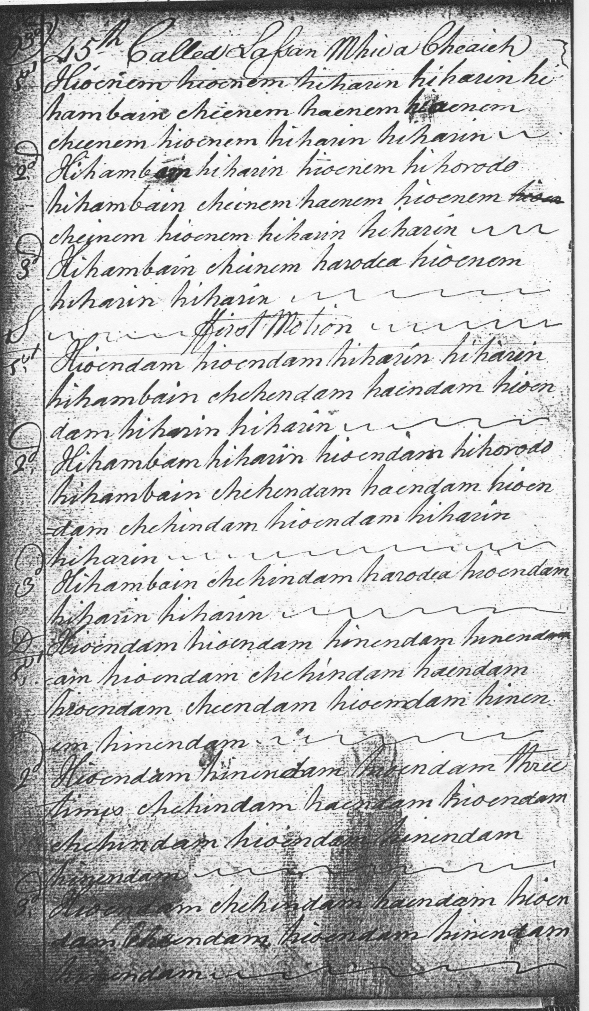
This would suggest something along the following lines:

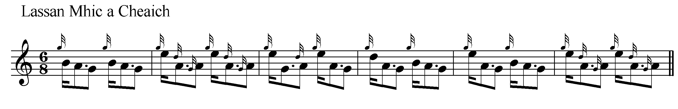

And so on.
The ground seems metrically similar to the siubhal of “In Praise of Morag/Marion’s Wailing”, and like it, the intention seems drivingly rhythmical; also the above suggestions assume that the vocable “hiharin” has three pulses, each syllable representing a pulse, and not the standardized five-pulse gesture into which it is normally translated by the editors of the Piobaireachd Society’s Second Series.

Angus MacKay sets the tune as follows:

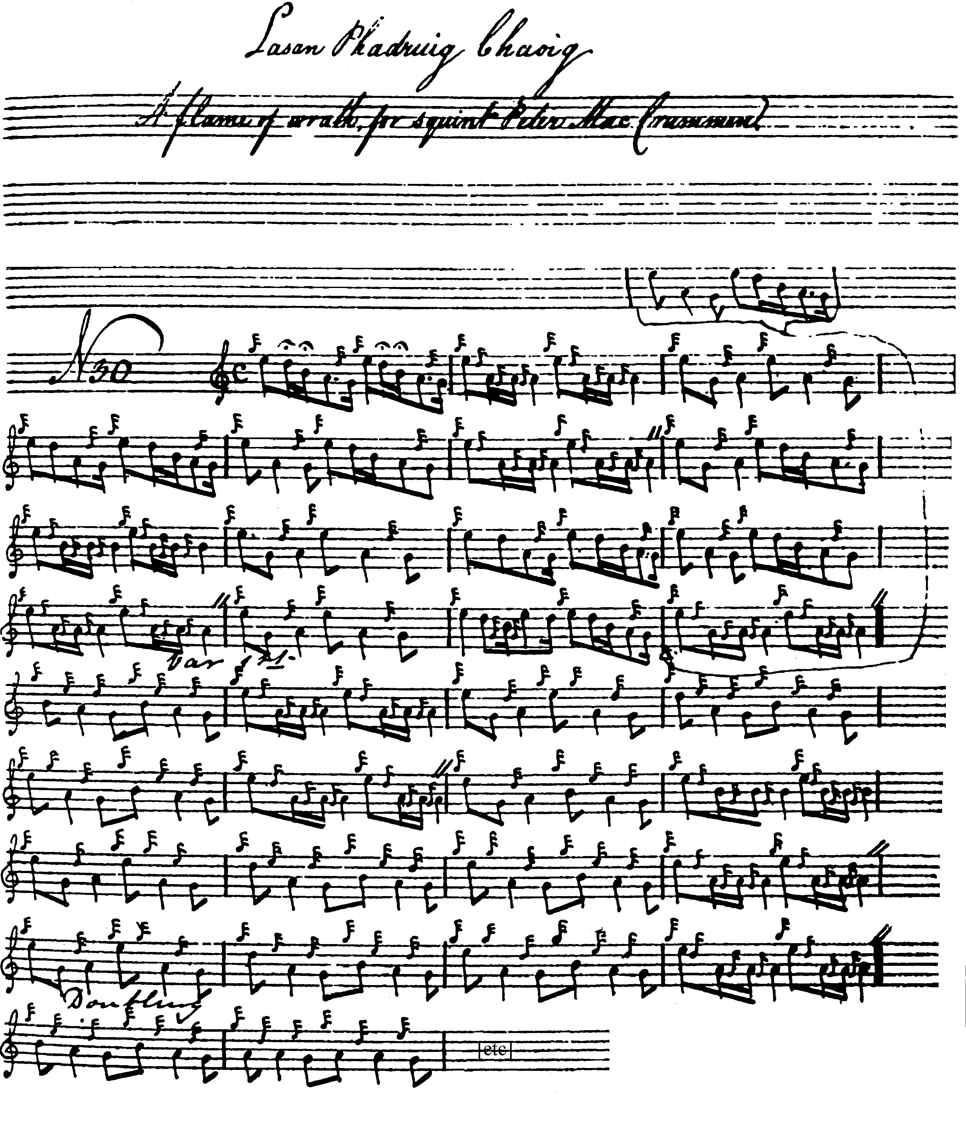

The “Kintarbert” setting adds little to the above. Although carefully dotted and cut, it is incompletely ornamented and is not reproduced here.

Most notators appear to have struggled with the timing of this interesting tune. Of the later settings David Glen’s might be considered one of the more shapely interpretations. Glen set the tune as follows:

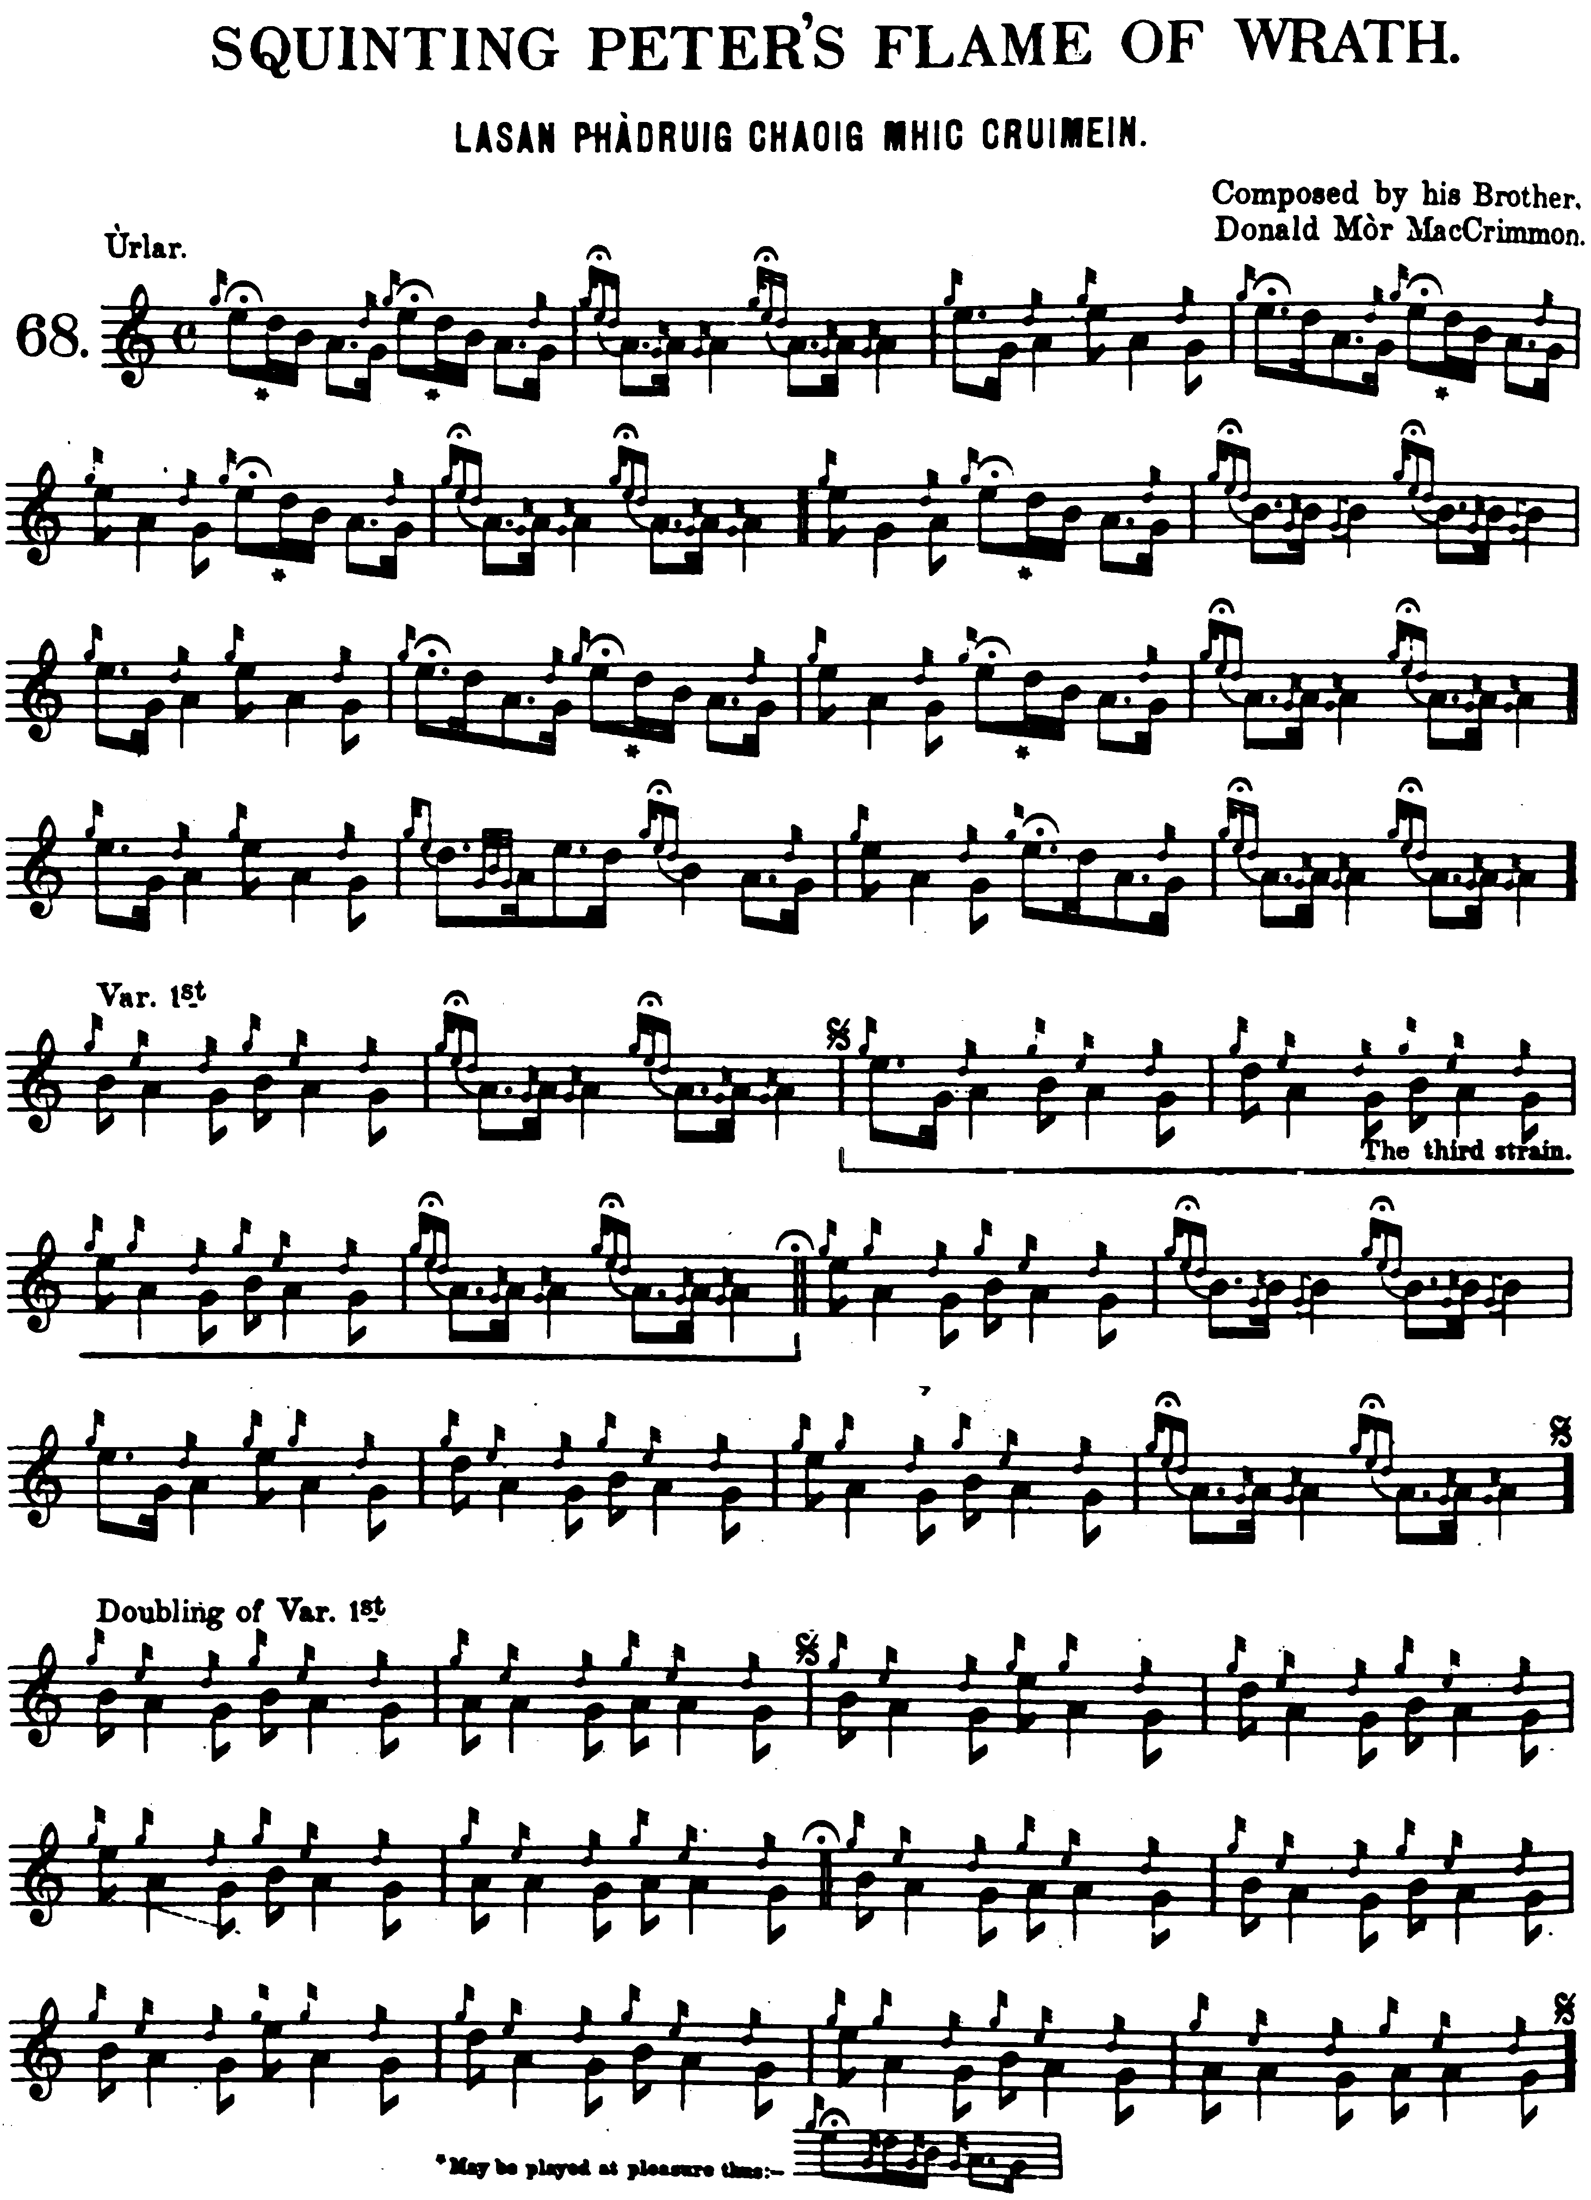

Glen times the crunluath variations thus:

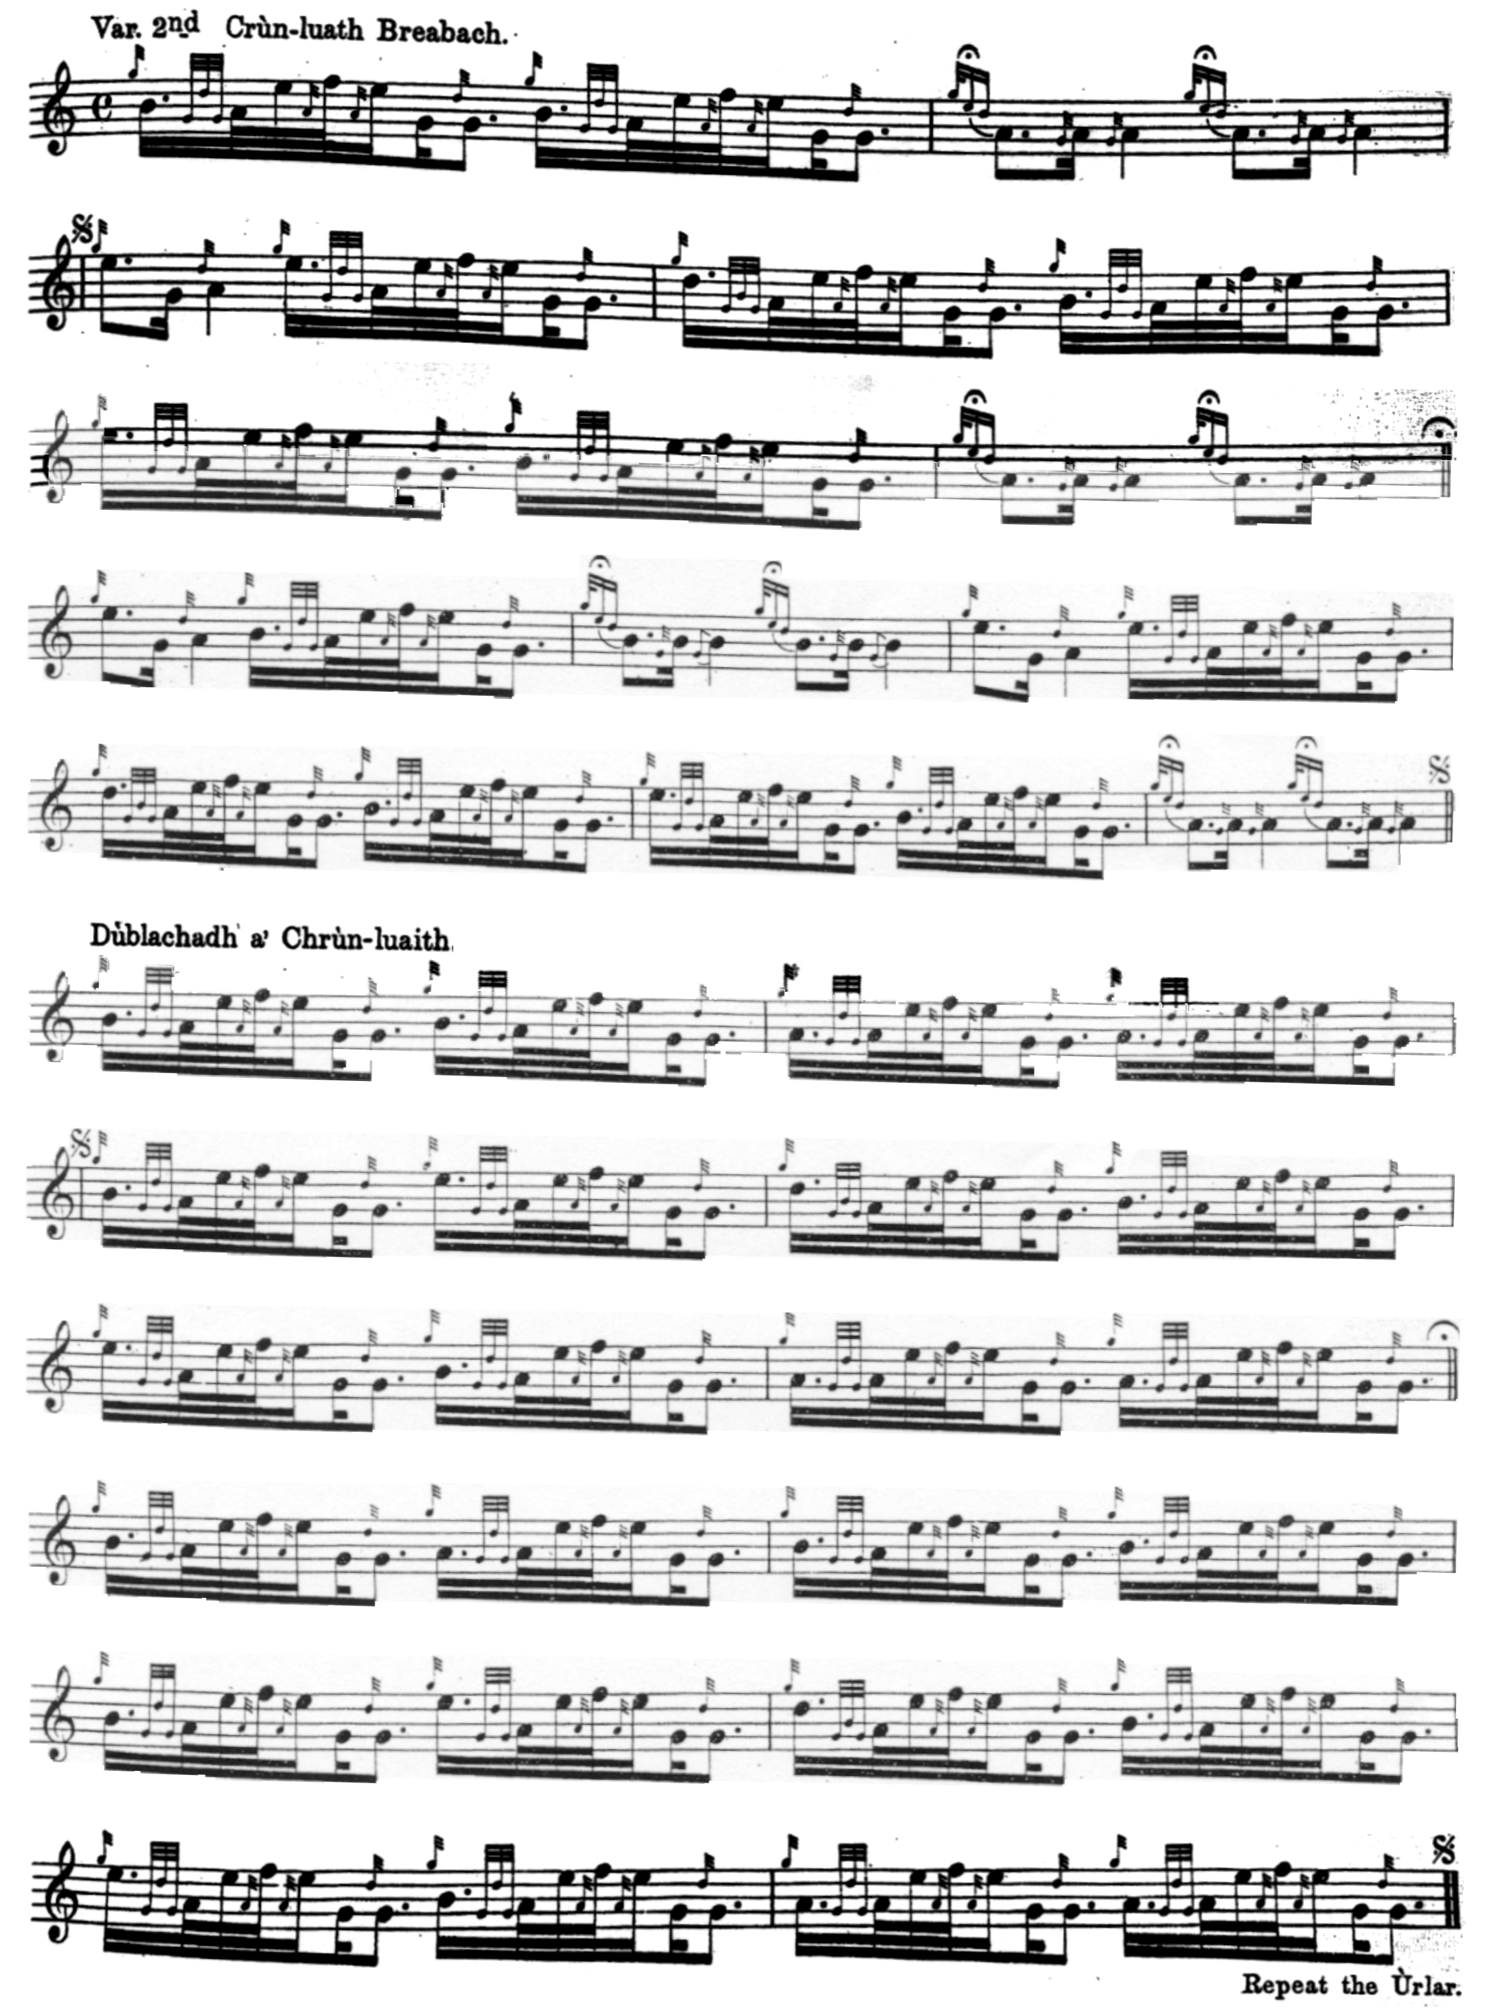

Commentary

Gesto’s notes to his collection (published as “Remarks by Captain MacLeod, as far as he has been informed by the late John MacCrimmon, piper, Dunvegan, Isle of Skye”, Celtic Magazine, vol. 8, 1883, pp.434-5) state: ‘Lasson, alias the Flame of Phadrig Chiegh. Played by Patrick Maccrimmon at a time he, with his party, set fire to many houses in Kintail, in consequence of a quarrel between the Mackenzies and the Mackays of Lord Reay”.

James Logan gives the story in fuller form in his “Account of the Hereditary Pipers” prefixed to Angus MacKay’s Collection of Ancient Piobaireachd:

Donald Mòr had a brother who lived in Glenelg… who was known by the name of Patrick Caog, on account of a squint or defect in one of his eyes. This young man had a quarrel with his foster brother, a native of Kintail. Sometime after the dispute, while he was in the act of washing his face, in a burn or rivulet adjoining his dwelling, the Kintail man came behind him, and treacherously with his dirk gave him a mortal blow. This being made known to Donald Mòr at Dunvegan, he prepared to revenge the untimely death of his brother, and taking his Pipes up to MacLeod’s room, he threw them on the bed. MacLeod surprised, demanded to know what had occurred. In few words he related to him the affair, when the laird pacified the enraged Piper, and promised him, on condition of his remaining at home, to see justice done before the expiration of twelve months. Macleod thought that his wrathful Piper would forget the cruel murder by that time, and allow his ire to abate; but such was not the case, for on the termination of the twelve months, he set out himself for Glenelg, without informing any one of his intention; and finding on his arrival there that the murderer of his brother had gone to Kintail, he pursued his journey thither.

The offender, having been apprised of his arrival, concealed himself in the house of a friend; and the inhabitants of the village not choosing to deliver him up, MacCrimmon was so enraged, that he resolved to set their houses on fire,--a resolution which he found an opportunity of carrying into effect that night, and burned eighteen of their houses, which caused the loss of several lives. (This is called Lasan Phadruig Chaog, or a flame of wrath for Squinting Peter). Donald then made his escape to Lord Rea’s country, where he remained for some time under the protection of Donald Duaghall Mackay, afterwards Lord Rea, with whom he had been formerly acquainted.

As sometimes happens, however, a quite different tale attaches to the tune, this one referring to the famous piper Iain Dall MacKay as follows:

One of the MacCruimeins, a celebrated musician known by the cognomen of Padruig Caogach, owing, we suppose, to his inveterate habit of twitching or winking with his eyes, was about that time composing a new pipe tune. Two years had elapsed since the first two measures of it had become known and popular, but owing to its unfinished state it was called “Am Port Leathach”. Some of the greatest poets have experienced more difficulty in supplying a single line or couplet than in the structure and harmonisation of an entire piece. Musicians, too, have experienced similar perplexities, and Padruig Caogach had fairly stuck. The embryo tune was everywhere chanted and everywhere applauded, but no—the genius of composition seemed to exult at a distance and to wink at Caogach’s perplexity.

Tender of his brother piper’s reputation, our blind author set to work and finished the tune, which he called “Lasan Phadruig Chaogaich,” or Padruig Caogach’s Flame of Wrath, thus nobly renouncing any share of the laudation which must have followed upon the completion of the admired strain. Patrick, finding his peculiar province usurped by a blind beardless youth, bribed the other apprentices to do away with his rival’s life. This they attempted while walking with John at Dun Boreraig, where they threw their blind friend over a precipice twenty-four feet in height. John alighted on his feet and suffered no material injury. The place over which he was precipitated… is yet recognised as “Leum an Doill”. The completion of “Lasan Phadruig Chaogaich” procured great praise for our young musician, and gave rise to the following well-known proverb, “Chaidh am foghlumaiche os cionn Mhic Cruimein,” that is, the apprentice outwits the master. (John MacLean, “Am Piobair Dall”, Transactions of the Gaelic Society of Inverness, vol.XLI, 1951-2, pp.283-306 [285].

The second tune bearing this title appears in Niel MacLeod of Gesto’s Collection of Pibaireachd or Pipe Tunes (first published 1828, reprinted Edinburgh 1880, pp.25-6) with the title “Played by Patrick McCrimmon, commonly called Lassan Phadrig Chiegch”. There are published settings in Thomason’s Ceol Mor (pp. 351-2, with the title “A Satire on Patrick Chaoig”) and G. F. Ross’s Some Piobaireachd Studies (Glasg., 1926, p.27), and also his Collection of MacCrimmon and other piobaireachd (Glasg., 1929, pp.22-3). Manuscript sources for this second tune include

--Angus MacKay’s MS (ii, 119, with the title “MacDonalds Salute or Duntron”; --Colin Cameron’s MS, (title “Failte MhicDhomhnuill. MacDonald’s Salute”, ff.129-30); --Duncan Campbell of Foss ‘s MS, (ff.38-39, marked “as played by Patrick More MacCrimmon Failte MhicDhomhnuill The McDonald Salute”);--Uilleam Ross’s MS, (ff.123-4, title “Failte Mhic Dhomhnuill The Macdonalds Salute”); --David Glen ‘s MS, (ff.40-1 and 388-9, the latter of these being a rather forced interpretation of the Gesto canntaireachd version by Dr. Charles Bannatyne).
For a fuller account of this piece see “MacDonald’s or Duntroon’s Salute” in the present site.

* * *

Electronic text © Dr. William Donaldson, Aberdeen, Scotland, November 2002; revised Cambridge, Massachusetts, 27 December 2024

