MacLeod of Raasay’s Salute
There are settings of this tune in the following manuscript sources:
--Donald MacDonald’s MS, ff.53-58;
--Peter Reid’s MS, f.47;

and in the following published sources:
--Angus MacKay, Collection of Ancient Piobaireachd, pp.9-11;
--Donald MacPhee, Collection of Piobaireachd, ii, 5-7;
--C. S. Thomason, Ceol Mor, p.55;
--David Glen, Collection of Ancient Piobaireachd, pp.37-9.

Donald MacDonald sets the tune like this:
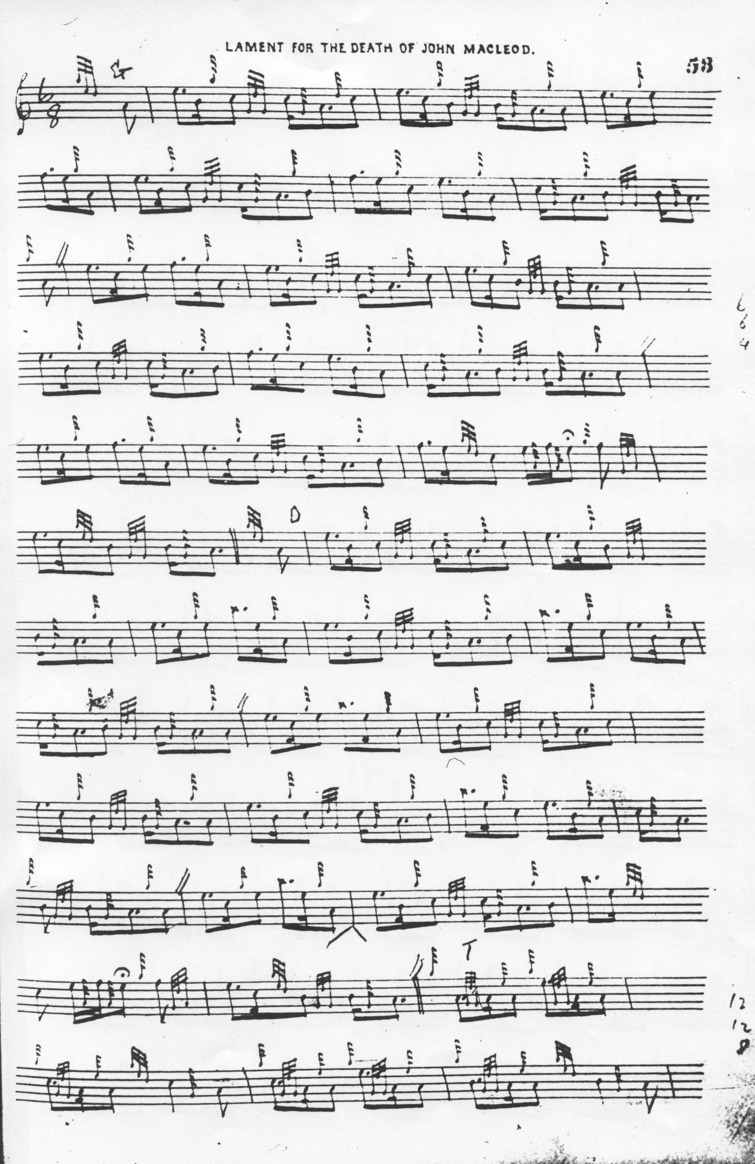
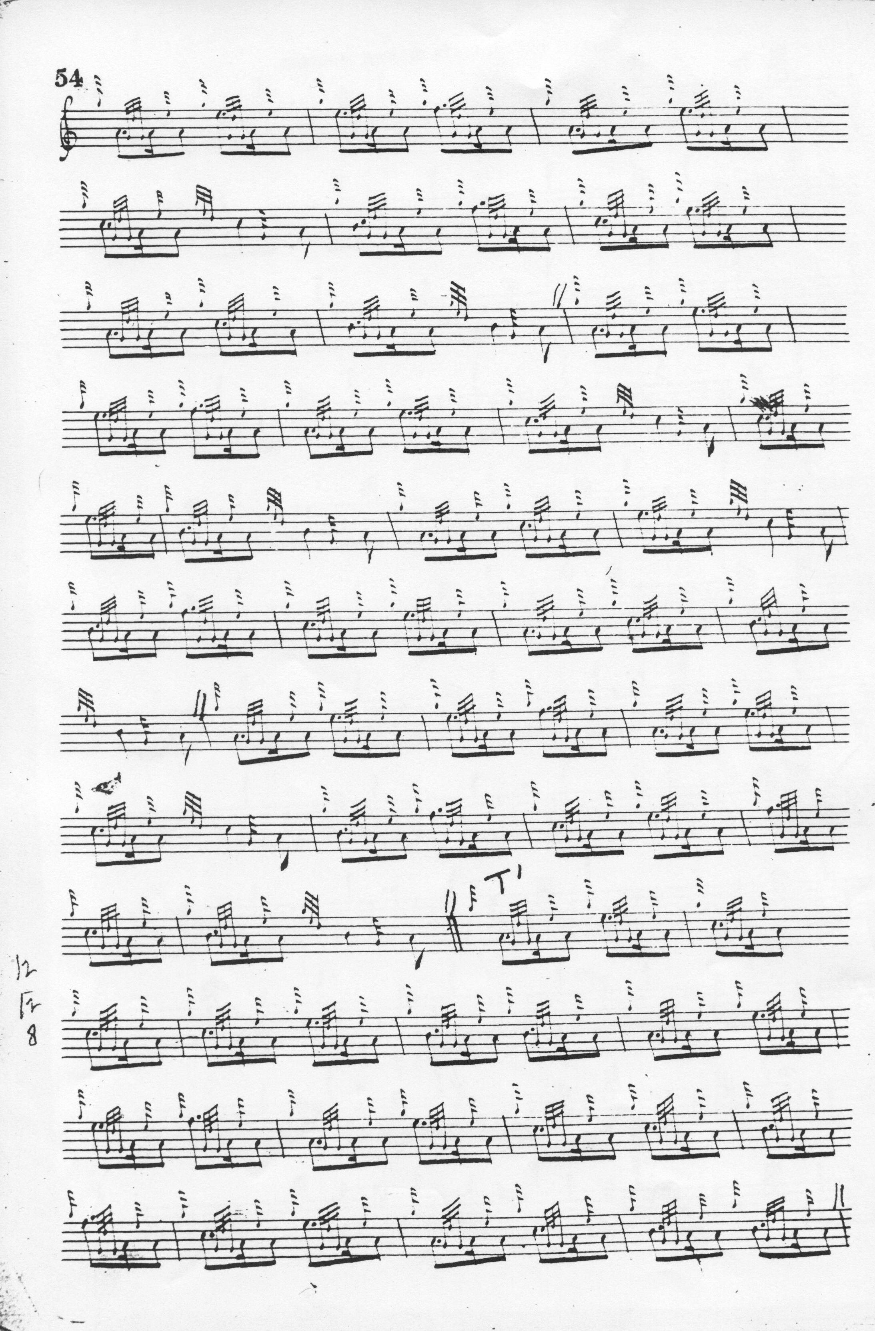
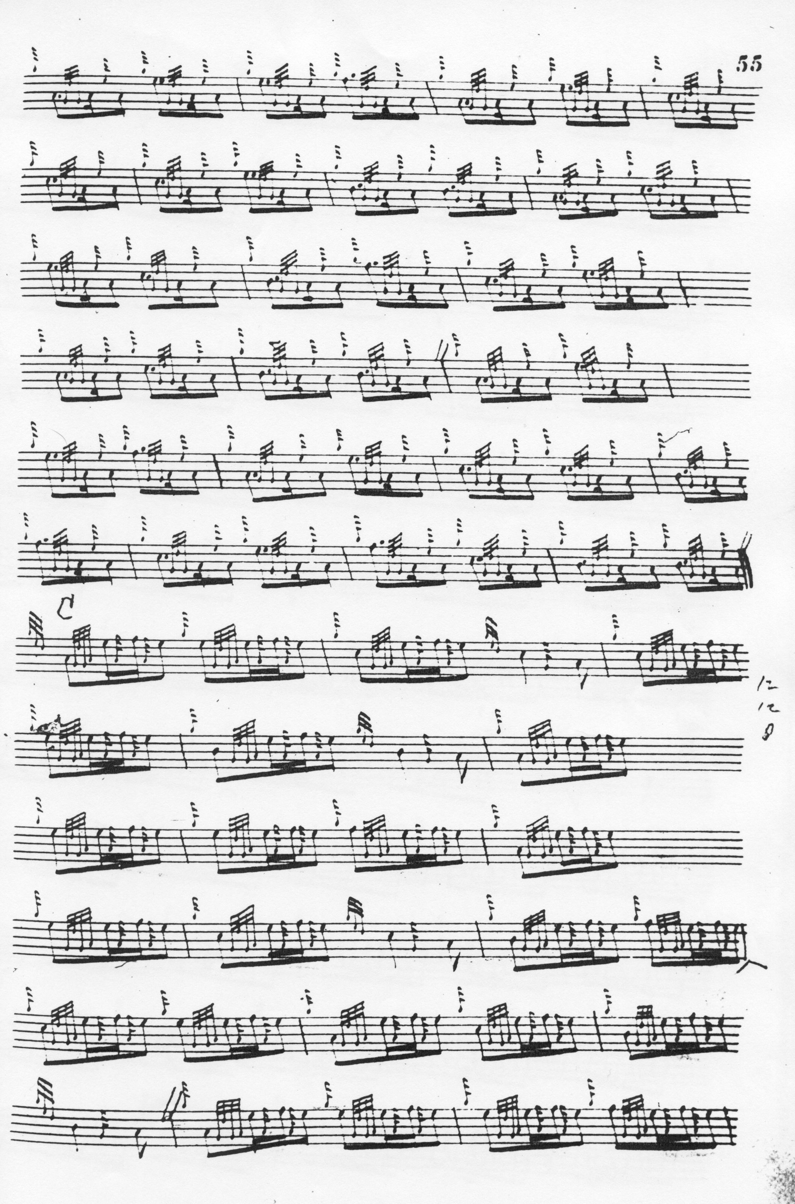
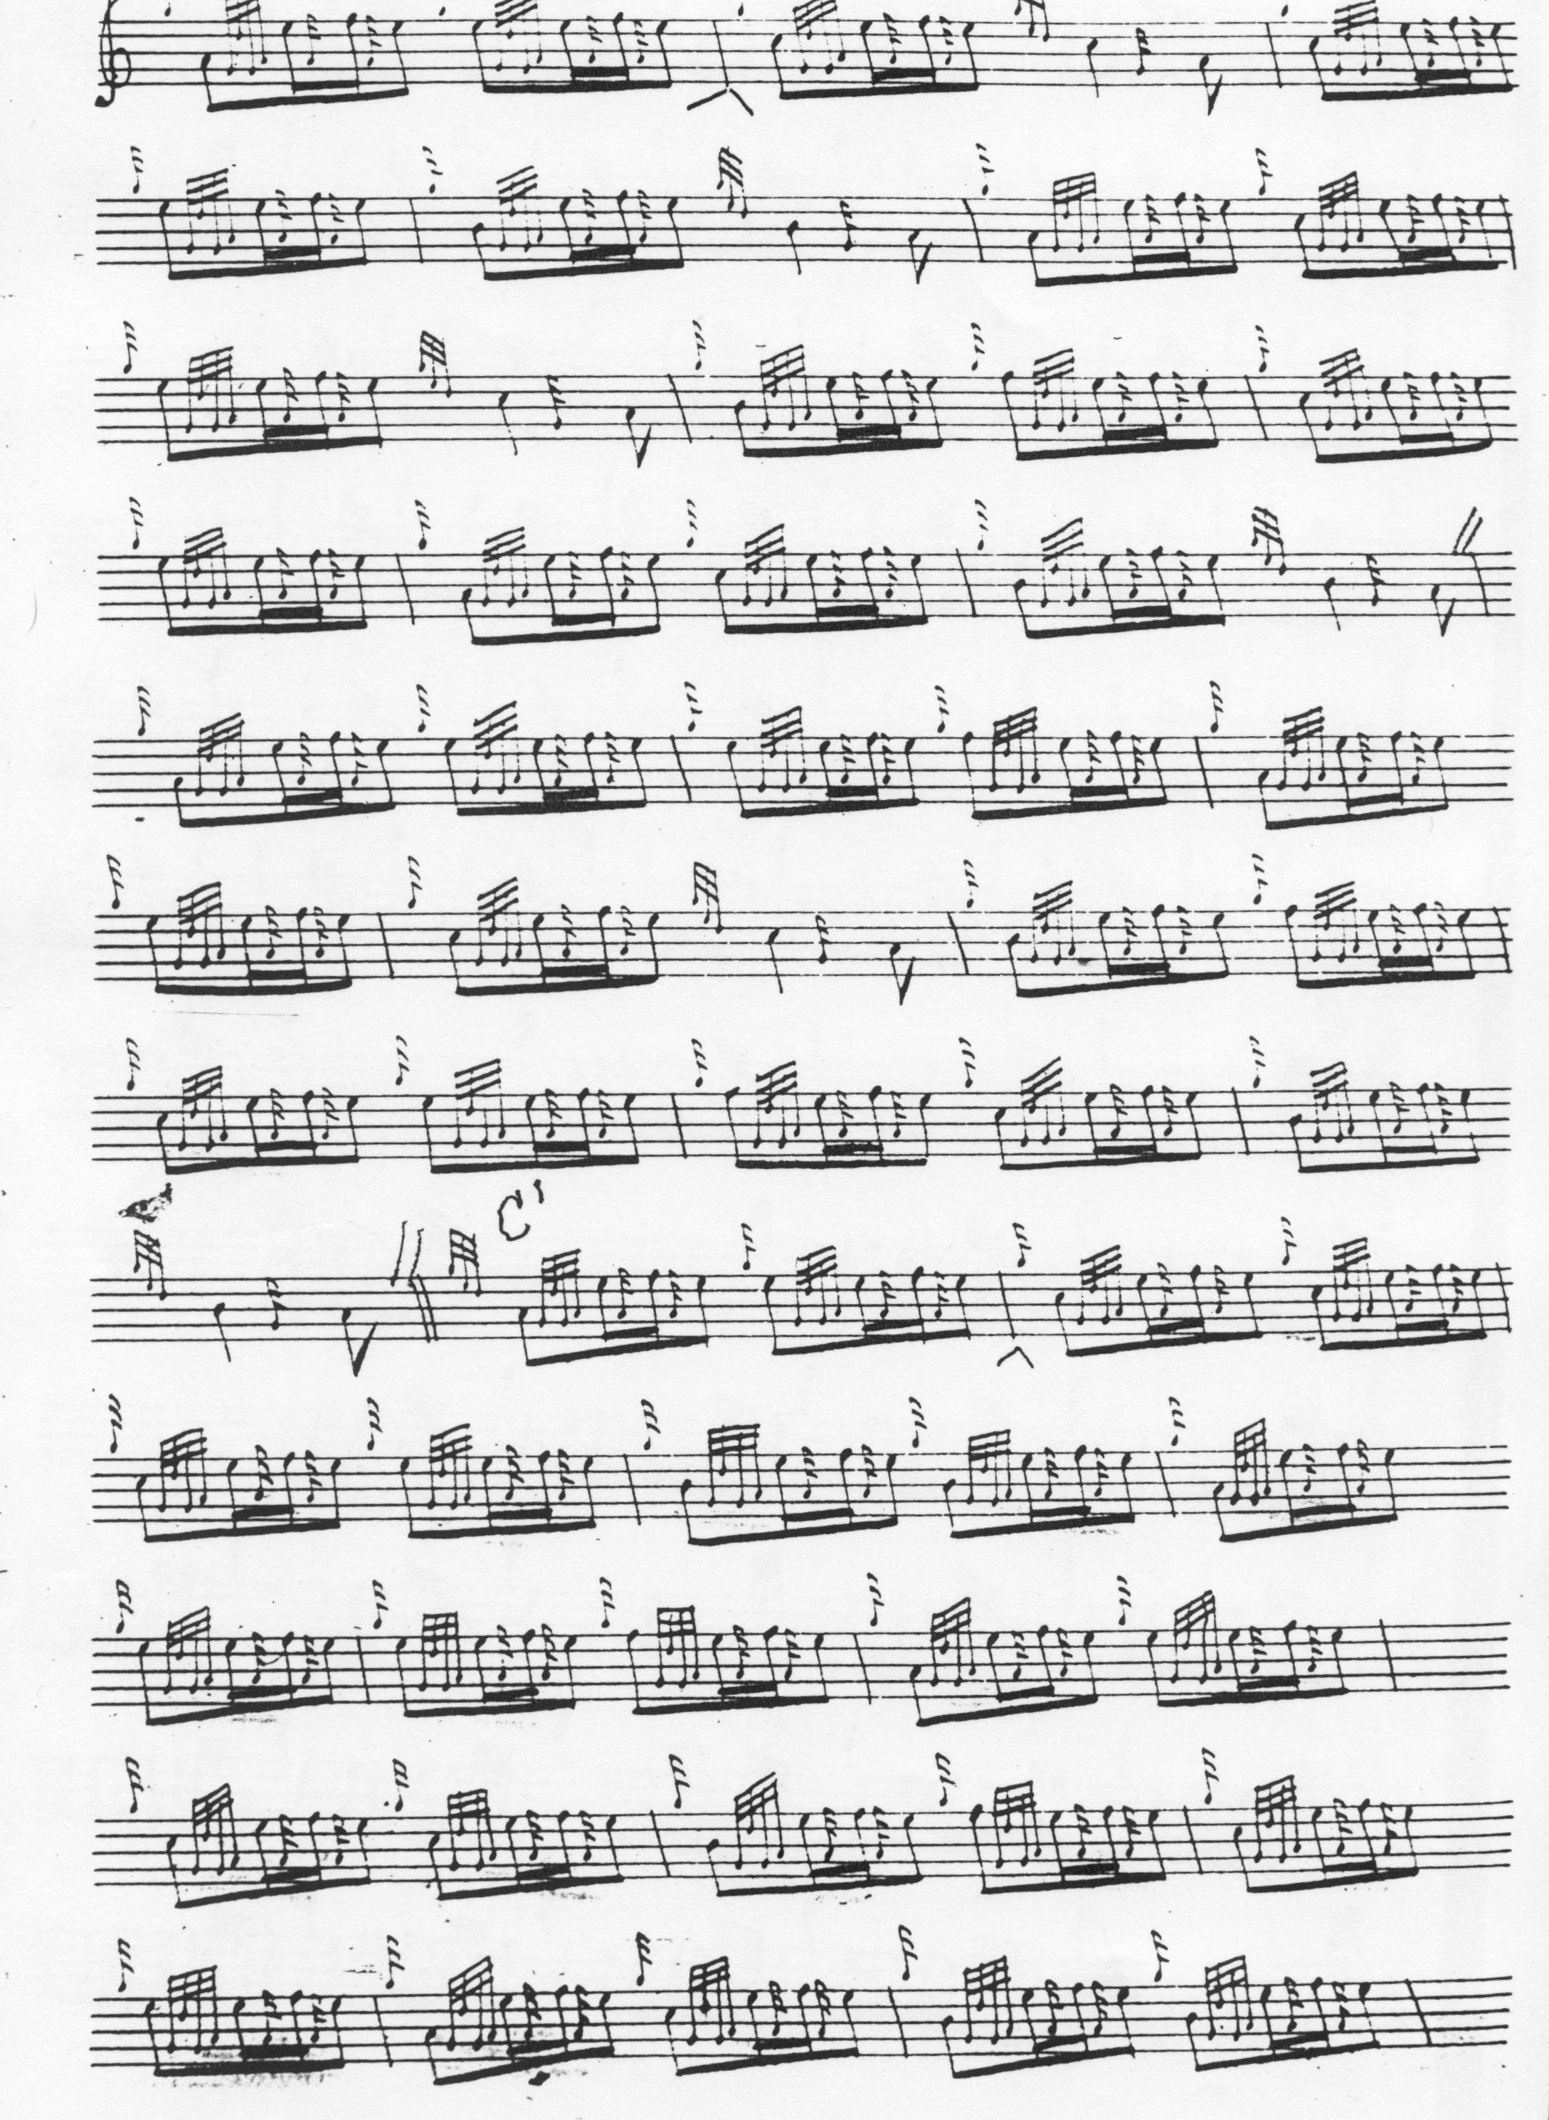

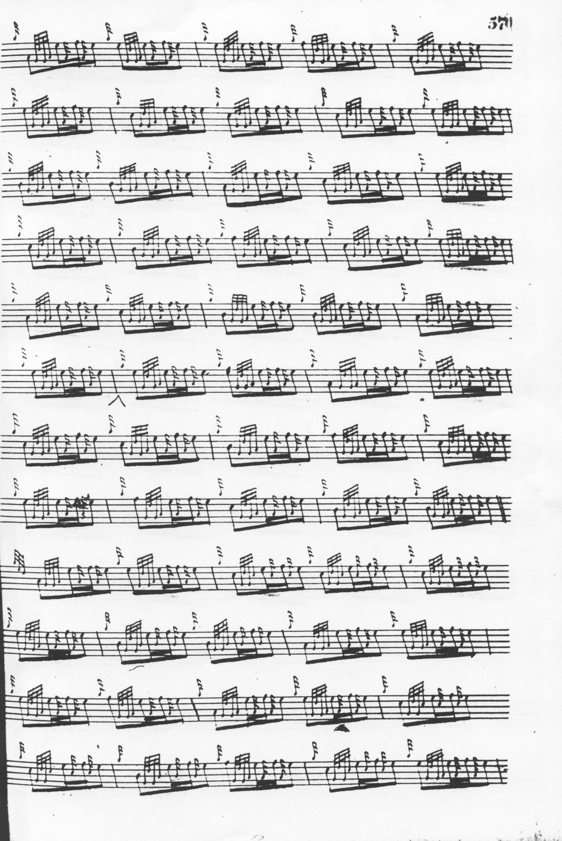
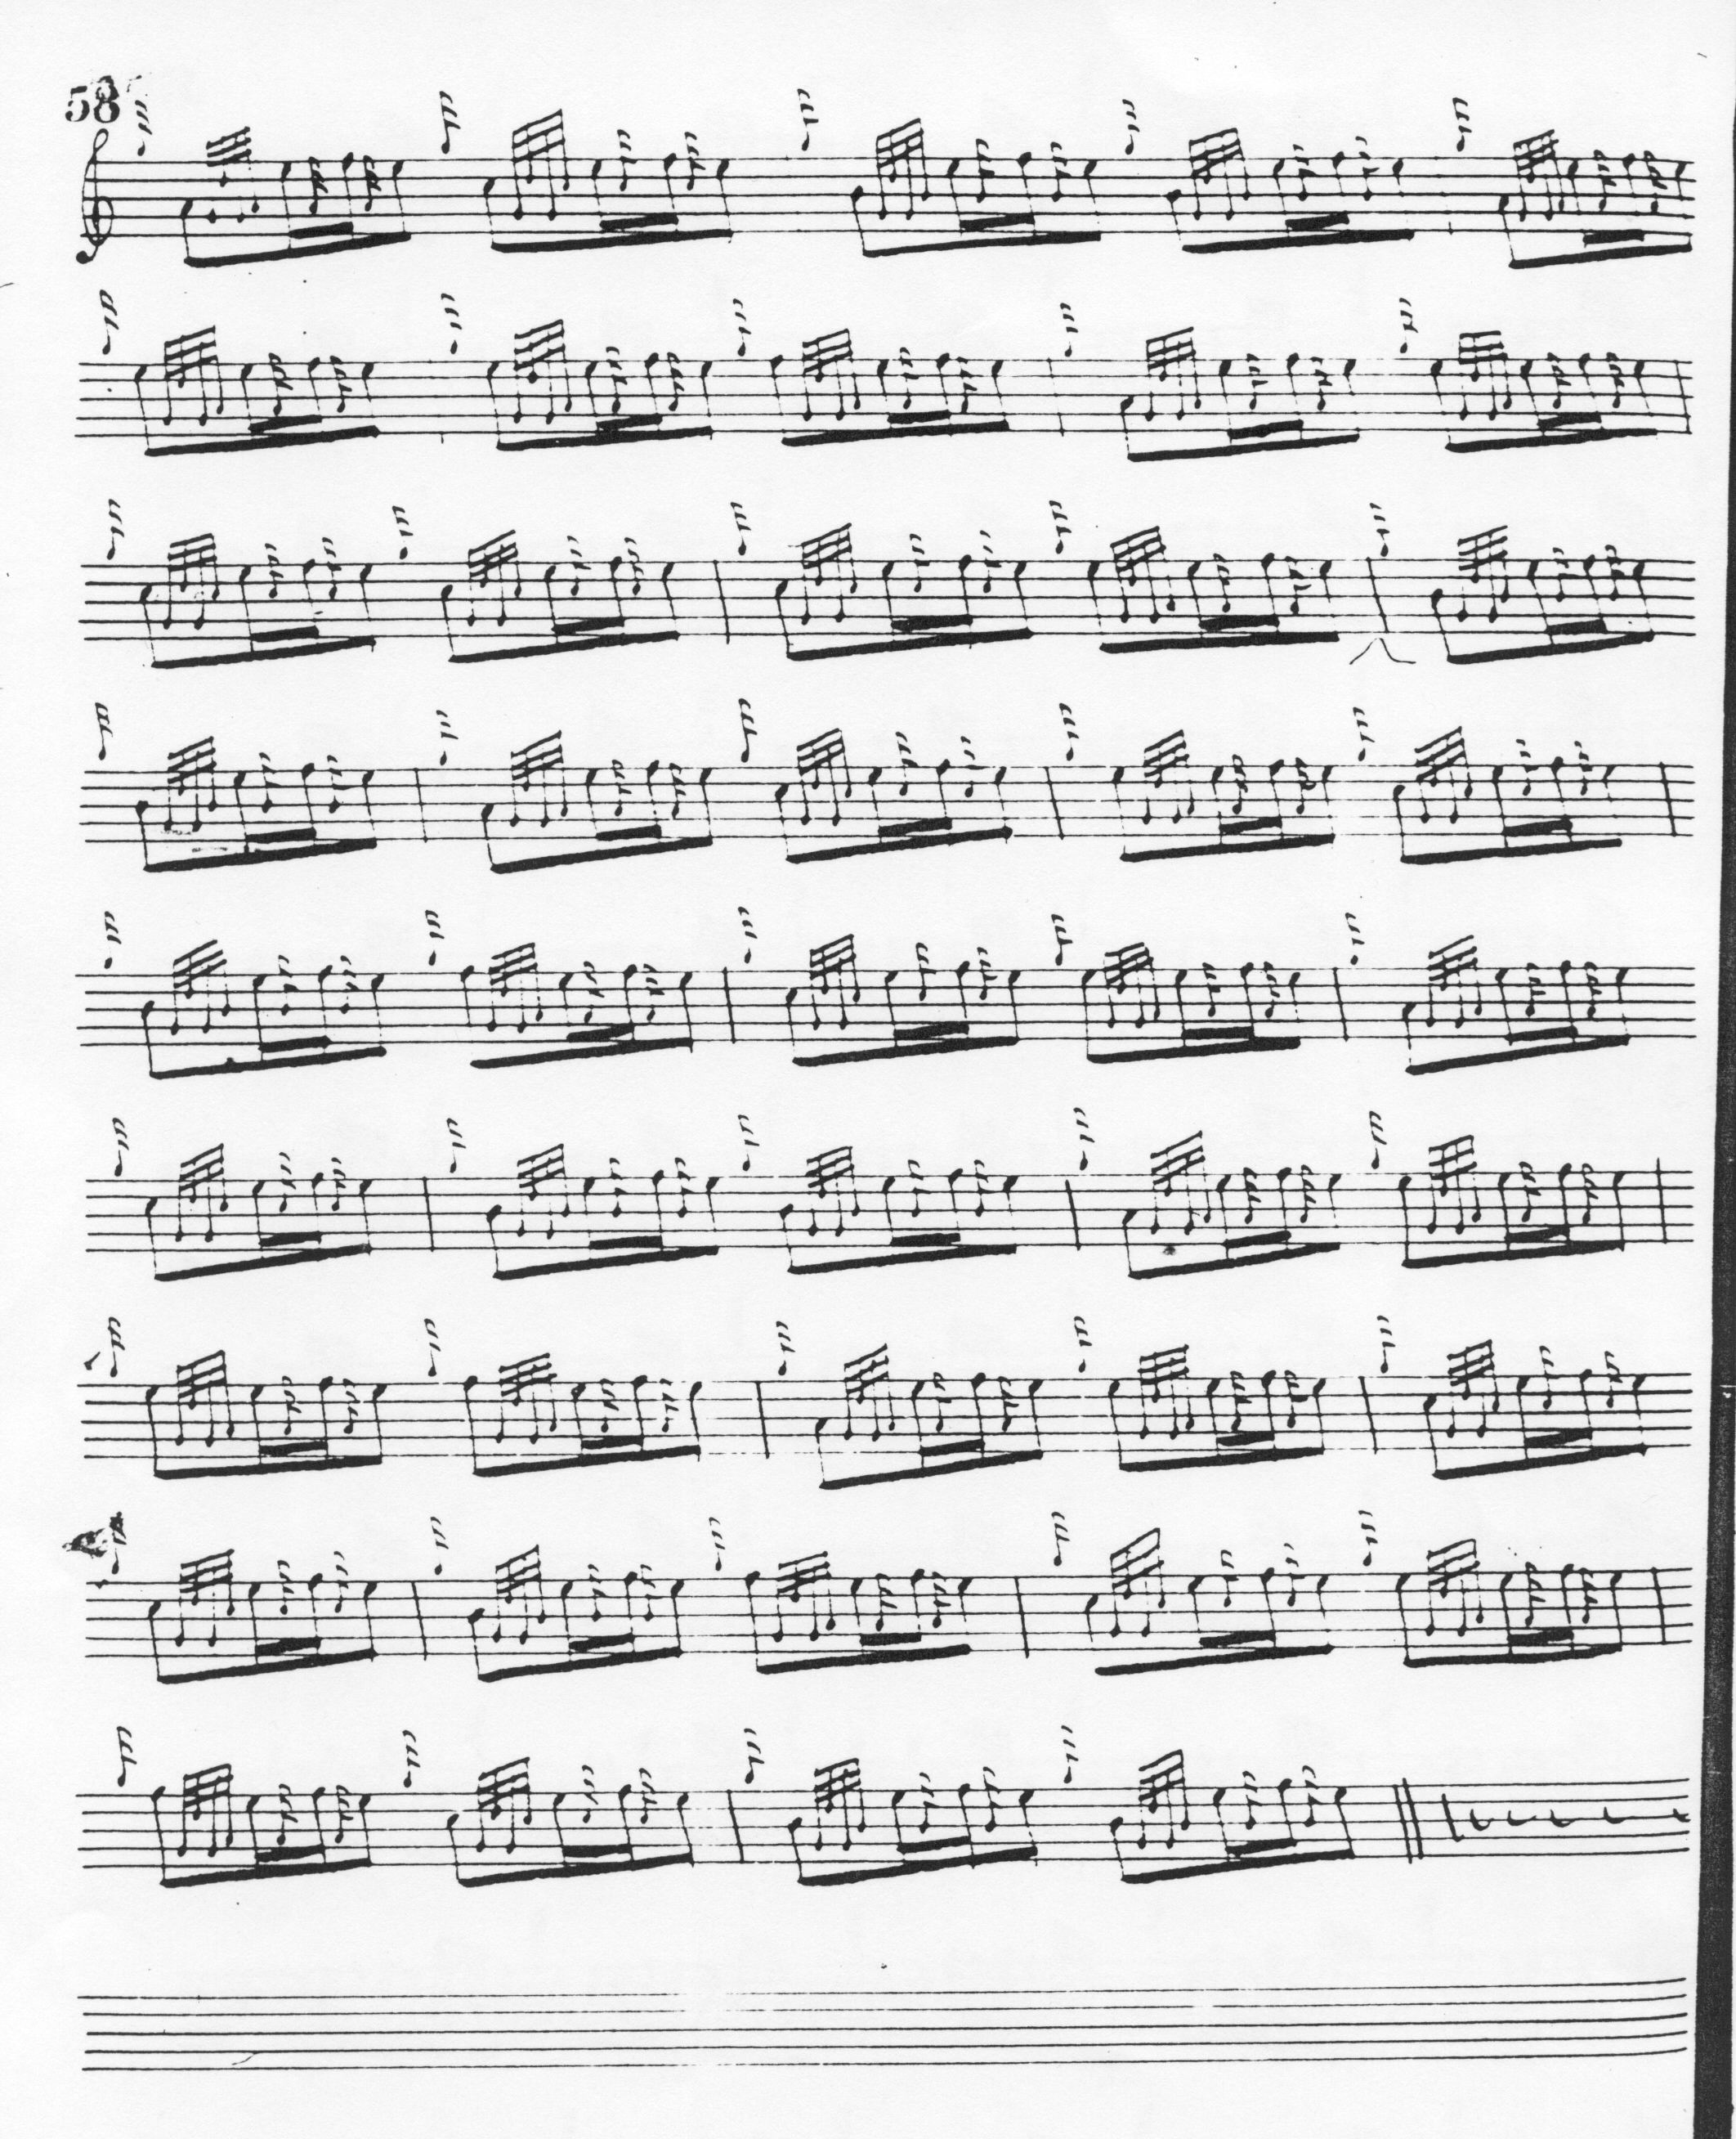

MacDonald has no siubhal; he proceeds from the thumb variation to taorluath singling and doubling and crunluath singling, doubling and a mach. He gives no indication of repeats of the ground within the tune or at its close. MacDonald, Reid and MacKay have the same rhythmically awkward feel in the closing sequence of the ground and thumb variation, as if they had all experienced difficulty notating it. MacDonald calls this tune a lament (although there is no entry for this piece in his MS notes to the tunes in his collection), while Angus MacKay considers it a salute. Bearing in mind Joseph MacDonald’s remarks about the tonality of laments and their characteristic avoidance of the third interval of the scale in A, one might feel inclined to follow MacKay here.

Peter Reid sets the tune as follows:

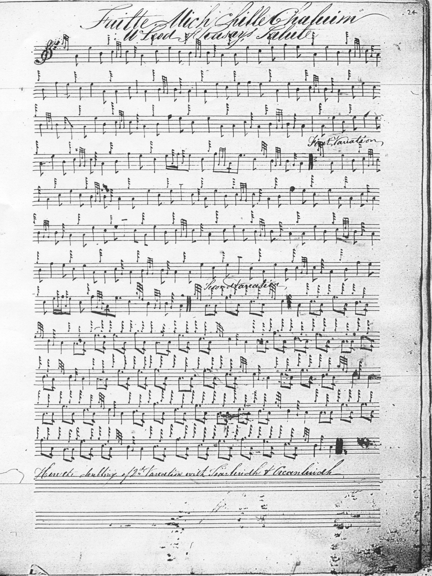

The note at the foot of Peter Reid’s setting says “here the doubling of 2nd Variation with Taorluidh & Creanluidh”. Although we now believe it possible that Reid could actually have studied with Donald MacDonald in Campbelltown, he uses a similar title to Angus MacKay’s. He has MacDonald’s anacrusis, but does not follow the latter in every detail of the tune. For example, the B>A figure in MacDonald’s bar five in the ground is two low As in Reid; on the repeat of line one (MacDonald’s bar 8) we get grip B > low A, rather than MacDonald’s cut down from the C. Since this is repeated at the corresponding position in the Thumb Variation, we may suppose that Reid intended this—i.e. it is not a slip. Reid’s concluding gesture in the ground seems rhythmically more plausible than MacDonald’s but even so, the GED cadence on the final figure seems superfluous Reid approaches the Thumb Variation differently as well, evoking high A more sparingly than MacDonald. Reid includes a siubhal singling and doubling, (which MacDonald and MacKay do not), before passing to his taorluath variations and in it he follows--in line two-- the tone row adopted by Donald MacPhee for the later variations of the tune.

Angus MacKay sets the tune like this:

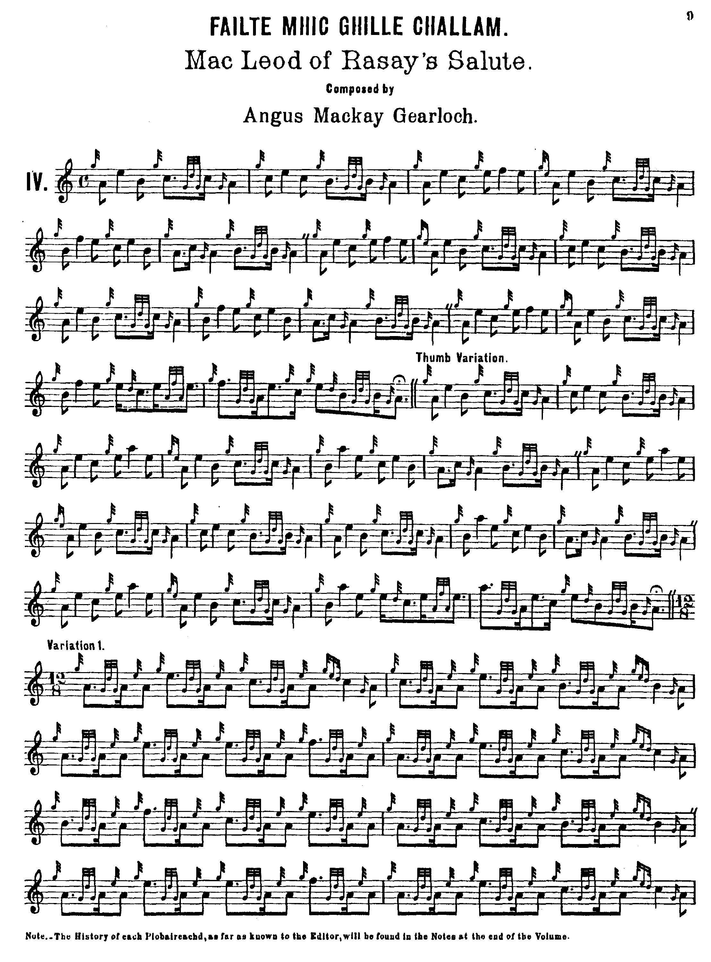
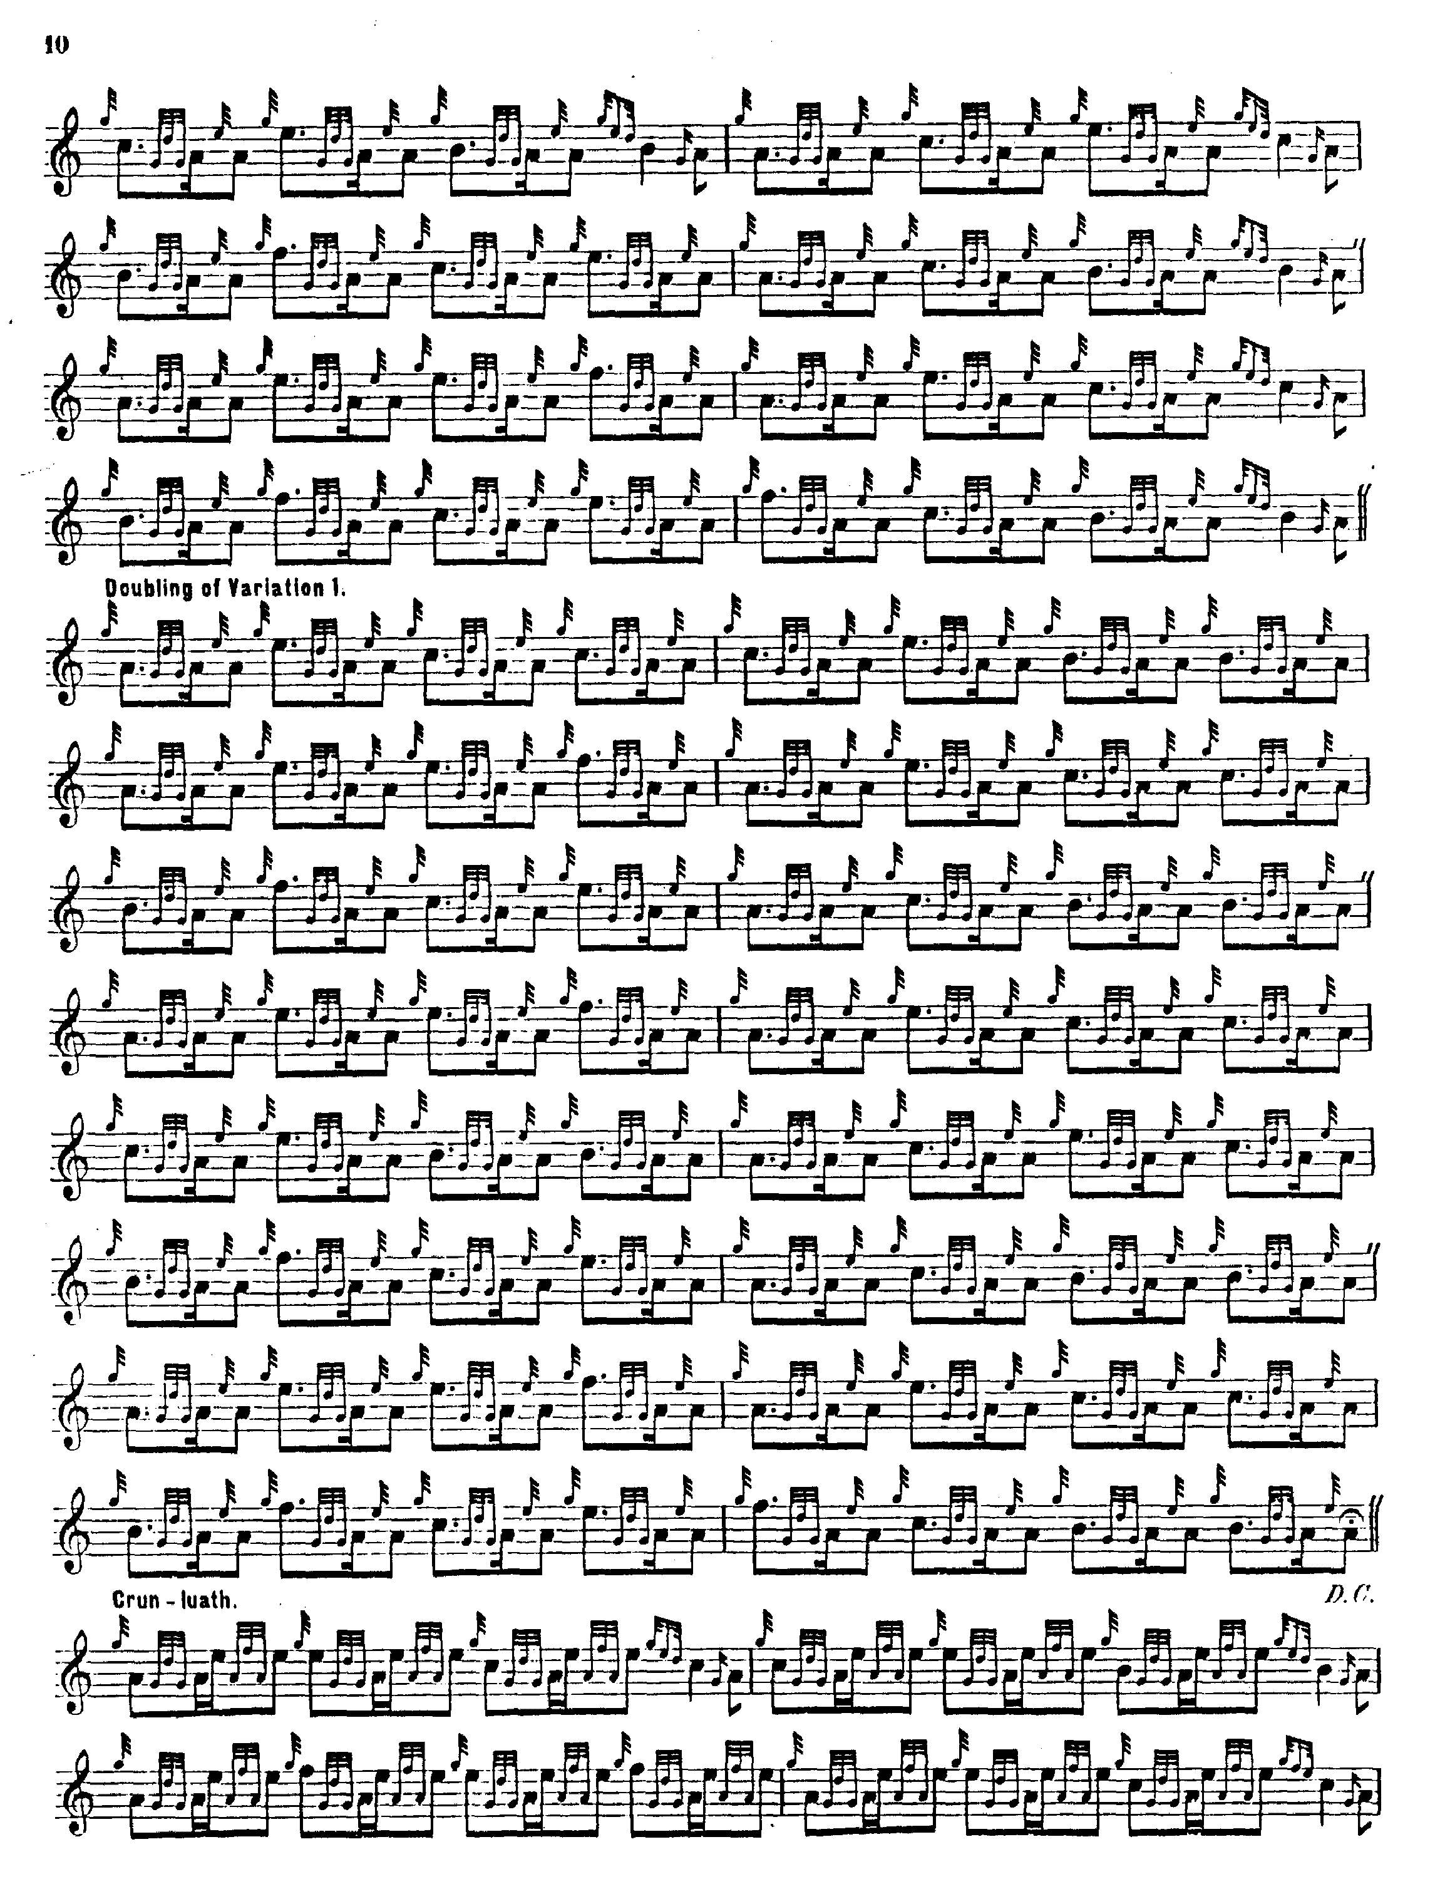
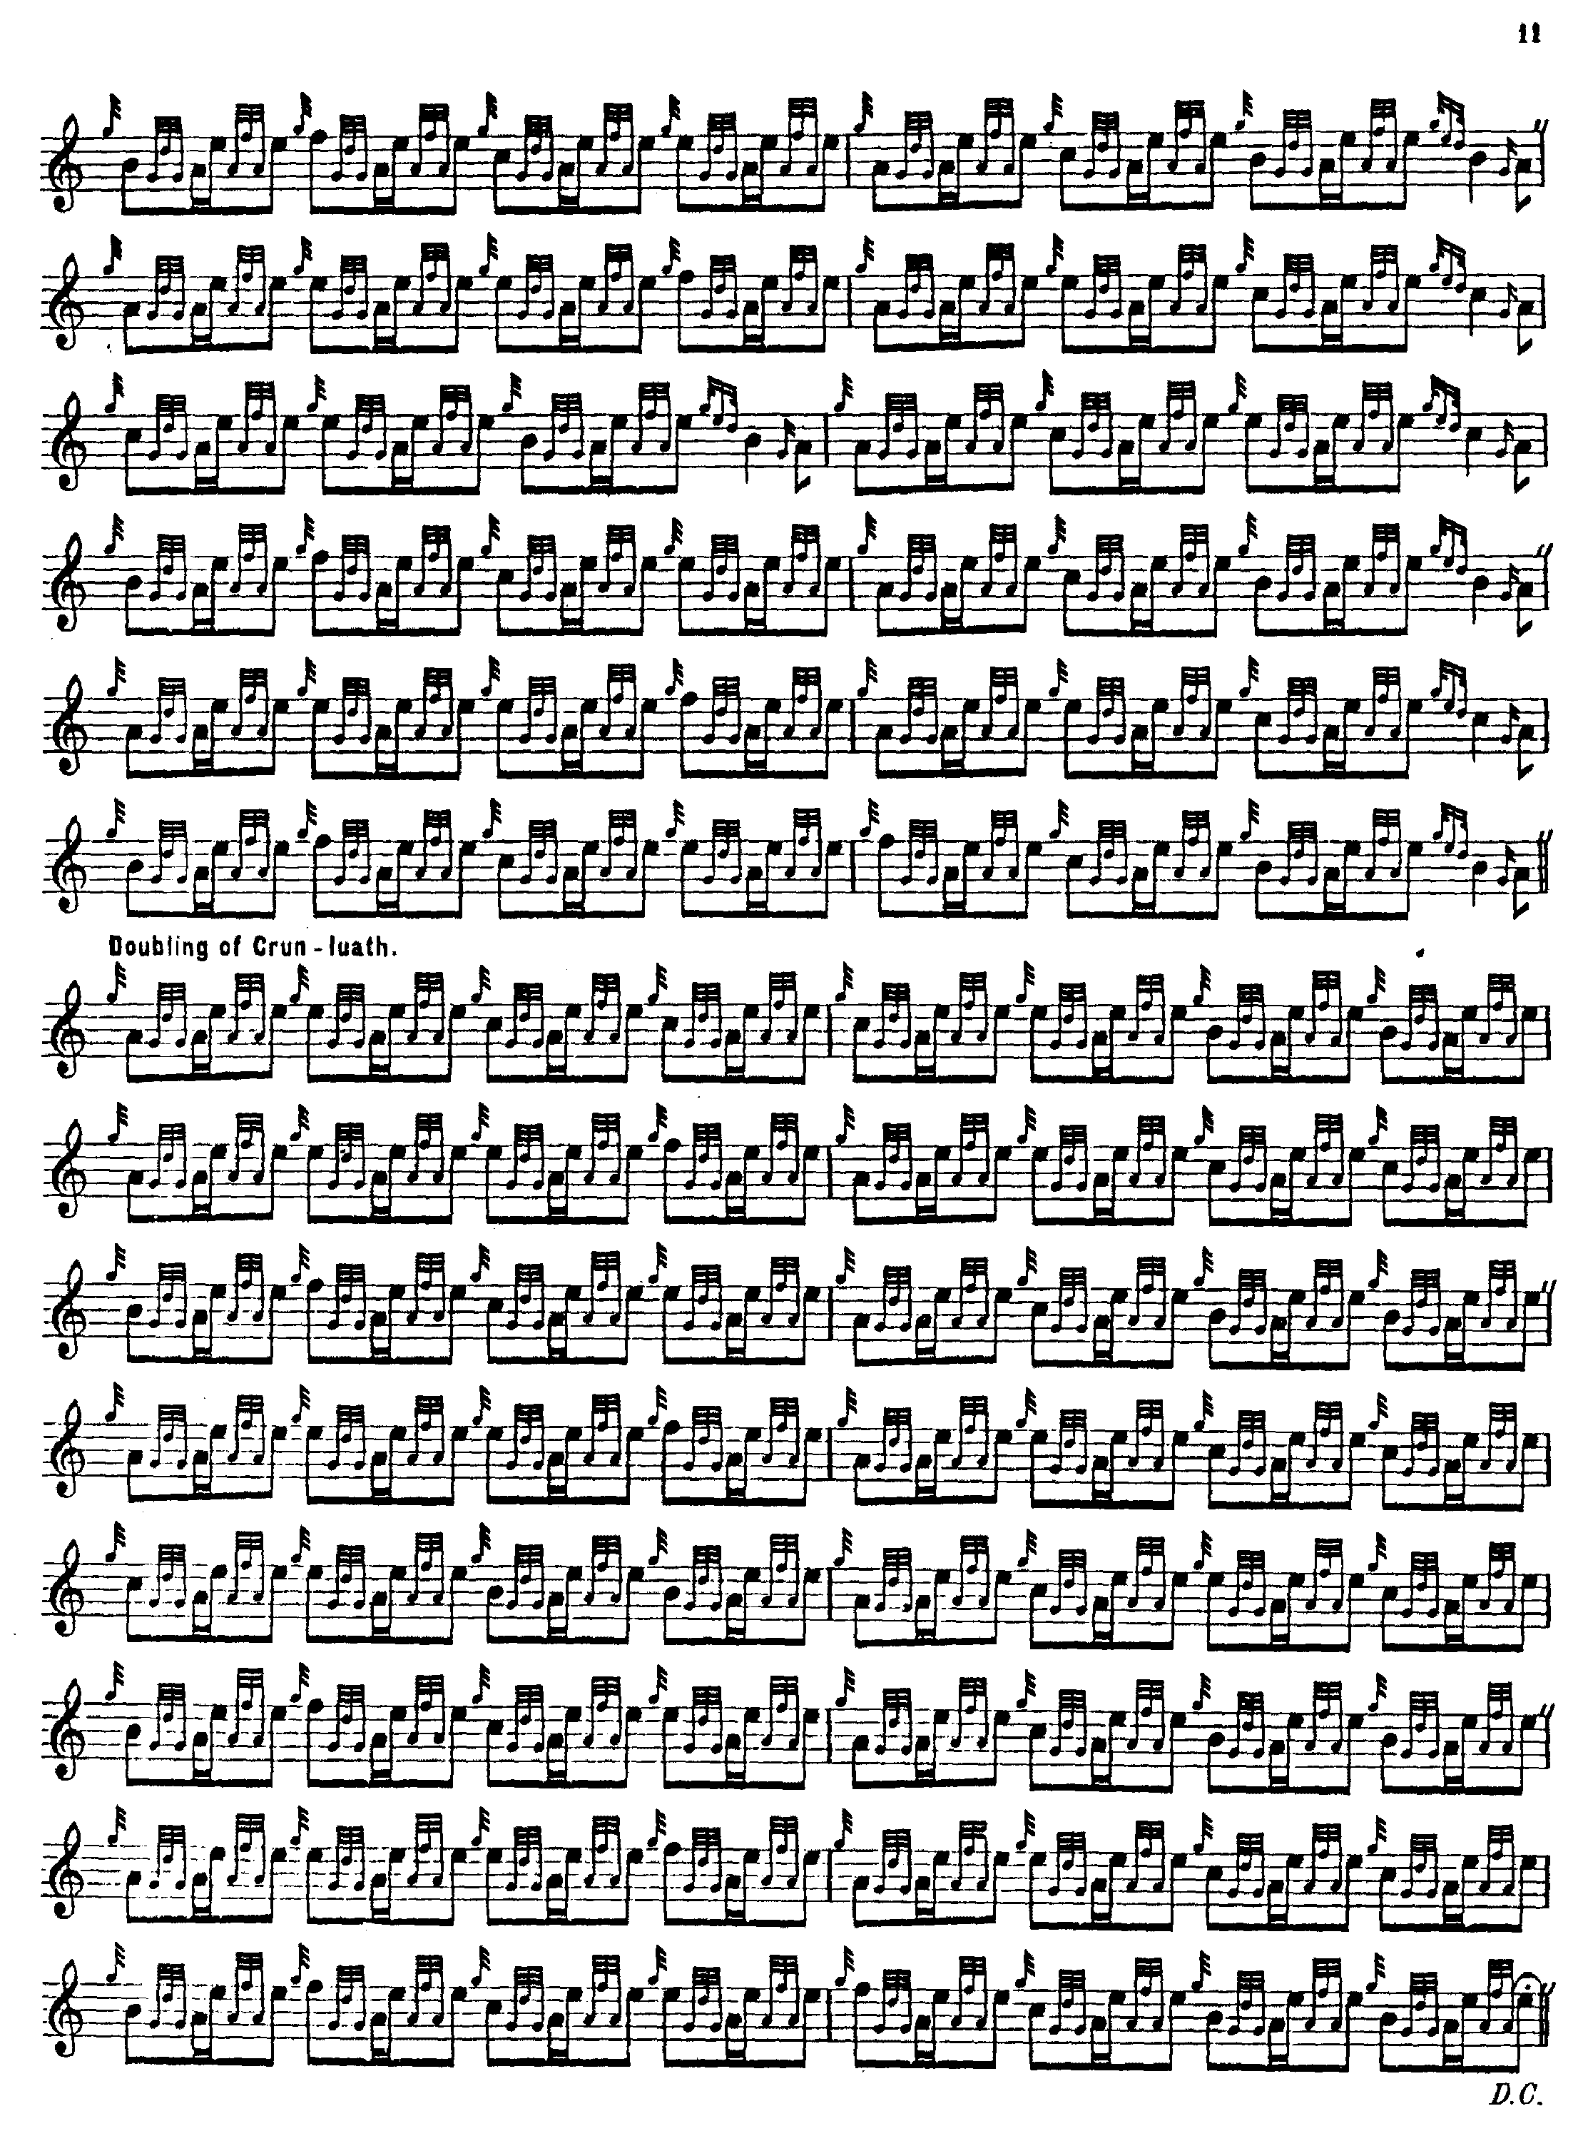

MacKay’s approach is broadly similar to MacDonald’s in the development of the tune, but he differs from the latter in a number of details. MacKay avoids opening with the anacrusis we see in Reid and MacDonald, but traces of it remain in the rather awkward E cadence at the beginning of the second half of the A phrase in the ground and thumb variation. We note too his squarer 4/4 timing. MacKay repeats the ground at the end of the taorluath and crunluath variations, but has no crunluath a-mach.

Donald MacPhee sets the tune like this:
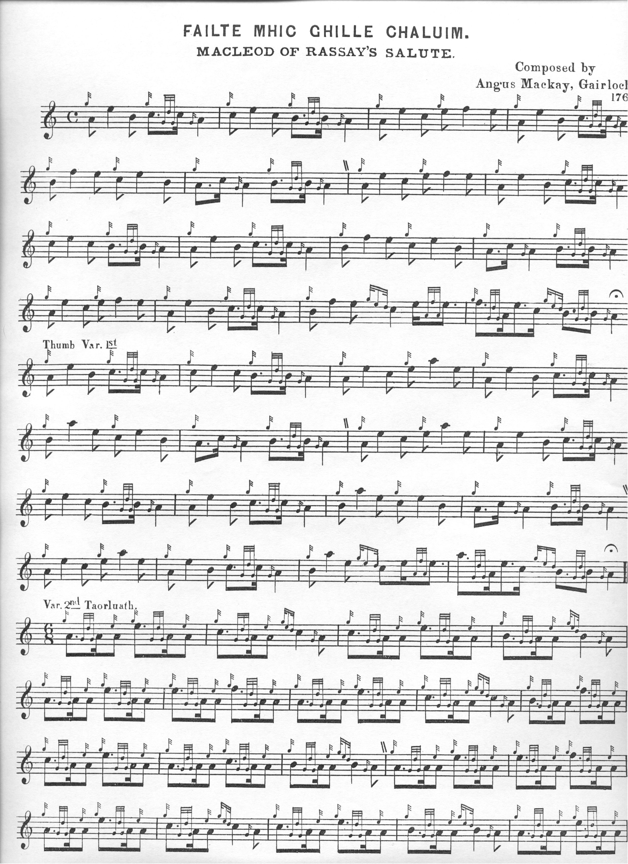
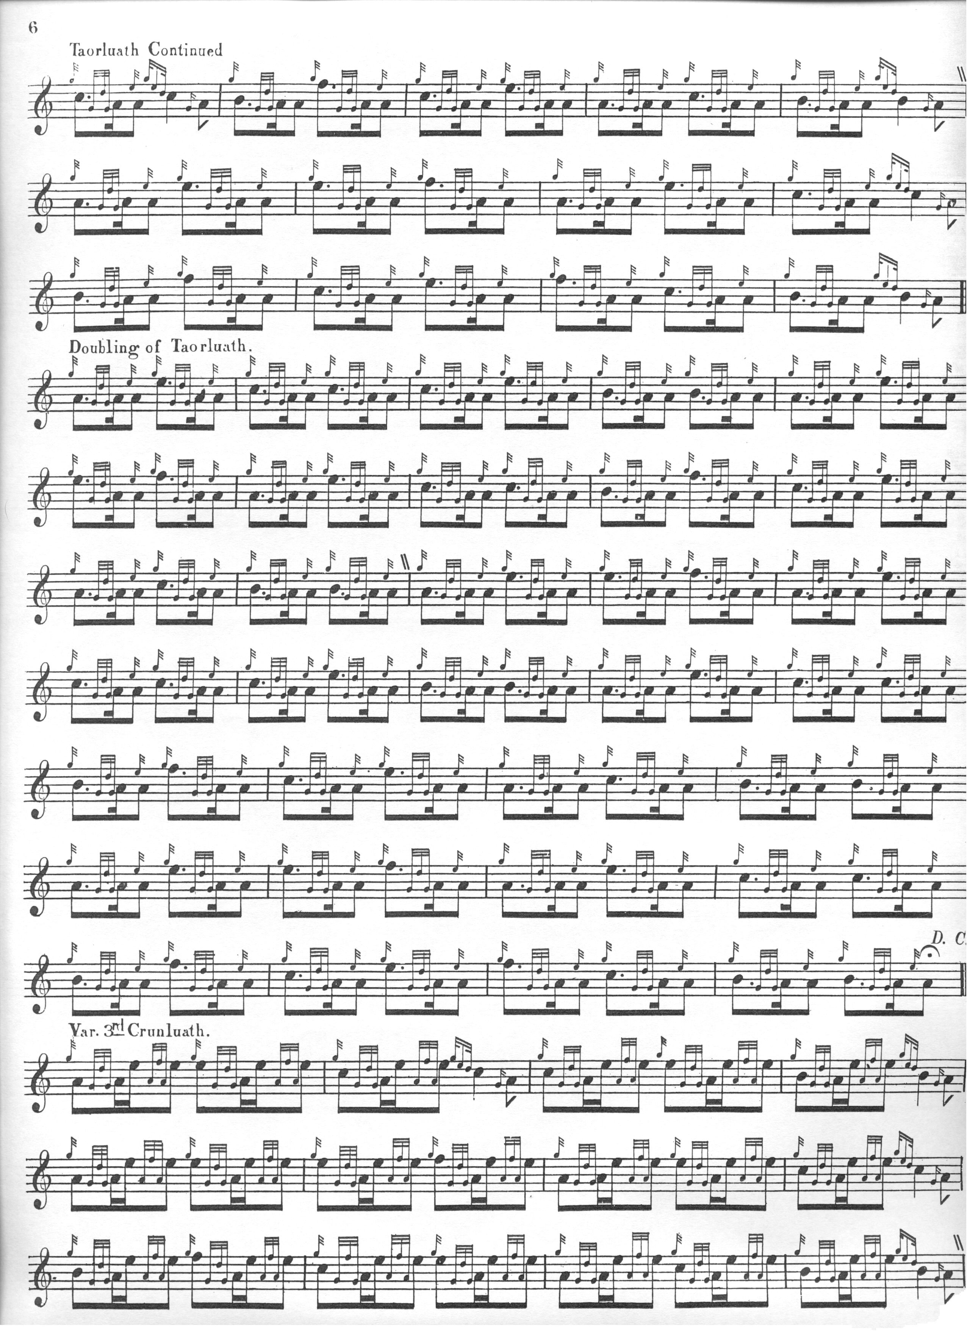

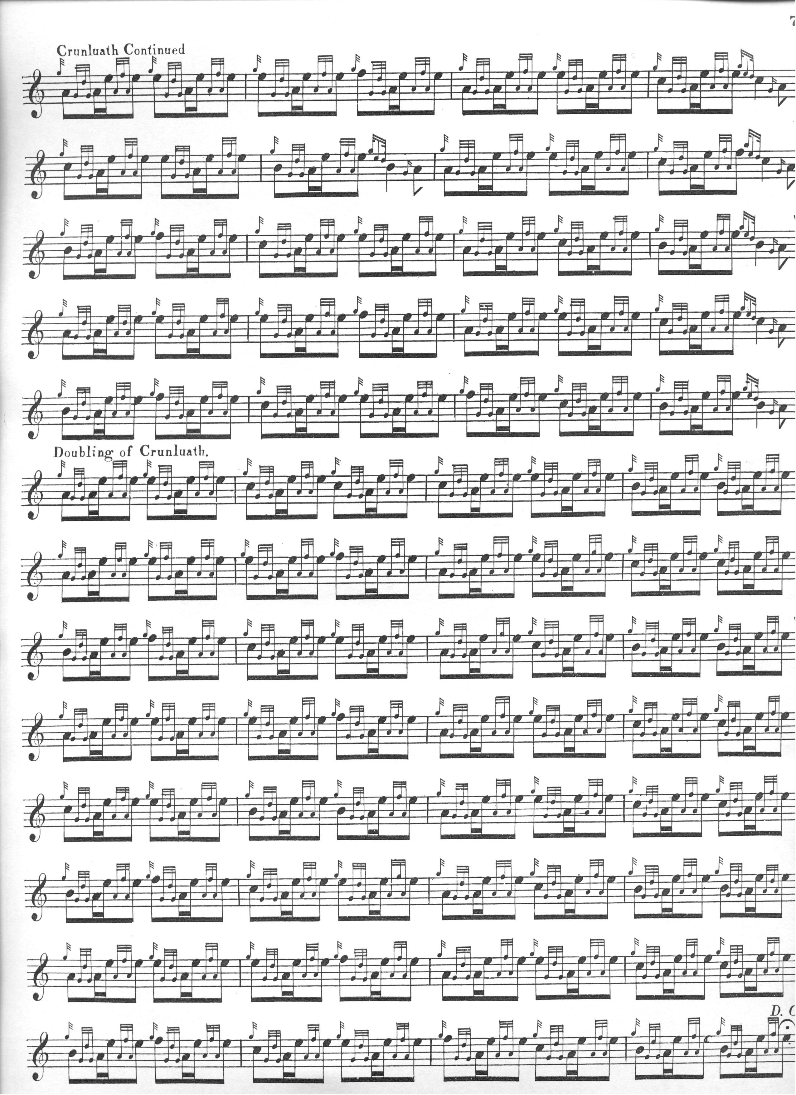

MacPhee broadly takes MacDonald and MacKay’s route through the tune, although he drops the obtrusive E cadence in the middle of the A phrase of the ground. In accordance with his general editorial policy of making his variations closely follow the tonal contours of the ground, he adjusts the tone row in bars nineteen and twenty of the variations so that they read A-E-C-C rather than MacDonald and MacKay’s A-C-E-C, although this was to create controversy later.

C. S. Thomason seems to have had an open mind on the matter, reproducing both MacDonald’s and MacKay’s grounds and thumb variations, and the taorluath and crunluath as they had set them, and then as given by MacPhee on adjacent pages. He cites Colin Cameron amongst his sources for this tune:

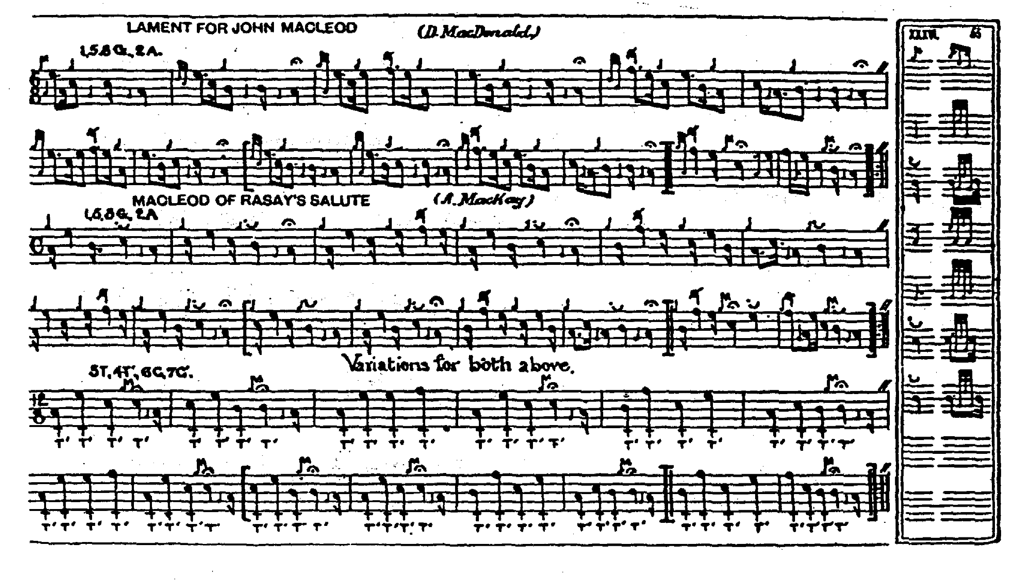

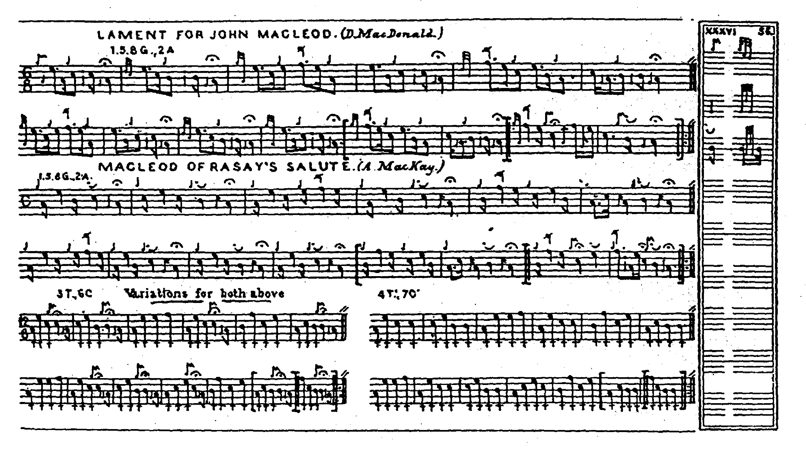

David Glen sets the tune like this:
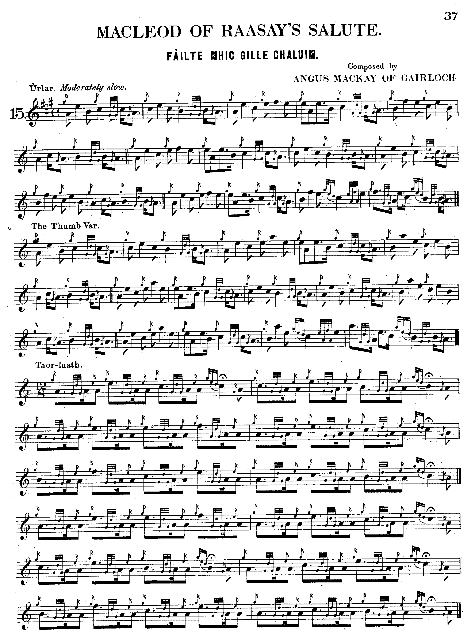

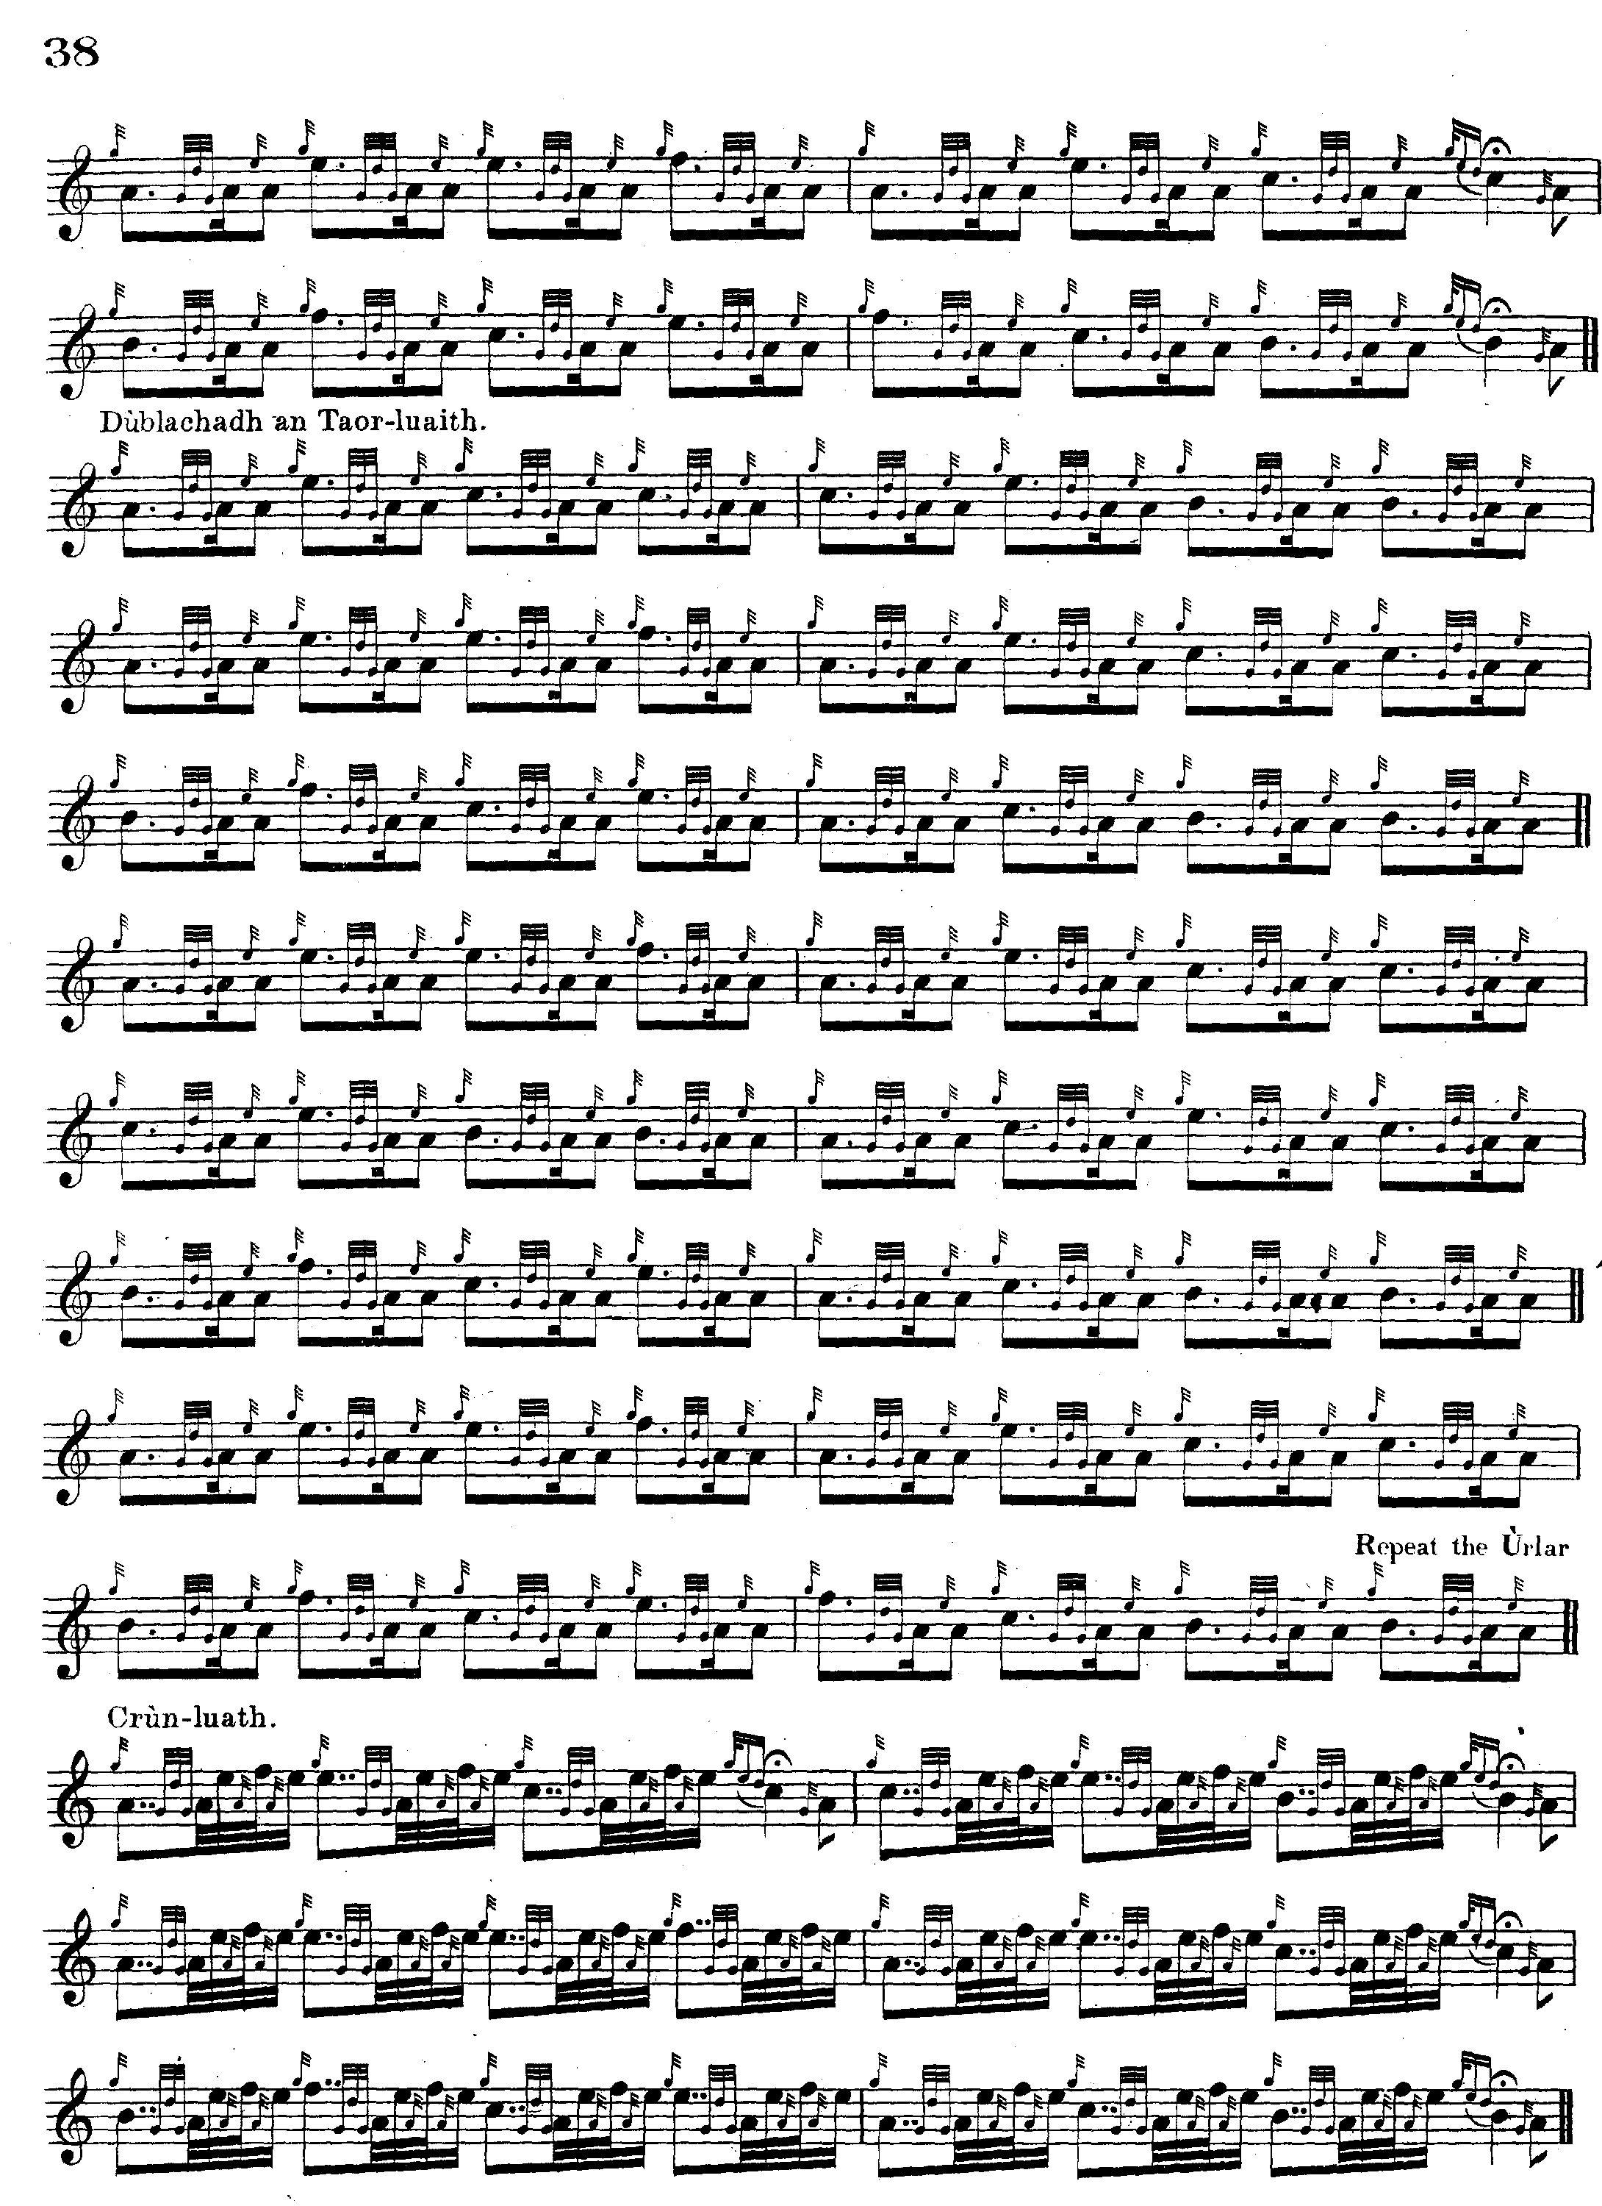

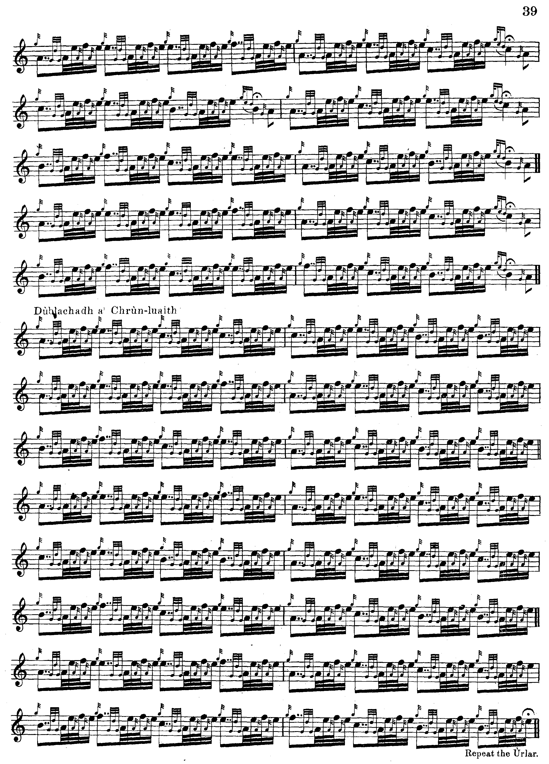

Commentary:

“Fionn”’s note in David Glen’s Collection of Ancient Piobaireachd gives the background of the tune as follows:

This Salute is said to have been composed by Angus Mackay of Gairloch, son of Iain Dall Mackay, on the birth of James Macleod, tenth of Raasay, in 1761. John, ninth of Raasay, who was Laird during the visit of the learned Dr. Johnson, had a large family of daughters, six of whom were born before the birth of the heir in 1761. There were great rejoicings at the birth of James, and Angus Mackay, seeking to give expression to his own joy as well as that of the Macleods of Raasay, composed this well known composition. James, tenth of Raasay, died in
1824, and was succeeded by his son John, eleventh of Raasay. (“Historic, Biographic,
and Legendary Notes to the Tunes”, p.7).

The MacKay pipers of Gairloch are the subject of an interesting account in Osgood MacKenzie’s book A Hundred Years in the Highlands (London, 1921), as follows:

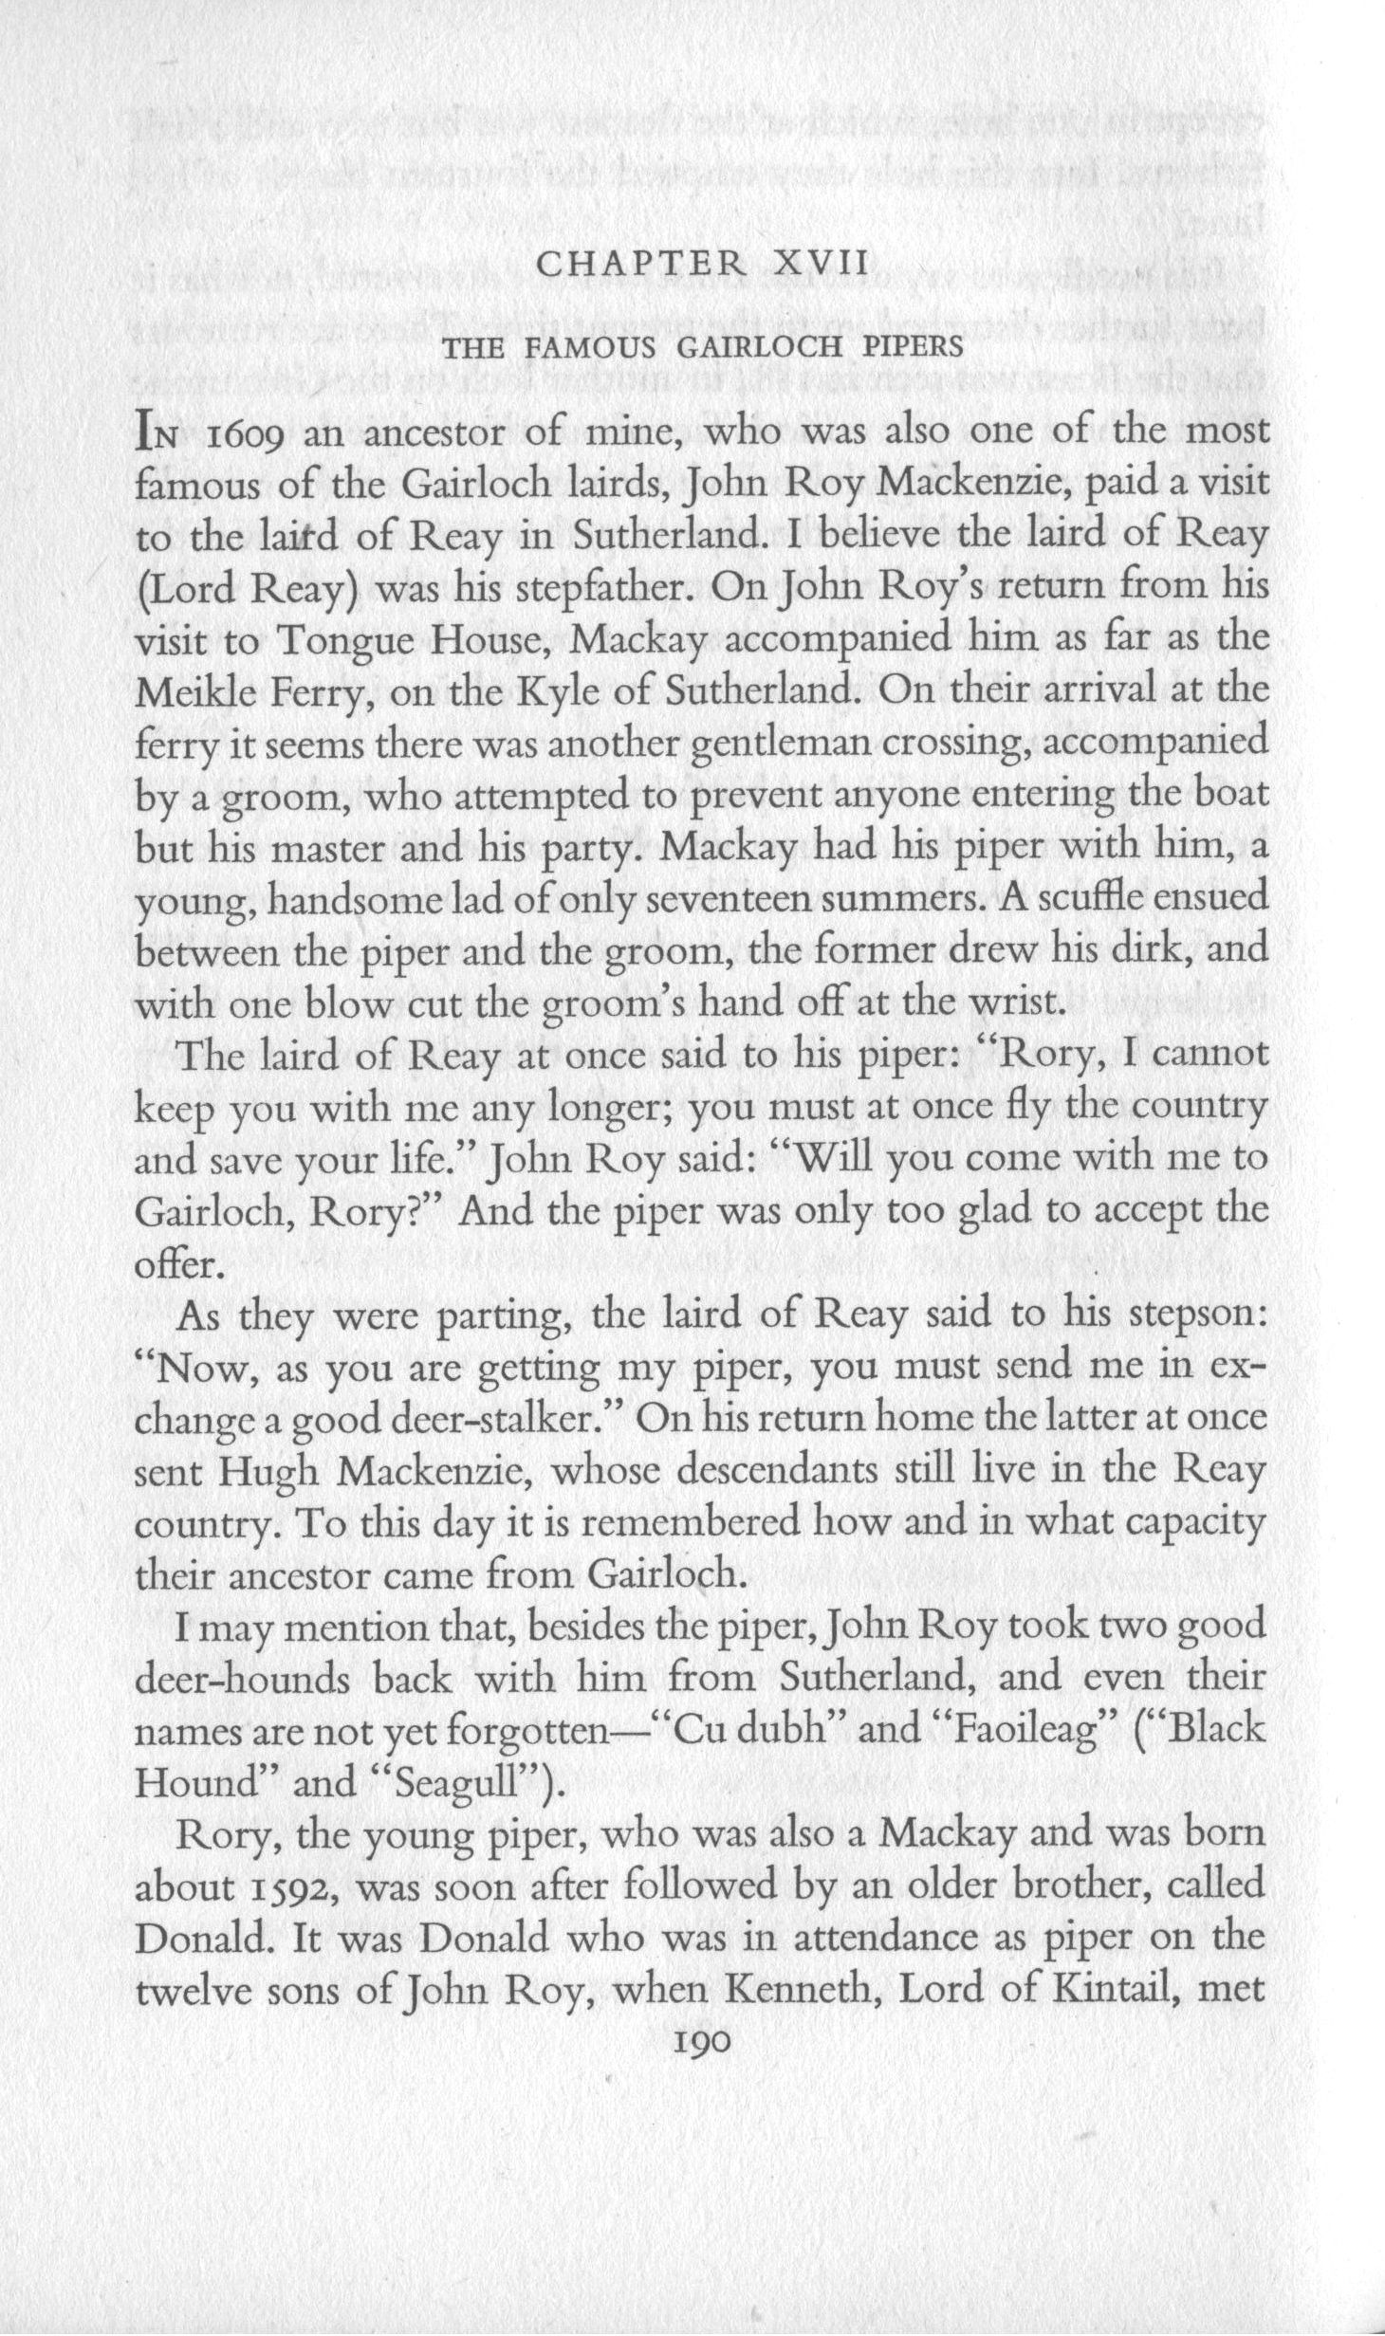
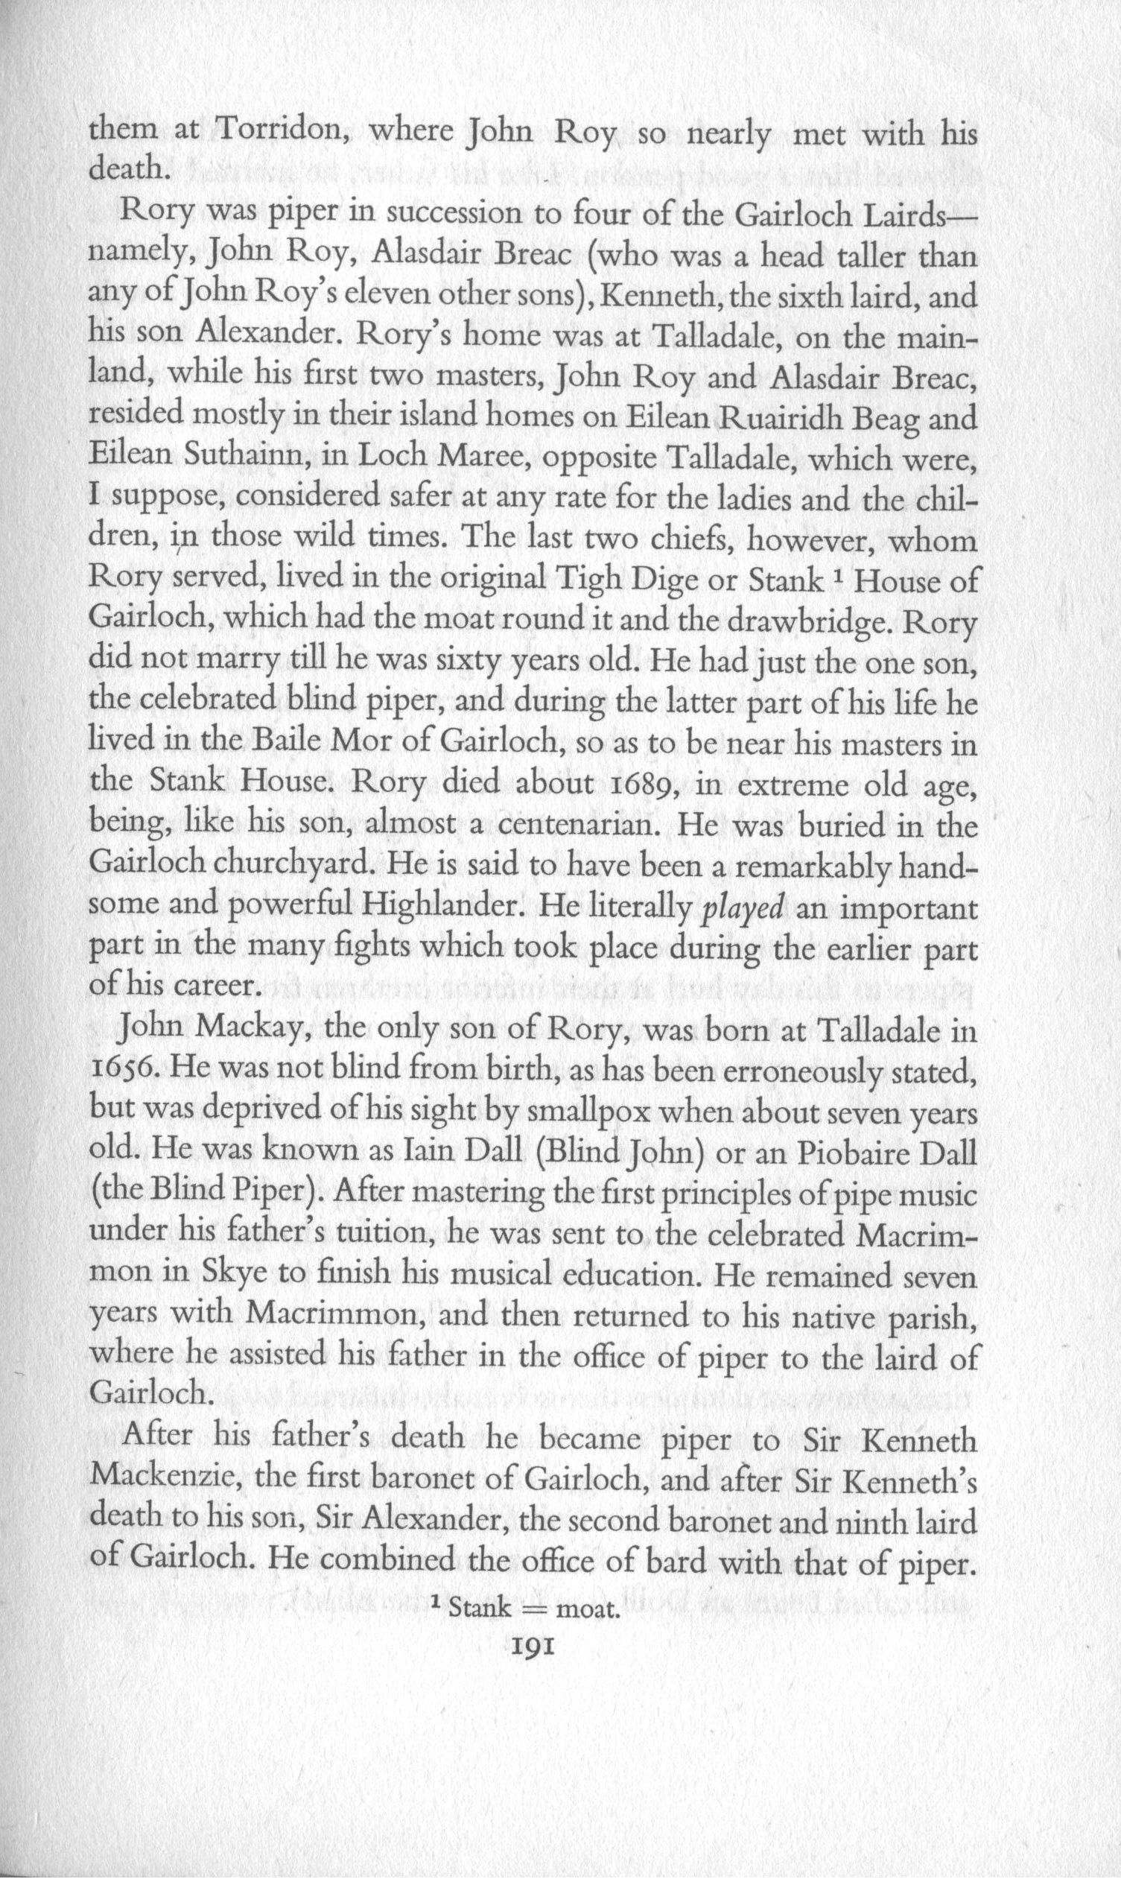
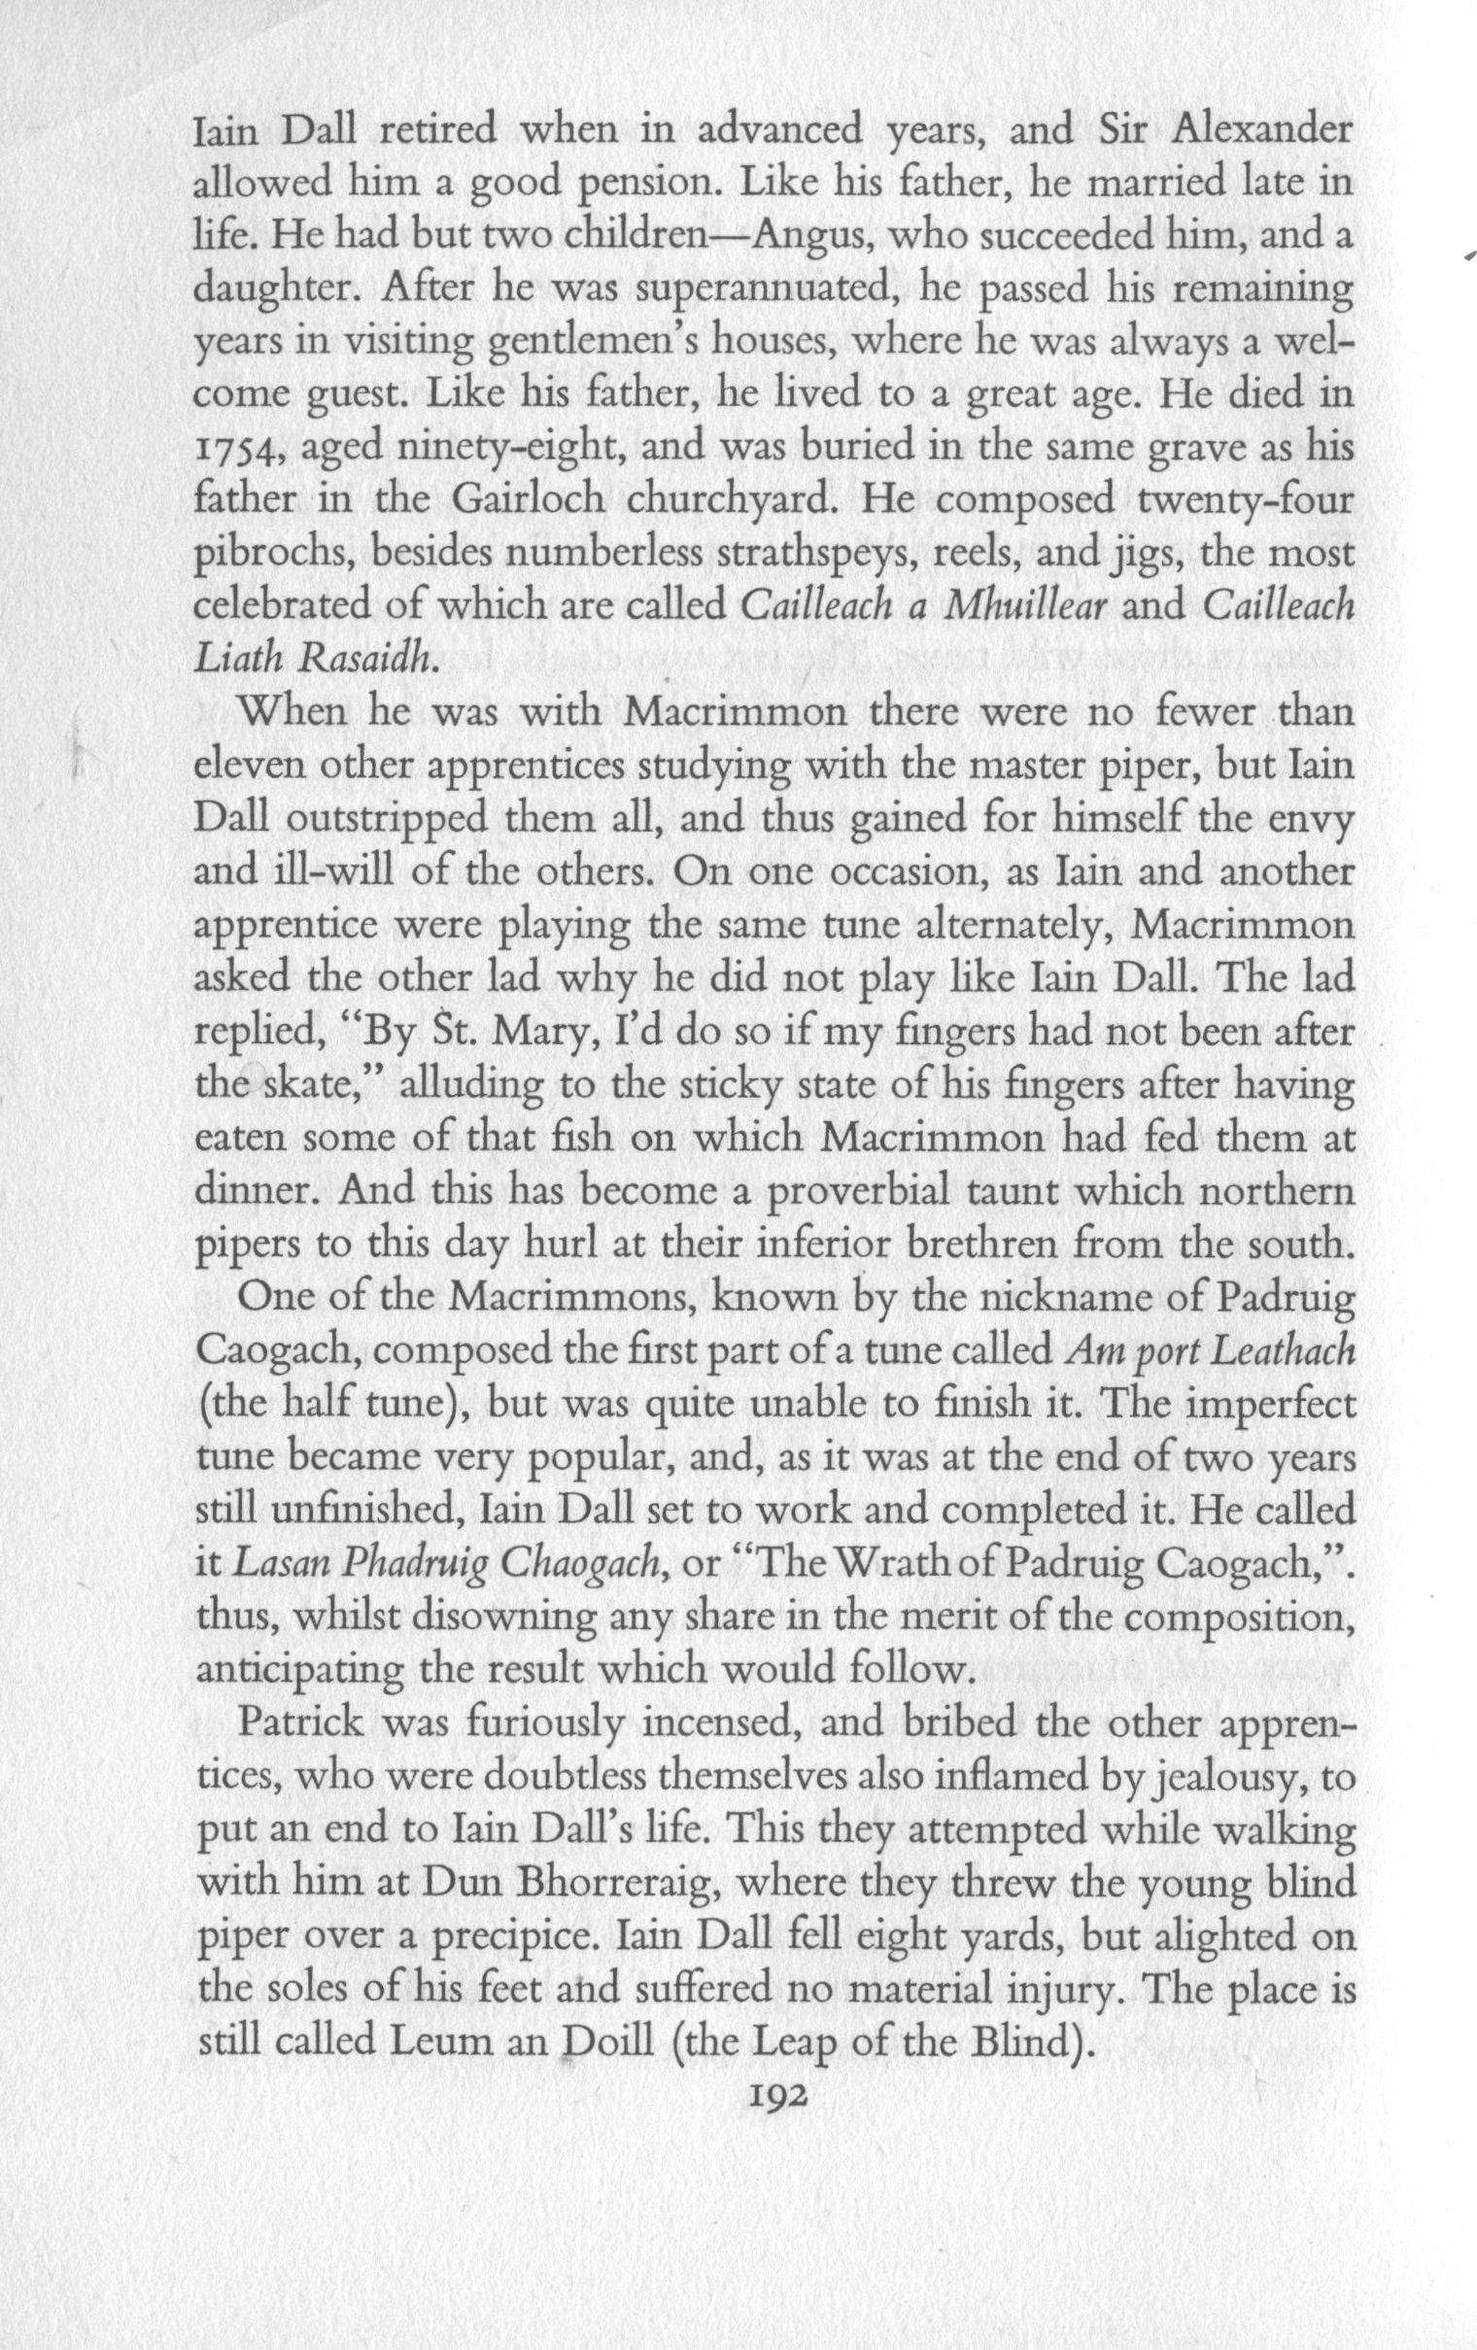
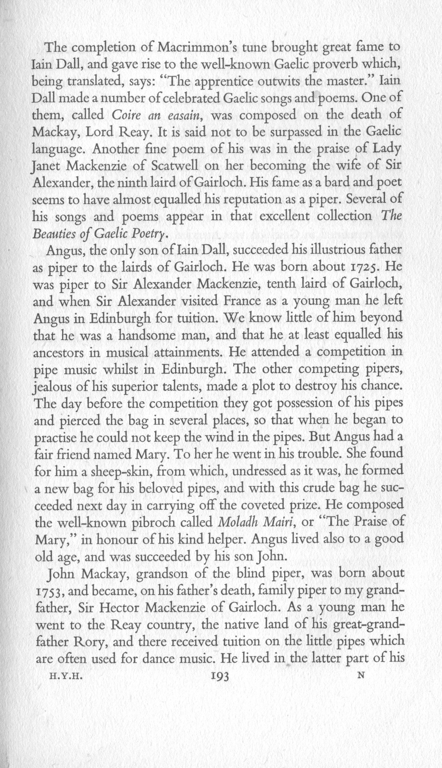
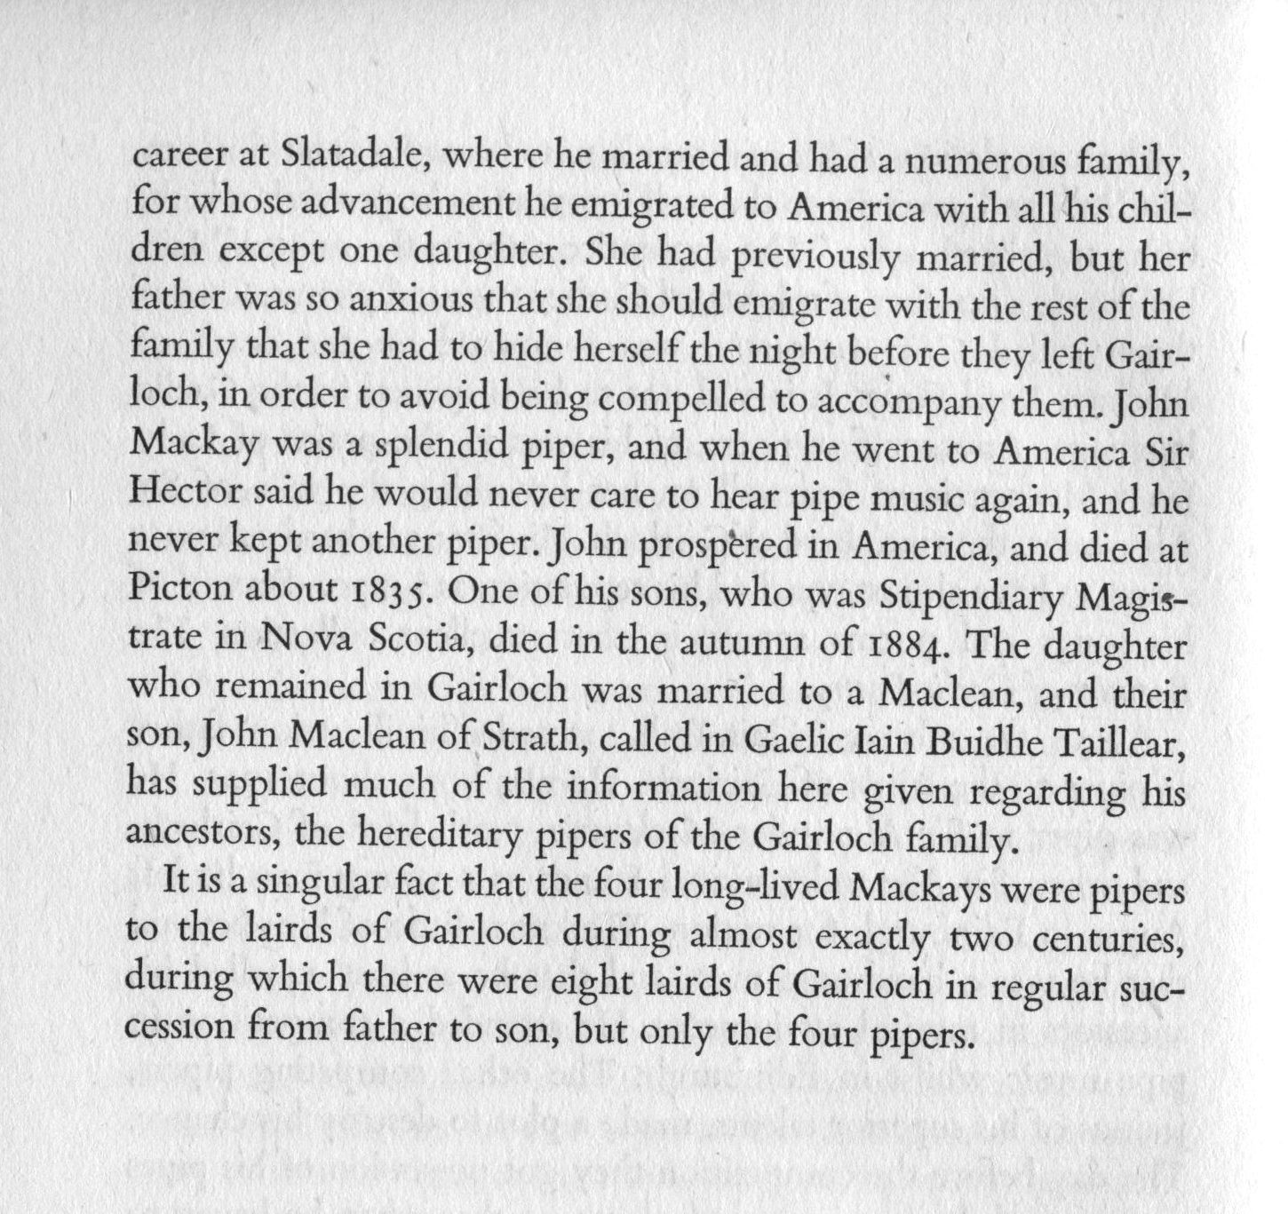

“MacLeod of Raasay’s Salute” became the subject of an exchange in the Oban Times in 1883 which sheds interesting light on the authority being claimed for Angus MacKay’s work by the later years of the nineteenth century, the growing tyranny of the printed score and the pedantry to which it could give rise. At Oban that year, the famous John MacColl had won playing the tune in his teacher Donald MacPhee’s setting, provoking the following comment from a correspondent in Renfrewshire, writing under the pseudonym “Vandaura”:
it is frequently noticed, even at some of the best gatherings, that competitors mis-place parts of the tune, and again leave some parts out altogether. Mistakes of this kind, probably the result of nervousness, carelessness, or ignorance, should never be overlooked by the judges. But it is a fact, nevertheless, that such cases are at times overlooked, and the judges as if it were to show their own ignorance or carelessness on some of these occasions have awarded the bunglers first honours, to the infinite disgust of all the other professionals. As a case in point I may just here state that McColl, who was lately awarded the silver cup presented by the Marquis of Lorn, and competed for at Oban, did not lift the variations of his piobaireachda [sic] of[f] the ground work of the t[une], an error sufficient of itself to have put him hors de combat. The judges may not have noticed this; it matters not, it is a fact all the same, and can be vouched for by many of the professional who were present and declared, and justly so, that the cup was fairly won by John MacBain. It is cases of the above kind that tend to bring bagpipe competitions into disrepute, and dishearten our best performers, and will ere long if not checked by a [sic] honest and careful system of judging reduce competitions to what they are well nigh already--a farce. (“Bagpipe Competition”, from “Vandaura”, Oban Times, 10/11/1883, p.5)
John MacColl himself replied, claiming that certain professional pipers were too ignorant to be influenced by MacKay's (or by implication) any book, continuing that his critic
...says that I did not lift the variations of my Piobaireachd off the ground work of the tune when competing for the silver cup at Oban Games. Now, I beg to differ with him. I know I did not play it exactly as some of the professionals he refers to would, for I did not wish to do so. I was speaking to some of them about the tune on many occasions, but they could only say—“That is not the way it is in MacKay's book.” I believe some of them never spent five minutes to look if MacKay took the variations properly off the ground work. If “Vanduara” or any of his professionals takes the trouble to compare MacKay’s book and MacPhee’s, on the tune of “Macleod of Raasay’s Salute” (this being the tune referred to), and carefully look how each bar in the ground work is carried on in the Taorluadh and Crunluath variations, they will, if they properly understand how a Piobaireachd is composed, come to the conclusion that in one of the bars MacKay put the “cart before the horse,” this being the great blunder for which “Vandaura” thinks I should have been put hors-de-combat Why is this case taken as an exception? I know pupils, and sons of one of our best authorities for Piobaireachd, [one assumes Donald Cameron] who all play a different style." (“Bagpipe Competition,” 24/11/1883, p.4)

As noted above, it is interesting that a tune with such obviously “bright” tonality—a pentatonic scale A-B-C-E-F, giving considerable emphasis to the C--should be identified by Donald MacDonald as a lament. We may note, too, the significant melodic ties with “Scarce of Fishing”.

* * *

Electronic text © Dr William Donaldson, Cambridge, Massachusetts, 1st May 2014

