MacDonald of Staffa’s Salute

This tune is preserved in a single manuscript source:
--Peter Reid’s MS: ff.30-31.

Reid treats the tune as follows:
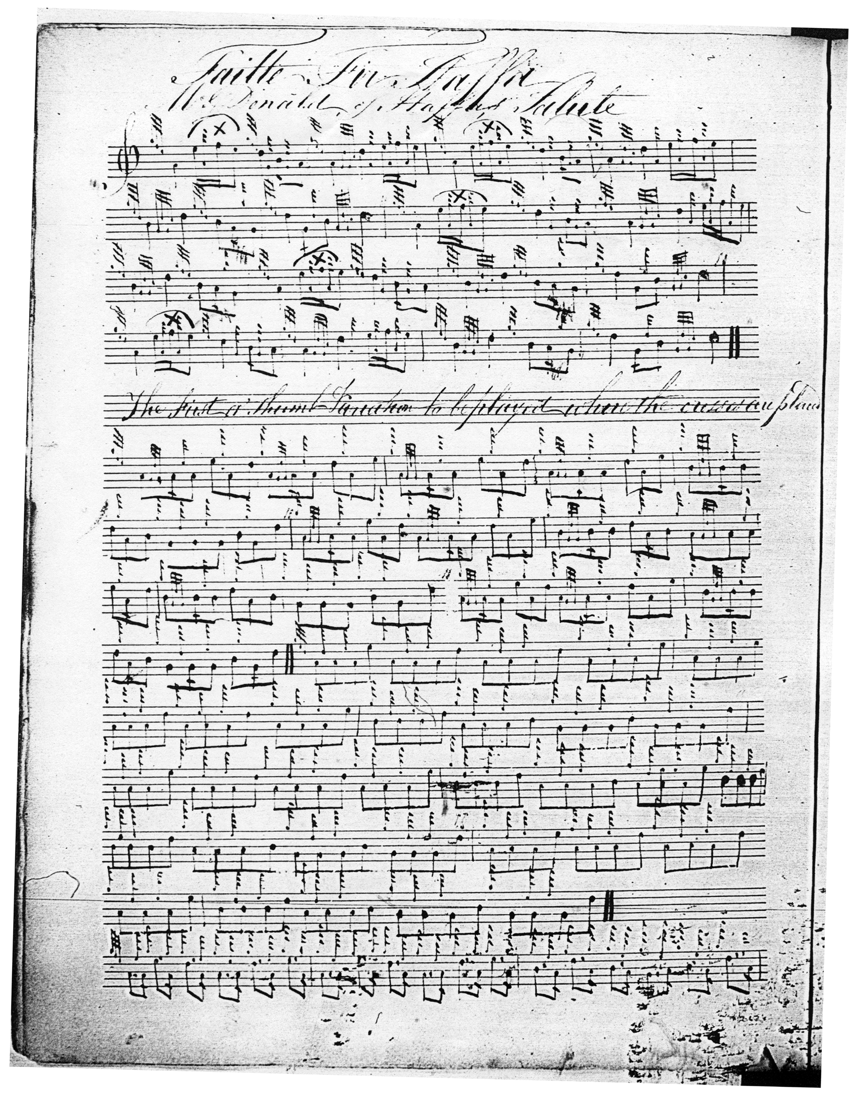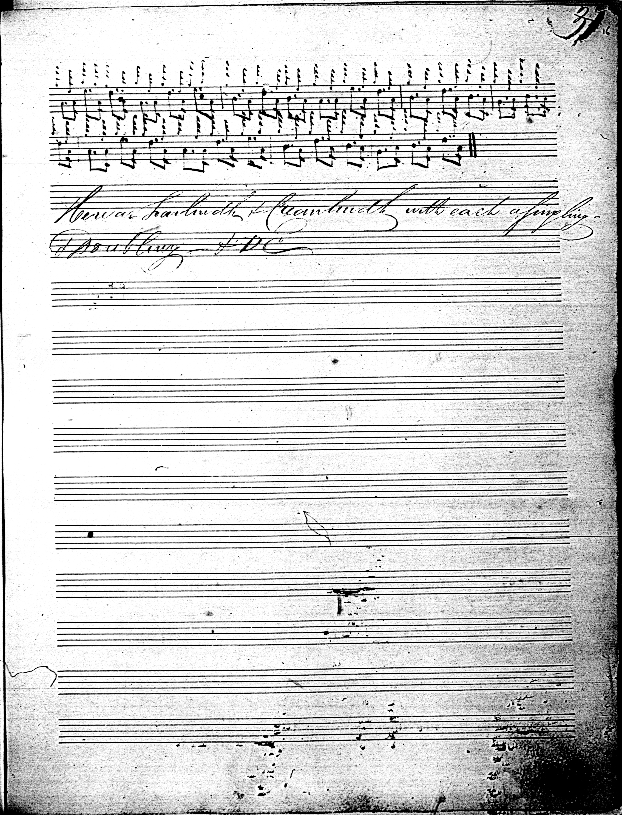

There is a single modern published setting in the Piobaireachd Society Collection (Second Series), vol.13, pp.405-6. As the reader will note, a number of things have been altered from the original, including the title. Various note values are changed; the siubhal is moved from the position specified by Reid, and a doubling not in Reid is added; the taorluath fosgailte variation is re-timed; and a crunluath a mach variation appended which Reid does not have. Reid says simply “Here a Taorluidh & Creanluidh with each a singling & Doubling,--& D[e]C[apo thema].”

Commentary:
The dedicatee of this tune, Reginald or Ranald MacDonald of Staffa, was a prominent figure in the fashionable movement to “Celticise” of Scotland in the later years of the eighteenth and early years of the nineteenth century culminating in the famous visit of George IV to Edinburgh in 1822. Peter Reid himself enters the story at this point, he being said as a young man to have been one of the pipers welcoming the king when he landed at Leith. Ranald MacDonald was Hon. Secretary of the Highland Society of Scotland and a friend of Sir Walter Scott. He employed Archibald McArthur, one of the famous McArthur dynasty, as his personal piper. Ranald MacDonald sprang from of the family of MacDonald of Boisdale which rose to considerable prominence in the second half of the eighteenth century being effectively tutors of Clanranald. As such they were active in the evictions commonly known as “The Clearances”. Scott celebrated a visit he made to the attractive island of Ulva, off the coast of Mull, which the family owned, with a typical flourish:

The proprietor of the isle, Macdonald of Staffa, a fine, high-spirited young chieftain,
was our pilot and guide through the Hebrides. He is much loved by his people,
whose prosperity he studies much.... In the Isle of Ulva, where he has his house,
we were treated with something like feudal splendour. His people received us under arms,
and with a discharge of musketry and artillery. His piper was a constant attendant on our parties, and wakened us in the morning with his music.
Quoted in Angus and Archibald MacDonald, Clan Donald
(3 vols. Inverness, 1896-1904, vol 3, p.295)

By a generation later the island had been decimated in the Clearances. The current population is in single figures.

The engraved portrait below, shows the laird of Staffa posed romantically at the mouth of Fingal’s Cave. This captures the ethos of the period very well, with its increasingly fanciful and elaborate notions of “Highland Dress”, including high-crowned Glengarry bonnet with three eagle feathers to indicate the wearer’s chiefly status, scarf plaid, elaborate sporran mollach, web of belts and cross-belts, and small armoury of firearms, sword, powder-horn and dirk—the whole projecting an impressive image of wealth and power. Despite the suggestion of ancient possession, MacDonald was actually a lawyer, who ultimately became Sheriff-depute of Stirling. Most of his money and acres came by virtue of marriage. The ascendency of the Boisdale family was not of long duration:

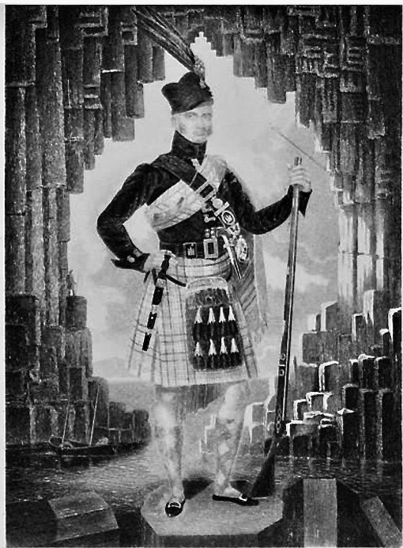

Fingal’s Cave is world-renowned, but Staffa itself is a tiny postage-stamp of a place and appears to have become entirely depopulated by the end of the seventeen hundreds. MacDonald sold the island in 1816, so this may give some indication of the date of composition of this interesting piece.

The laird of Staffa himself seems to have been well-disposed towards traditional culture and actively assisted in promoting the field collecting activities of Alexander Campbell. Campbell came originally from Perthshire, and was a prominent musician in Georgian Edinburgh, a pupil of Tenducci and editor of Albyn’s Anthology, who traversed the Western Highlands and Isles gathering material at the behest of the Highland Society in the autumn of 1815. Campbell wrote:
Being now in the Isle of Mull I…set out for the Isle of Ulva, on the way to which I overtook our learned secretary Staffa’s brother accompanied with Dr Hamel, the celebrated Russian traveller; and traversing the isthmus from Aros to Loch na Keill we embarked for Ulva, and landed safely in that island, time enough for dinner. It was here that I expected to commence my laborious task in earnest. And it was under Staffa’s roof that I did so. For, knowing of my coming, he had with great precision prepared everything requisite for obtaining the object I was in pursuit of. Soon after my arrival here, the persons most reputed for local antiquarian knowledge, oral tradition, recitation, and singing were convened. And the fruits of my industry, in which I was assisted by Mr John Currie, school-master, are 24 iorrams, boat songs etc. Before I left Ulva I visited the islands of Staffa and Iona, or Icolumkill. In the principal cave of the former I heard the effect of the great highland bagpipe, which excites so much wonder and admiration in the mind of those who can relish this sort of melody. The resounding tones of the piper…. With the thundering noise of the Atlantick dashing into the farther end of the cavern, is awfully sublime. The performer, Staffa’s piper, played with pathos the Lament for the slain on the fatal field of Culloden. He is a pupil of Donald MacCrimmon, the celebrated professor…I had spent many days in Ulva and taking leave of my friends… I departed with regret. Passing over the sound to Laggan Ulva, part of the property of Staffa in Mull, I ascended the heights and pursued my route by a shortcut over the hills to Ballochry, where I arrived a little before dusk the evening of 16th August, the morning of which was spent in getting Staffa’s attestation to each piece I had taken from vocal recital (quoted in Joe Currie, Mull: The Island and its People. Edinburgh: Birlinn, 2000, p.294).

*

Electronic version © Dr. William Donaldson, Cambridge, Massachusetts, 4 June 2022

