MacKenzie of Gairloch's Lament

There are settings of this tune in the following manuscript sources:
--MacArthur/MacGregor Manuscript, ff.79-84:
--Robert Meldrum’s MS, ff.134-7;

and in the following published sources:
--Frans Buisman and Andrew Wright, eds., The MacArthur-MacGregor Manuscript of Piobaireachd (1820), pp. 112-3, 153;
--Angus MacKay, Ancient Piobaireachd, pp. 110-15);
--David Glen, Ancient Piobaireachd, pp. 206-8;
--C. S. Thomason, Ceol Mor, pp.158-9.

Both MacArthur and MacKay versions are developed along similar lines:

Ground
Thumb variation,
Pendulum movement
singling
doubling
Taorluath
singling
doubling
Crunluath
singling
doubling
(with a trebling of the crunluath in the MacArthur/MacGregor),

there are significant differences between the sources, most notably in the tone row, the MacArthur/MacGregor being more varied in this respect than MacKay, and many may find it more pleasing. The MacArthur/MacGregor is also a good deal more rich and subtle in its approach to ornament. In the MS source a later hand has added “M’Kenzie of Garlochs Lament (this name is doubtful)”. The examples which follow show the typical MacArthur/MacGregor style:

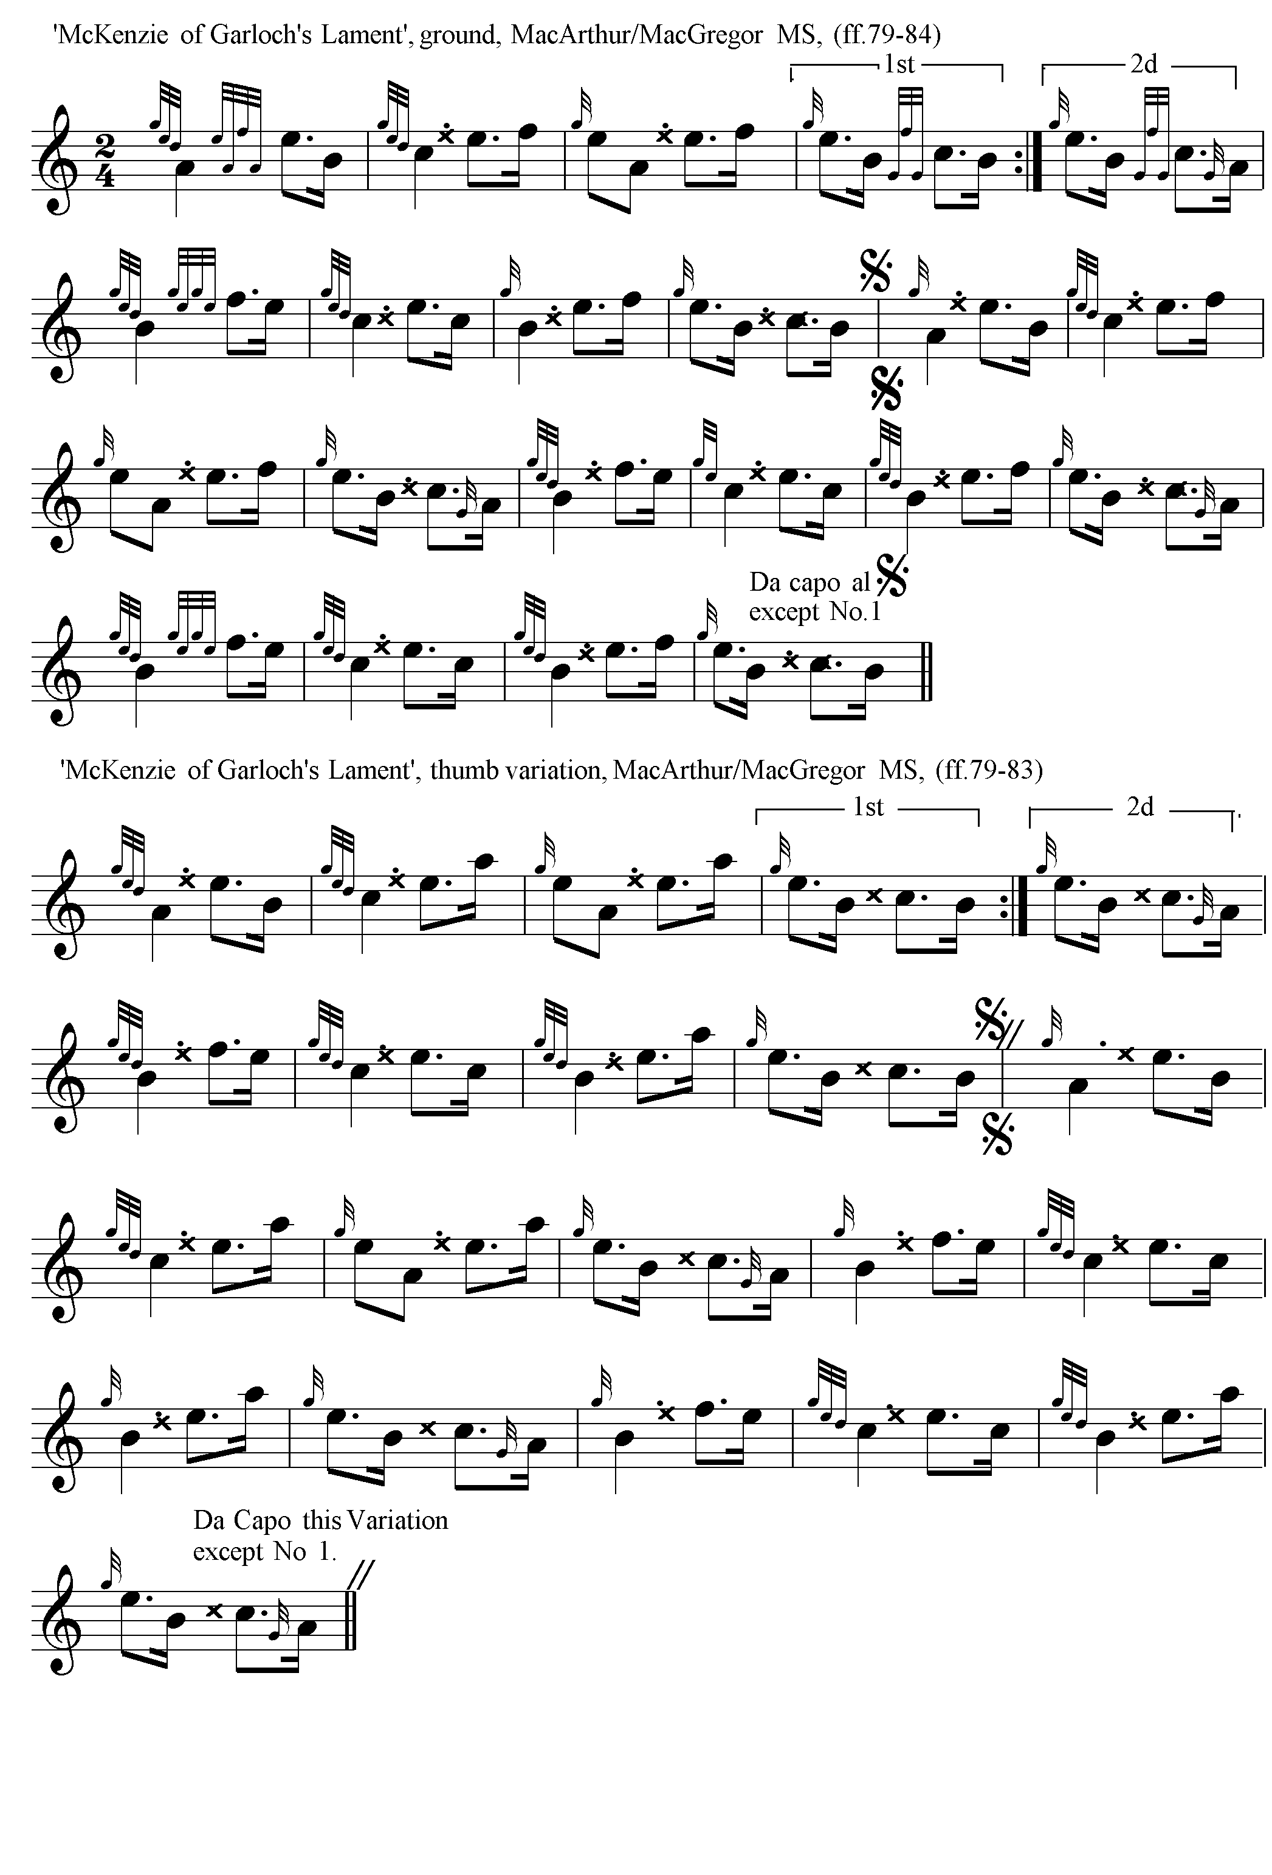
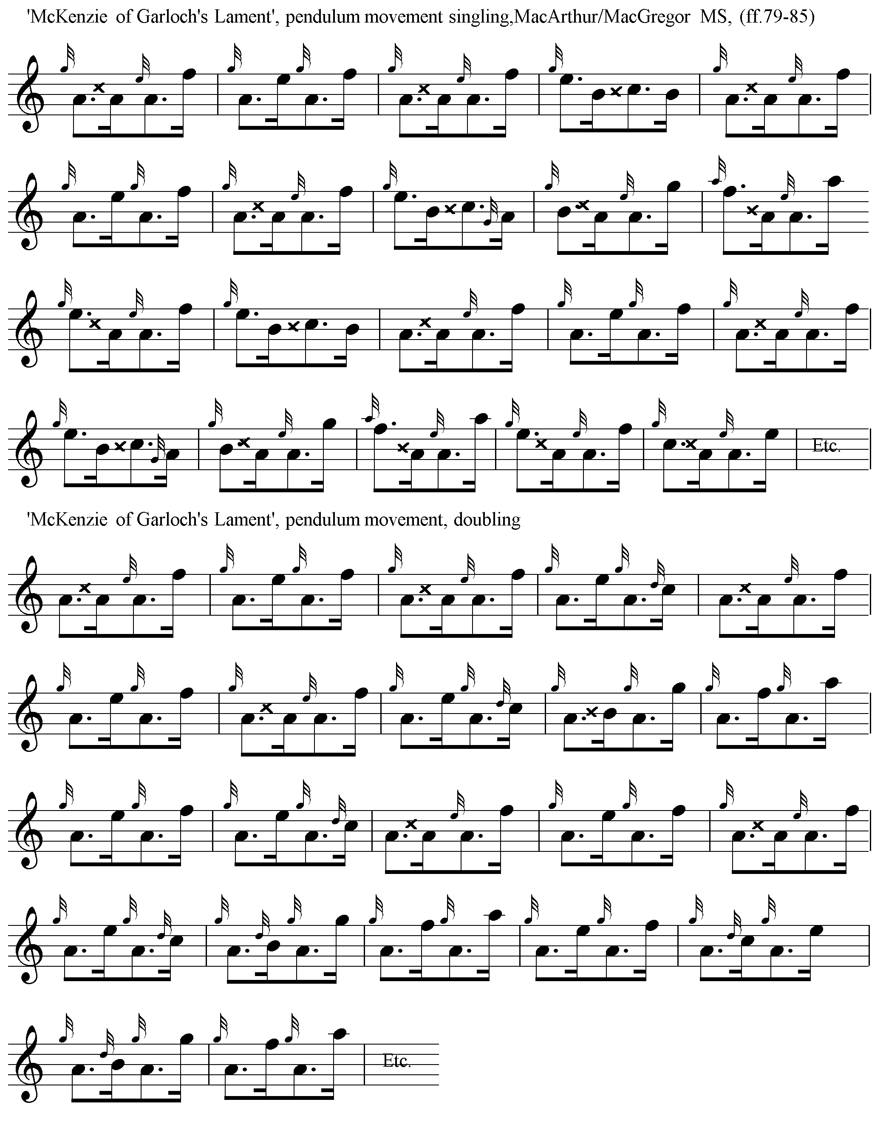
The reader will note that the pendulum movement is pointed ‘down’.

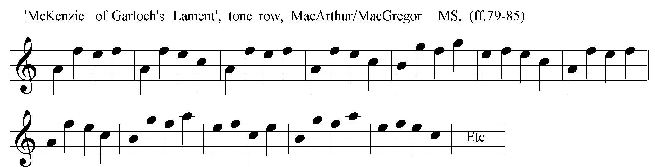

The examples which follow show Angus MacKay’s typical timings:

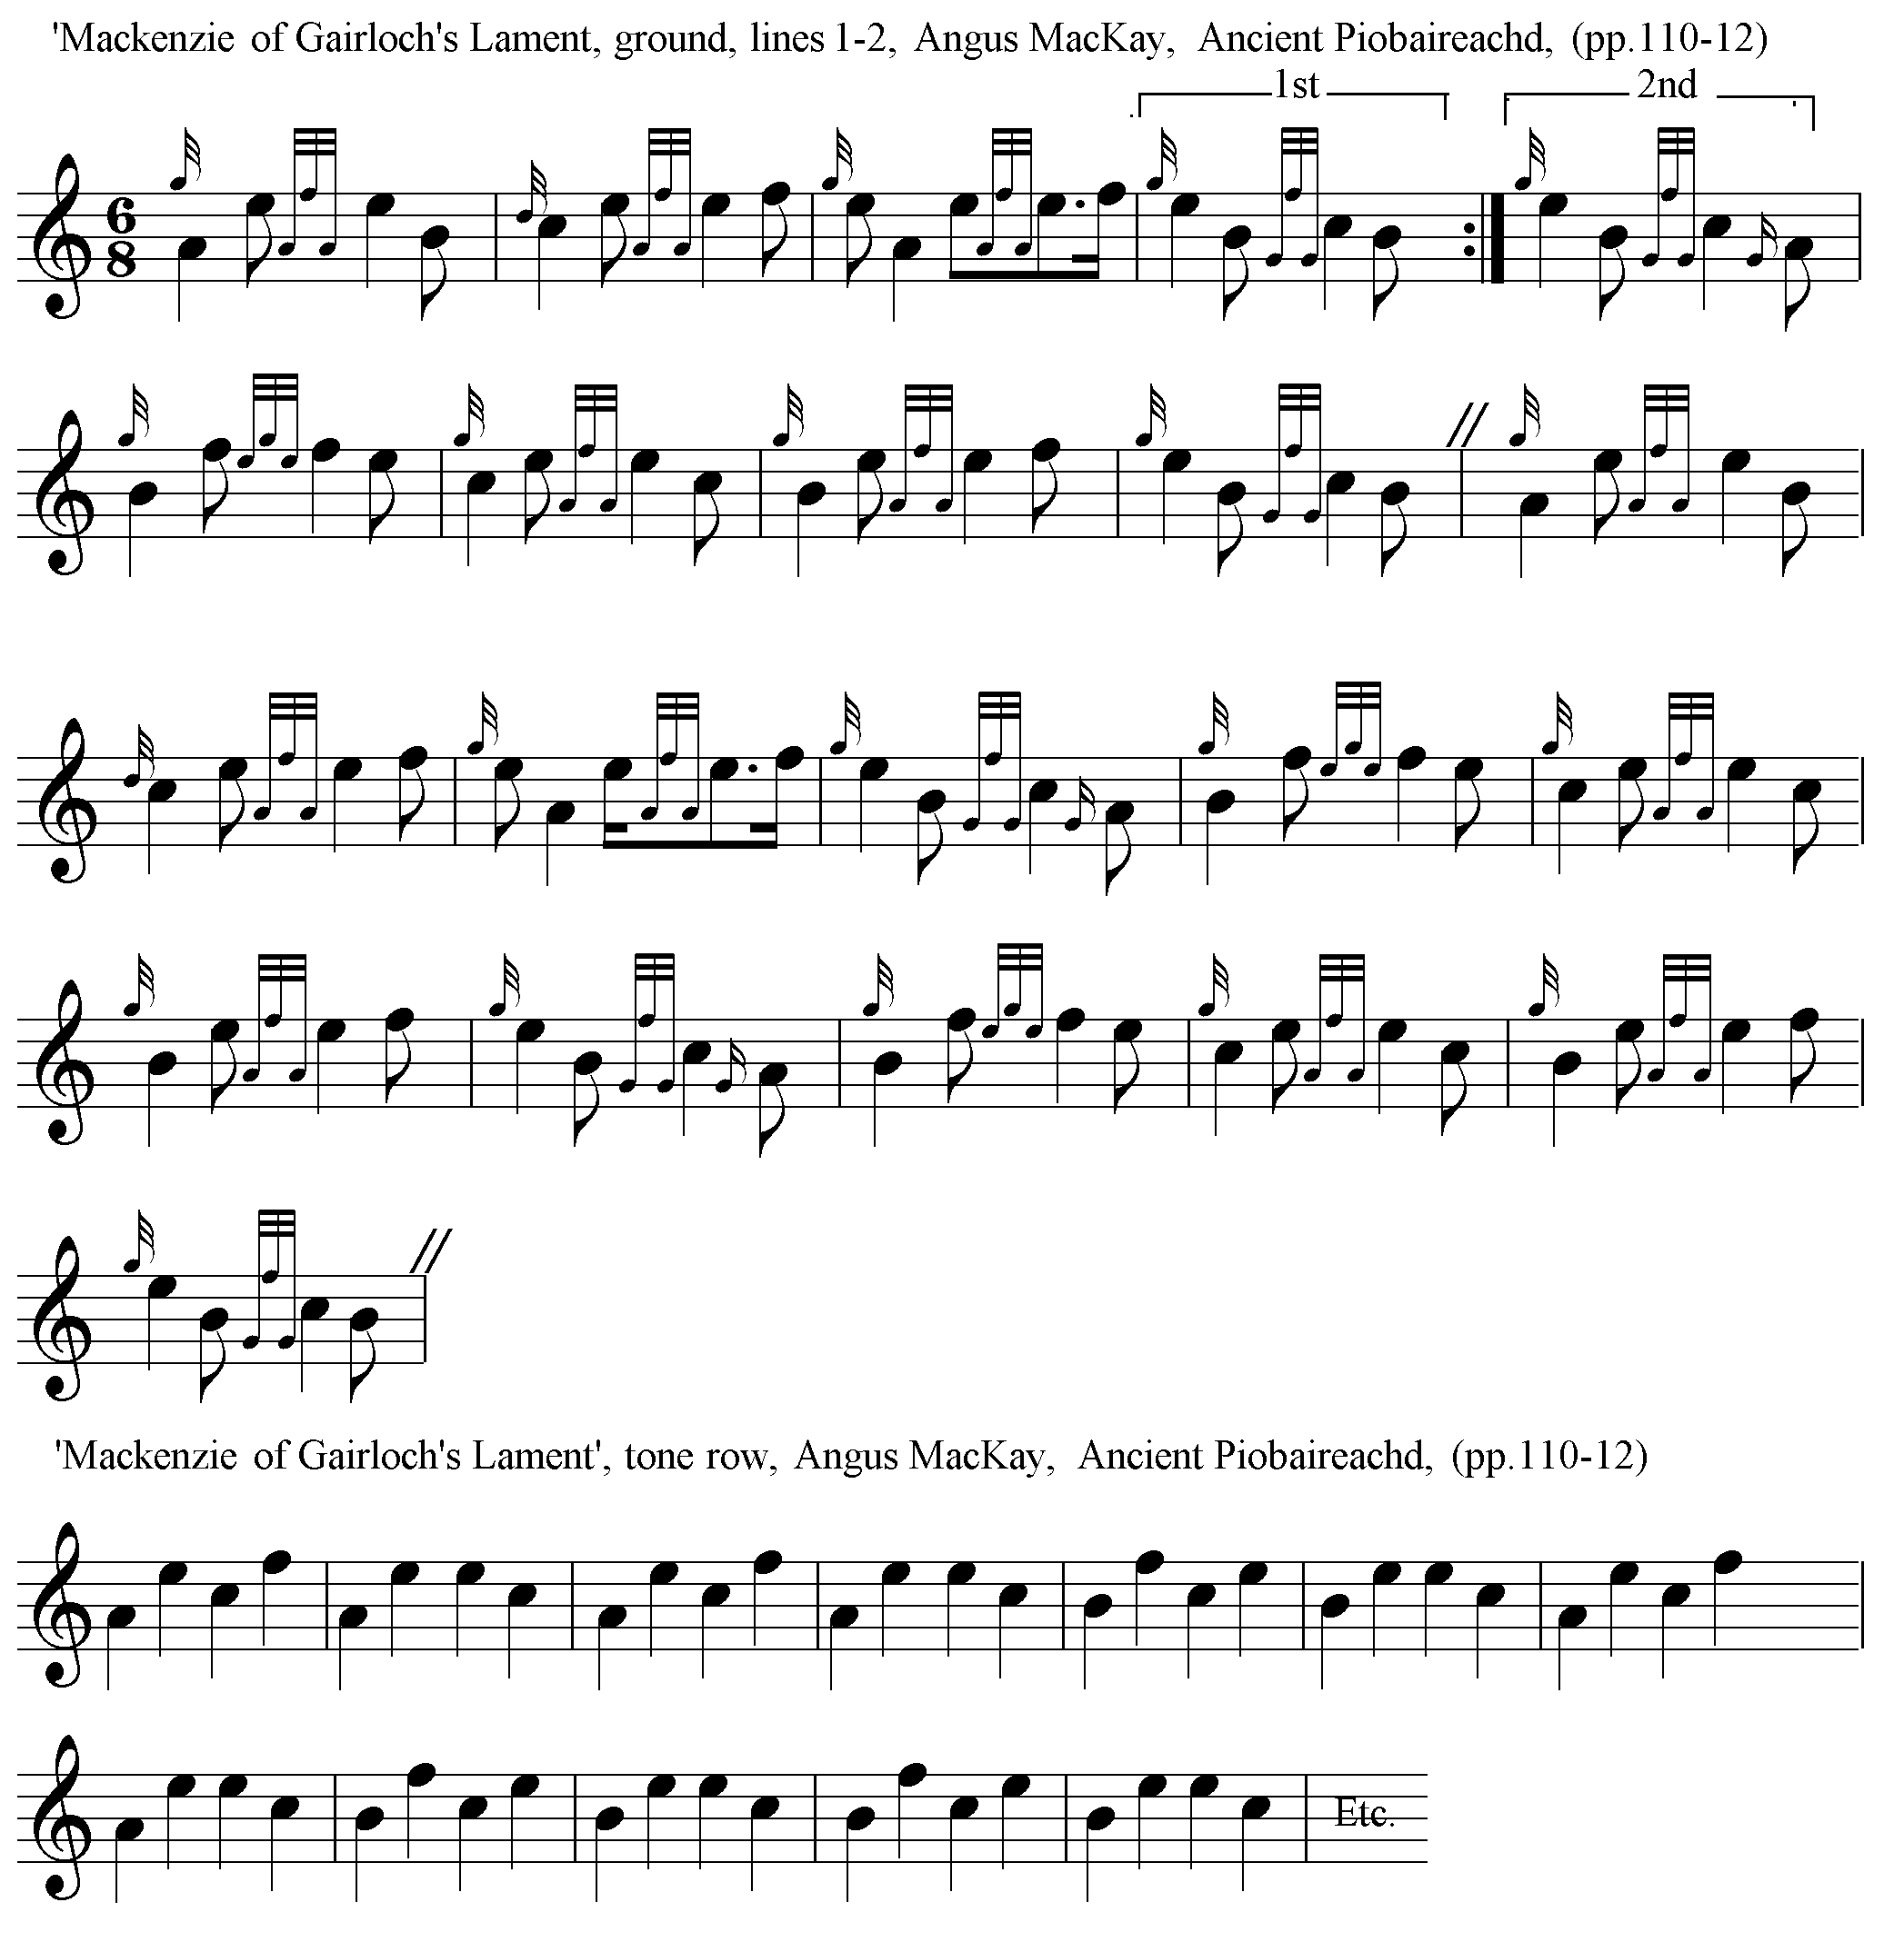

MacKay directs that the ground be repeated after the Taorluath doubling and at the end of the tune.

Of the later published sources, the tune appears in C. S. Thomason’s Ceol Mor, based on the version in Angus MacKay’s Ancient Piobaireachd. Thomason's abbreviated notation is often useful in revealing the tonal framework of a tune and suggesting links with others. “MacKenzie of Gairloch’s Lament”, for example, has echoes of the tune published by Thomason as “March of the MacDonalds” (Ceol Mor, p.130), from Donald MacDonald’s MS (ff.236-9), which has links in turn with “The Glen is Mine” (Ceol Mor, p.128), more clearly visible in Peter Reid's version of that tune (f.60) entitled, “The Glen is our own and all that it contains”:

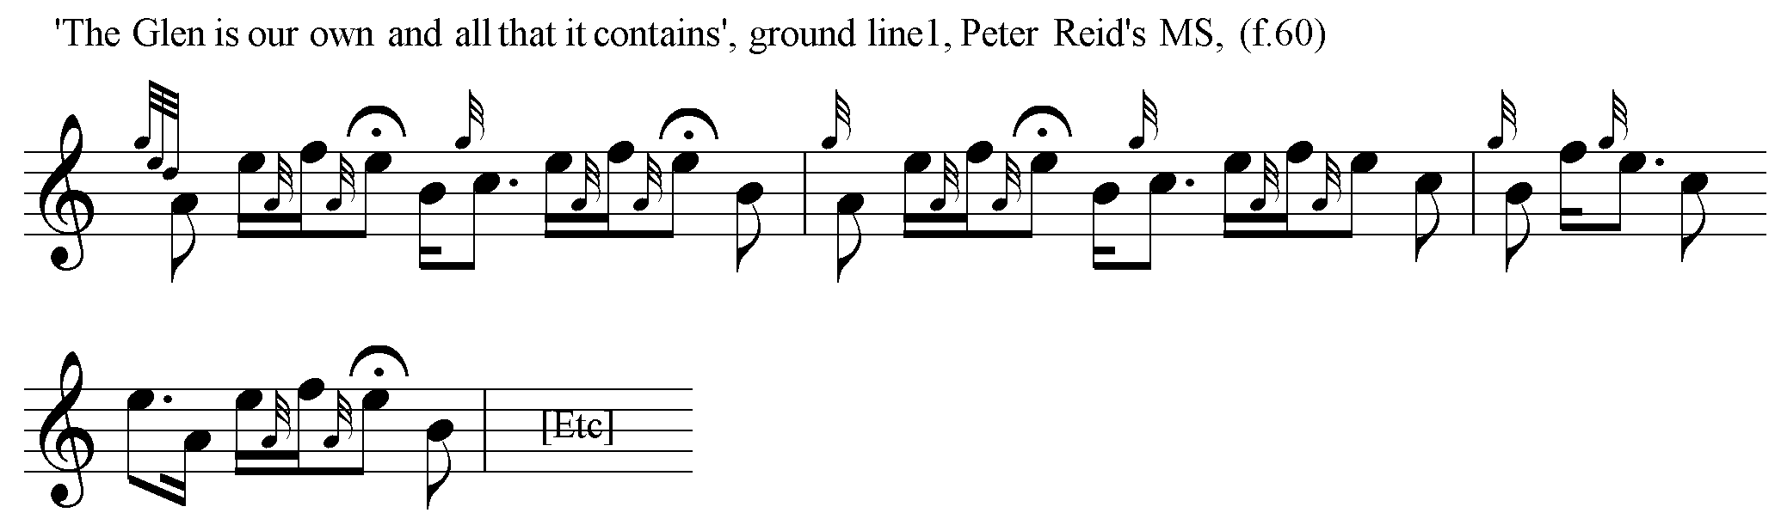

Electronic text © William Donaldson, Aberdeen, Scotland, 2001; revised Cambridge, Massachusetts, February 2025.

