MacLeod’s Rowing Tune (MacLeod’s Salute)

This tune is recorded in the following manuscript sources:
--Donald MacDonald’s MS, (ff.150-156);
--David Glen’s MS, (ff.179-81);

and in the following printed sources:
--Niel MacLeod of Gesto, Pibereach or pipe tunes, as taught verbally by the McCrimmen pipers in Skye to their apprentices, pp.20-21;
--Angus MacKay, Ancient Piobaireachd, pp.39-40,;
--C. S. Thomason, Ceol Mor, pp.109-110--a fine setting, preserving the little triplets in the siubhal doubling as Donald MacDonald does and giving both a taorluath and crunluath a-mach);
--David Glen, Collection of Ancient Piobaireachd, pp.223-5);
--William Stewart, et al., eds., The Piobaireachd Society Collection (First Series, iii, 4-5 (which shows strong influence from Glen but does not include a taorluath a-mach);
--G. F. Ross, Collection of MacCrimmon and other Piobaireachd (pp.18-19 which also shows strong influence from Glen, but gives the taorluath a mach as optional).

The earliest recorded setting of this tune seems to be the one preserved in Donald MacDonald’s manuscript, which treats it as follows:

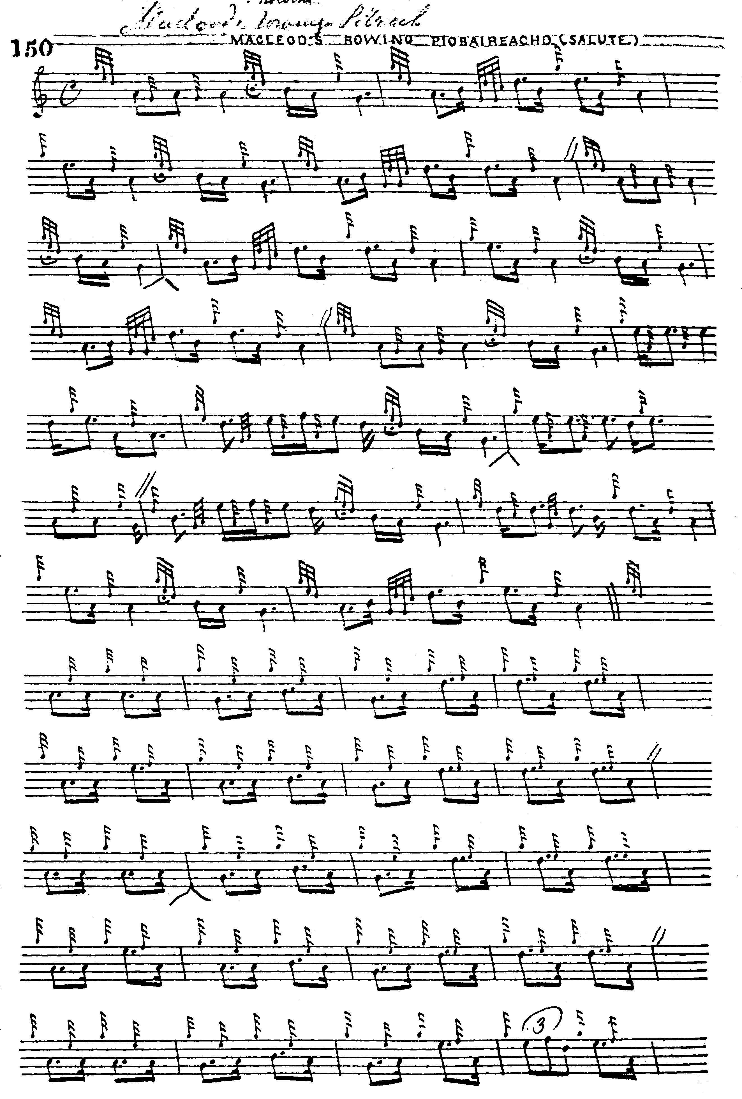

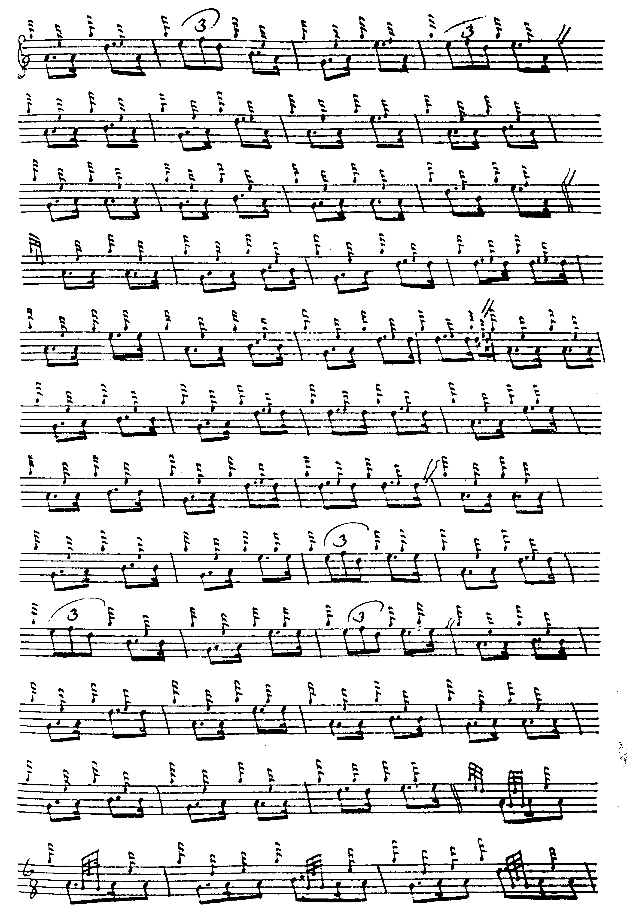

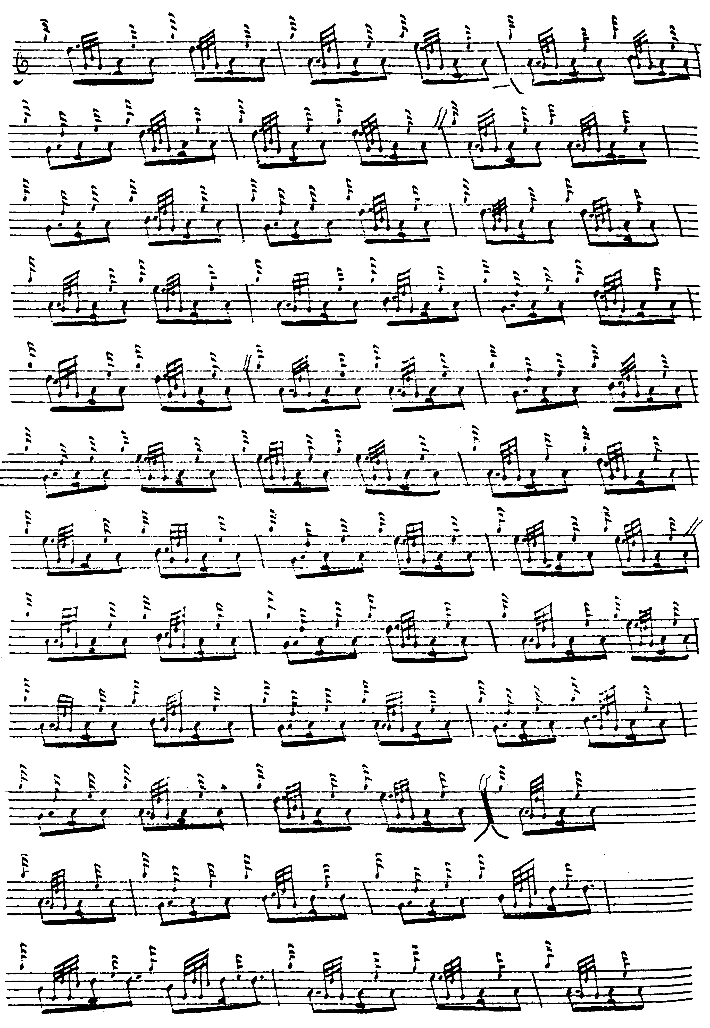
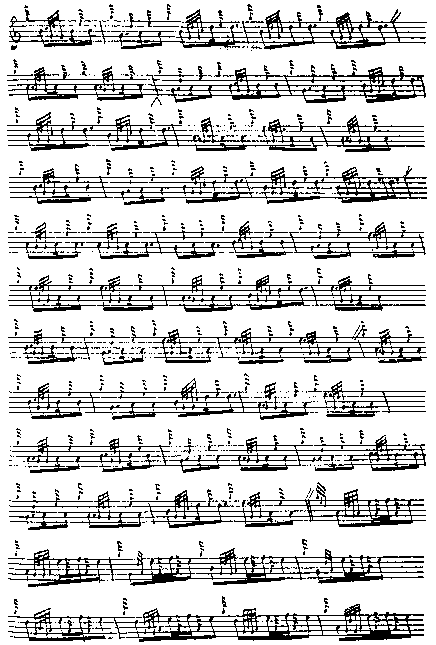
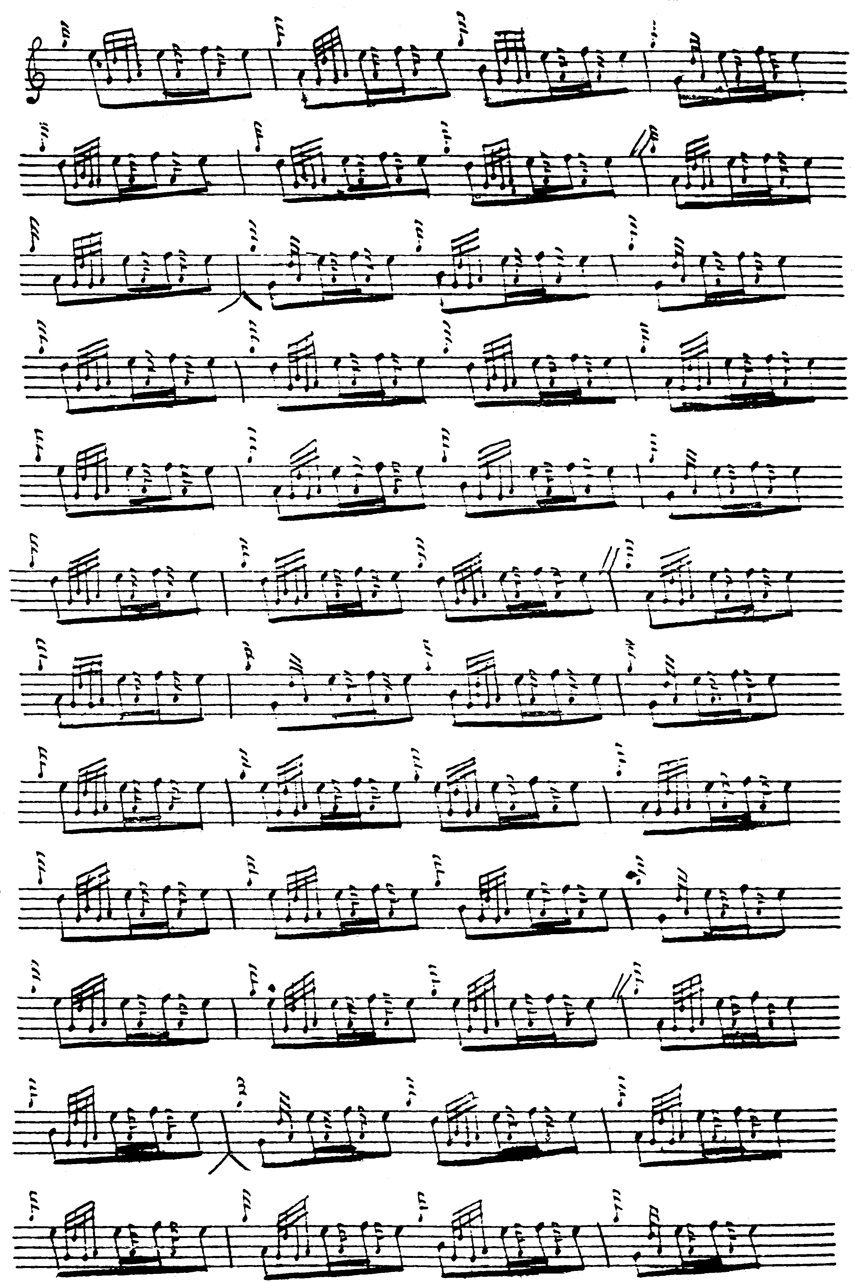

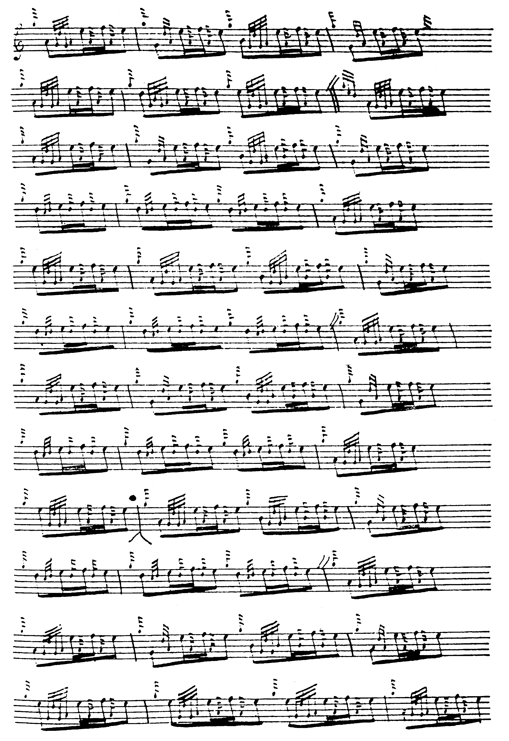
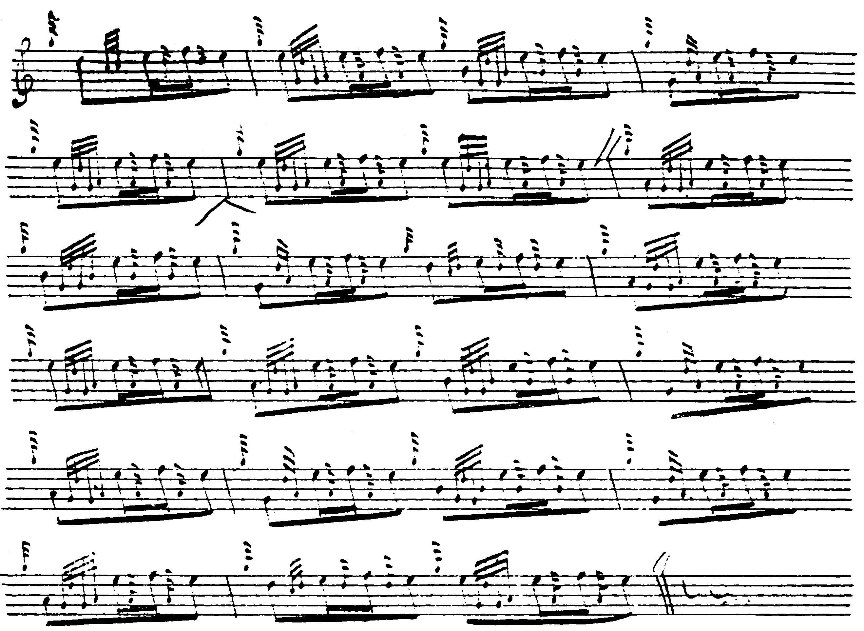

The inverted “V’s” under the score at various points may have been added by a later hand. Note, however, the little inverted fermatas under the E cadence notes at various points in the ground. For a discussion on the timing of such movements in Donald MacDonald’s scores, see The Highland Pipe and Scottish Society 1750-1950 (pp.109-12, given as an appendix below).

The earliest of the published settings is Niel MacLeod of Gesto’s canntaireachd collection Pibereach or pipe tunes, as taught verbally by the McCrimmen pipers in Skye to their apprentices of 1828. Gesto, whose informant was Iain Dubh MacCrimmon, gives the title as “Lamentation for McLeod of Greshershish”. The tune is developed as follows: ground, first variation singling and doubling, and concludes with a duinte taorluath and crunluath singling; there is no a-mach. The Gesto setting is missing a couple of vocables in the variations throughout and contains an apparently redundant syllable at the end of each variation (unless this is perhaps intended as a concluding flourish to mark the end of the musical paragraph). It proceeds as follows:

Slow. Hiererine, hioenin,
him botrao, hainin,
hienin, hioenin,
him botrao, hainin,
hiererine, hioenin,
hiereriea, hienin,
habotria, hioenin,
hiereriea, hienin,
hiendo, botriea, hioa, hindi,
hia virlao, hainin,
hienin, hioenin,
him botrao, hienin.
1st Var. I hiendan, hiendan, [?missing syllable?] hochin,
hiendan, hachin, hachin, hachin,
hiendan, hiechin, hiendan, hochin,
hiendan, hachin, hachin, hachin,
hiendan, hiendan, [?missing syllable?] hochin,
hiendan, hiechin, hievia, hiechin,
hiendan, hachin, hievia, hochin,
hiendan, hiechin, huvia, hiechin,
hiendan, hochin, hiendan, hiechin,
hiendan, hachin, hachin, hochin,
hiendan hiechin, hiendan, hochin,
hiendan, hiendan, tao hiechin, hiendan.

And so on.

Angus MacKay’s setting differs from that given in the Piobaireachd Society Collection (Second Series) in the timing of the eallach, the little runs down in the ground and in having no taorluath or crunluath a-mach. MacKay sets the tune as follows:

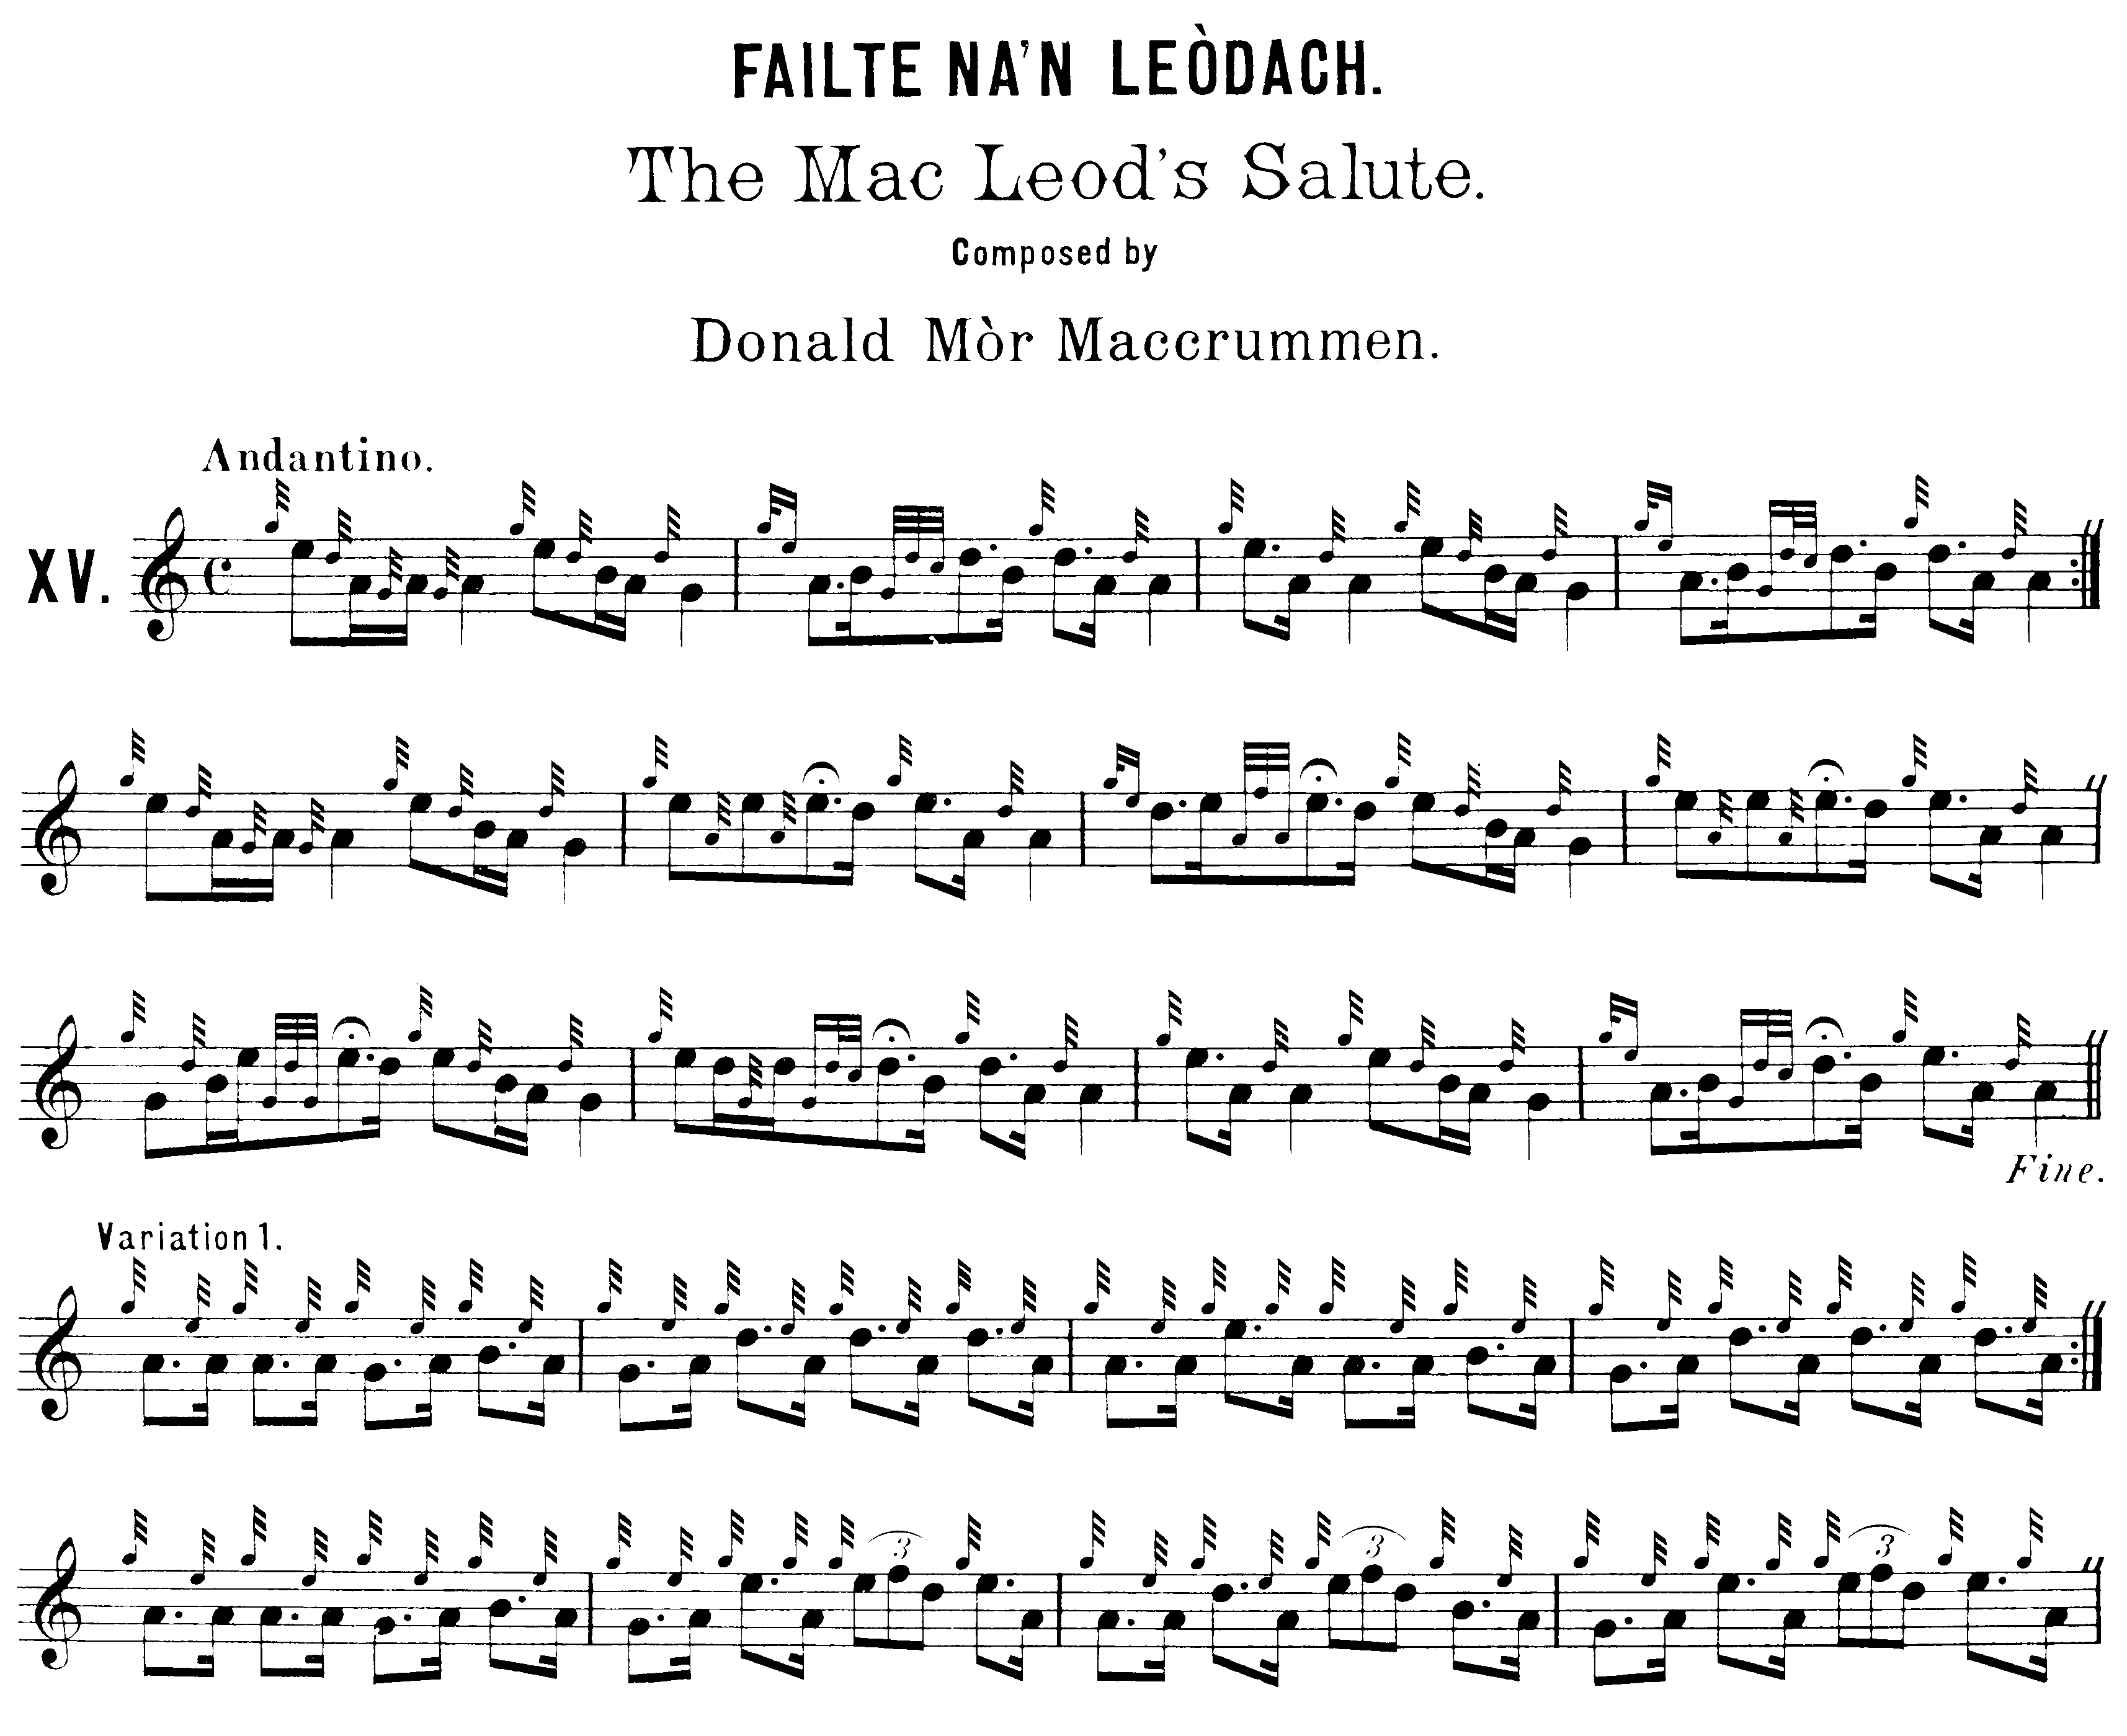
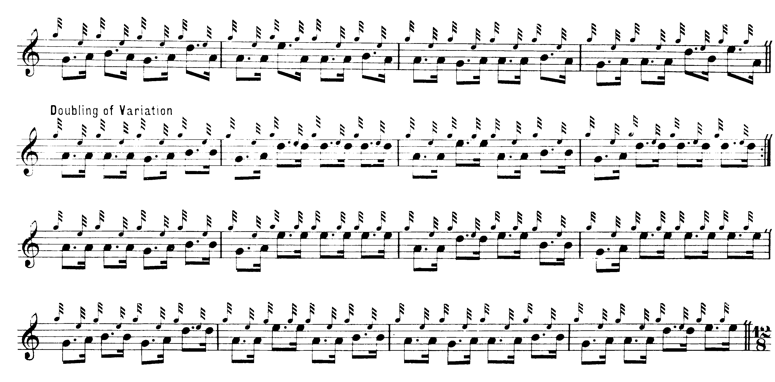
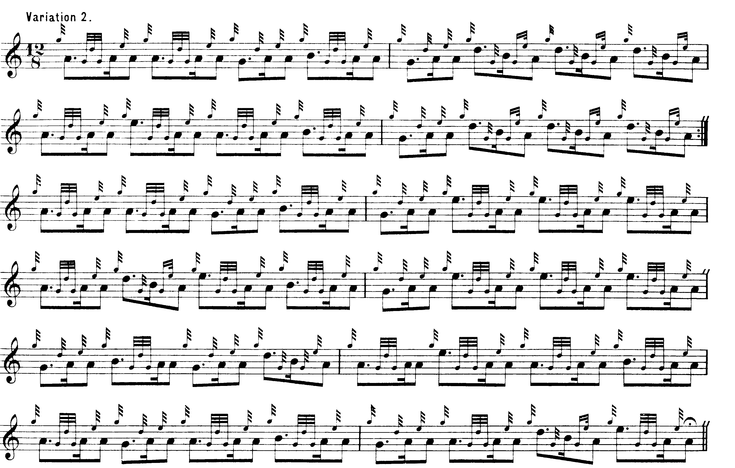

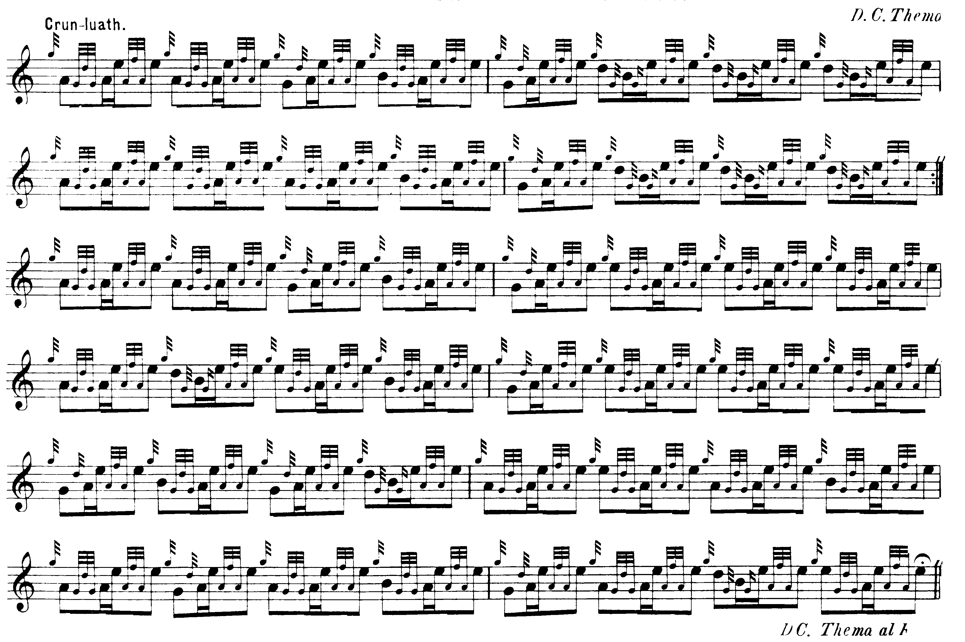

A number of the later printed settings derive from David Glen’s Collection of Ancient Piobaireachd. With his usual careful symmetry, Glen gives both a taorluath a-mach and a crunluath a-mach. He sets the tune as follows:

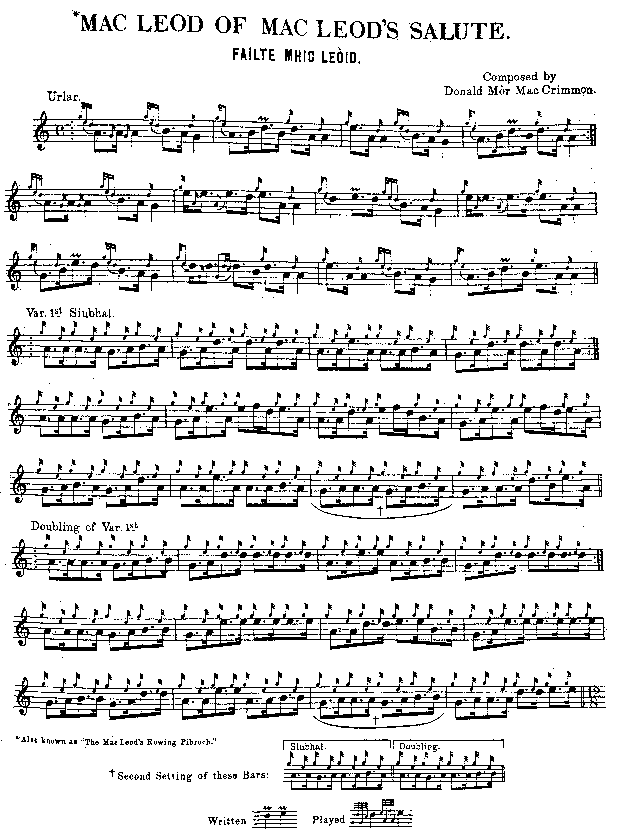
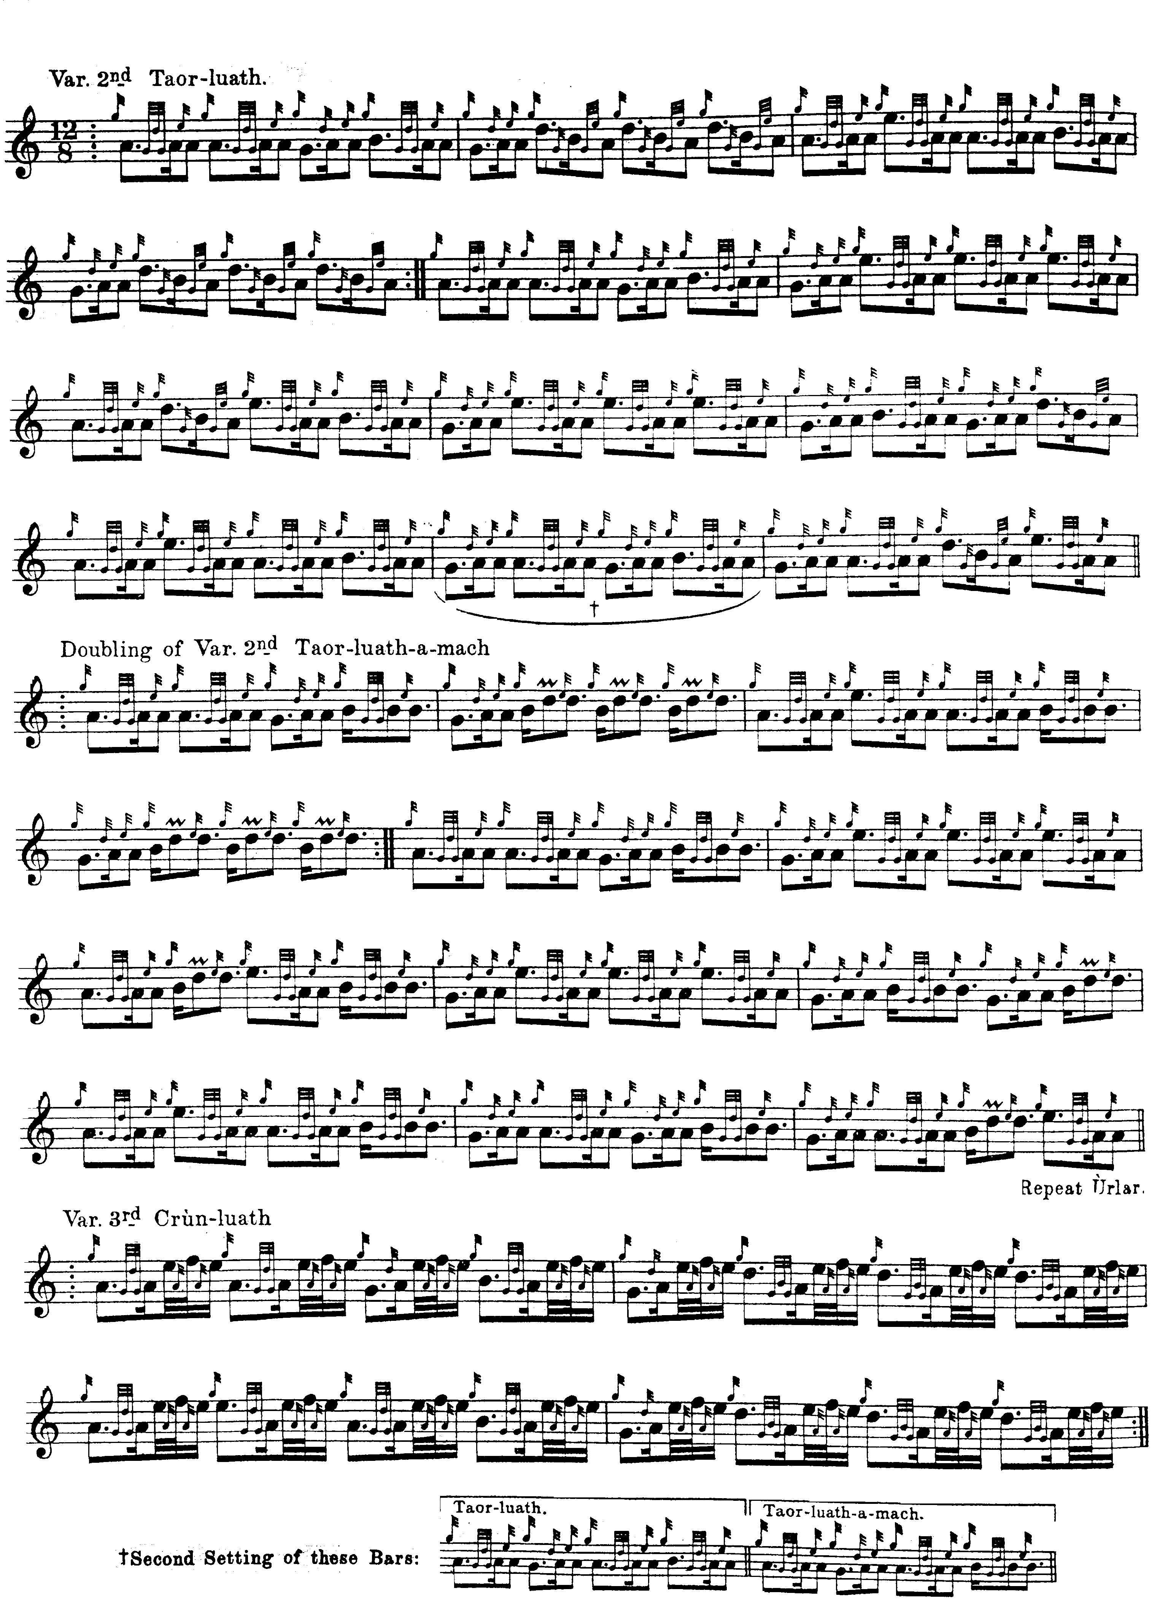

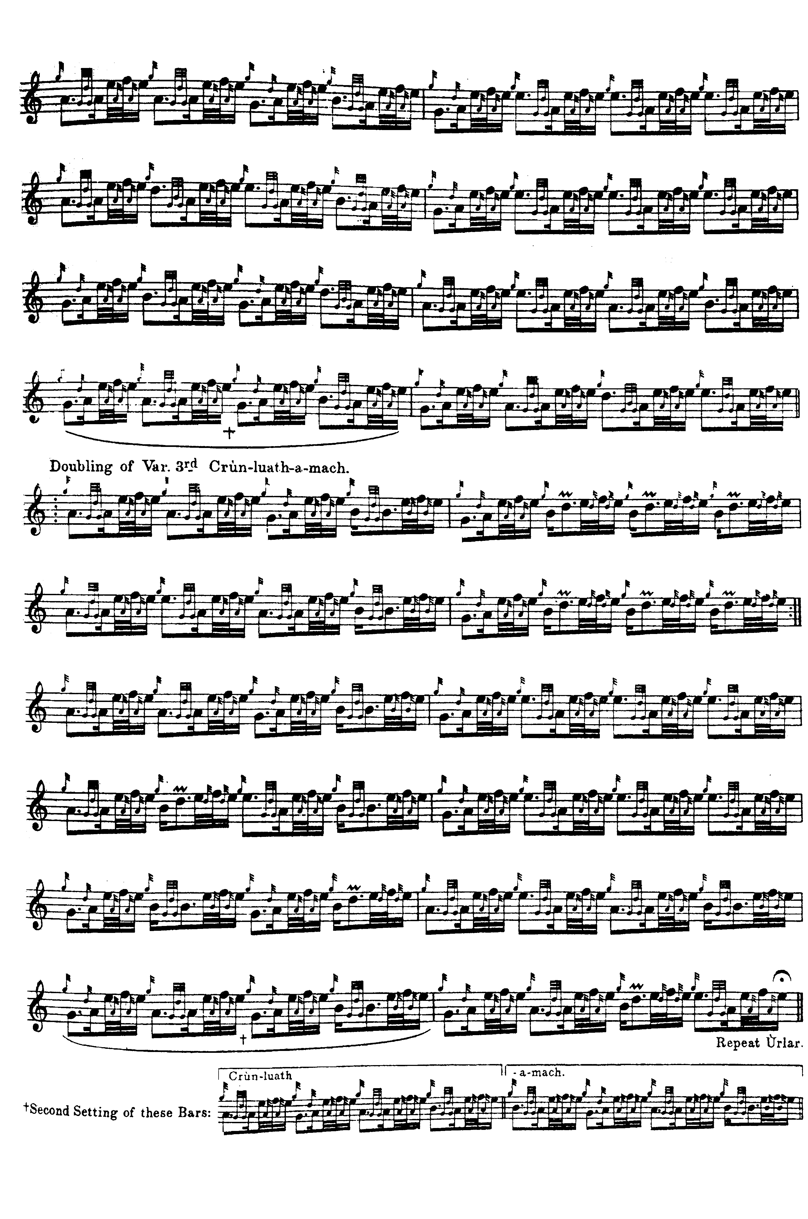
Commentary

Relatively little is known about the context of this tune; the main story is given by “Fionn” in his “Historic, Biographic and Legendary Notes to the Tunes” in David Glen’s Collection of Ancient Piobaireachd. “Fionn” states that “This tune is said to have been composed about 1603 to Ruairidh Mór Macleod, Chief of the Clan, by Donald Mór MacCrimmon. The occasion was the end of a long feud between Donald Gorm and Ruairidh Mór. On a reconciliation being effected, Donald Gorm was invited by Ruairidh Mór to banquet in Dunvegan Castle. When Donald Gorm appeared in sight of the Dùn he was met by Macleod’s famous piper, Donald Mór MacCrimmon, who welcomed the Chief of the MacDonalds by playing ‘The MacDonalds’ Salute’, which tune he composed for the occasion. It was in connection with the same banquet that he played ‘Fàilte Mhic Leòid.’” p.20.

R. B. Nicol said that “MacLeod’s Rowing Tune” was the title by which John MacDonald of Inverness always referred to this piece.

Appendix

Timing of Donald MacDonald’s introductory movements:

“The clarity with which Donald MacDonald’s system distinguished between ornament and melody notes was achieved at a price, in that it required whoever used it to be very sure about what was a grace-note and what was not. He called all his ornamental figures ‘appoggiaturas’, and gave a typical selection in his section of ‘Instructions’ to Ancient Martial Music of Caledonia, called ‘Example 5th. Shewing the Appogiaturas’:

In contemporary notational practice, then in a period of rapid change, ‘appoggiatura’ was a highly ambiguous term. Presumably MacDonald used it because he thought that his ornamental notes resembled appoggiaturas in taking time from the following melody note. The problem for the later interpreter is, how much? During the Baroque and early Classical period, the appoggiatura took

(i) half of an undotted main note
(ii) two-thirds of a dotted main note;
(iii) all of the first of two tied notes in compound metre;
(iv) all of a note before a rest.

But appoggiaturas could be ‘long’ or ‘short’--in which latter case they might have very little value--and only the musical context offered any guide as to which was which. In classical music the appoggiatura was typically a single note, usually a quaver or semi-quaver, set in reduced type, and might be (but was by no means always) tied to the following note with a slur. It was played on the beat and took the accent--unless it were a ‘passing appoggiatura’ in which case it was played before the beat, as many of Donald MacDonald’s seem obviously intended to be. Then there was the double appoggiatura form, which bore a rather closer resemblance to the compound ornaments found in piping. Like the single appoggiatura this tended to occupy the scale degrees just above and below the principal note (differing from many pipe ornaments once again) and had the effect of delaying the accent on the following note.

In MacDonald’s notation single gracenotes were used to distribute accent and to divide melody notes at the same pitch. To these, the fixed value of a demi-semi-quaver was assigned. But the compound appoggiaturas were different. It seems clear that some of them must have possessed considerable time value, whilst others had virtually none, but which ones, and how much, was left to be determined by the rhythmical context. Ultimately, perhaps, only performance tradition could tell the player how to treat these symbols, and MacDonald’s system seems built upon an assumption of ready access to this. For example, in a strongly rhythmical tune like Bodaich na’m Brigis (‘The Carles with the Breeks’), it is possible that the introductory notes on the A and B echo beats were intended to be played as timed, with the exception of the opening one, which is probably a ‘cadence E’:

But in Ceann na Drochaid Mhoridh (‘The End of the Great Bridge’), the opening figure cannot be treated in this way, because the melody would then start on an awkward off-beat and be a pulse short in the bar. What is set as this:

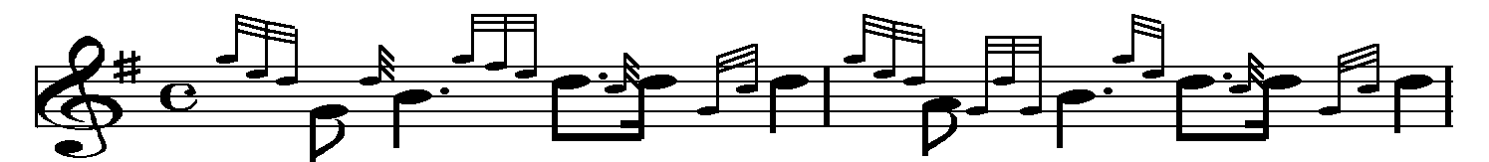

was presumably intended to be timed somewhat along the lines of:

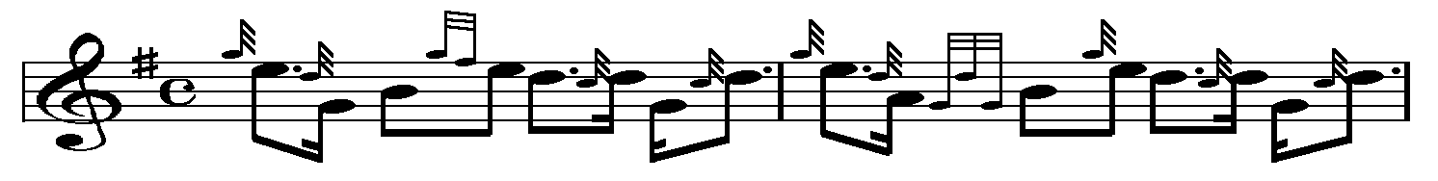

The result was a system in which the same symbol could mean different things in different contexts, and a conventional expression could be notated in several different ways, even in the same tune. Here, for example, is the opening sequence of Failte Chlaun Raonuill (‘Clanranald’s Salute’) from the MS of Peter Reid, an important early user of MacDonald’s system. Reid was born in Campbeltown probably in 1801, and worked as a clerk in Leith, and later in Glasgow. He was one of the pipers who welcomed George IV to Edinburgh during the royal visit of 1822:

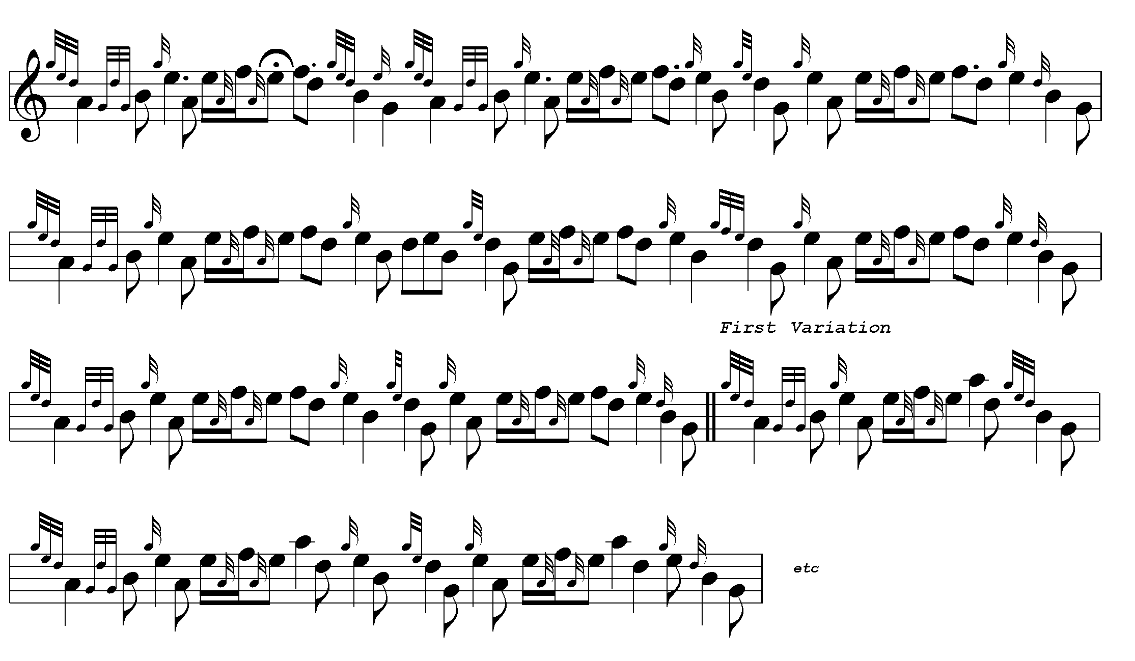

In Reid’s setting, the conventional figure:

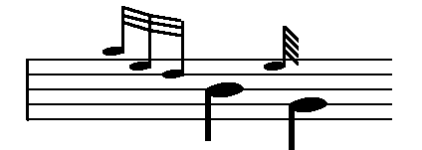

is also represented like this:

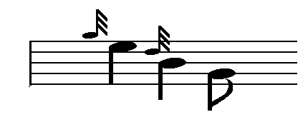

and this:

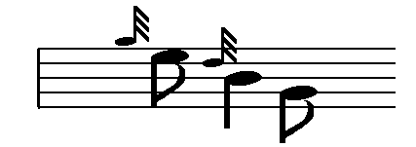

So that while the G and D notes remain constant in value, the E can apparently range from a demi-semi-quaver to a crotchet.

This potential for ambiguity is of more than theoretical interest. Various later changes in playing styles were to spring directly from the notational conventions established by Donald MacDonald and his contemporaries. As piobaireachd entered the 20th century, written or printed texts were assigned an overriding priority by those who relied upon them as the basis of their authority. A common introductory gesture like:
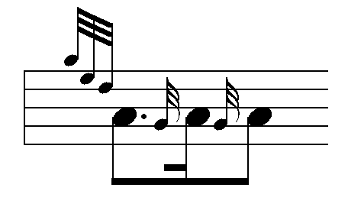

which was probably timed as follows:

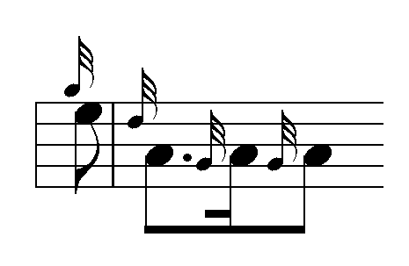

could be transformed into something like this:

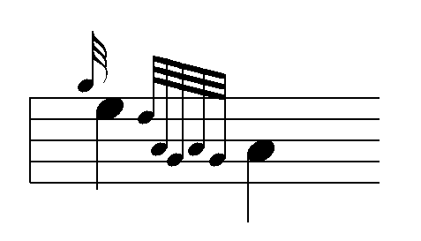

for which there was no sanction in performance tradition. Yet the latter, played as written, became mandatory at the leading competitions, effectively displacing more traditional and musically coherent styles.

* * *

Electronic text © Dr. William Donaldson, Aberdeen, Scotland, November 2002

MacDonald, Ancient Martial Music, ‘Instructions’ p.6. Musicologist Peter Cooke pointed out that most of MacDonald’s ornaments cannot strictly be called appoggiaturas because these were devices with a precise harmonic role which, he suggested, many of them do not fulfil in piping: “Letter from Peter Cooke”, in International Piper, vol.2, no.7, November 1979, pp.20-1.
Rastall, p.222.
Donington, pp. 203, 206, 208.
Richard Rastall, The Notation of Western Music An Introduction, (Lond., 1983) p. 225.
See Cannon, Compleat Theory, pp.14-16, for a useful recent overview of this subject.
MacDonald, Ancient Martial Music, pp.102-5.
Ibid, pp. 111-5.
Peter Reid’s MS, (dated Glasgow 1826), NLS Acc. 22118, f.19. For further information about Reid, see John MacLellan, ‘The Literature of the Highland Bagpipe Peter Reid’s Manuscript’ in International Piper, vol. 3 no. 8, December 1980, pp.14-15.
Peter Cooke, ‘Changing Styles in Pibroch Playing’, Part 11, International Piper, vol.1, no.3, July 1978, pp.11-13.

