Nameless, Hiorodo tra cherede che

This tune is recorded in a single manuscript source:
Colin Mór Campbell’s Nether Lorn Canntaireachd, ii, 100-101.

It is numbered 42 in the volume.

Colin Mór sets the piece like this:

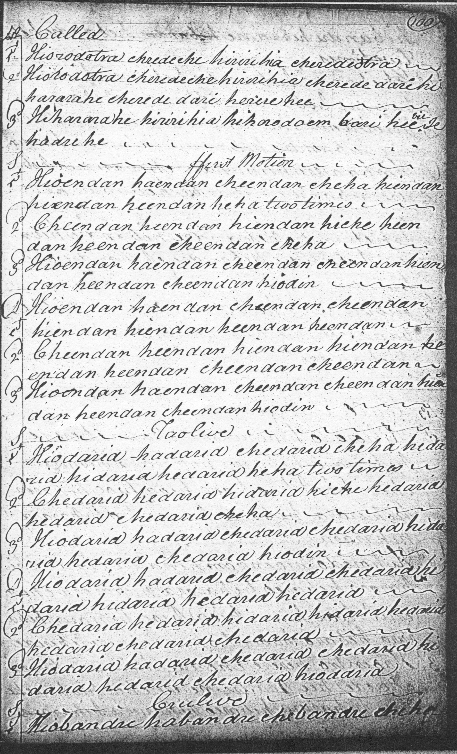
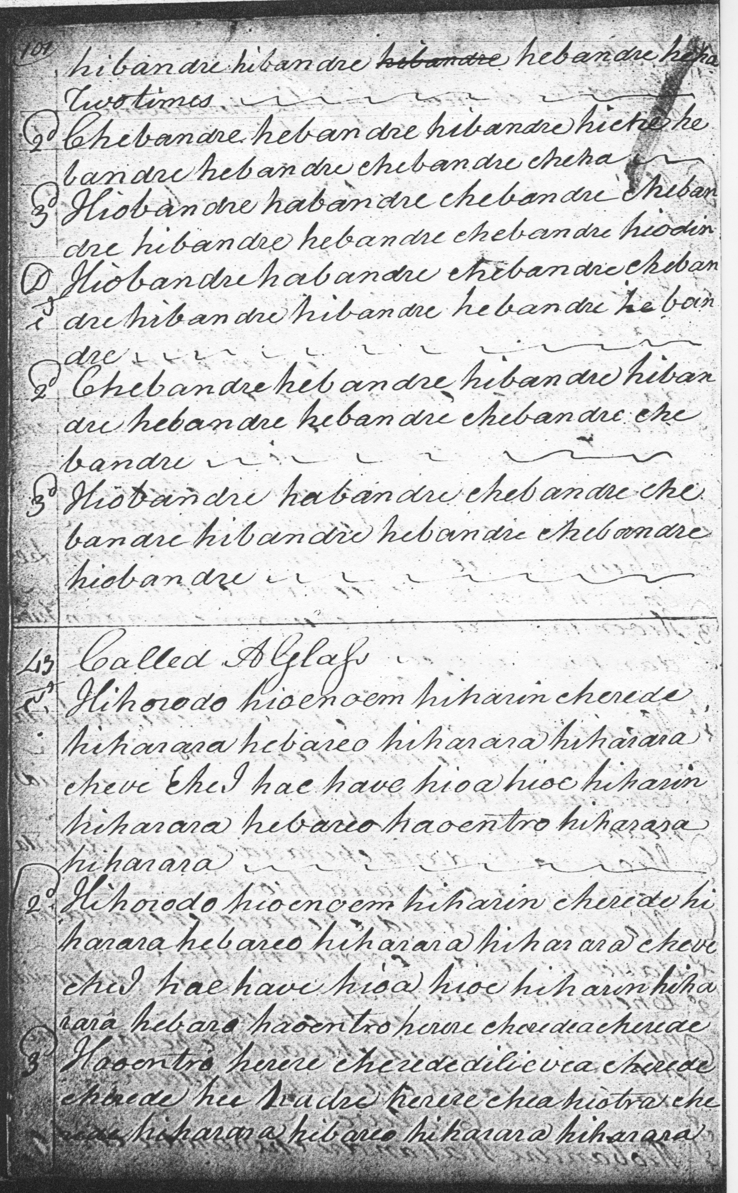
There are minor transcription errors common in this source; however, the score might be interpreted as follows:

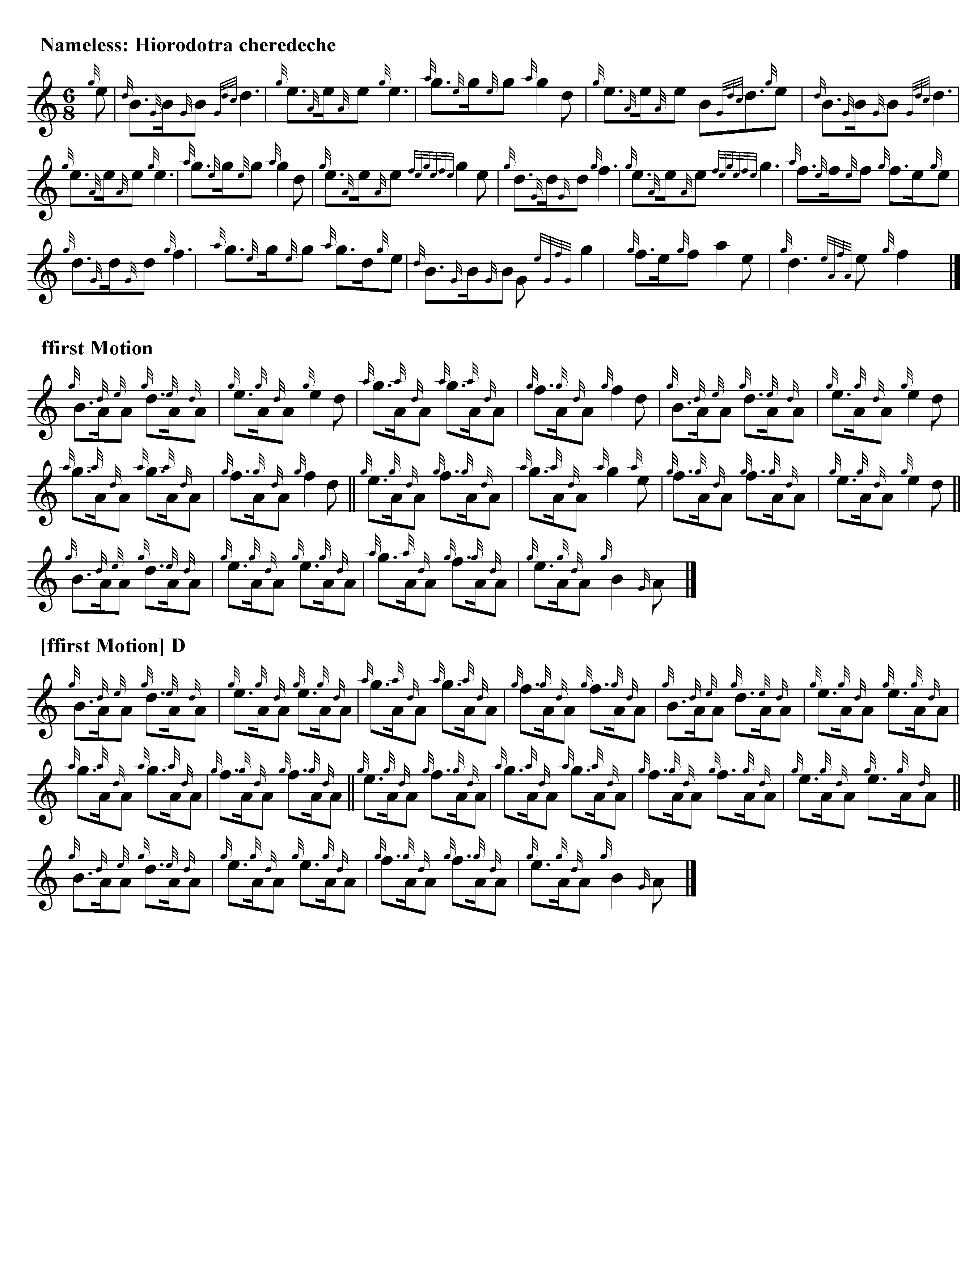
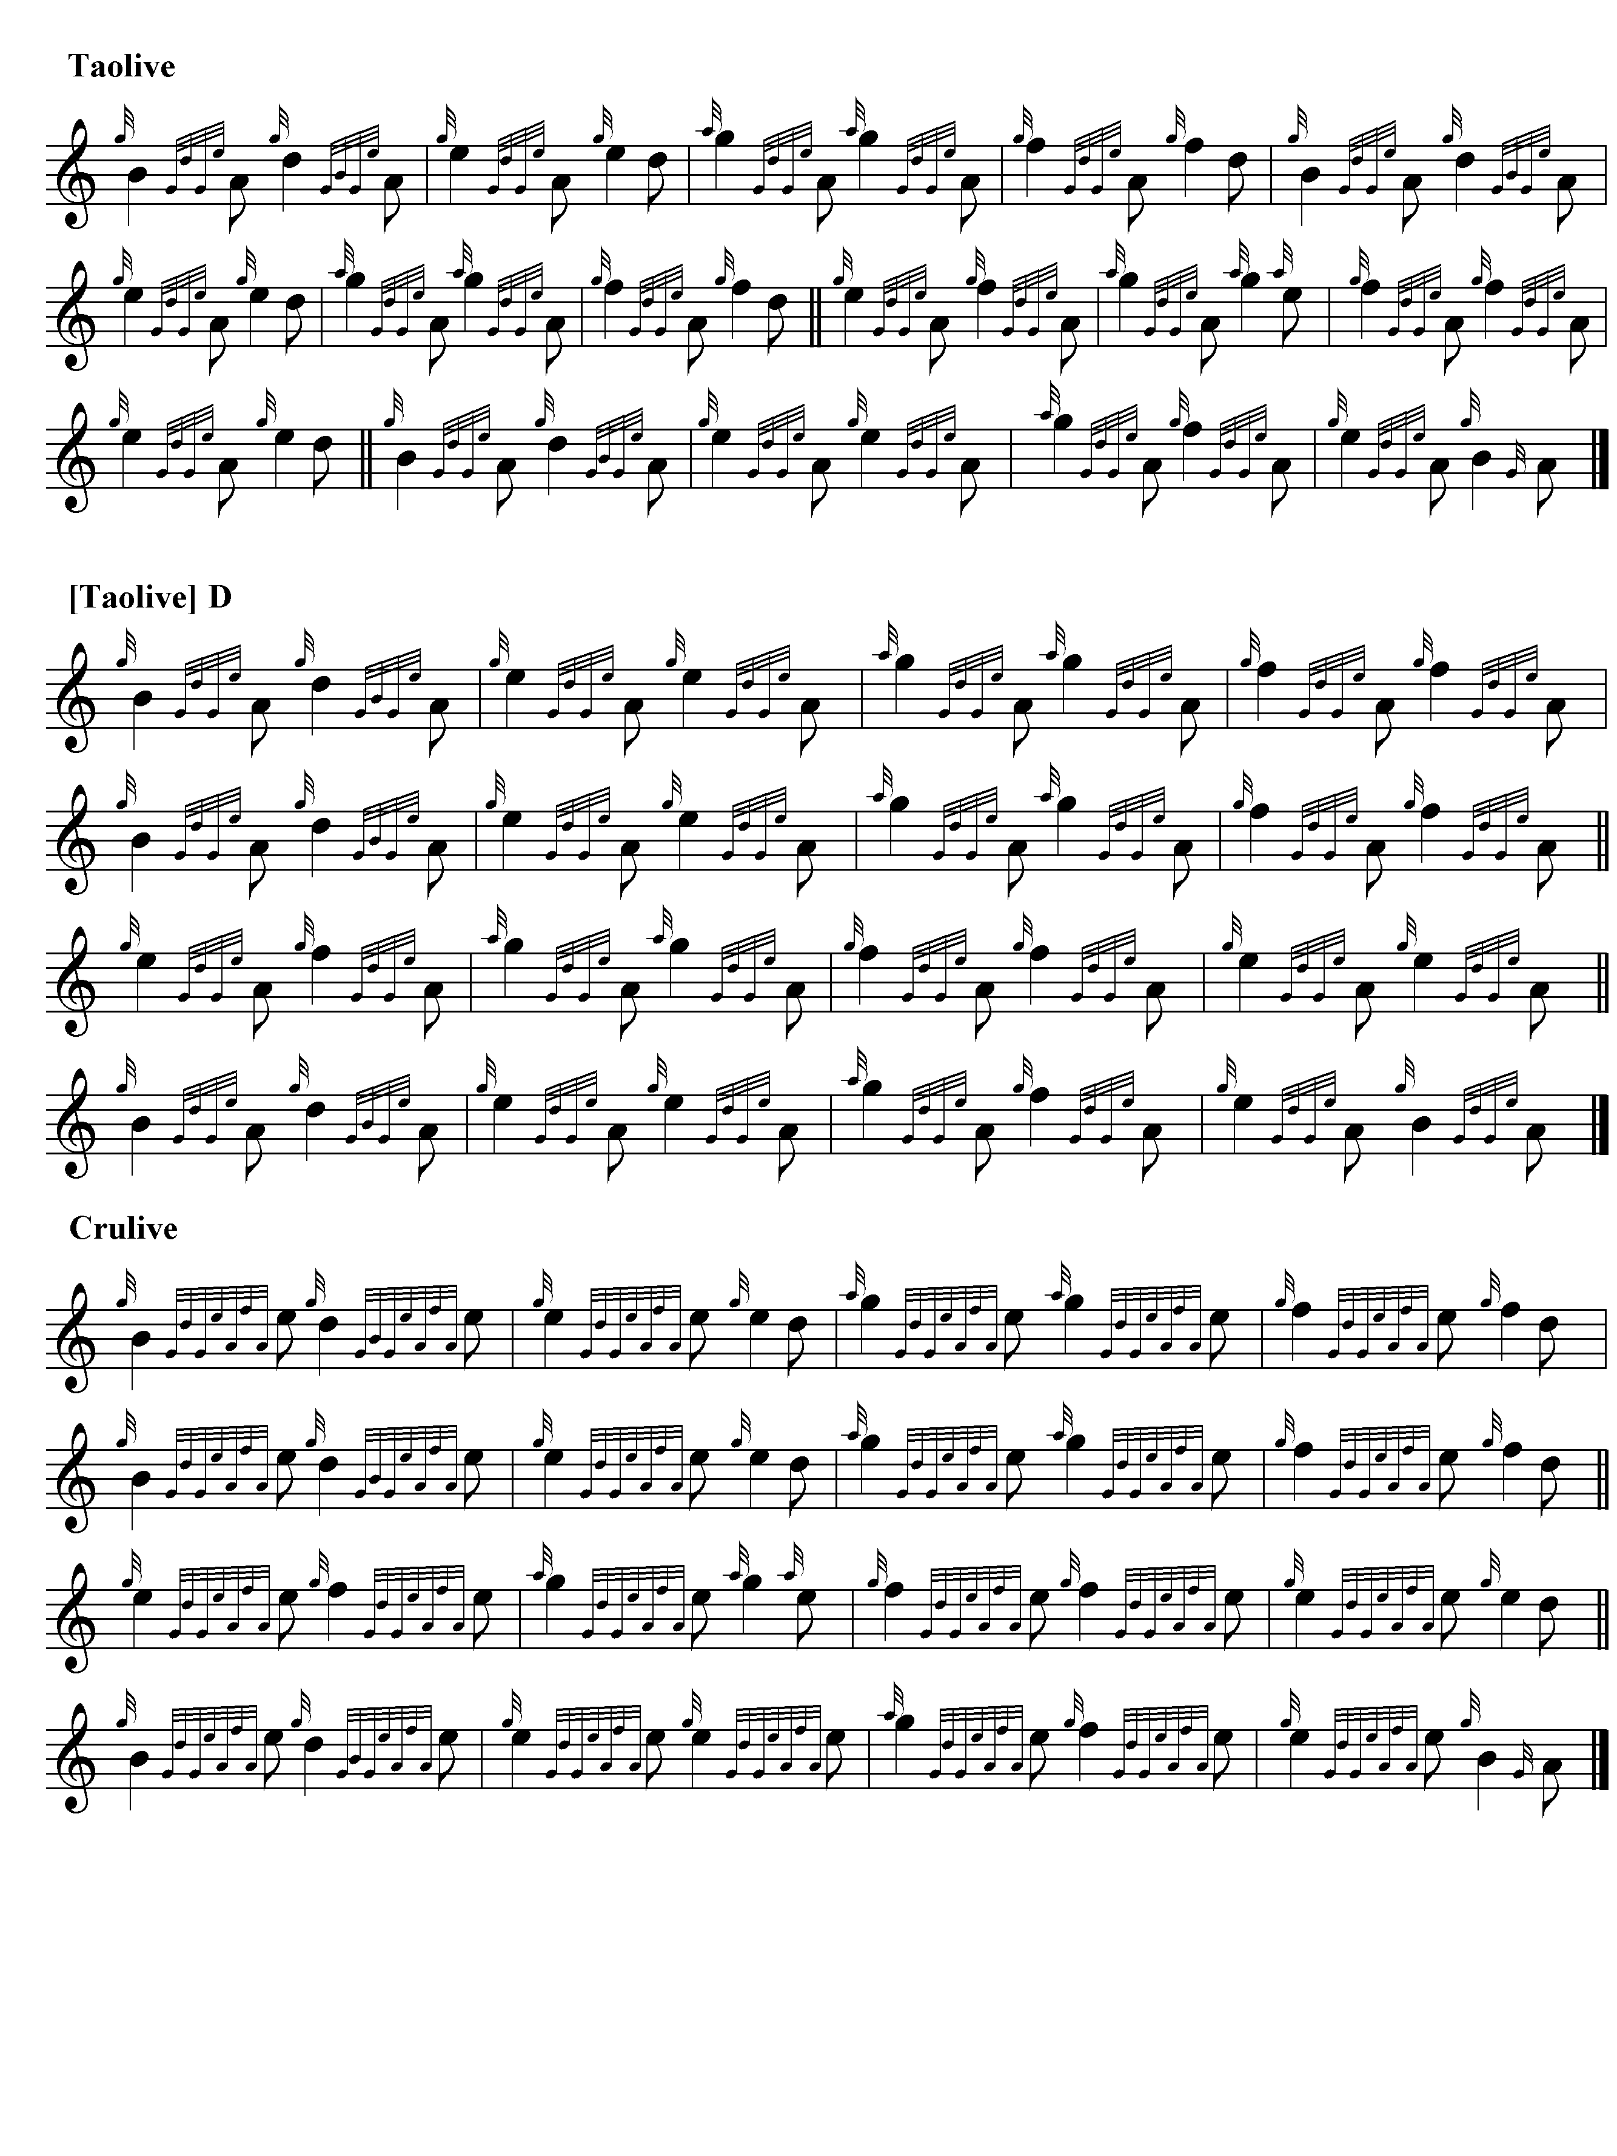

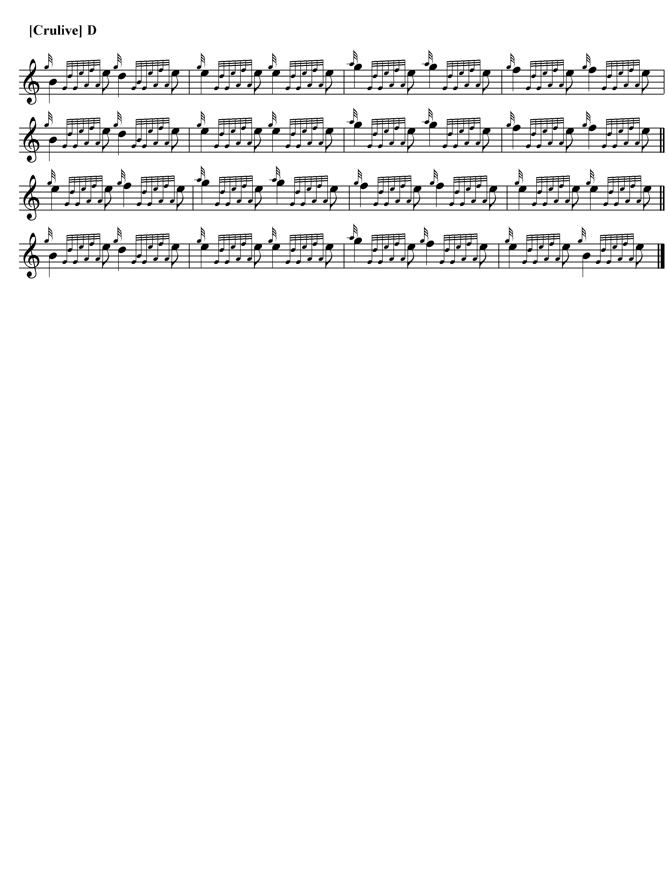
As it stands, the tune presents a number of interesting questions of interpretation. The ffirst Motion singling and doubling could be timed “up” or “down”, either “showing” the first quaver of each figure, or dropping swiftly to the second, to give a more staccato effect. This latter timing would resolve the problem that emphasizing the initial quaver makes it sounds too much like a skeletal version of the immediately following taorluath singling and doubling. The accompanying audio file shows both timings. The other way round this would be to repeat the ground between ffirst Motion doubling and the taorluath singling, as well as between the taorluath and crunluath movements, as one probably should. The ground is quite a strong one, and could probably stand this degree of exposure, especially if one varied the timing of the echo beats, as, again, tradition would seem to allow. The recording gives some indication of what this might sound like.

Commentary

A number of the “Nameless” tunes in the Nether Lorn Canntaireachd have a common “feel” in terms of tonal contour and melodic motif, with a prominent role for the upper register of the chanter, suggesting a common composer or compositional pool. These might include the nameless tunes number 42, 44, 45, 46 (entitled Aird’s March), 49 (“One of the Cragich”) and perhaps others.

*

Electronic text © Dr. William Donaldson, Cambridge, Massachusetts, 6 November 2022.

