The Rout of Glenfruin (2)

There are settings of this tune in the following manuscript sources:
--Colin Mór Campbell’s “Nether Lorn Canntaireachd “(i, 27-9, with the title “MacGrigor’s March”);
--Hannay-MacAuslan MS, ff.5-8 (with the title “ Ruaig Ghlinne Freoir or The Pursuit of Glenfroin”);
--Angus MacKay’s MS, ii, 65-6;
--Donald MacKay’s “Ballindalloch MS”, ff.5-6;

--Robert Meldrum’s MS, ff.145-7 (marked “J. MacDougall Gillies Setting. John Died in 1925. R.M.P.M.”);

and in the following published sources:
--Donald MacDonald, Ancient Martial Music of Caledonia, pp.48-52 (with the title –“Ruaig Ghlenne Fruin (properly Glenn a Bhroin). The Valley of Sorrow The Rout of Glenfruin. A Desperate Engagement between the MacGregors and Colquhouns 1602 In the above Glen near Loch Lomond where the latter were routed with great slaughter”);
--C. S. Thomason, Ceol Mor, p.22;
--David Glen, Collection of Ancient Piobaireachd, pp.88-9;
--William Stewart, et al., eds., Piobaireachd Society Collection (first series), v, 13-14;
--John McLennan, The Piobaireachd as MacCrimmon Played it, p.8.

The major sources develop the tune as follows:

Nether Lorn | Hannay-MacAuslan | MacDonald | Angus MacKay | Thomason | Glen | Piobaireachd Society  (1st series) | McLennan
Ground | Ground | Ground | Ground | Ground | Ground | Ground | Ground
Thumb var  singling  doubling  trebling | Thumb var  singling  doubling | Thumb  var  singling  doubling | Thumb  var  singling  doubling | Thumb  var  singling  doubling | Thumb var  sing.  doub. | Thumb  var  sing.  doub. | Thumb Var  singling  doubling
 | Ground | Ground
 | Siubhal singling doubling trebling | Siubhal  singling  doubling  trebling |  | Siubhal  singling  doubling  trebling | Siubhal  sing.  doub.  treb. |  | Siubhal  singling  doubling
 | Ground | Ground
 |  |  | Leumluath  singling  doubling  trebling | Leumluath  singling  doubling |  | Leumluath  singling  doubling
 |  |  | Ground
Taorluath  singling  doubling  trebling | Taorluath  singling  doubling  a mach | Taorluath  singling  doubling  a mach | Taorluath  singling  doubling  trebling | Taorluath  singling  doubling  a mach | Taorluath  singling  doubling  a mach | Taorluath  singling  doubling | Taorluath  singling  doubling  a mach
 | Ground | Ground | Ground | Ground
Crunluath  singling  doubling  trebling  a-mach | Crunluath  singling  doubling  a-mach | Crunluath  singling  doubling  a-mach | Crunluath  singling  doubling  trebling | Crunluath  singling  doubling  a-mach | Crunluath  singling  doubling  a-mach | Crunluath  singling  doubling  a-mach | Crunluath  singling  doubling  a-mach
 | Ground | Ground | Ground | Ground | Ground

Colin Campbell’s setting in the Nether Lorn is both pleasingly symmetrical and musically interesting, with a typically playful extension of the tone row in the doublings of the Thumb, Taorluath, and Crunluath variations. The Thumb variation shows this characteristic arrangement, thus:

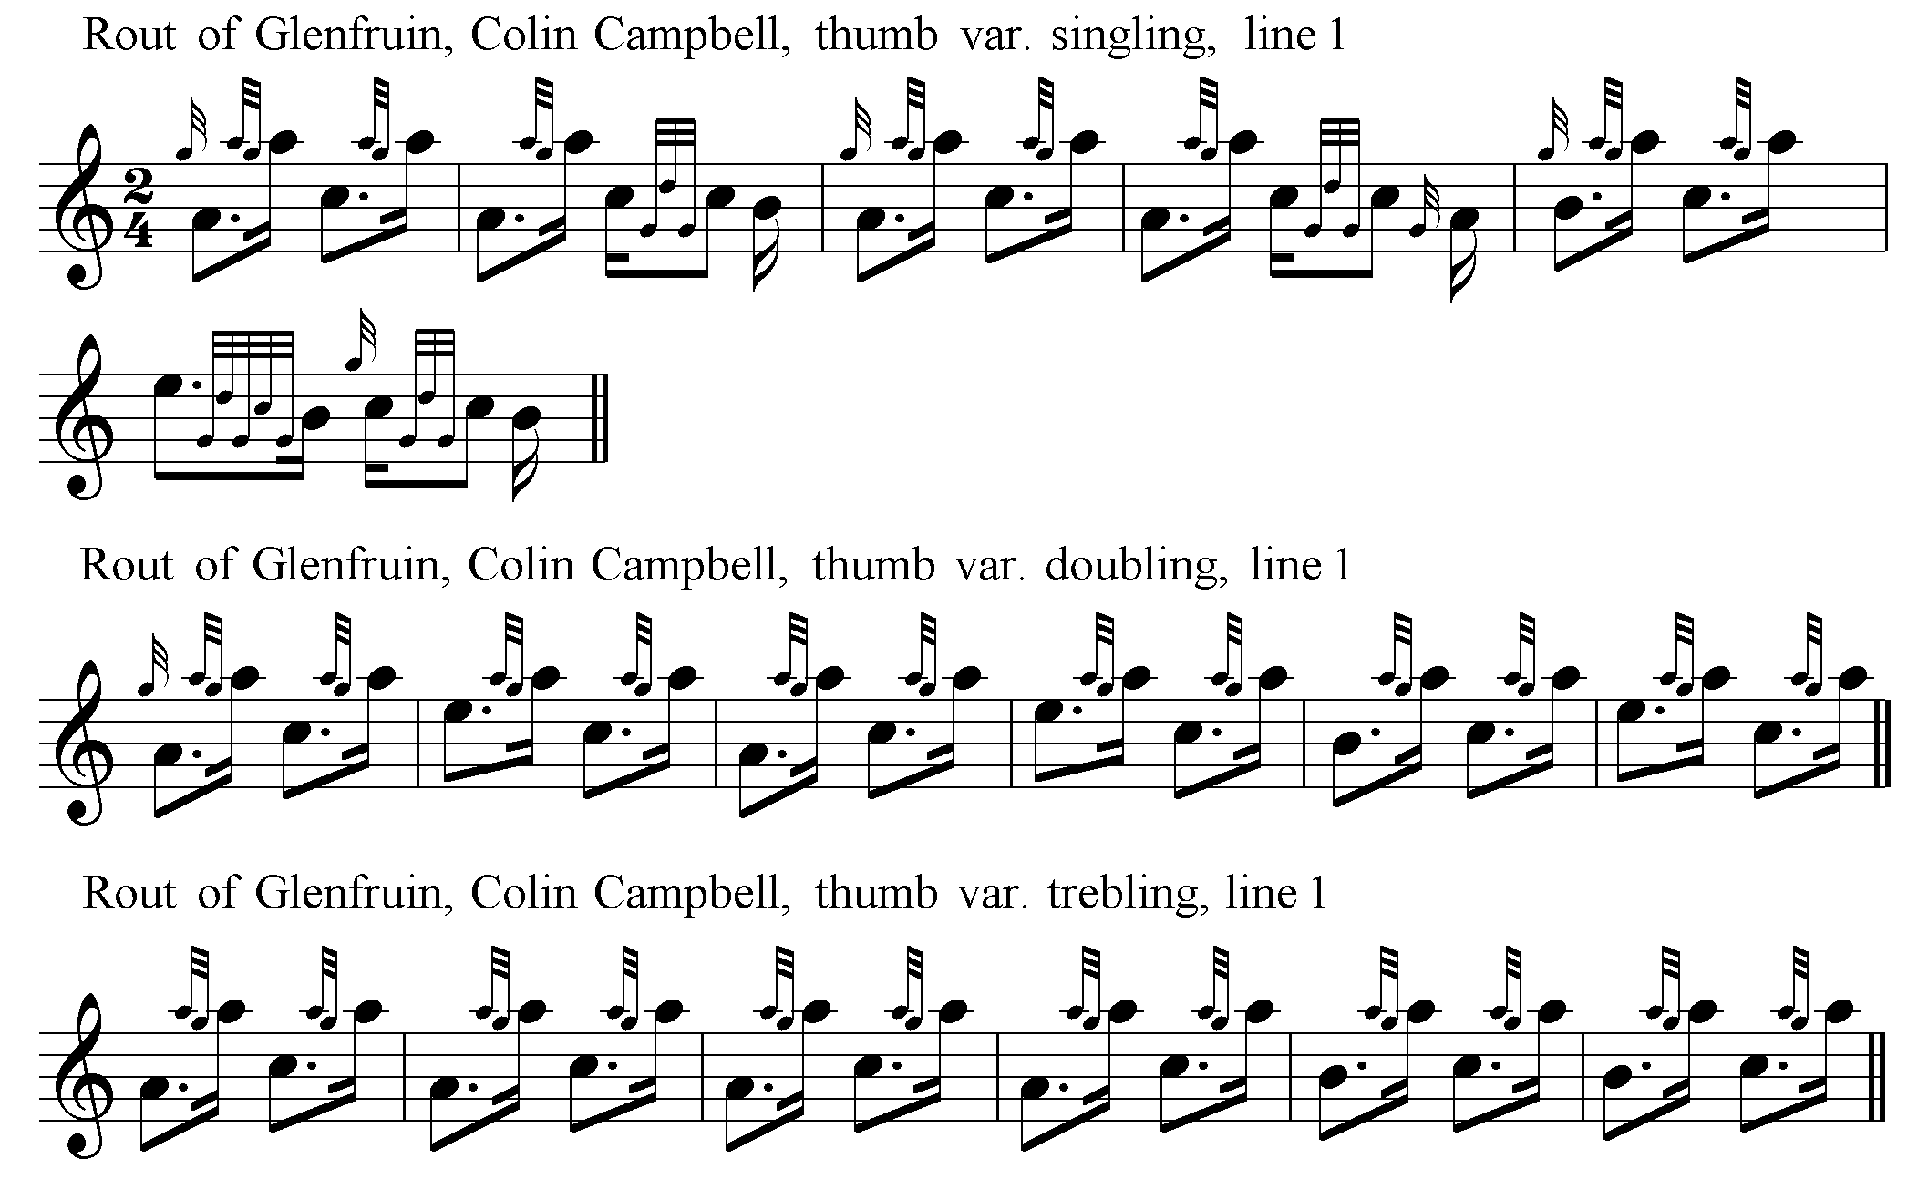

Colin Campbell’s original score is as follows:

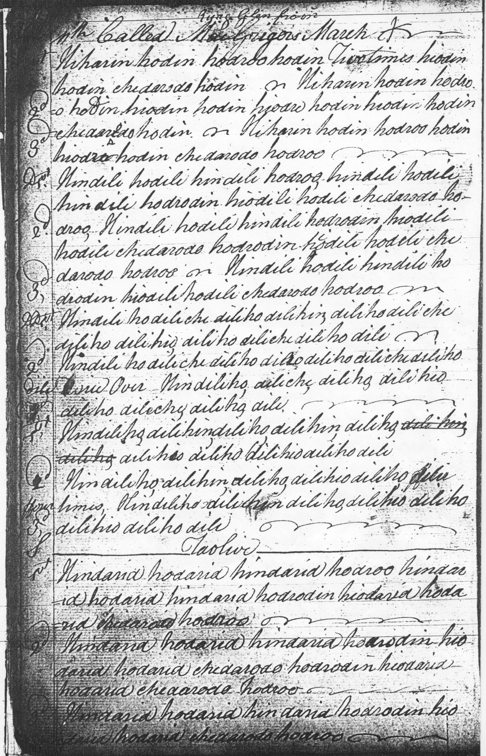

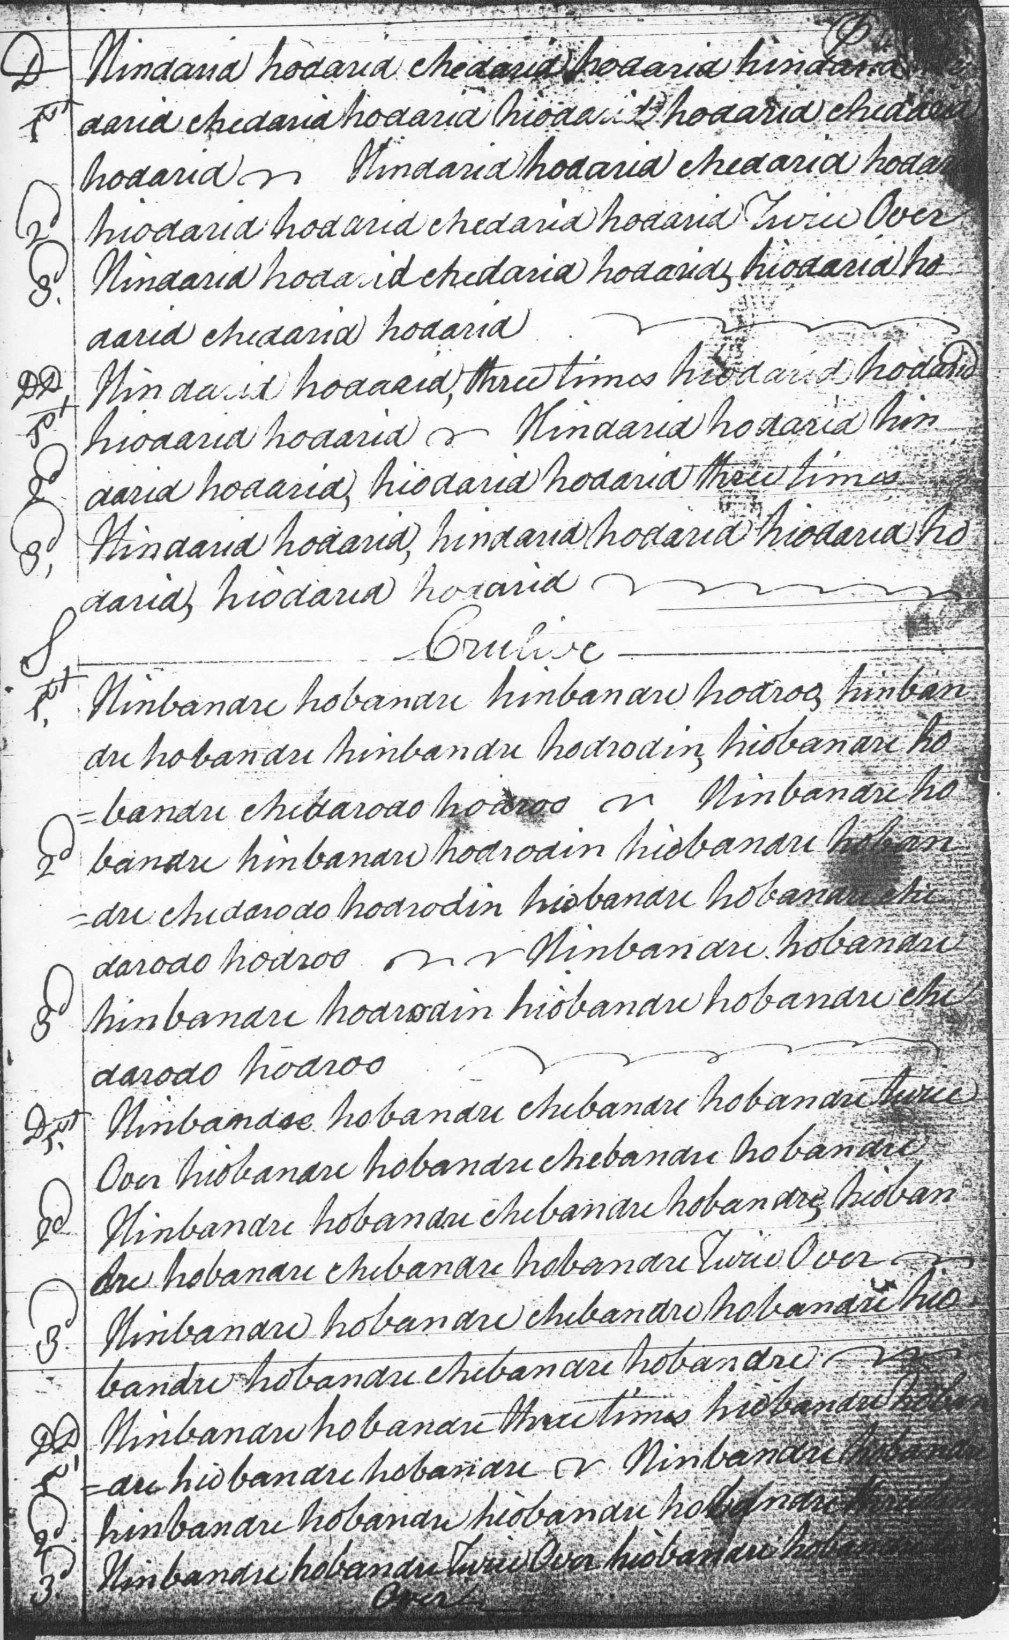

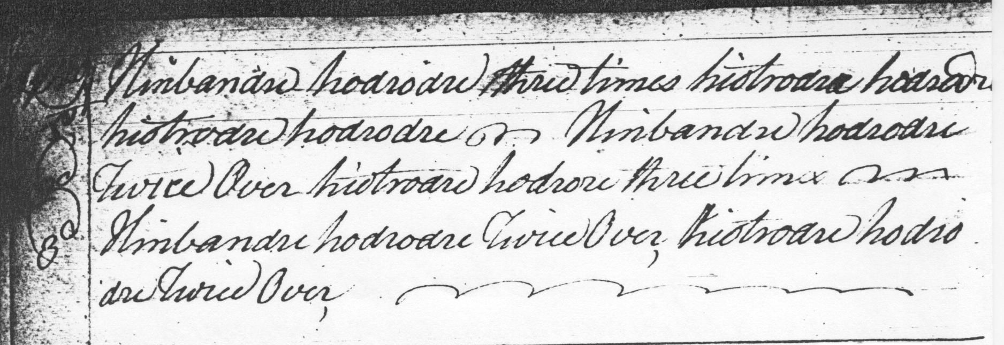

One point of interest about Colin Campbell’s notational system emerges quite strongly in this tune, namely his intended timing of the introductory gesture on A, “hiharin”. The system as a whole seems quite strongly onomatopoeic, the syllables framed in such a way as to indicate rhythm as well as pitch. “Hiharin” would thus seem to imply a three-pulse gesture, perhaps as follows:

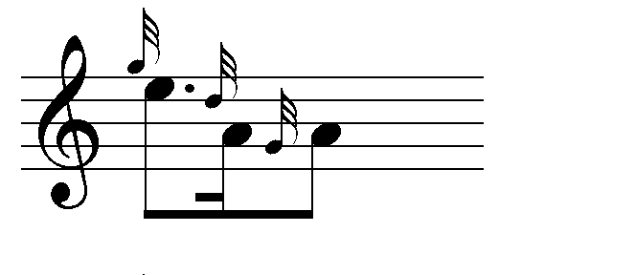

If this is so, then the standard modern timing of this gesture which contains five pulses:

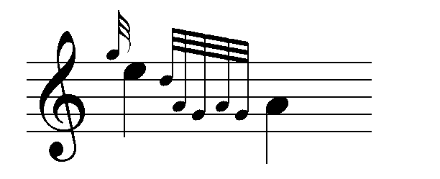

would be inappropriate here; as, strictly, would the differently accented timings of this movement by MacDonald and MacKay:

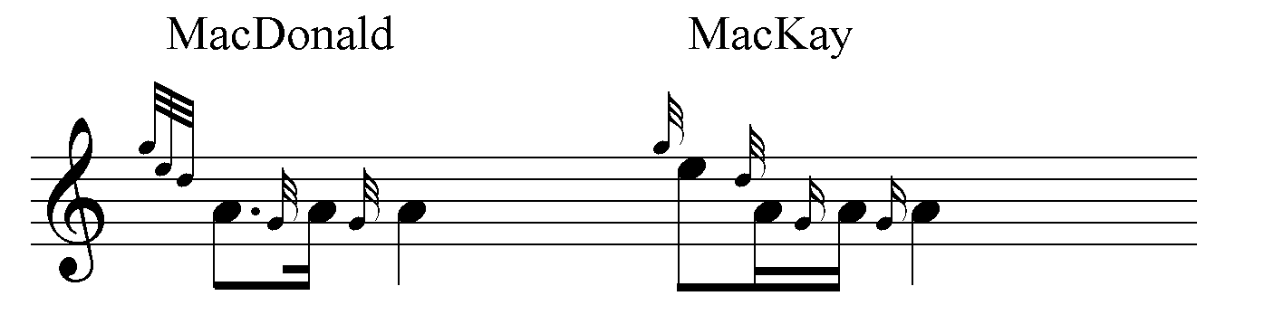

Campbell’s ground may thus, perhaps, have been timed as follows:

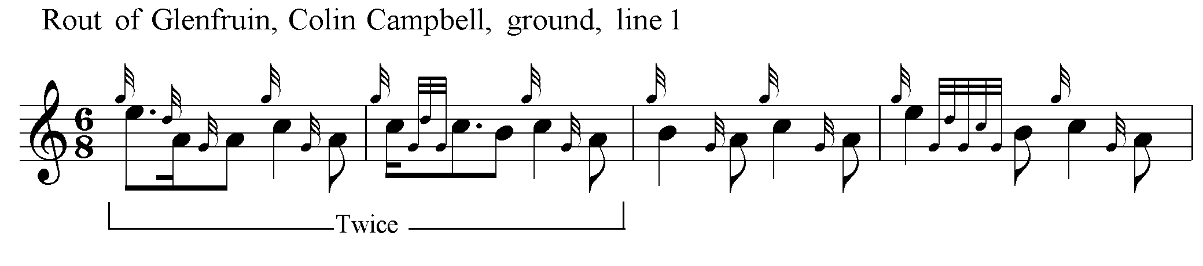

This produces an onwardly flowing line, avoiding the sense of frequent interruption induced by Donald MacDonald’s cuts down from C and B, which occur at the ends of most of the latter’s bars in the Ground. On the other hand, a timing something like the following—an equally possible interpretation of the canntaireachd notation--would be very much in keeping with some of the other scores:

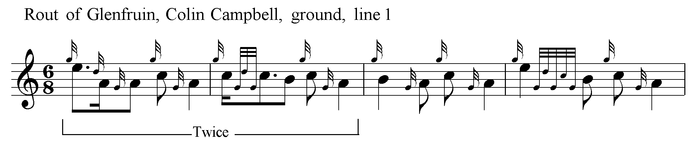

There are several notable features of Donald MacDonald’s setting, including his heavy cadencing of the ground. It seems clear from other scores that MacDonald’s GED demi-semi-quaver figures do not all have equal time value, and much depends on surrounding rhythmical context in their interpretation. Colin Campbell’s setting could—in theory-- be treated in a similar fashion; but I have not added the necessary cadencing above (which as a performer in the older tradition I would be perfectly at liberty to do) because the resulting flow of the melody line seems inherently attractive, and a feature one might wish to preserve. MacDonald’s frequent repetitions of the Ground should also be noted and also his characteristic timing of the opening quavers of his a-mach movements in the Taorluath and Crunluath variations:

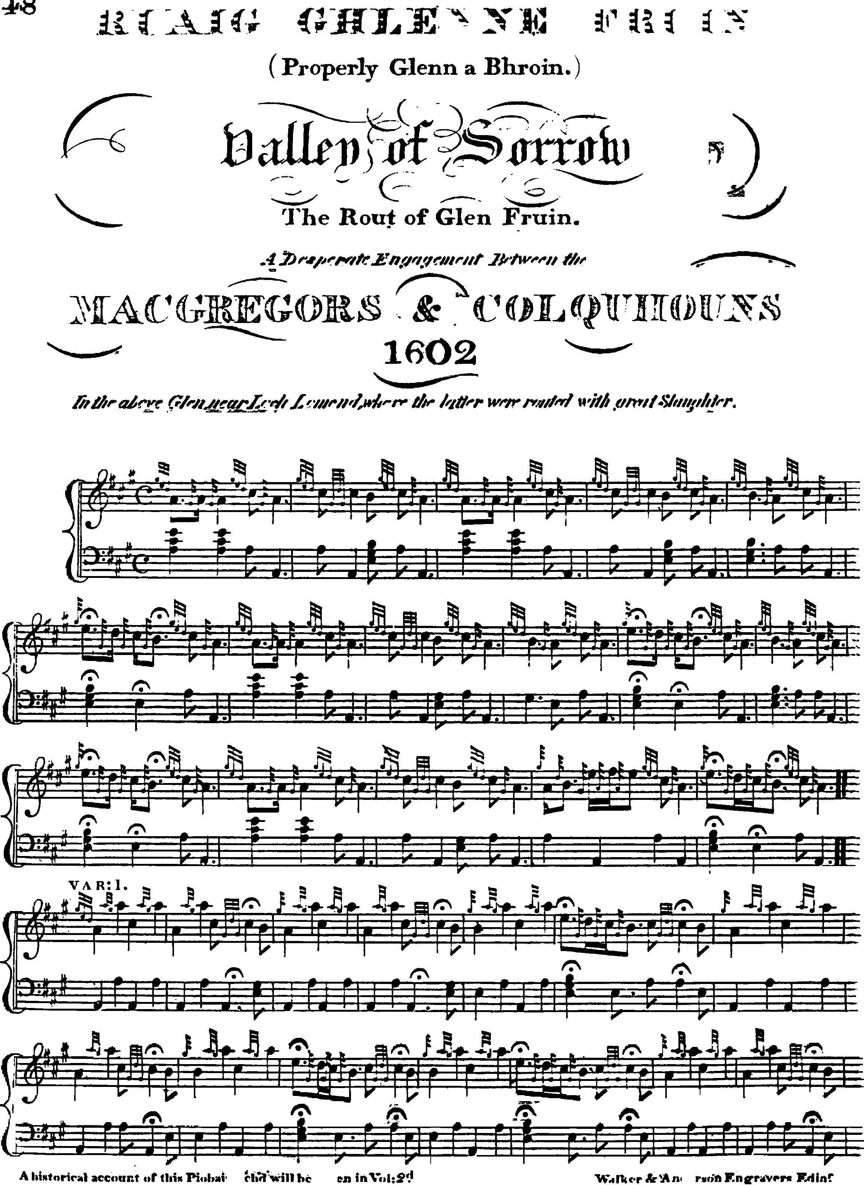

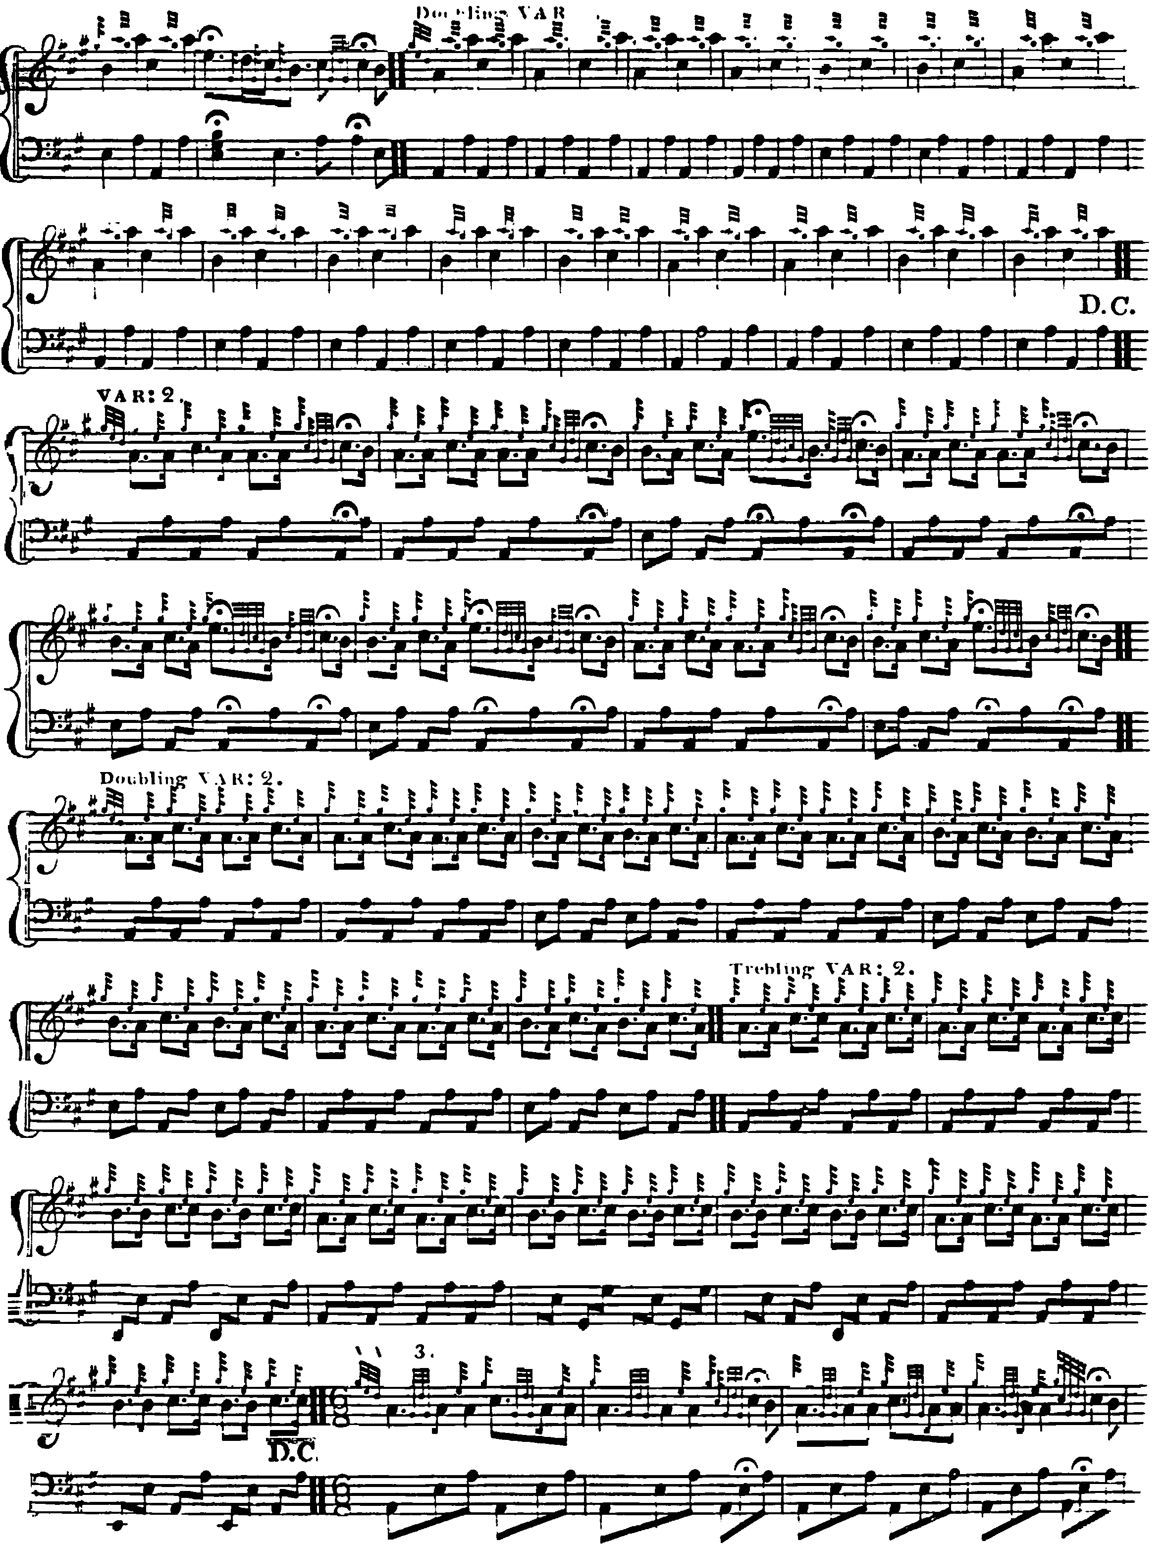

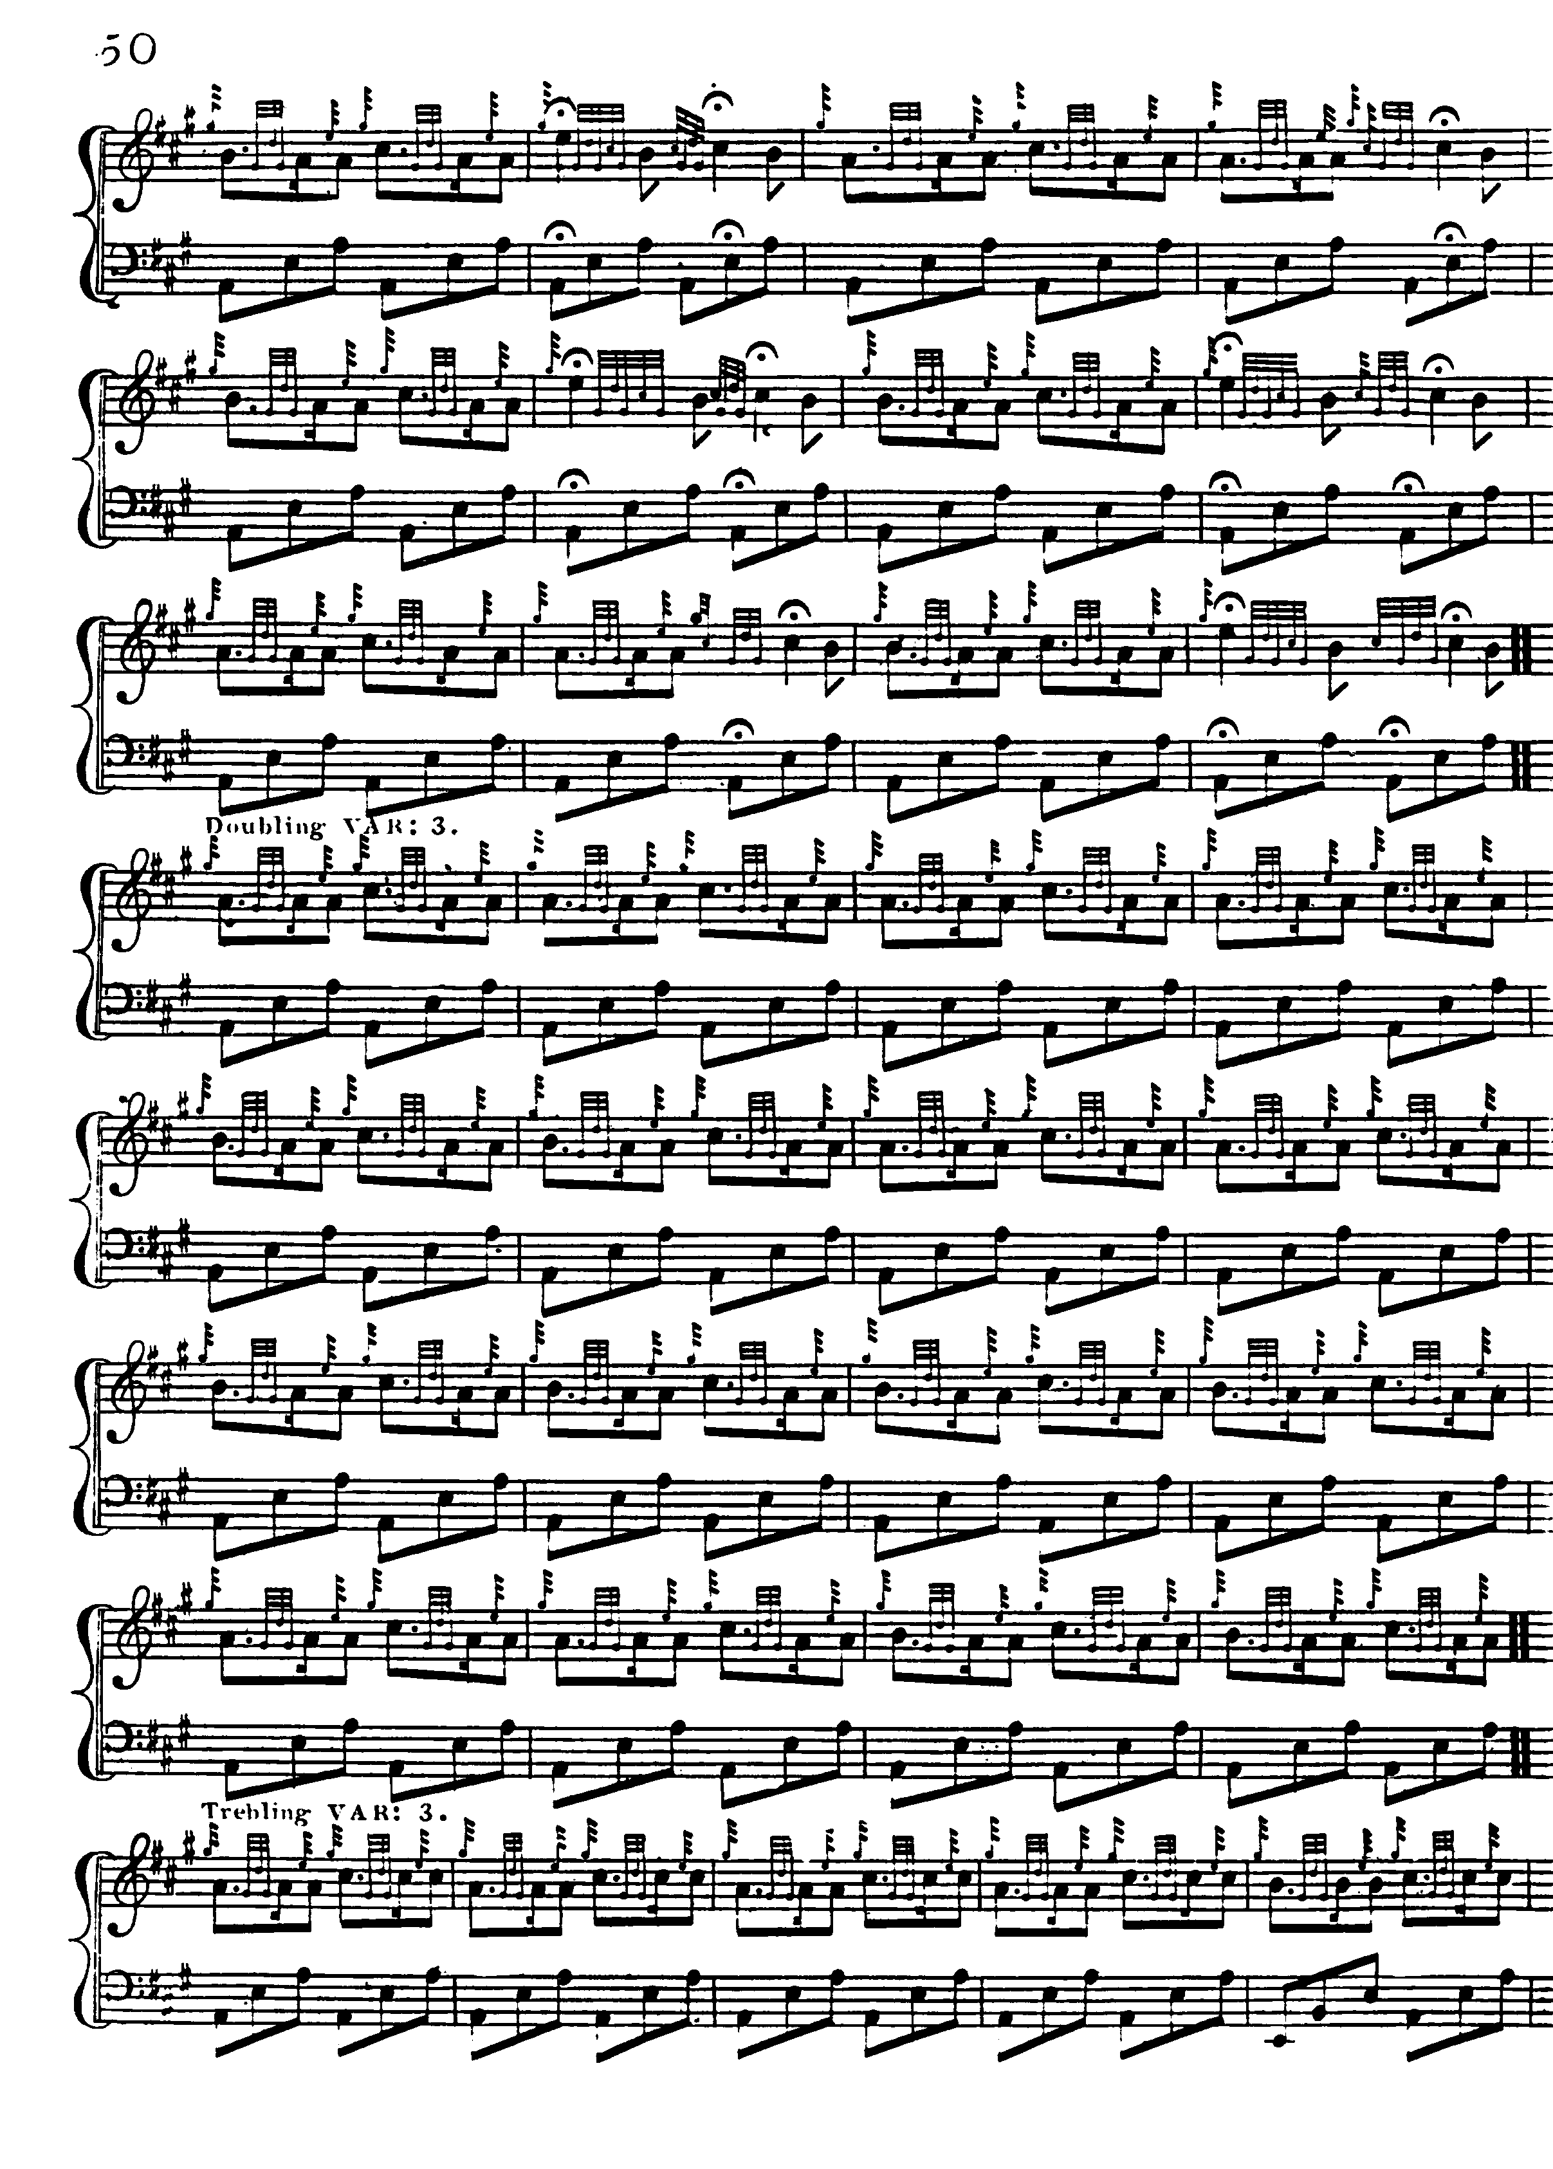
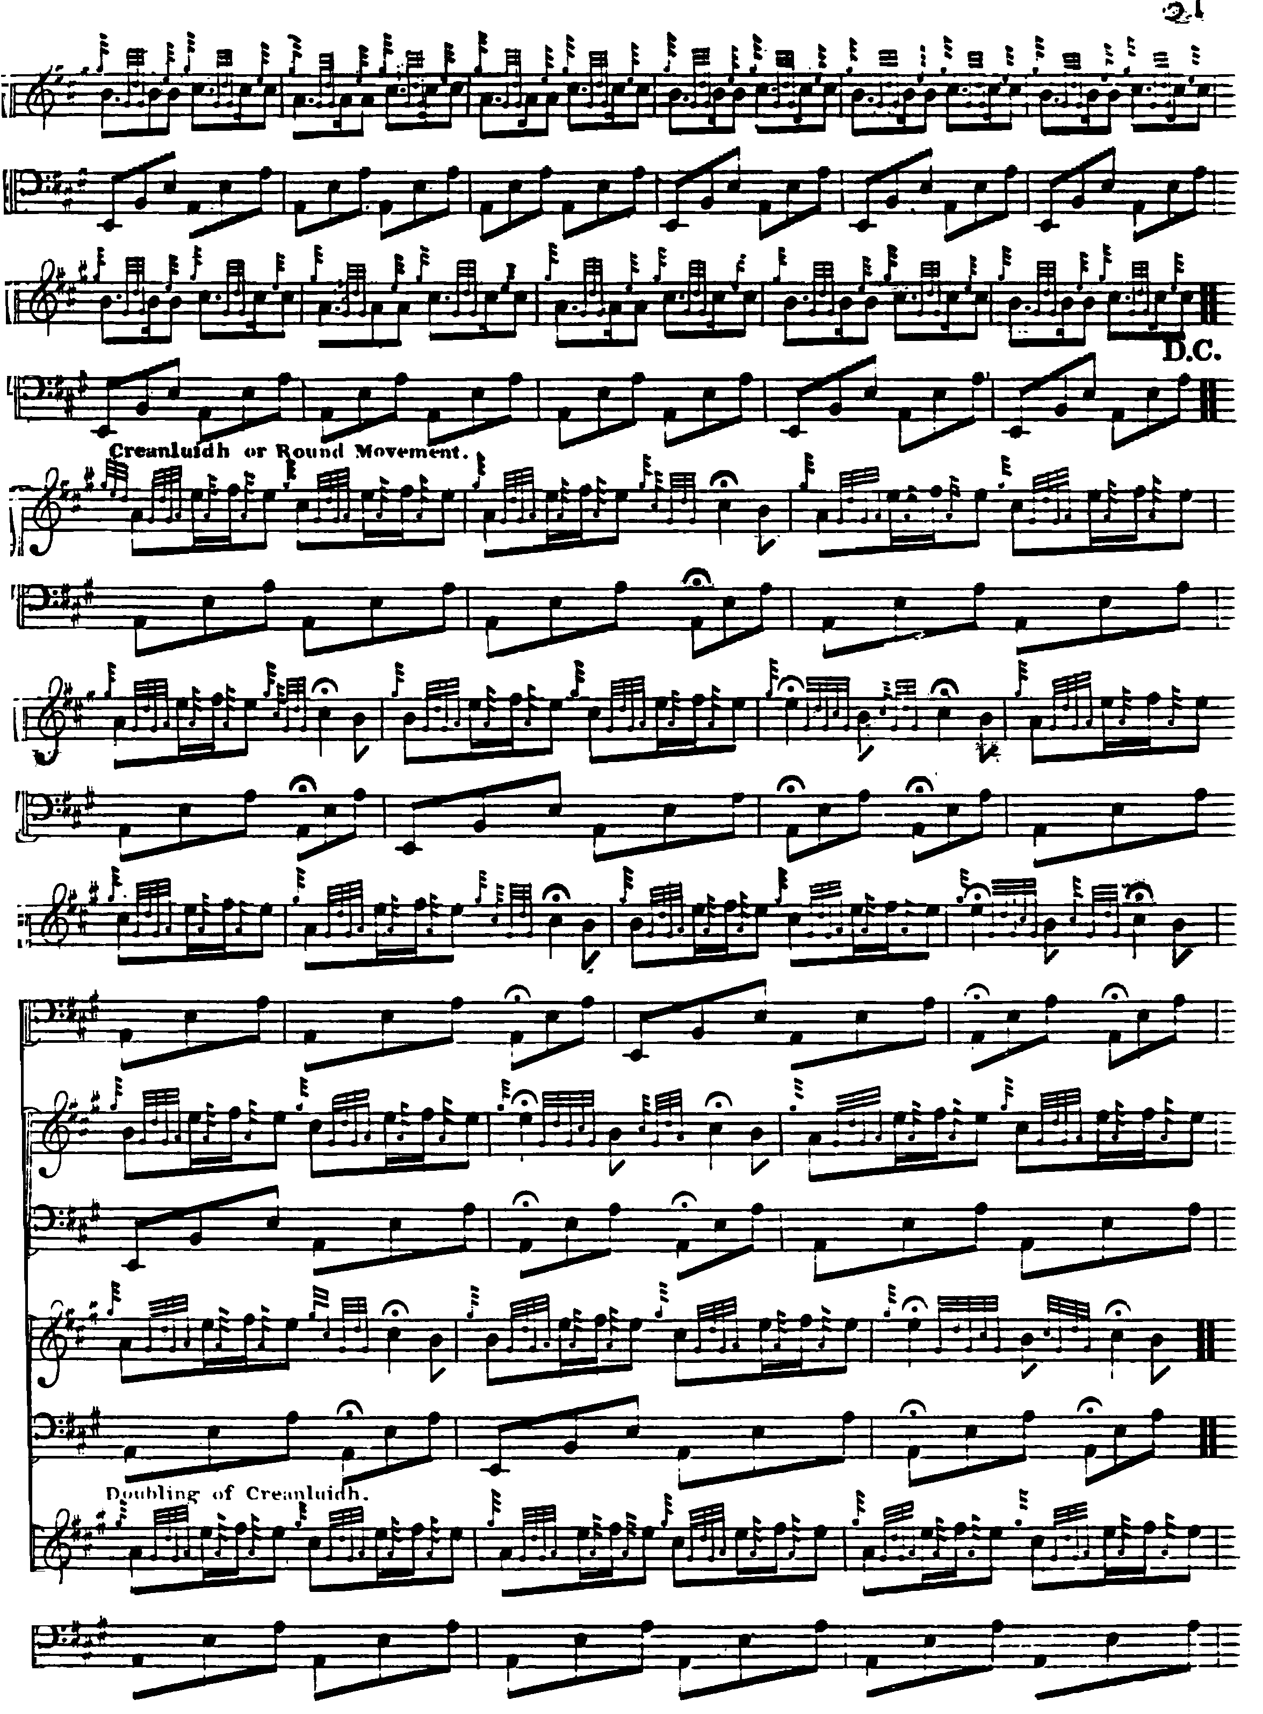

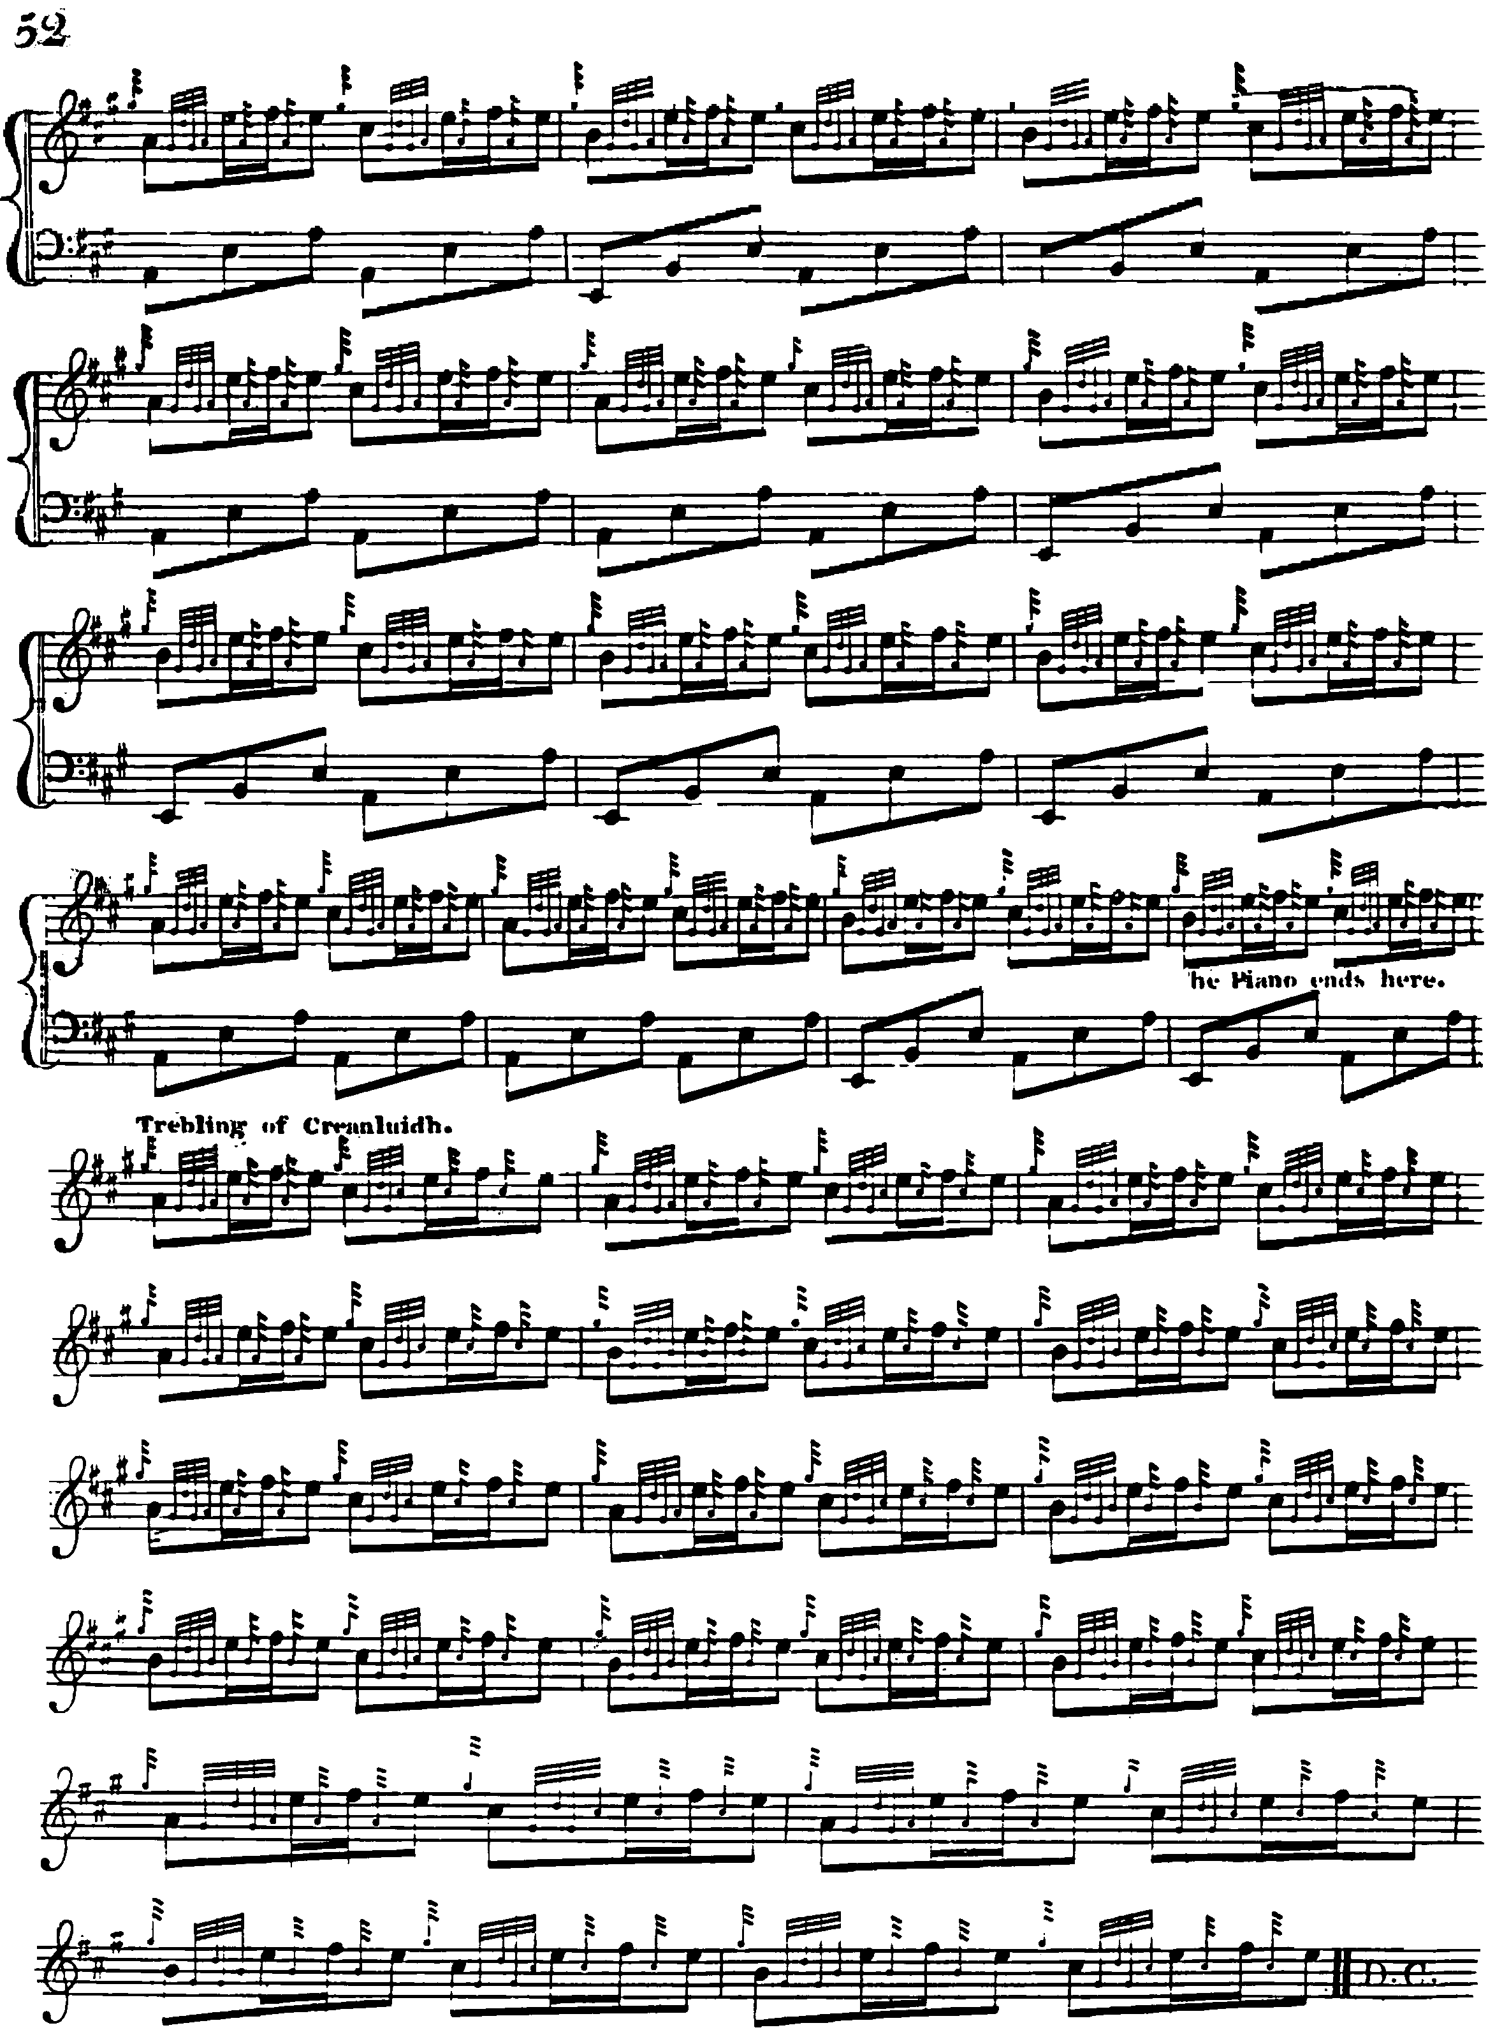

It is interesting that the Hannay-MacAuslan MS, sometime thought to have been one of Donald MacDonald’s sources, should develop the tune in exactly the same way, down to the frequent repetitions of the ground (indicated by the Dal Segno marks at the ends of sections) although there are a number of intriguing differences in detail:

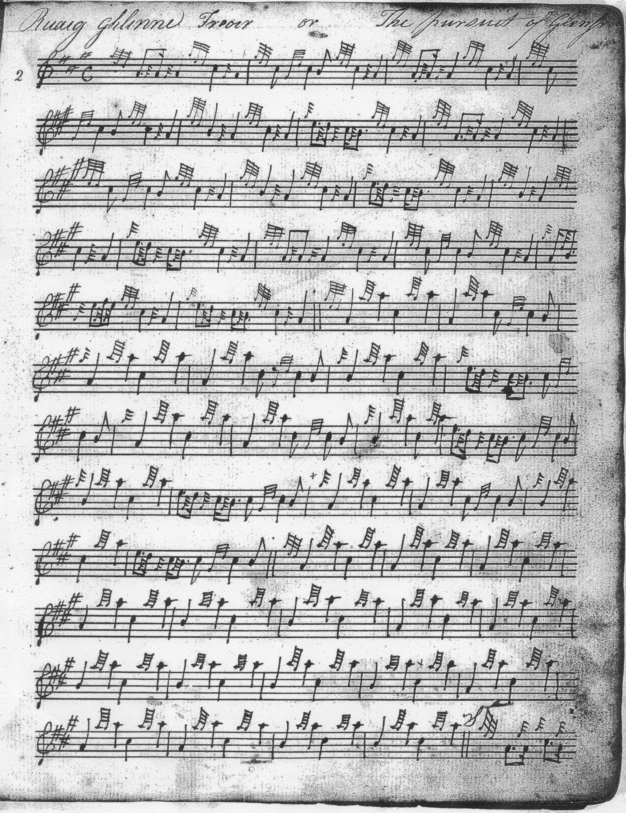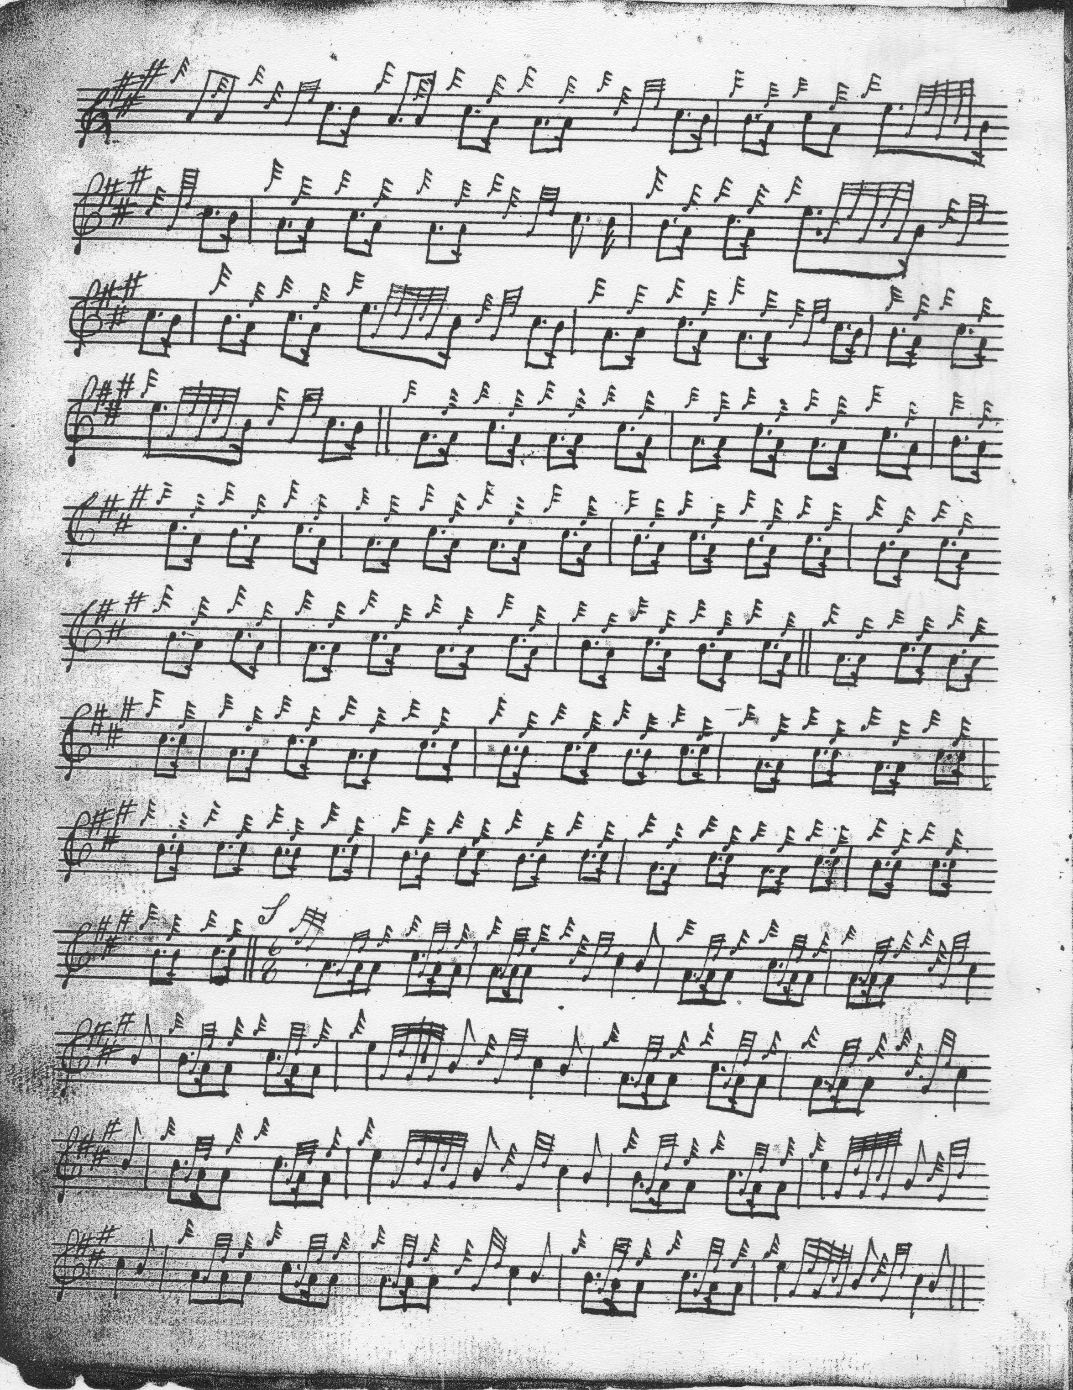

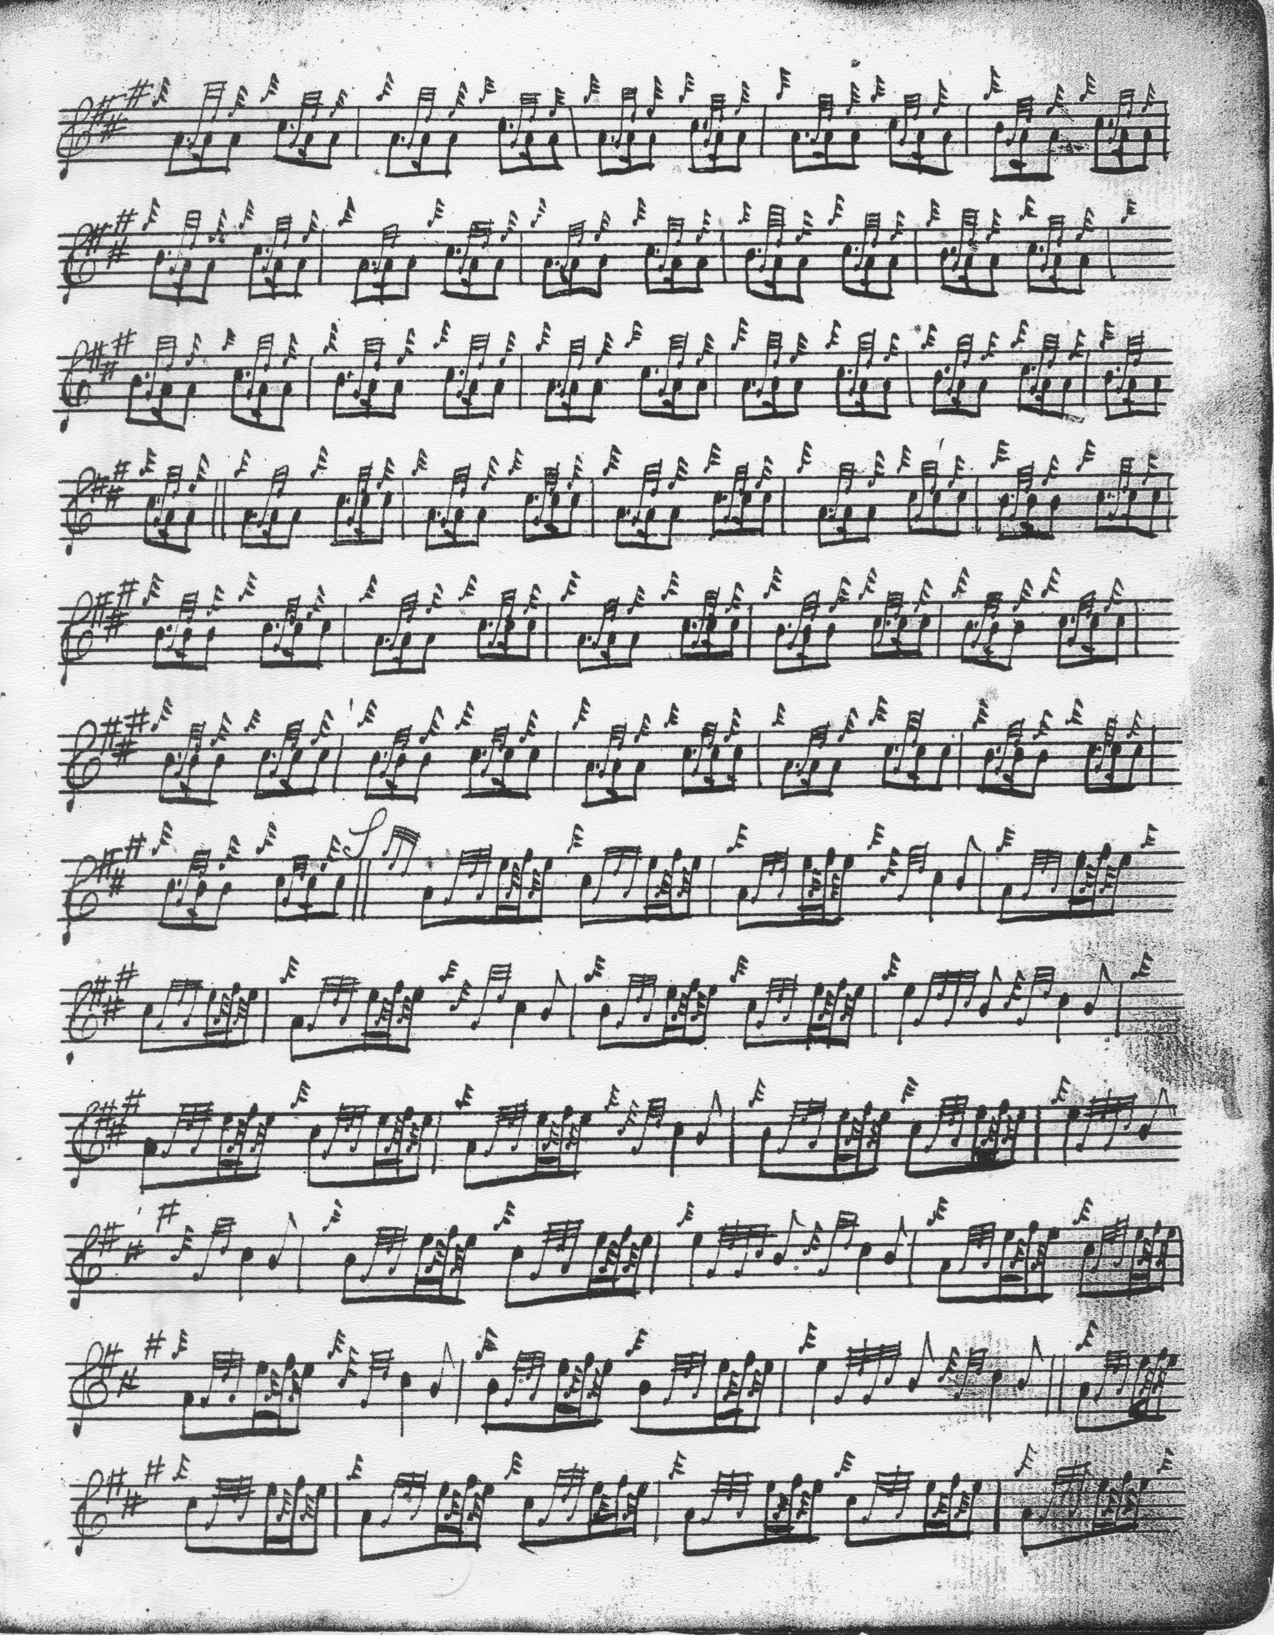

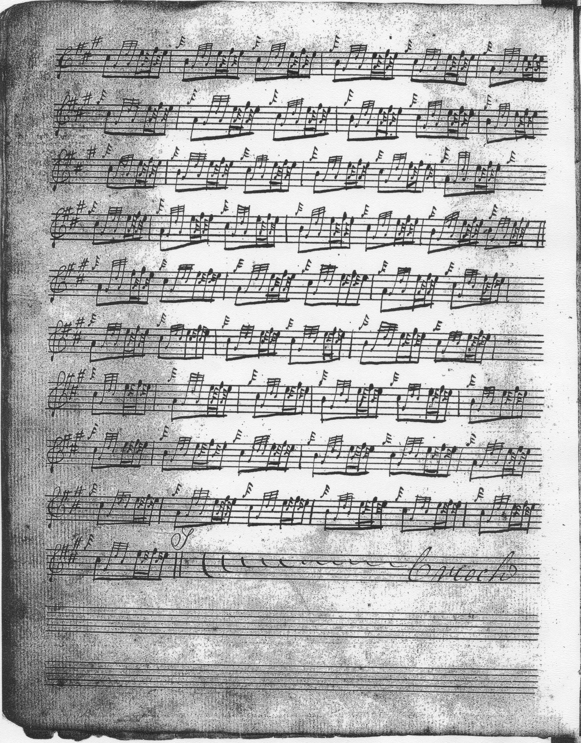

The reader will note the differences in pointing in the Ground from MacDonald’s published score, and in the framing of the taorluath and crunluath movements. These latter are discussed in detail in my book The Highland Pipe and Scottish Society 1750-1950 (East Linton, 2000; repr. Edinr., 2005) pp. 107-8.

Angus MacKay sets the tune like this:

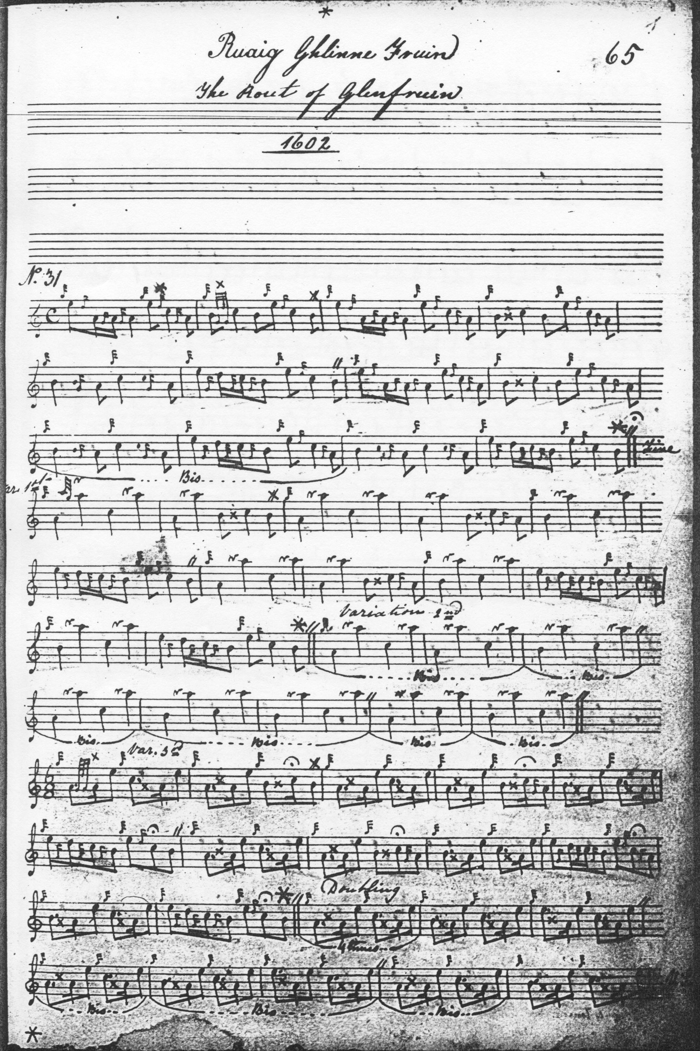
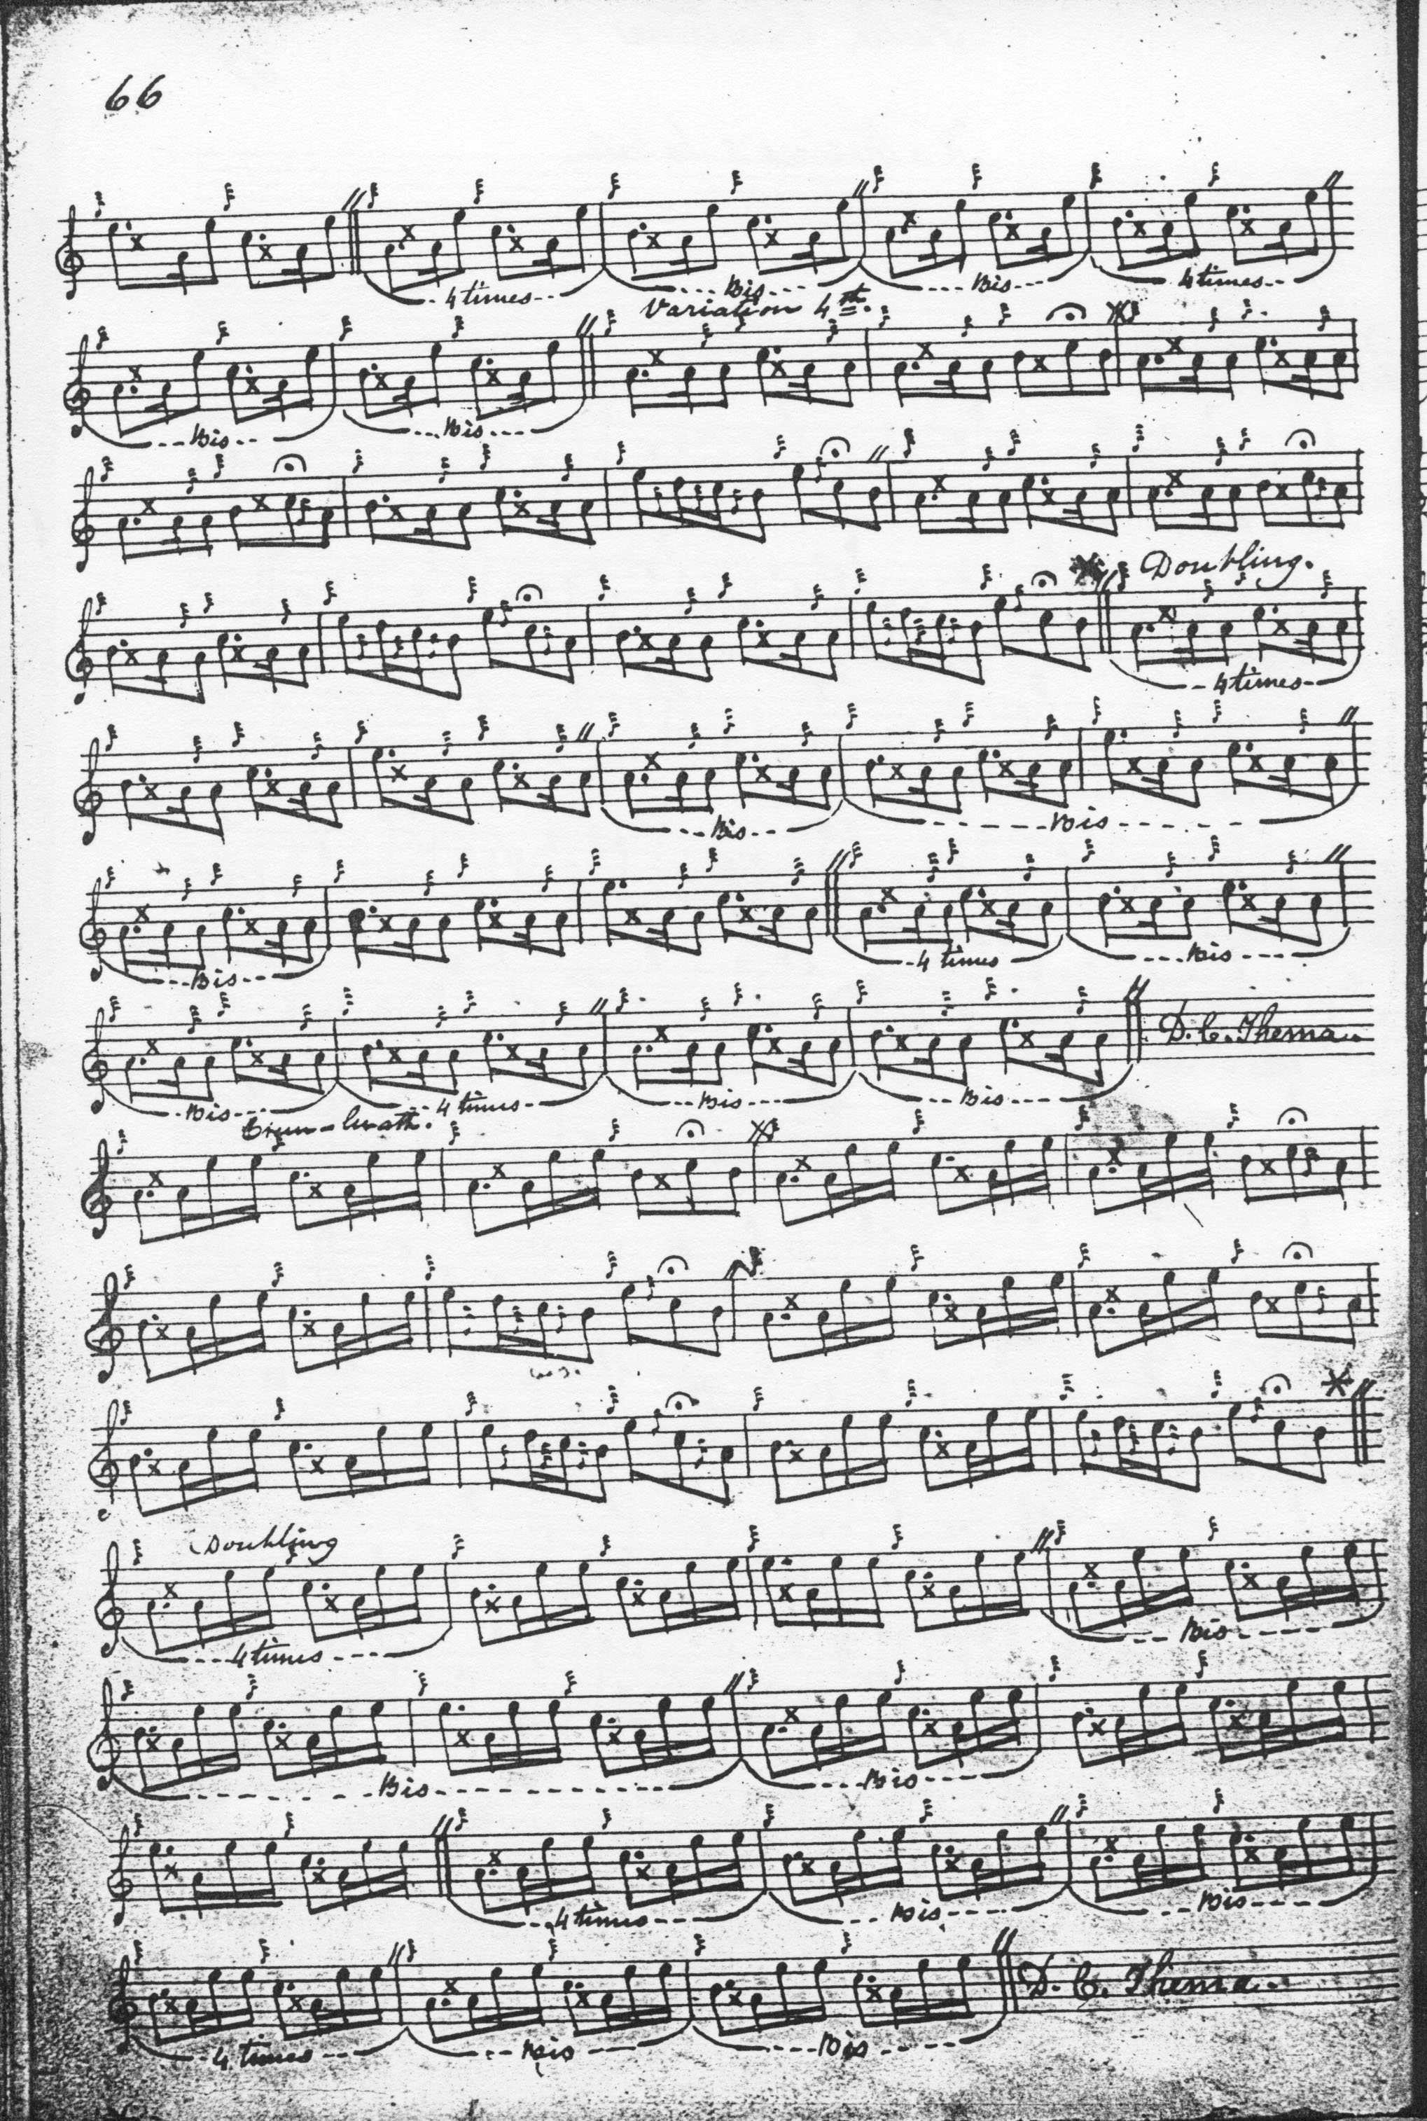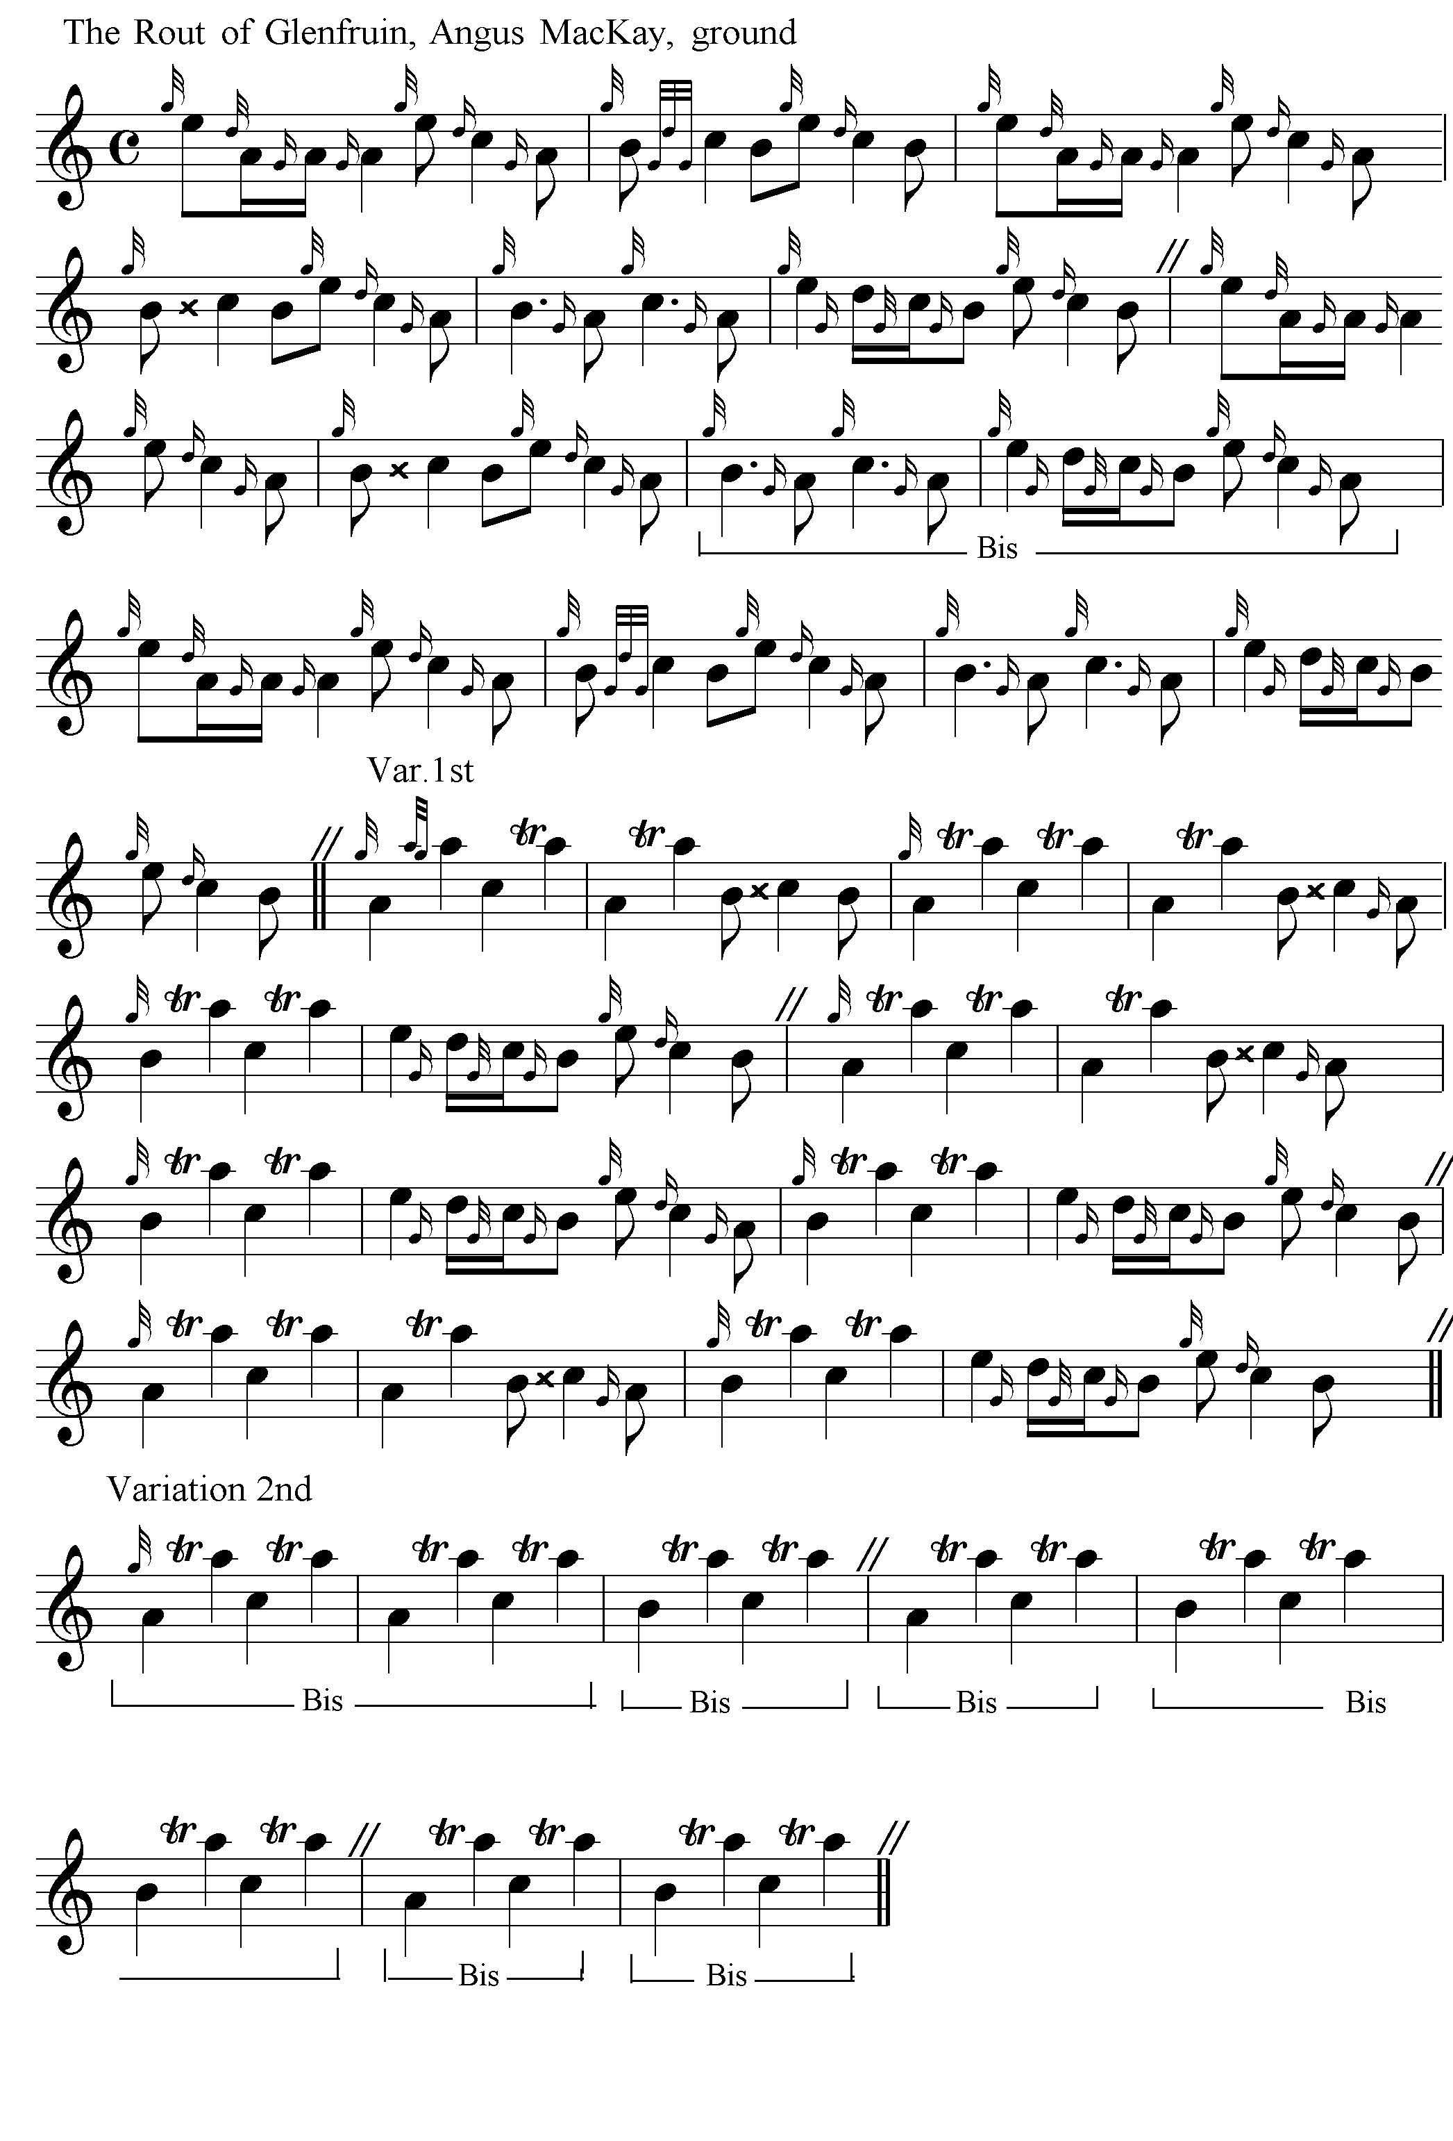
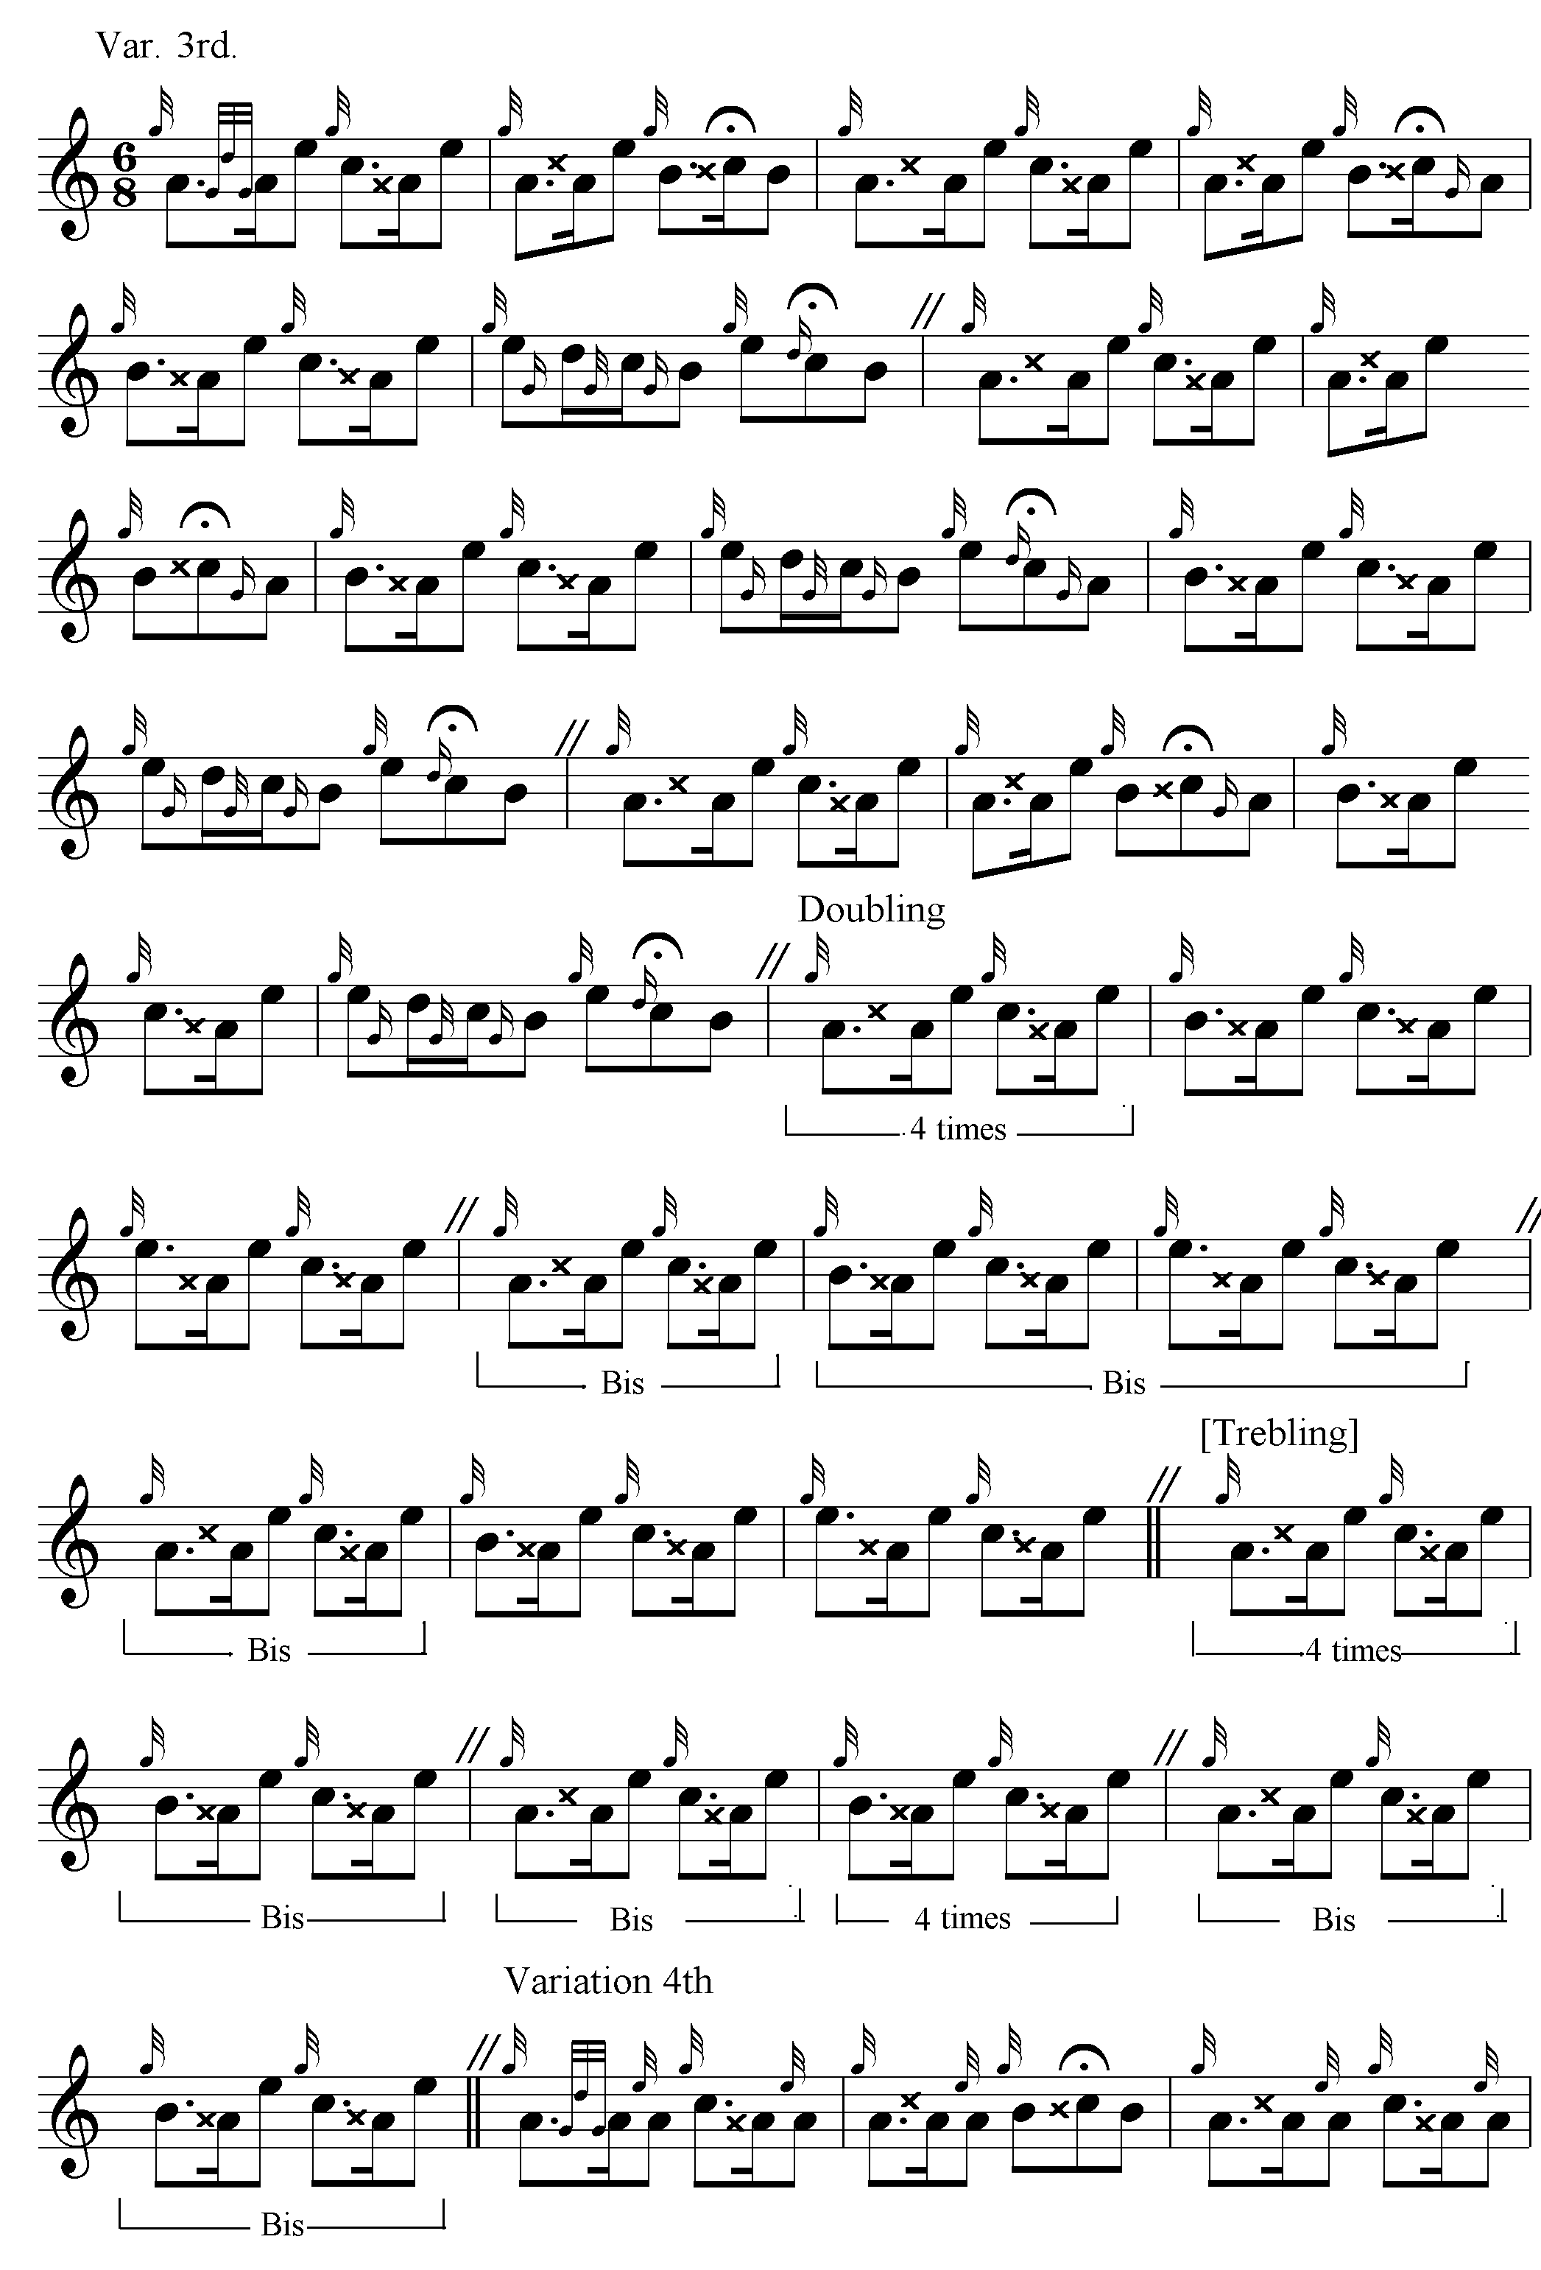
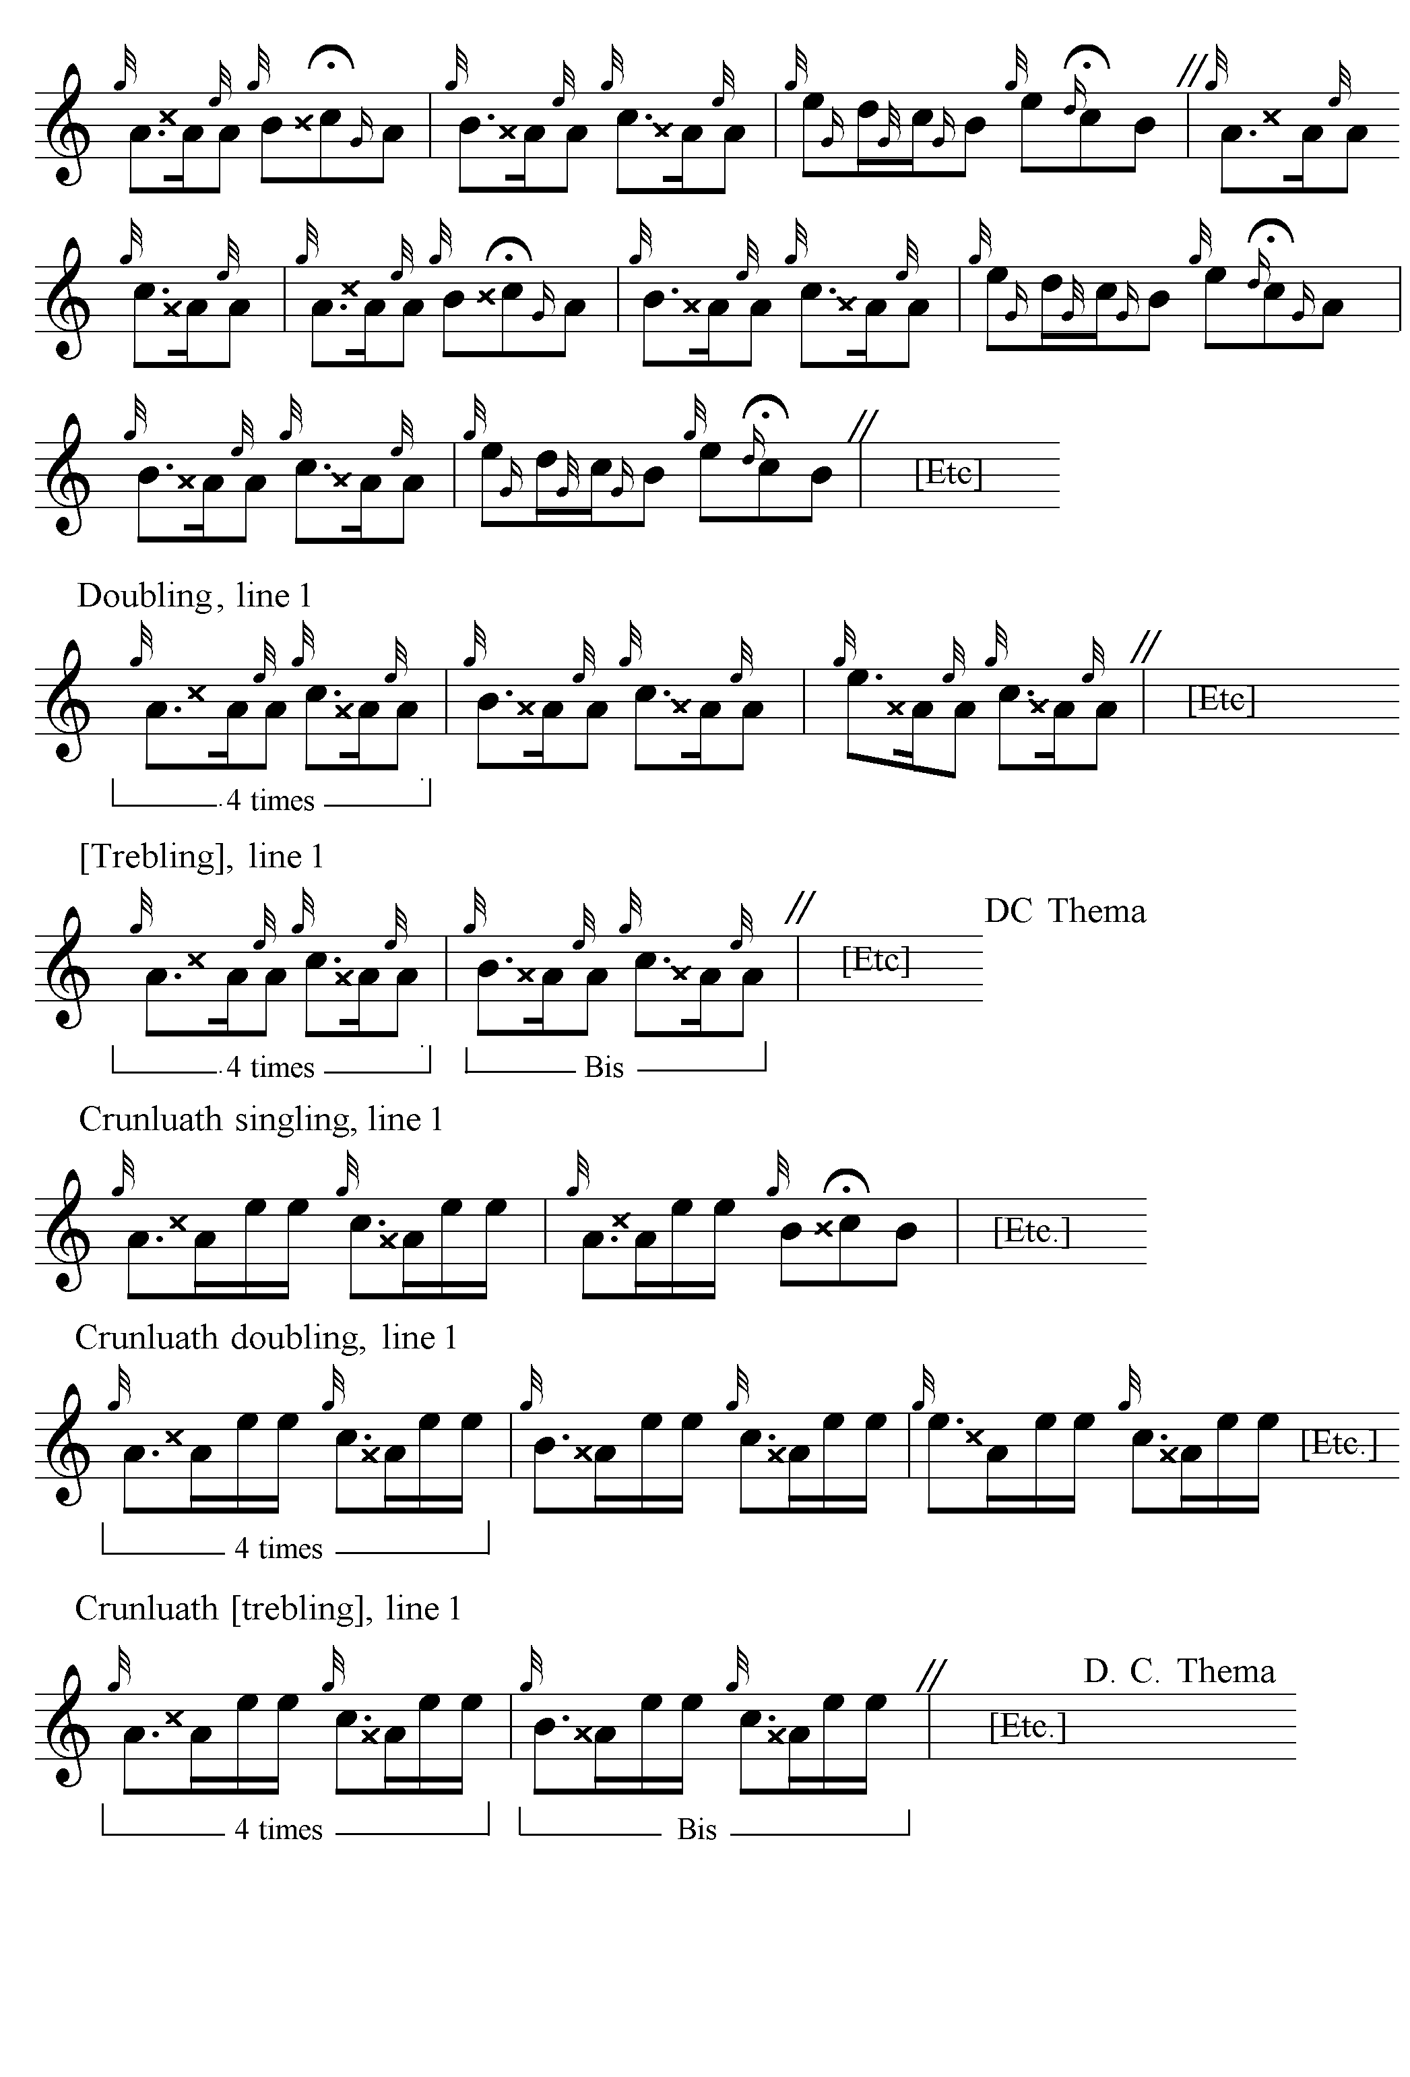

MacKay’s treatment of the BCB figure in the singlings of each variation is interesting, and the way the doublings from Variation 3 onwards extend the tone row up to E as Colin Campbell does, although with rather different effect. The Treblings are indicated in square brackets above because, although they are present in the score, they are not labelled by MacKay as separate movements.

Donald MacKay (the younger, nephew of Angus, friend and advisor of General Thomason) set the tune like this in his “Ballendalloch MS”:
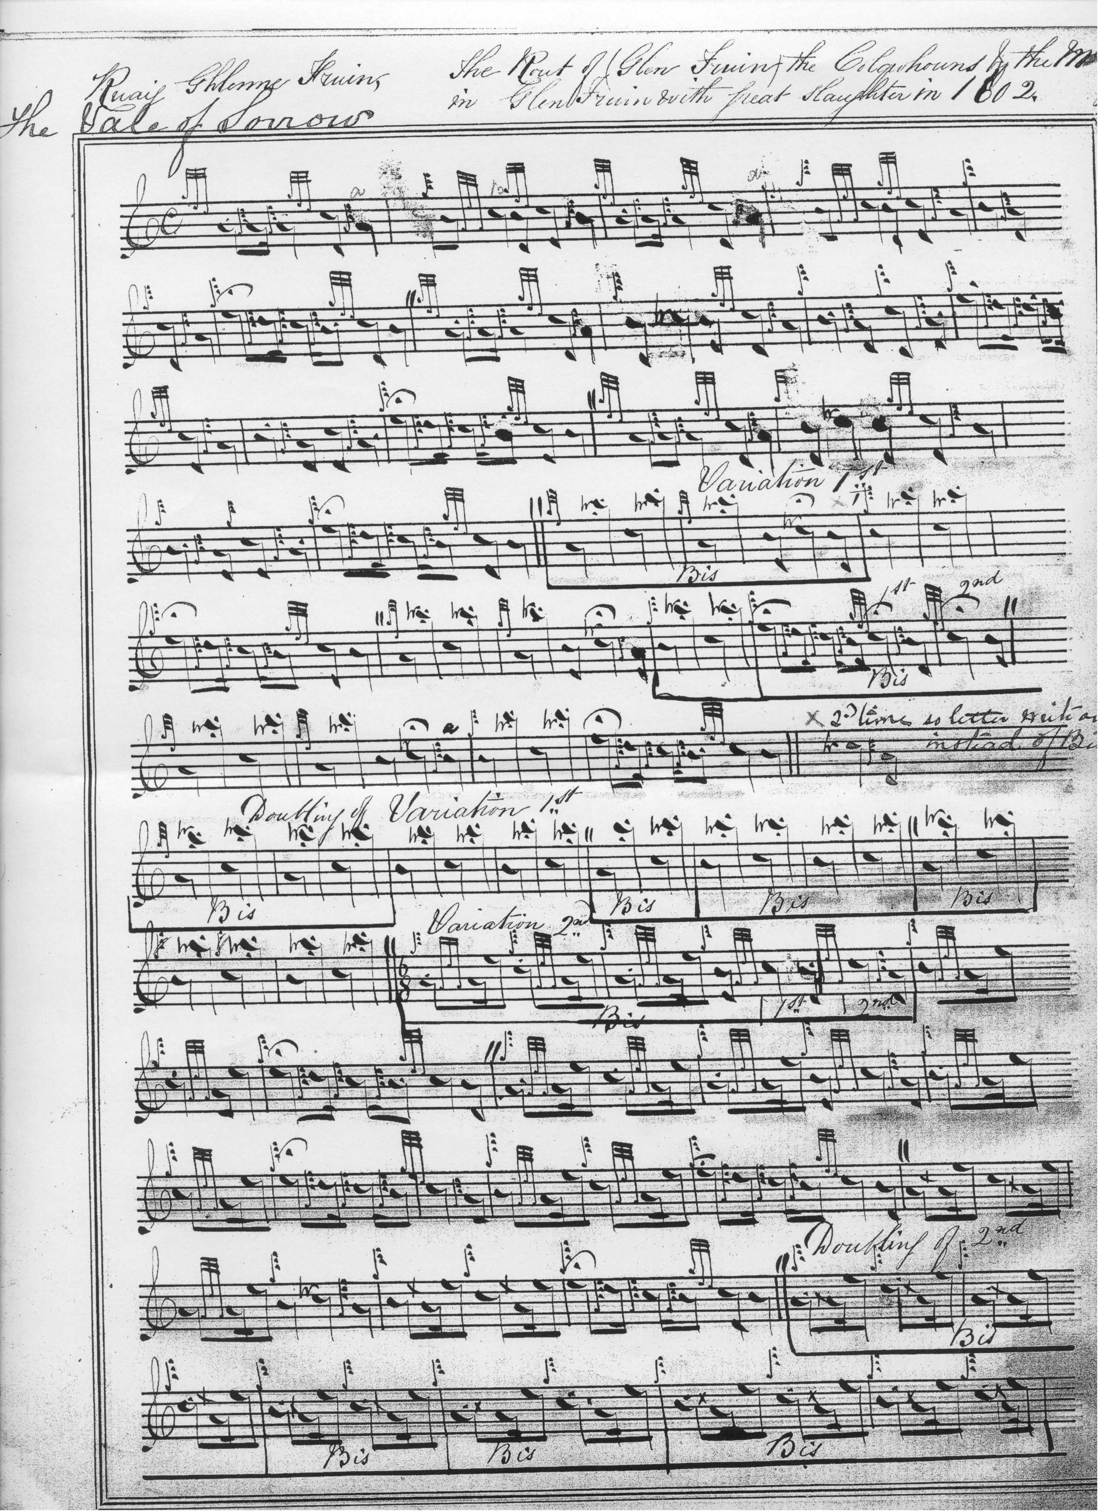

And so on. Donald MacKay has an interesting timing of the ground, with echoes of Donald MacDonald and his uncle Angus MacKay, although considering the piece as a whole, he takes the latter’s route through the tune.

When compiling his score C. S. Thomason cited the manuscripts of both MacDonald and MacKay and the teaching of Donald MacKay (Angus’s nephew), who had been taught the tune by Donald Cameron. Thomason’s score has obvious affinities with Angus MacKay, but at the same time it is the longest and most elaborate of the settings. It includes MacDonald’s Siubhal along with MacKay’s Leumluath and substitutes an a-mach for the trebling in the Taorluath and Crunluath variations. The resulting setting is typical of Thomason’s eclectic style, combining features from a number of different named scores to produce a composite text, often rather pleasingly as here:

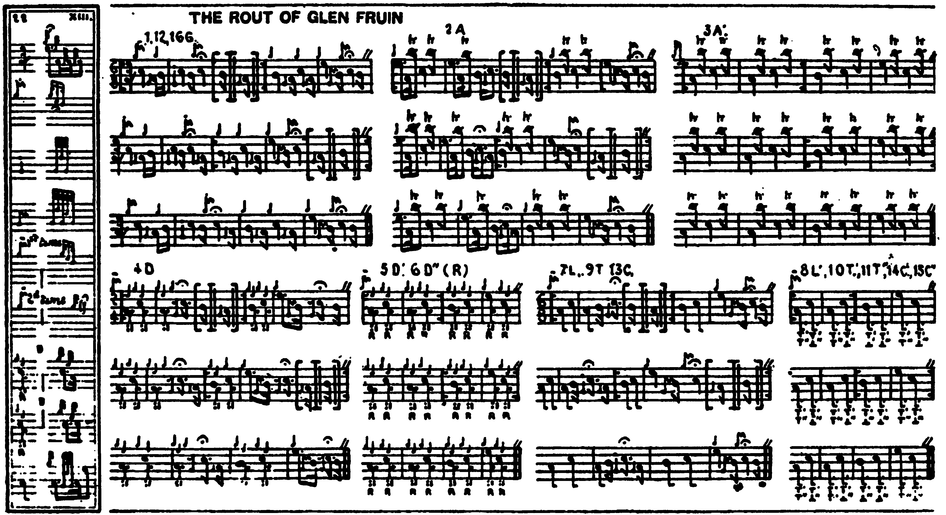

David Glen’s attractive score is closer to Donald MacDonald’s style but his relatively cadence-free ground contrasts interestingly with MacDonald’s and would produce a much more fluent effect (unless one treated some of MacDonald’s cadence groups as cuttings possessing little or no time value, as suggested above). Glen’s approach to the development of the tune is also more urgent, eliminating all of MacDonald’s internal recapitulations of the Ground:

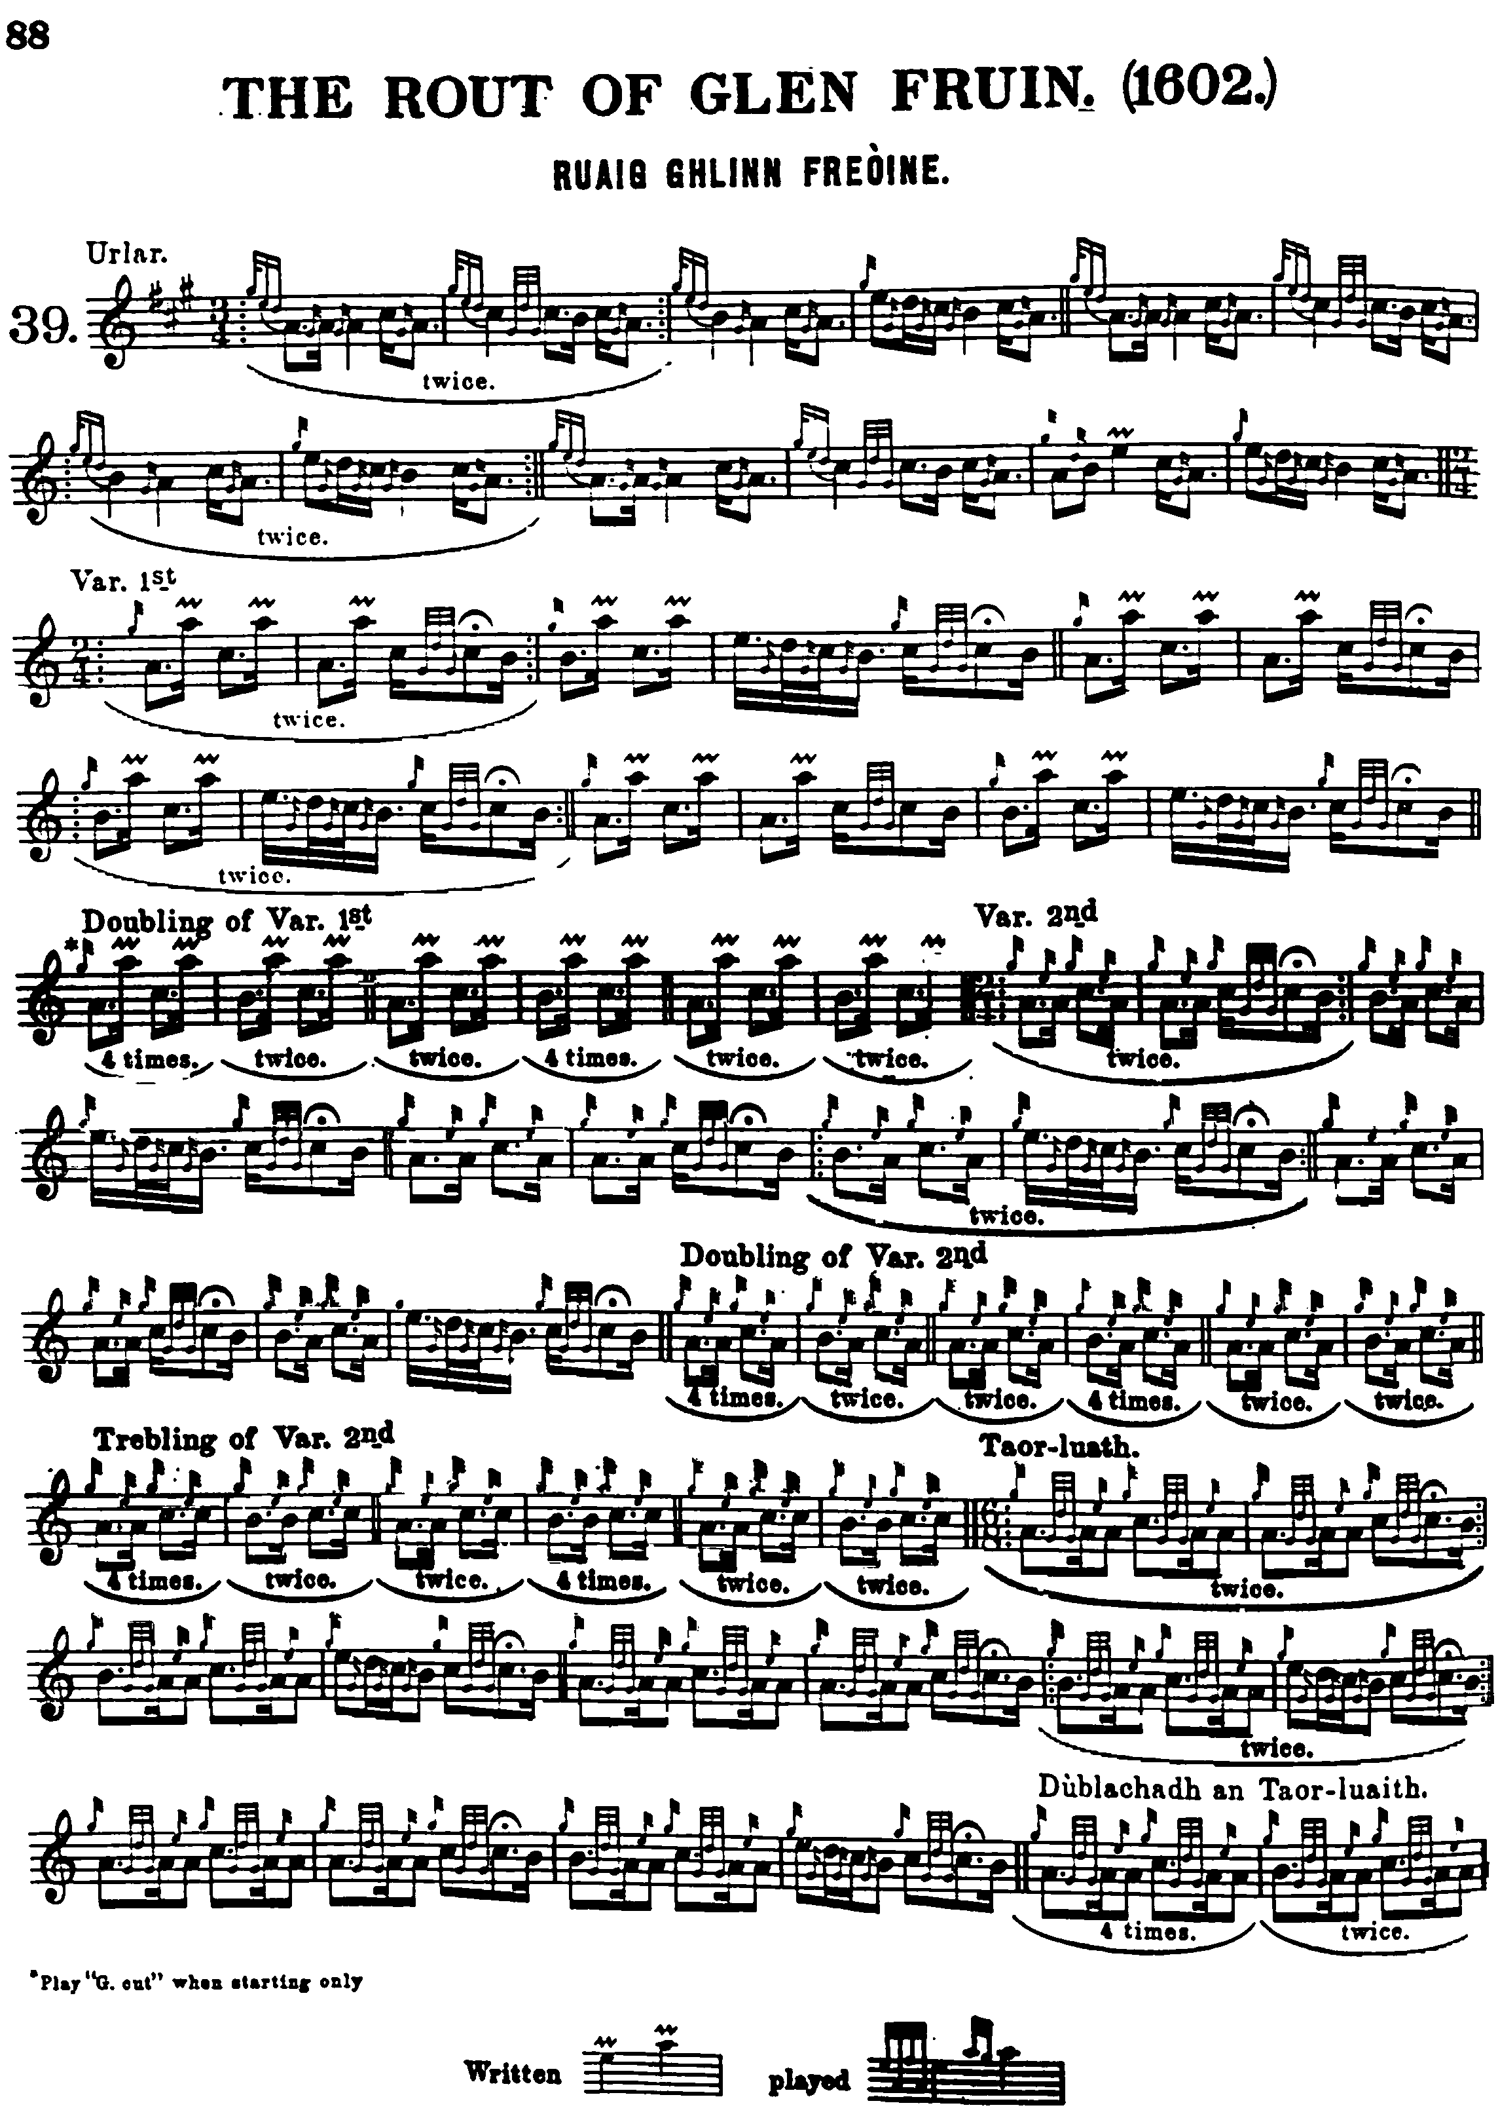

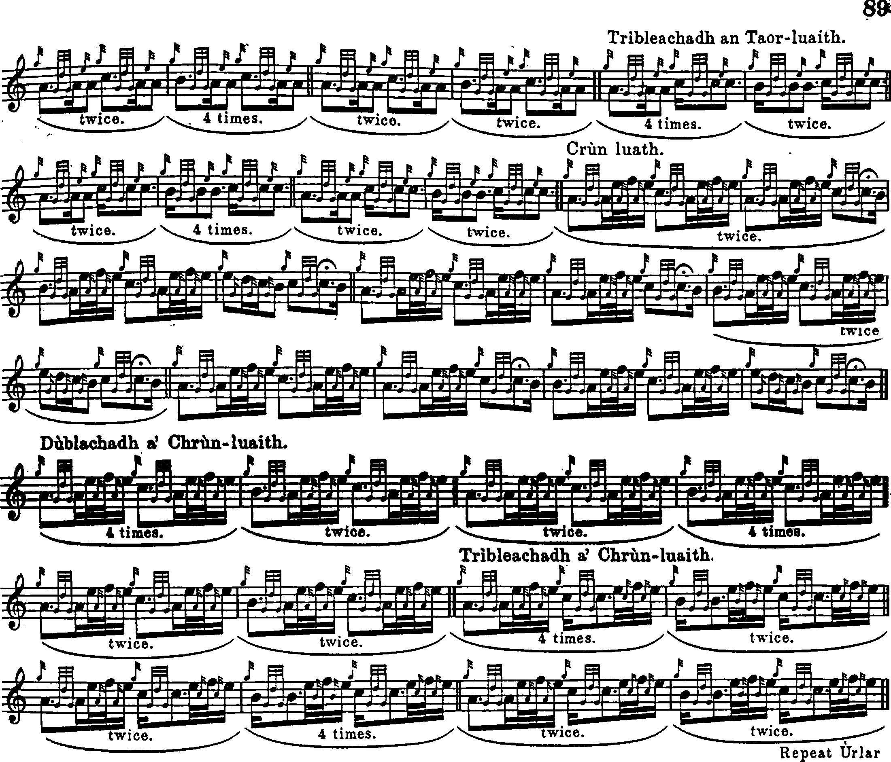

Piobaireachd Society 1st Series. Volume Five of this collection, containing “The Rout of Glenfruin” was published in July 1912 by the Society’s music committee, (whose active members were Capt. Colin MacRae, Major Stewart MacDougall of Lunga, and John Bartholomew of Glenorchard) in consultation with Willie Ross, John MacDougall Gillies, John MacDonald of Inverness, and Sandy Cameron (the younger). A new order of things prevailed following the death of the Society’s first editor, the fiery Major William Stewart of Ensay, who had been very much a one-man band. The Committee which succeeded him had a new remit, to consult more widely with pipers and to seek out old and alternative settings. Ross, MacDonald and MacDougall Gillies were present at the meeting on 29 October 1910 which considered the content and style of Volume V. This resulted in a pleasantly playable setting which, although it has obvious links with MacKay, apparently came down through John Bàn MacKenzie. The Ground, if played as timed, would get round the problem of the obtrusive E cadences; these are reduced to a semi-quaver (halving MacKay’s values) and his 4/4 translated into a more plausible 6/8 time signature. Also worthy of note is the introduction of a series of interesting cadences into the Thumb Variation, which opens the possibility of moving time values between the cadence and the following melody note, very much as Thomason does, perhaps along the lines of:

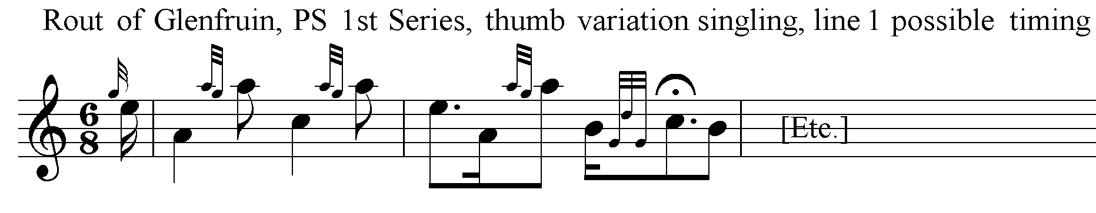

The tune is developed in balanced pairs of variations ending with a crunluath a-mach. There is no instruction to repeat the ground within the tune or at the end. The Society’s notes give the source as follows:

This tune is given as taught to Pipe-Major MacDougall Gillies by John MacGregor, who was piper to Sir Robert Menzies. MacGregor got the tune from John Ban MacKenzie. (PS, first ser., V, v).

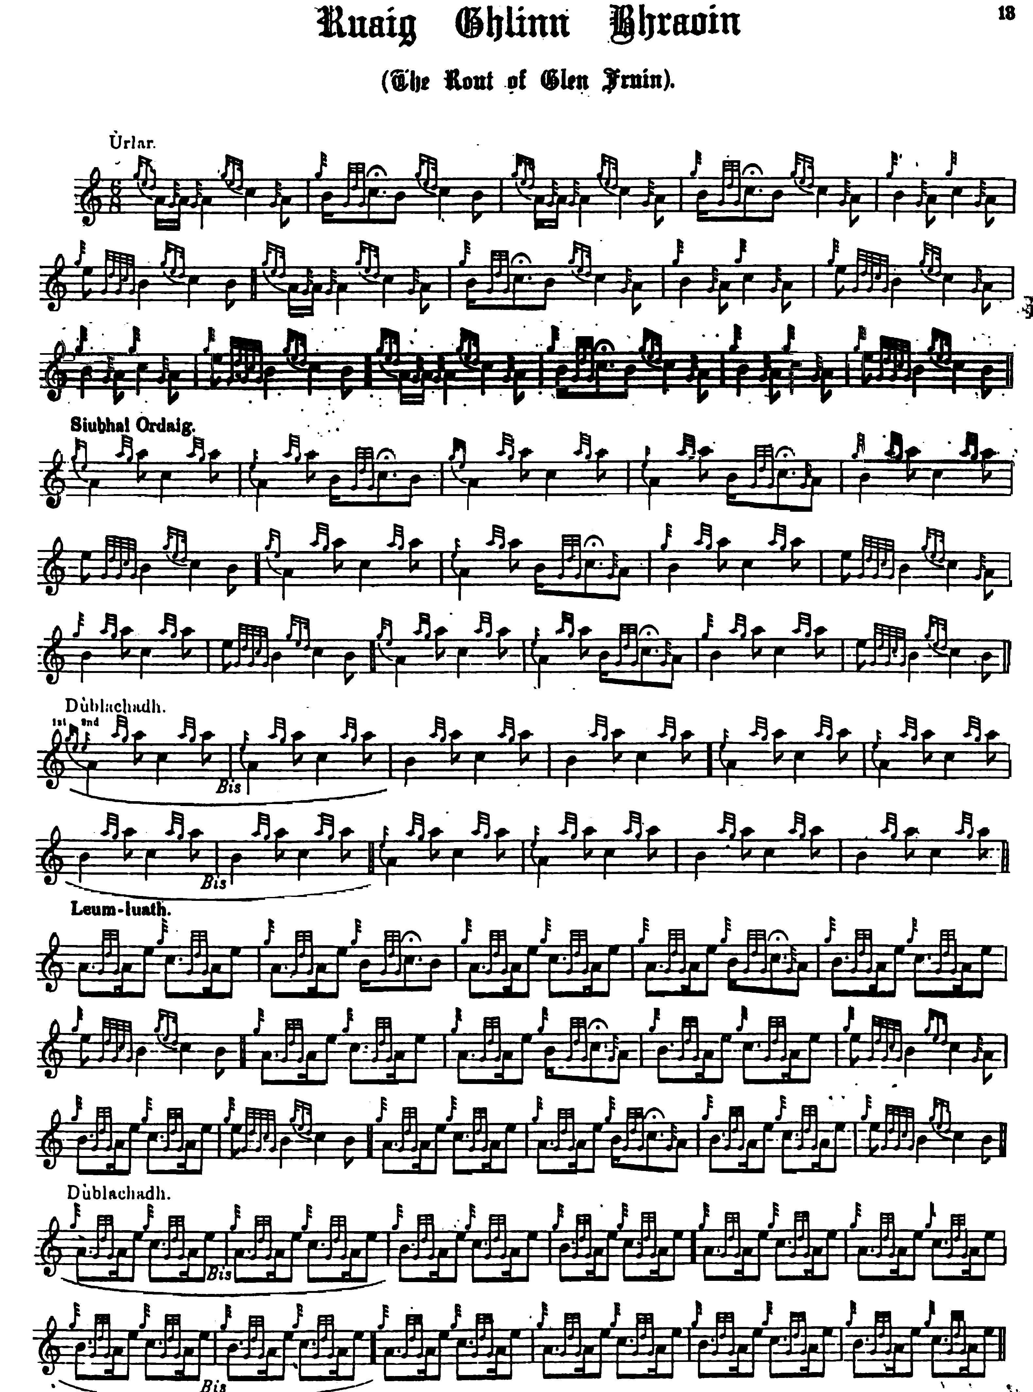

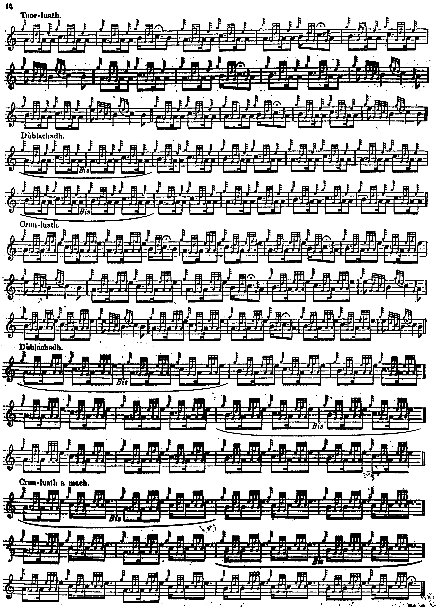

John McLennan sets the tune as follows:

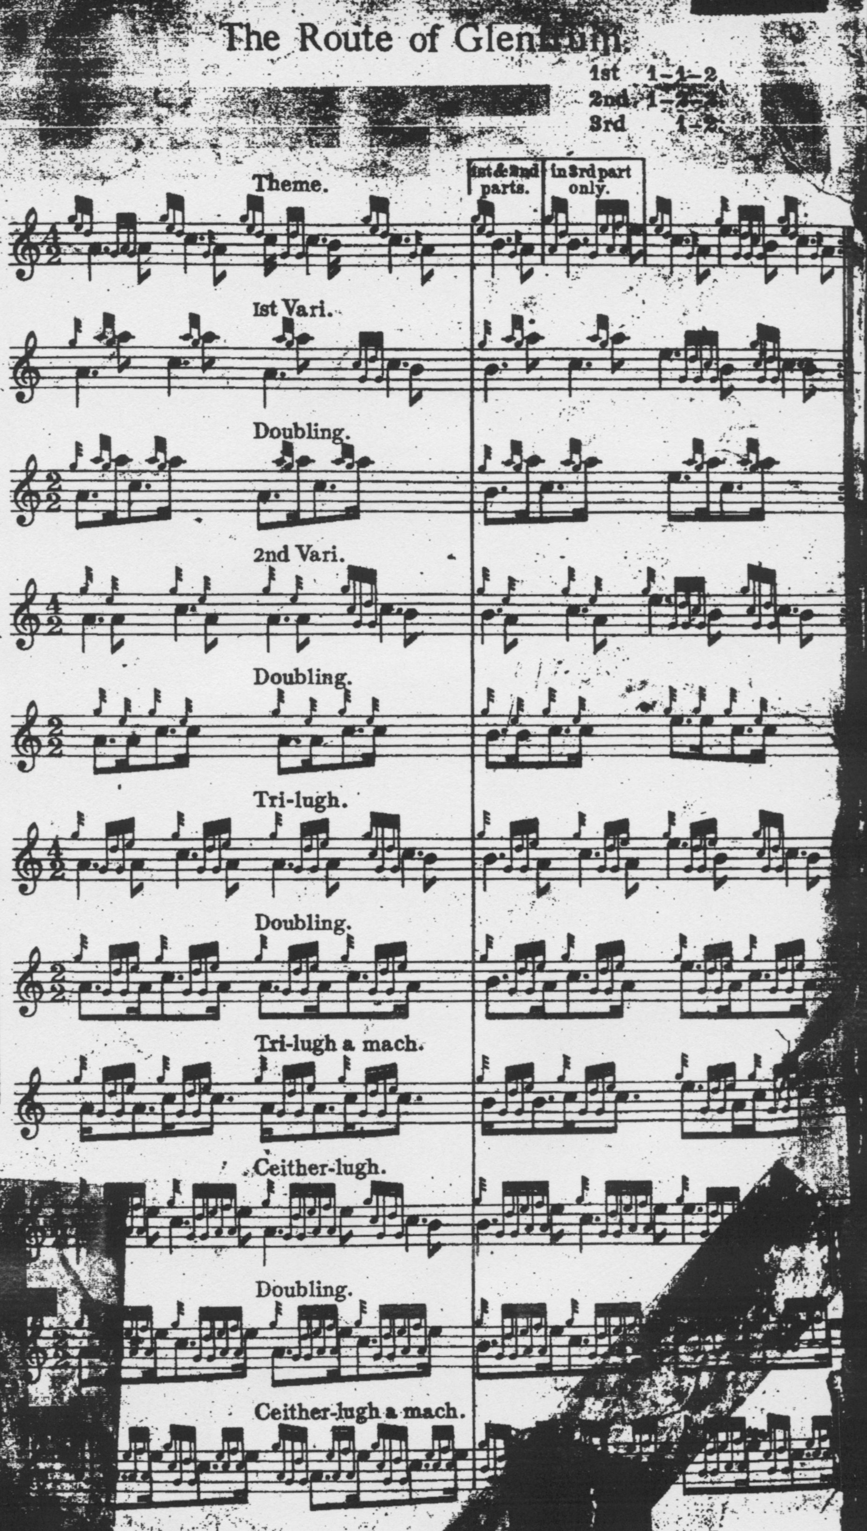

There are obvious affinities here with Donald MacDonald’s setting although with interesting differences in the pointing of the Ground. It is notable, however, that McLennan, like MacDonald, favours the “down” pointing of the opening gesture on A. Also noteworthy is the timing of the Taorluath a-mach, where the movement on A is “cut”—most unusually--as well as those on B and C.

John MacDougall Gillies’s setting preserved in Robert Meldrum’s MS is the same as that in the Piobaireachd Society Collection (first series)--unsurprisingly perhaps given that Gillies was a named source for the latter—and it is not reproduced here.

Commentary:
John Johnston of Coll comments on this tune in General C. S. Thomason’s “Ceol Mor Legends”, as follows:

...the piece is one of the very best, & melancholy in the whole range of piping, known to me at least. I have seen old grey haired men reduced to tears on hearing it, its otherwise a very interesting tune, somewhat longer than ordinary piobaireachds...
No books can convey its charms but actual tuition alone i.e. learned from man to man. (ff.28-29)

The Rev. John Laurie, minister of Rhu, gave an account of the historical events surrounding the Rout of Glenfruin in the entry he wrote for his parish in the New Statistical Account of Scotland (1845) referring to

…an age when armed men were the most prized produce of the soil, when military service was the best payment of mail [i.e. rent], and when the muster-roll occupied the place of the rent-roll. In few parts of Scotland was this more the case than in Dumbartonshire west of the river Leven. The three clans of MacFarlane, MacAulay, and Colquhon, plundered each other, or combined to sweep the low country of its flocks and herds. During the fifteenth and sixteenth centuries, the annals of this district would present a perpetual recurrence of raid and foray, in which rapine and sword united to embroil and impoverish the neighbourhood…Occasionally, other bands of plunderers invaded this district, among whom the more remarkable were the Macgregors, Campbells, Camerons, and Buchanans. One of those murderous conflicts was of sufficient importance to merit a place in the history of the times, and was fought in Glenfruin in February 1603. The older accounts of this transaction bear such marks of partiality as to be little worthy of credit, and the traditions of the district lead us to into great confusion…It seems enough here to state generally that, Alexander Colquhon of Luss having obtained a commission of lieutenancy against ‘thievis, sornaris, and broken men,’ who infested the Lennox, arrived in his country just as it had been invaded by Alistair Macgregor of Glenstrae at the head of 400 men. Colquhon rousing his vassals, and being assisted by some of the neighbouring lairds, and a number of the Dumbarton burghers, came up with the marauders at the farm of Strone, near the head of Glenfruin. A desperate combat gave victory to the Macgregors. Of their opponents 140 men were slain, the laird of Luss narrowly escaping, and many of those that fell being…landed men of good rank. The plunder carried away by the Macgregors consisted of 600 head of cattle, 800 sheep and goats, and 280 horses. The story of some students from Dumbarton having been massacred in cold blood, does not seem to be borne out by the records. The arm of the law, too long suspended from motives of policy or partiality, now descended upon the unhappy Clangregor, more in vengeance than in justice. The whole race were proscribed, their name prohibited, their children exiled from their native land, and it was not until 1774 that the many penal enactments against them, which defaced the statute book, were finally repealed. After the battle of Glenfruin, the country became by degrees more settled.” (Rev. John Laurie, Parish of Row [Rhu], Presbytery of Dumbarton, Synod of Glasgow and Ayr, in New Statistical Account of Scotland, vol.8).

Following a piping competition once in Fife where he had been judging, R. U. Brown
entertained the company after dinner. Carefully settling his beautiful pipe, (nobody tuned up quite so artistically as Bob Brown) he launched into his own version of MacDonald’s setting of this tune. None of the younger pipers knew it, and they listened with growing astonishment and admiration, and when he had finished, they enquired, breathlessly, “what was that?” And Bob, a man of immense presence and charm, half turned and smiled “Why, ‘The Valley of Sorrow’, or (significant pause), ‘The Rout of Glenfruin’”. Few doubted that they were in the presence of greatness.

***

Electronic text © Dr. William Donaldson, Aberdeen, Scotland, October 2001; revised Cambridge, Massachusetts, March 2025.

