Sutherlands’ Gathering

There are settings of this tune in the following manuscript sources:

--Colin Mór Campbell’s “Nether Lorn Canntaireachd”, (“Called Sutherlands Gathering”) i, 153-4;
--Peter Reid’s Manuscript, ff.35-6;
--Angus MacKay’s Manuscript, ii, 45-47 (and in the so-called “Kintarbert MS”, ff.23-5);
--Colin Cameron’s Manuscript, f.121;
--Duncan Campbell of Foss’s Manuscript, ff.2-5;
--Uilleam Ross’s Manuscript, ff.64-66;
--John MacDougall Gillies’s Manuscript, ff.86-7;
--David Glen’s Manuscript, f.60.

And in the following published sources:

--Uilleam Ross, Ross’s Collection, pp. 86-9;
--C. S. Thomason, Ceol Mor, p.39.

The earliest of the settings is that of Colin Mór Campbell. He treats the piece like this:

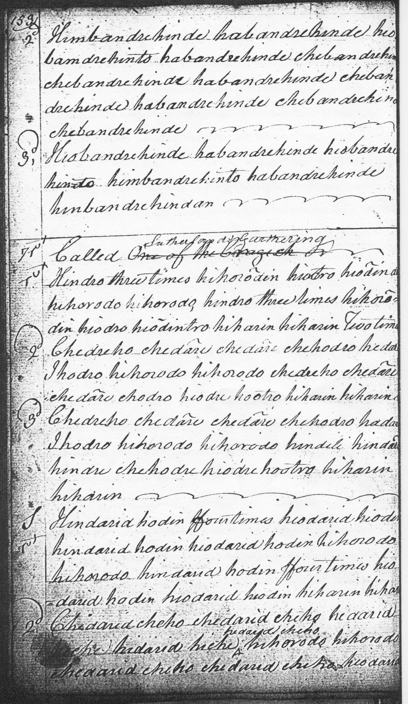
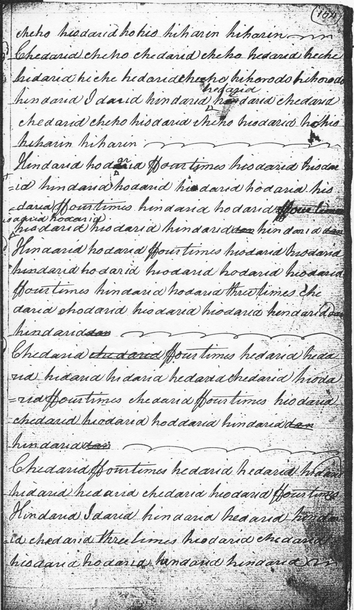
Colin Mór’s score has a ground of three lines of sixteen bars each, proceeding straight to a taorluath singling and doubling. The repeat sign following the double hiharin at the end of line one may be a slip, and has been treated as such in the transcript below, as has the second hohorodo movement and its equivalent in line one of the taorluath variations bringing it down from nine to eight bars. I have adjusted the taorluath doubling to make it to accord more closely with the singling. The Nether Lorn setting stops at the end of the Taorluath doubling. There is no indication that there may be more.

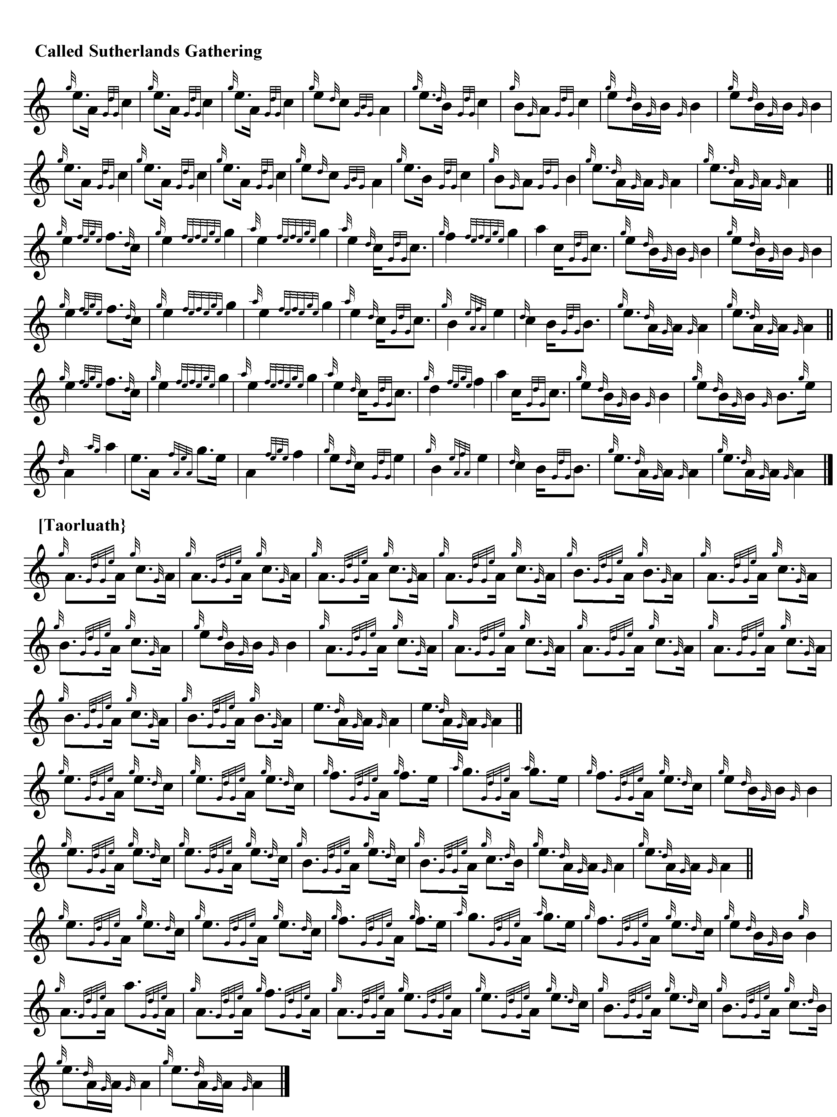
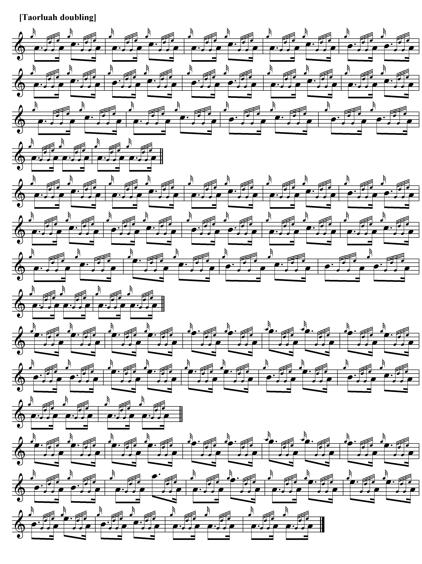

Angus MacKay sets the tune like this:

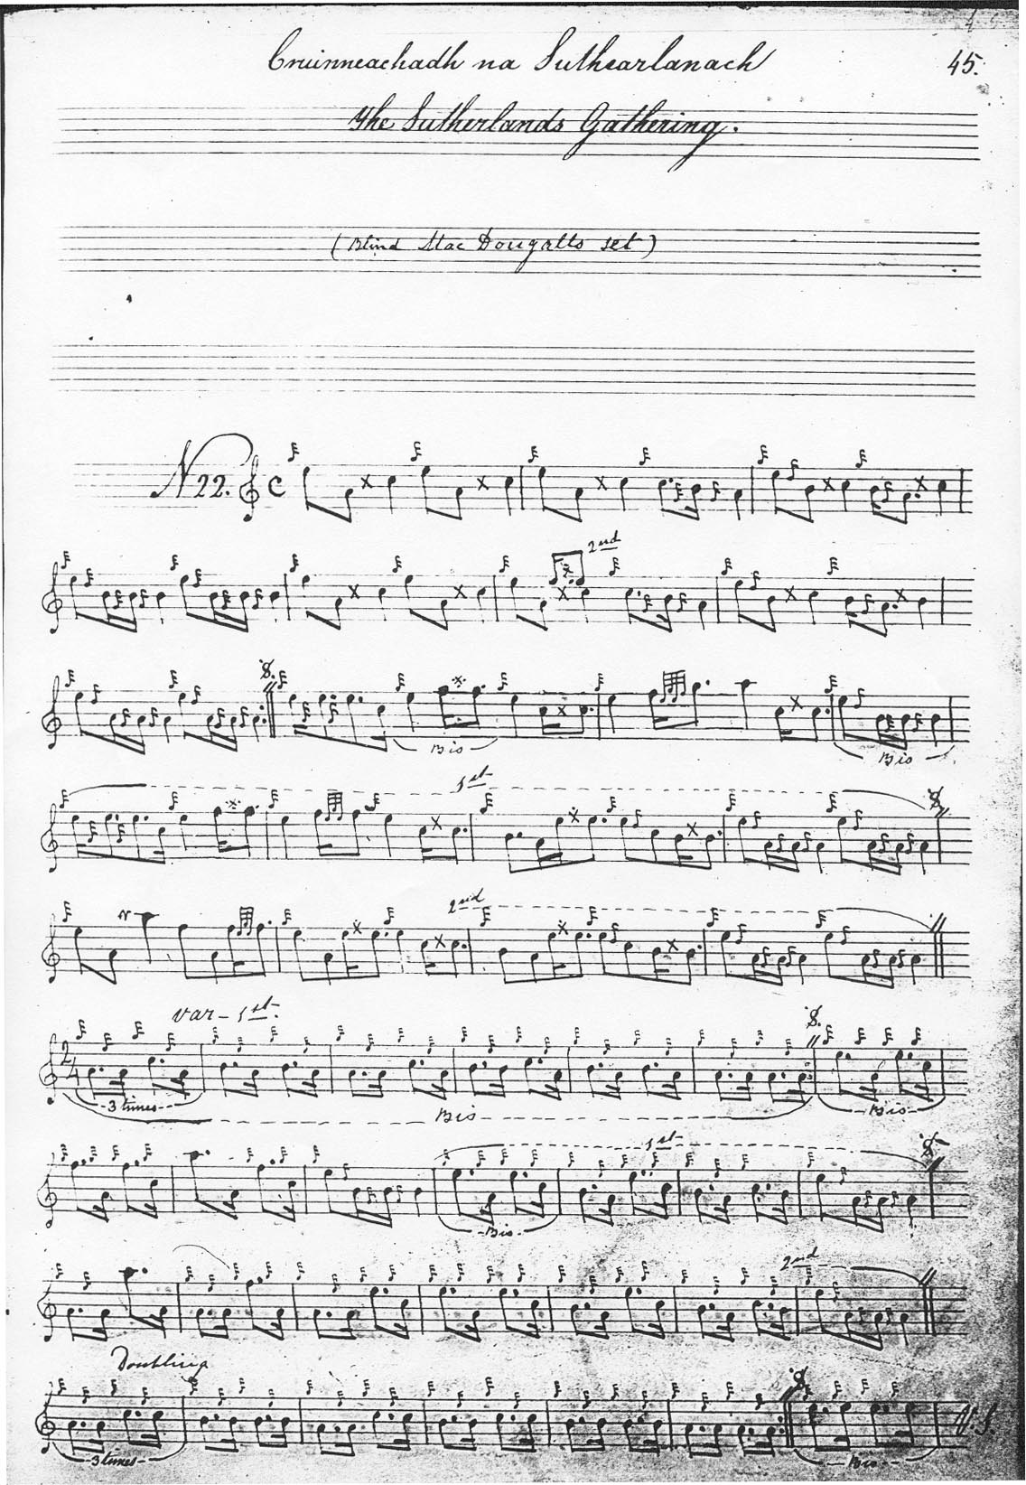
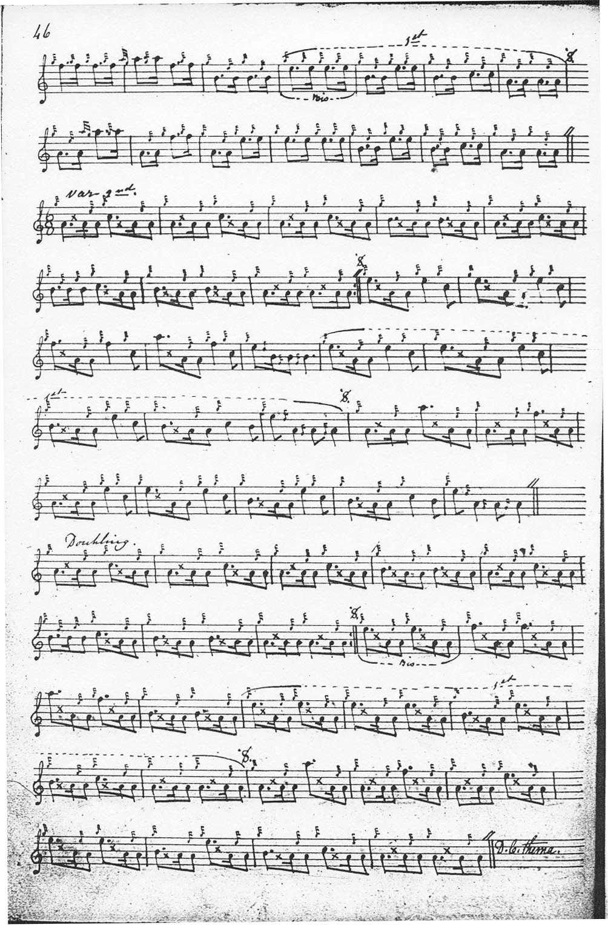
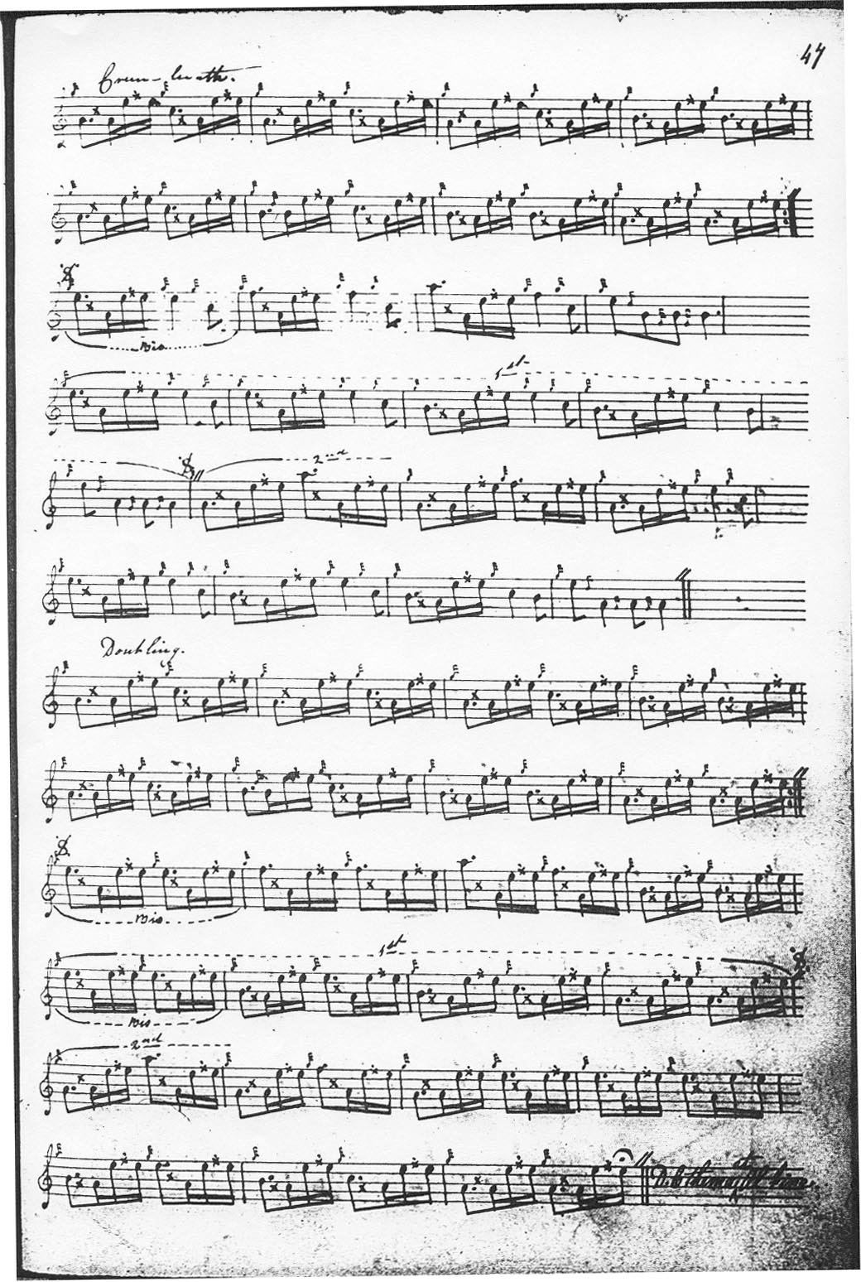

MacKay's text is identified as “Blind MacDougalls set”. Although irregular, this version may well be the most attractive of the available settings, including a rather appealing siubhal.
MacKay develops the tune as follows:

Ground
--line 1, 8 bars repeated;
--line 2, 8 bars repeated;----32 bars in all.
Siubhal
--line 1, 8 bars repeated
--line 2, first repeat 10 bars (it could be made up to a more satisfactory twelve by repeating the double-echo bars--single in the original, which would seem perfectly idiomatic);
--line 2 second repeat 12 bars
Taorluath
--line 1, 8 bars repeated
--line 2, first repeat 10 bars
--line 2, second repeat 12 bars
MacKay repeats the ground at the end of the taorluath variations. The crunluath variations follow a similar pattern to the taorluath. There are structural disparities, therefore, between the variations and the ground. One possible route through the tune is suggested in the accompanying audio file.

Peter Reid sets the tune like this:

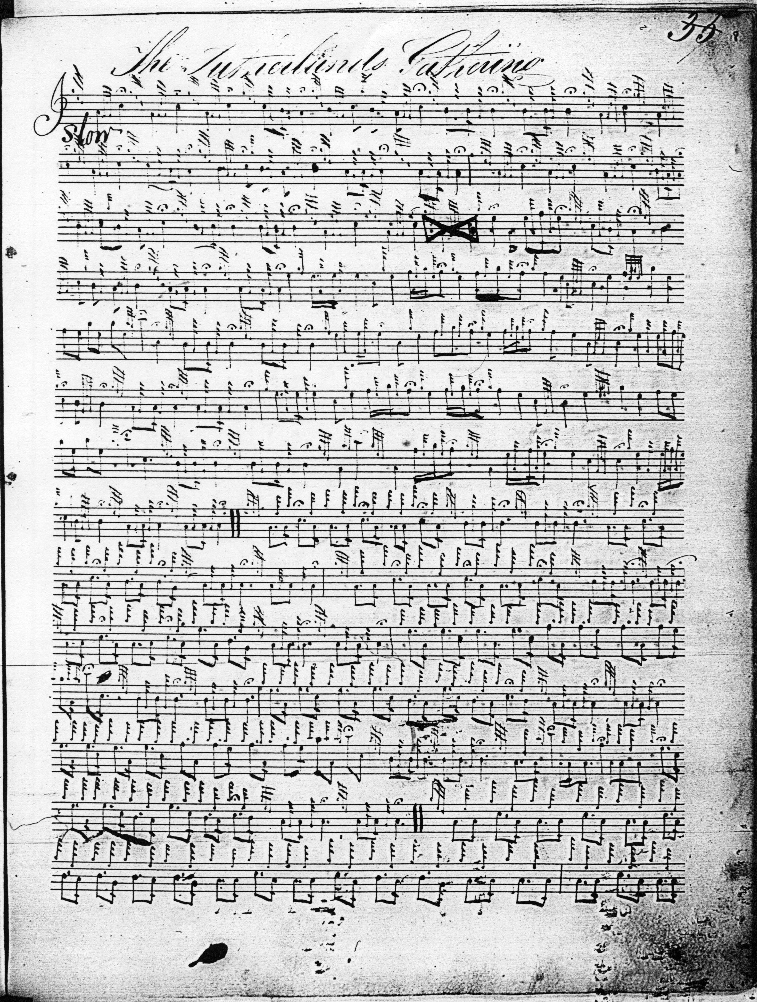
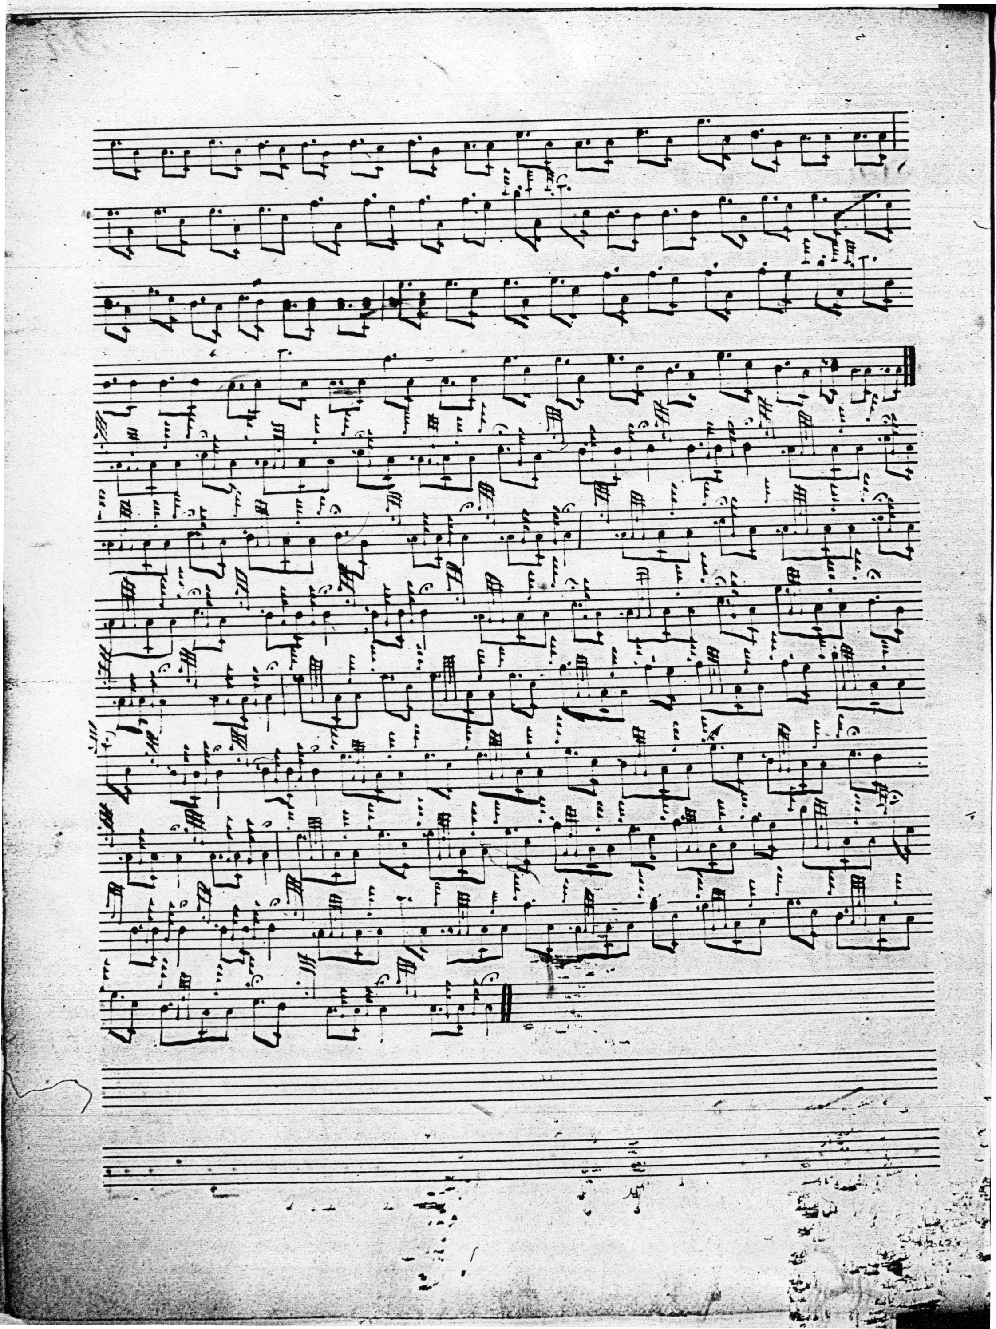

Peter Reid’s idiomatic and pleasing setting is notated without barlines and with only section endings marked, but the structure is clear enough:
Ground:
--line 1, 8 bars repeated;
--line 2, 8 bars in the first repeat; 8 bar in second repeat.
Siubhal
--line 1, 8 bars repeated;
--line 2, first repeat 10 bars; second repeat 10 bars.
Taorluath singling
--line 1, ten bars repeated;
--line 2 first repeat, 13 bars; second repeat, 14 bars.

One peculiarity of Reid’s setting is the curious figure, a succession of six even quavers F-E-high G-E-high G, in bar (and in a similar position in the repeat). Although written as melody notes, these could perhaps be intended to represent a throw from E to high-G, which at least would scan metrically which the phrase, as presently notated, does not.

Colin Cameron’s setting is an abbreviated transcript of MacKay adding nothing significant to its source and is not reproduced here.

Duncan Campbell of Foss supplies the missing double echo movement on B in line two in variation one in his source, which is clearly MacKay, but otherwise contributes little of significance to the piece and his score is not reproduced here.

John MacDougall Gillies’s setting is an outline sketch of Angus MacKay’s, and is not reproduced here.

Uilleam Ross: Ross’s score is simply a typeset transcript of Angus MacKay’s. It is good to have a printed setting of a potentially very nice tune, but Ross seems to have added little of his own; the scores are substantially identical:

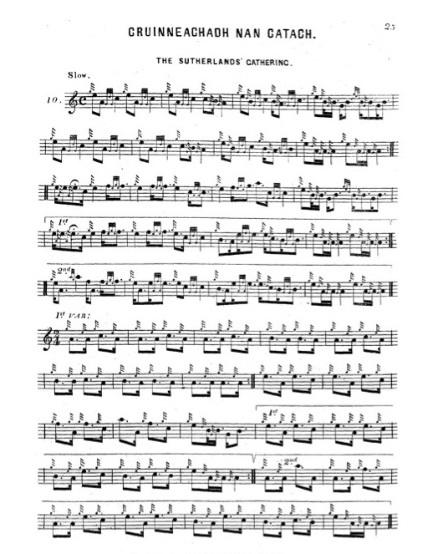

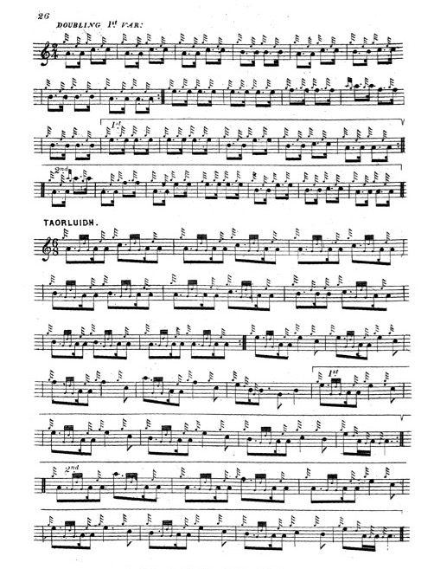

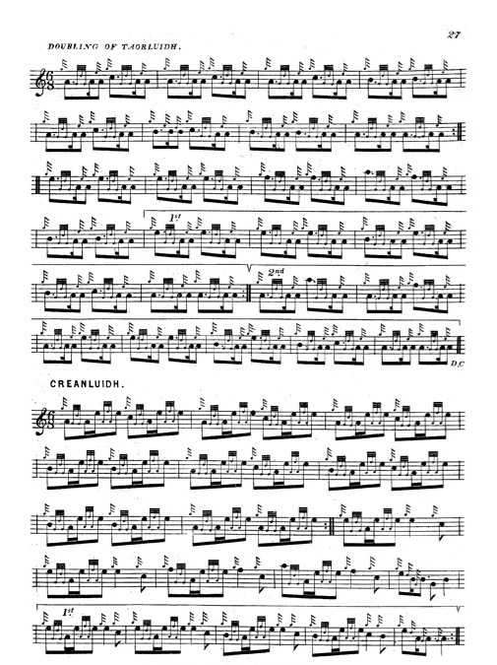

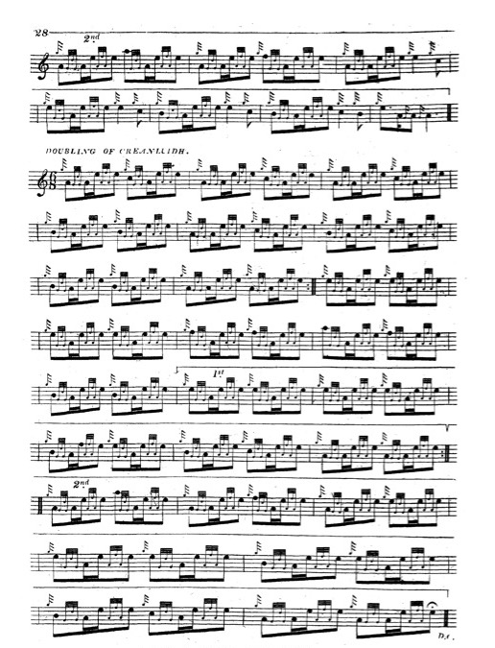
Uilleam Ross’s manuscript setting does not differ significantly from his published version and is not reproduced here.

David Glen’s recension of the ground offers an attractive solution to the notational problems posed in the other scores. He divides the ground into four lines of four bars each, giving the ground only, taking his variations, as noted, from Uilleam Ross:

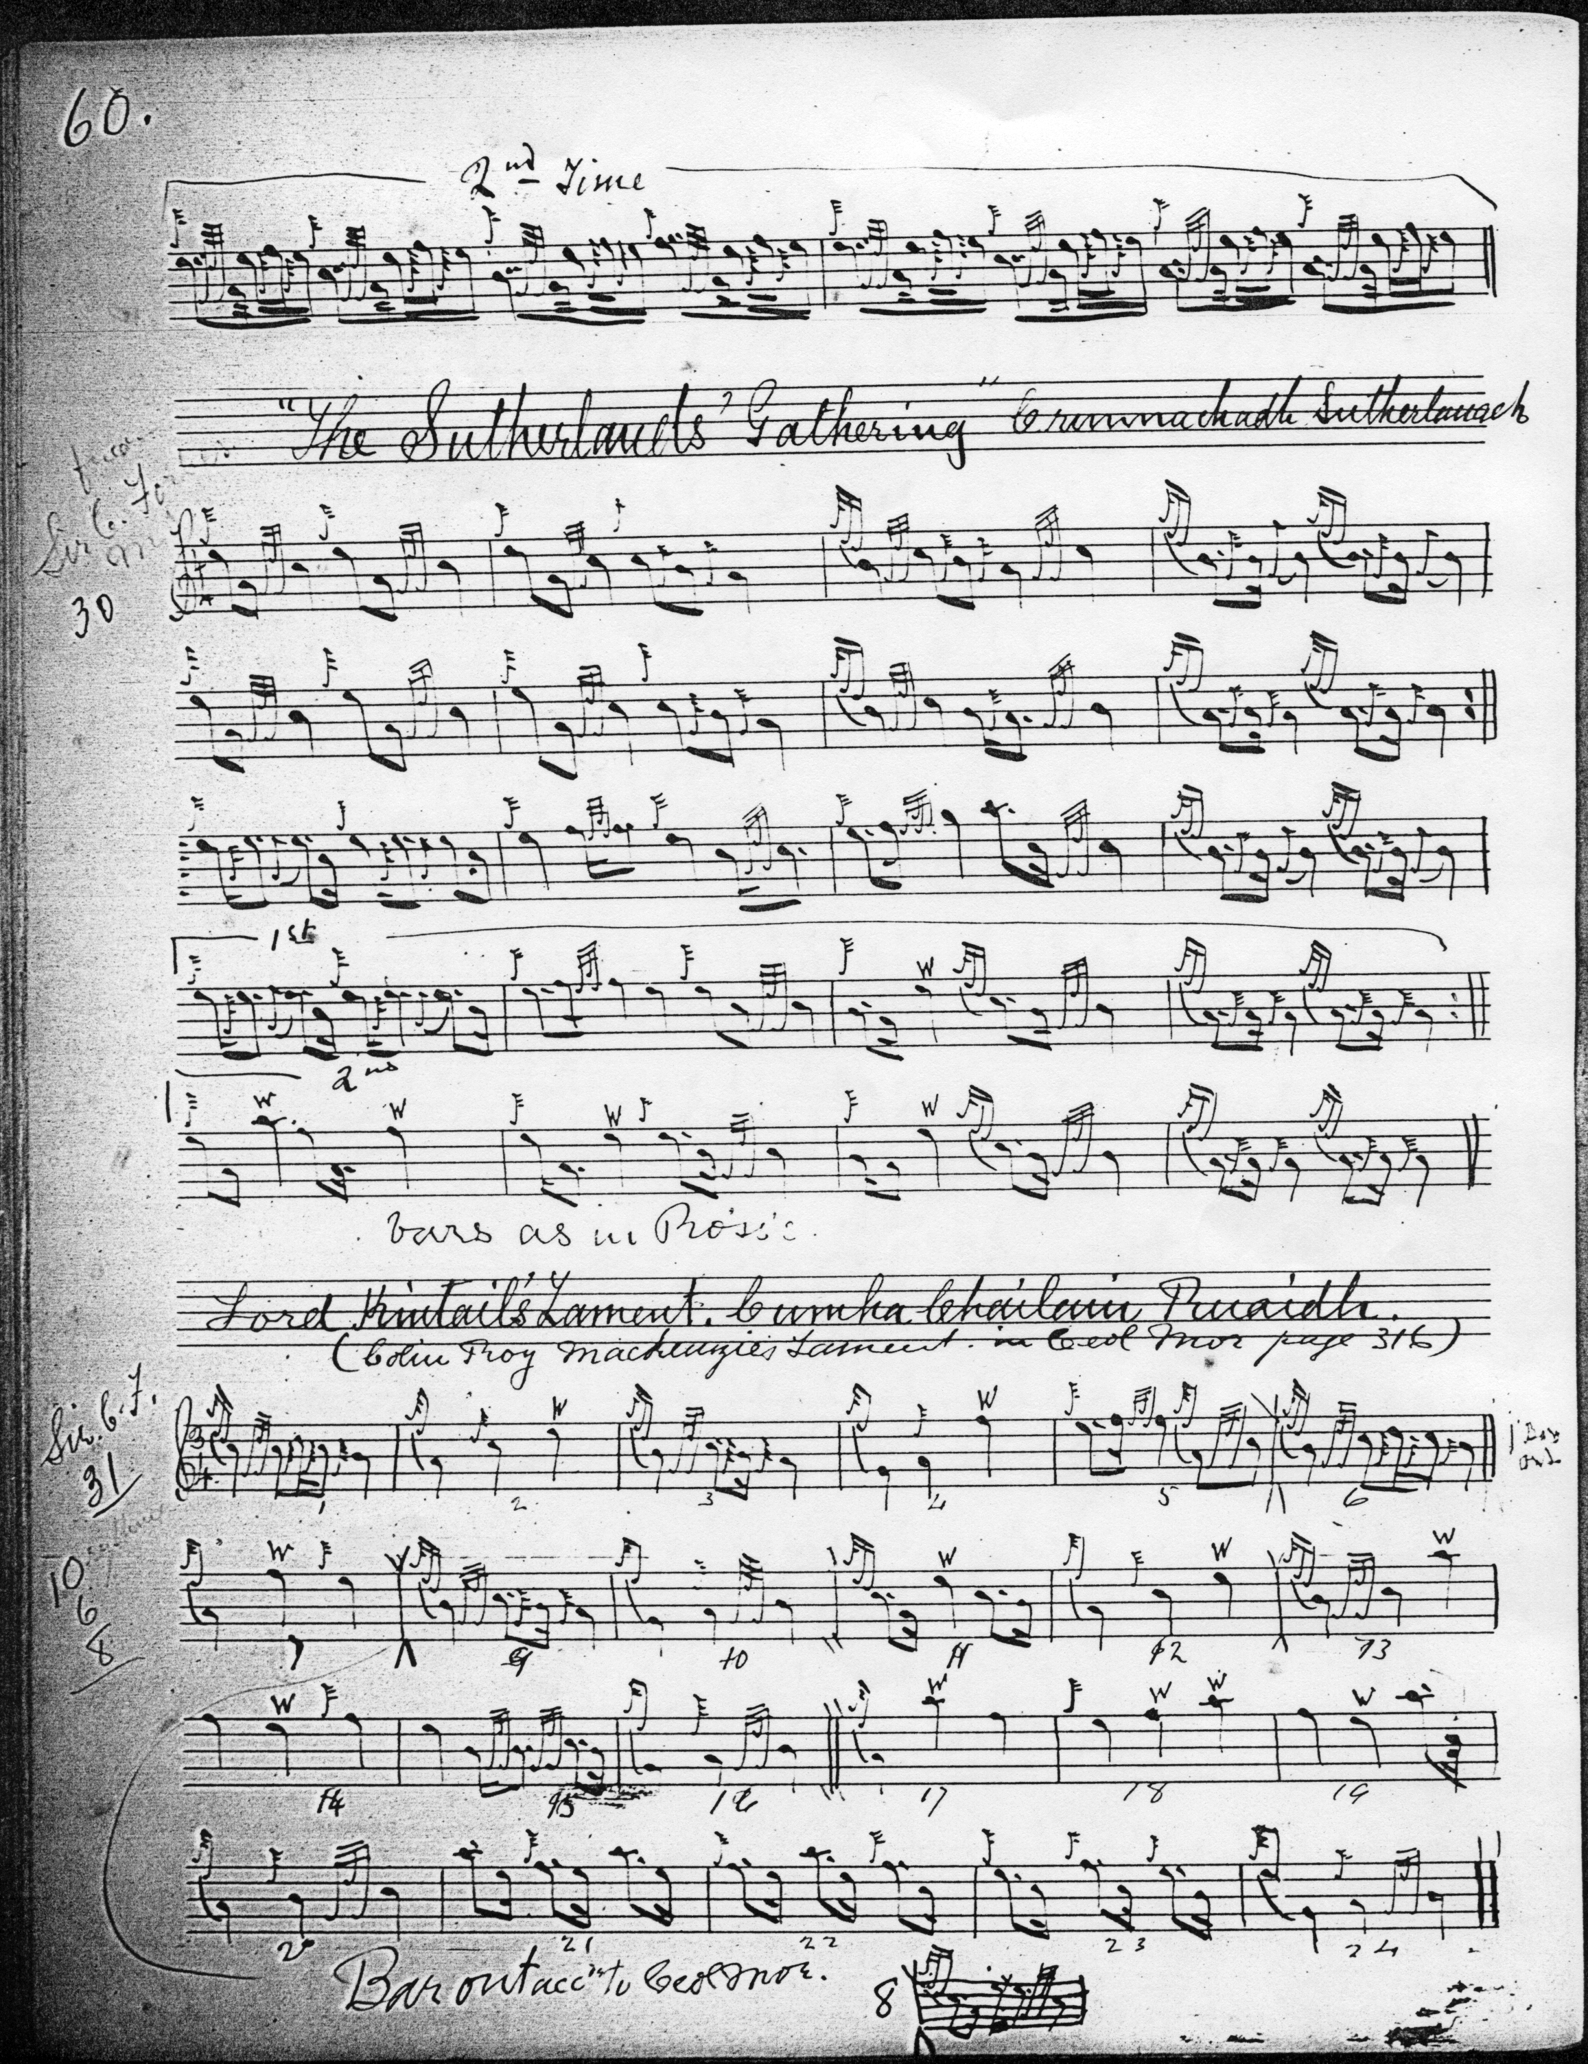

Commentary:

“Sutherland’s Gathering” is a good example of the tendency of tunes to occur as members of extensive “tune families”, interlinking nets of variants on a tonally-similar theme sometimes bearing the same, sometimes different, titles. Here there is a closely related piece with the title “Sutherlands March” recorded in the Nether Lorn Canntaireachd, i, 78-80; and in Donald MacDonald’s MS, ff.132-8. There are published settings of it in C. S. Thomason’s Ceol Mor, p.*327 with the title “MacLean of Coll’s Triumph”; and in David Glen’s Music of the Clan MacLean, pp.22-27, with the title “MacLean of Coll Putting his Foot on the Neck of his Enemies”, these latter settings being particularly attractive.

The Piobaireachd Society opted to make Simon Fraser’s setting of “The Sutherlands’ Gathering” their “A” text (Second Series, xiv, 449-454). Fraser emends the metrical shortcomings of his source (which is probably Angus MacKay filtered through Uilleam Ross’s published book) by repeating the double echo movements on B and A in appropriate places, as a sensible person should, but he weakens MacKay’s attractive tone row, and tacks on an a crunluath a mach movement which nobody else has got. This adds little to the tune for the thoughtful performer. It was a dubious decision to prefer Fraser to, say, an edited version of Angus MacKay, given the serious doubts about Fraser’s sources. Interested readers will find more on this topic in The Highland Pipe and Scottish Society 1750-1950ß, pp.351-2, 408-14.

The Sutherlands were an extended kindred in the far northern mainland of Scotland, where they were involved in frequent collisions with their neighbours the MacKays, and the Sinclairs of Caithness. Their chief residence at Dunrobin later became the seat of the notorious Duke of Sutherland one of the chief movers in the Highland Clearances.

There is a famous story told of him, how when he was trying to recruit for the Crimean War (1853-56) he was bluntly told “since you have preferred sheep to men, let sheep defend you.”

A two-hundred-foot-high statue of the duke, paid for by a “voluntary” subscription amongst the remaining tenants, still towers—despite several attempts to blow it up--over the little town of Golspie.

* * *

Electronic text © Dr William Donaldson, Cambridge, Massachusetts, 11th September 2022

