Welcome Johnny Back Again

There are settings of this tune in the following manuscript sources:
--Colin Mór Campbell’s Nether Lorn Canntaireachd, ii, 138-41;
--Angus MacKay’s MS, ii, 1-2 (and in the so-called “Kintarbert MS” ff.1-2);
--Duncan Campbell of Foss’s MS, ff.1-2;
--Uilleam Ross’s MS, ff.55-56;
--John MacDougall Gillies’s MS, f.36;
--David Glen’s MS, ff.30-31;
--McLennan Papers, f.12.

And in the following published source:
--C. S. Thomason, Ceol Mor, p.304.

This is quite a widely diffused tune, preserved in many of the old manuscripts.

Colin Mór sets the tune like this:

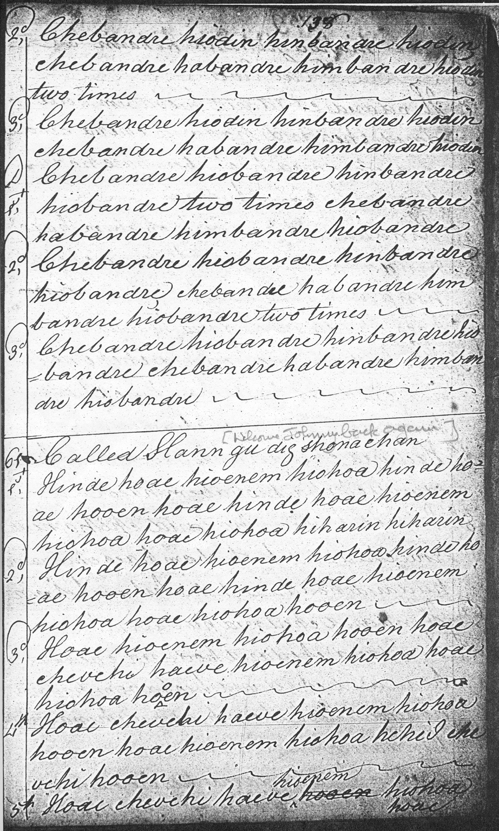

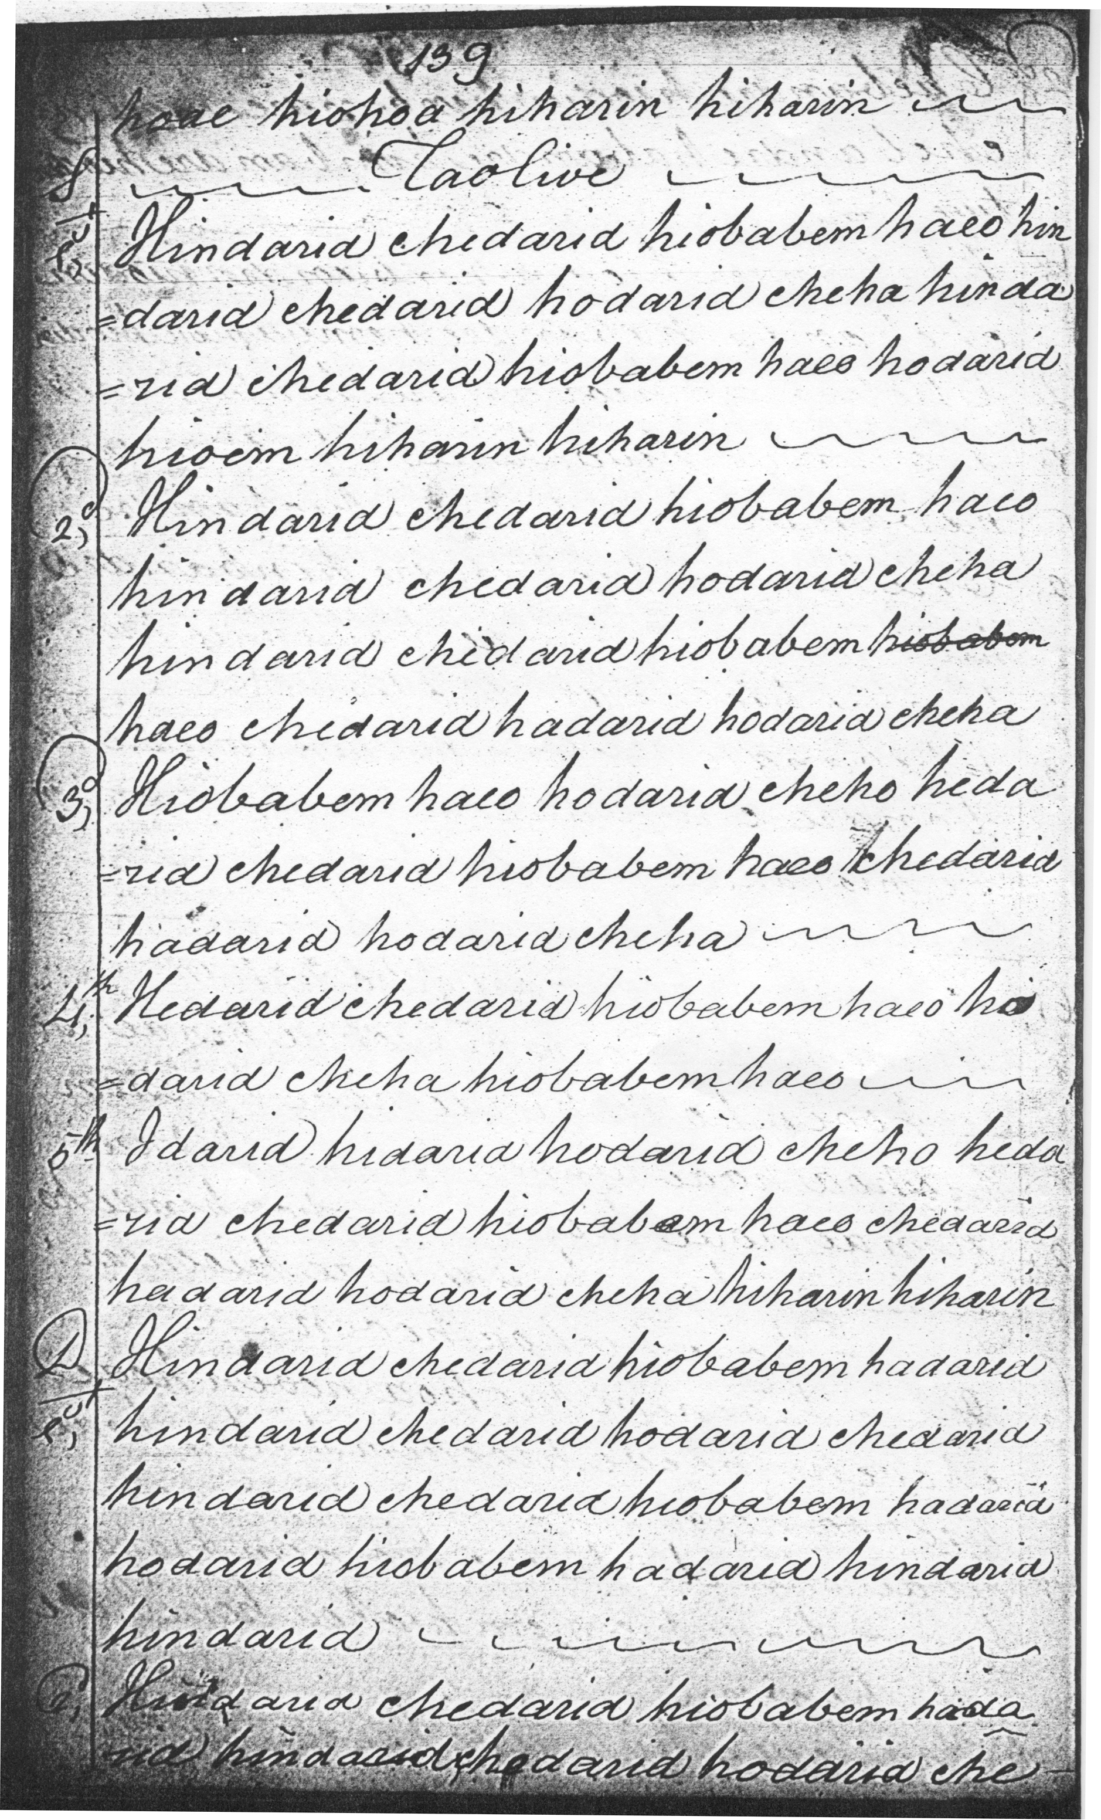
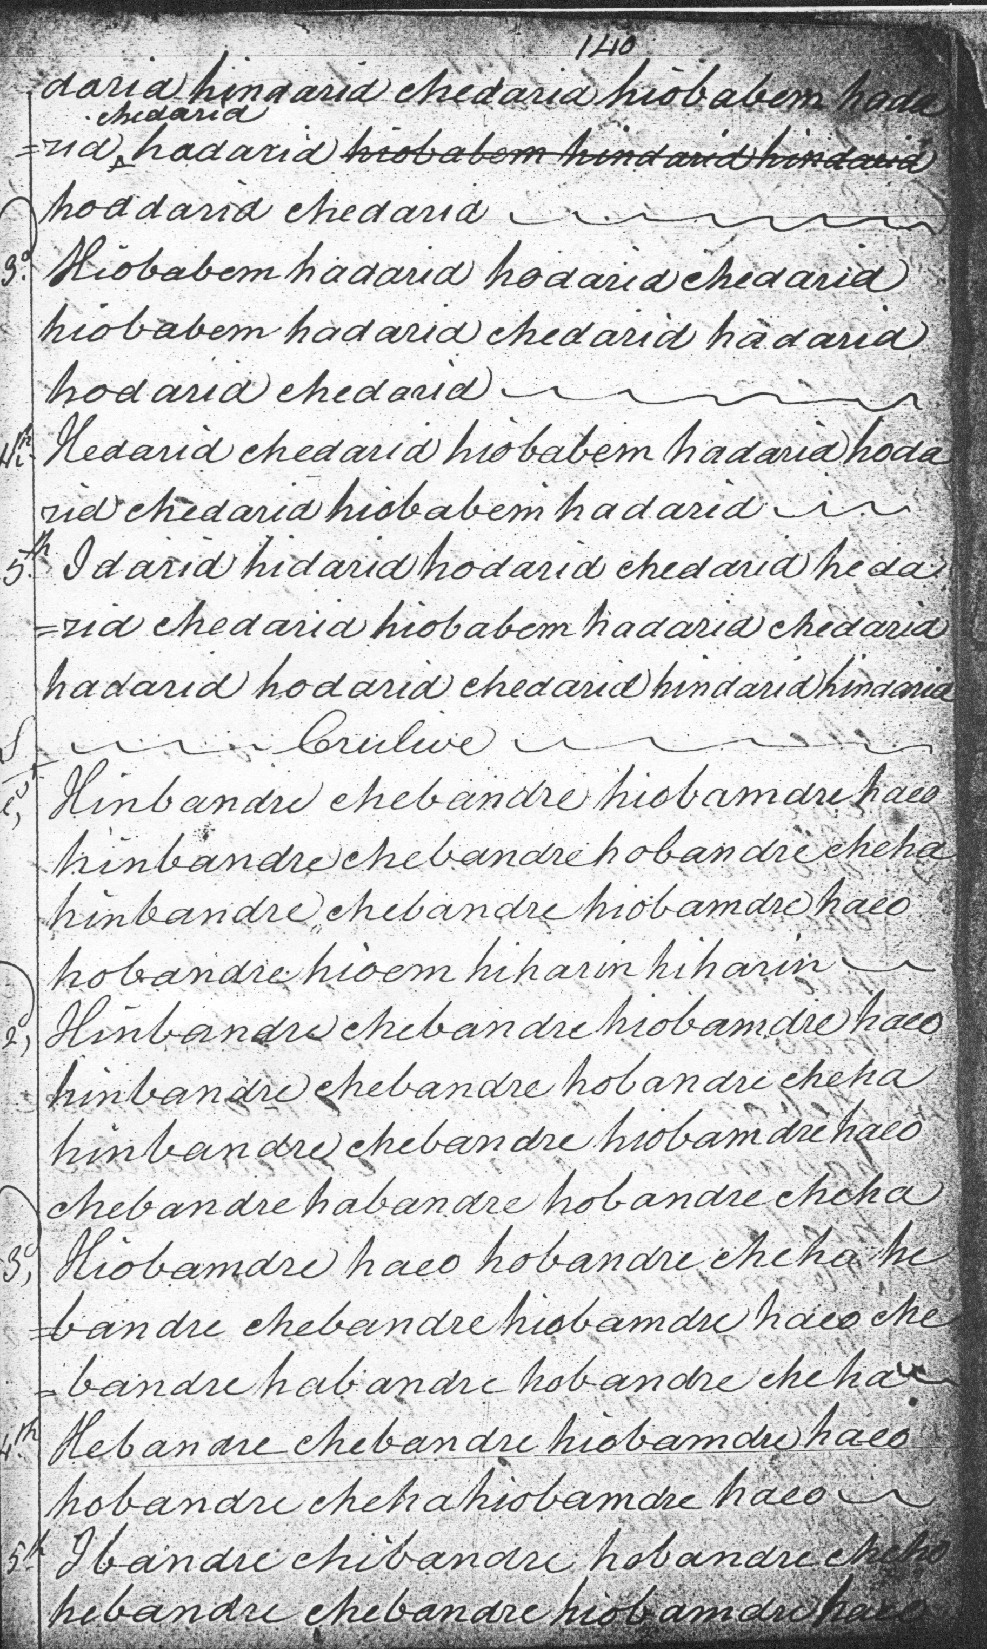
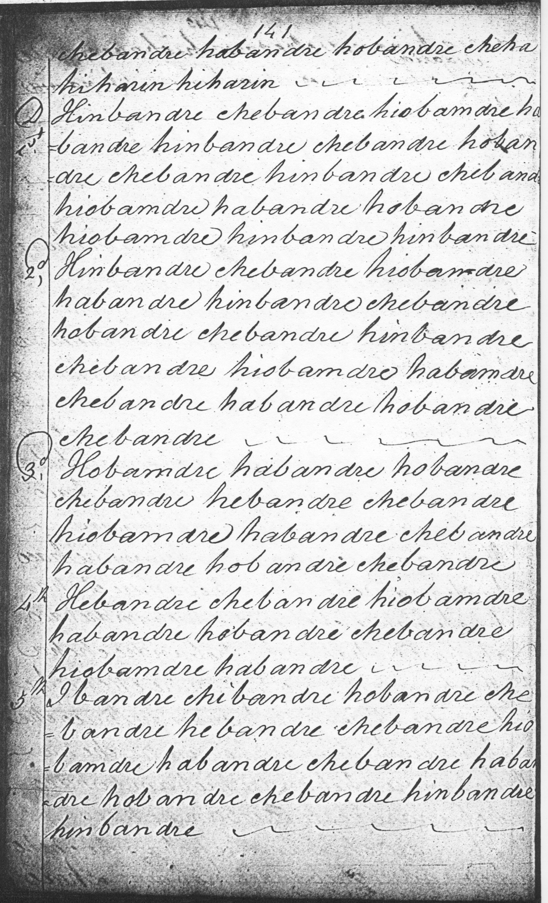

The strings of linking triplets at the heart of this piece seem to have created notational difficulties for several of the early editors. Here in Colin Mór we find line endings rather uncertainly marked. The line numbering seems clearly approximate, reflecting the problems of fitting such a tune accurately on to the written page. An overall pattern can be deduced readily enough, however: lines of eight bars each, a first line very similar to Angus MacKay’s, and two further lines in which the tune is developed rather more freely than in MacKay; roughly as follows:

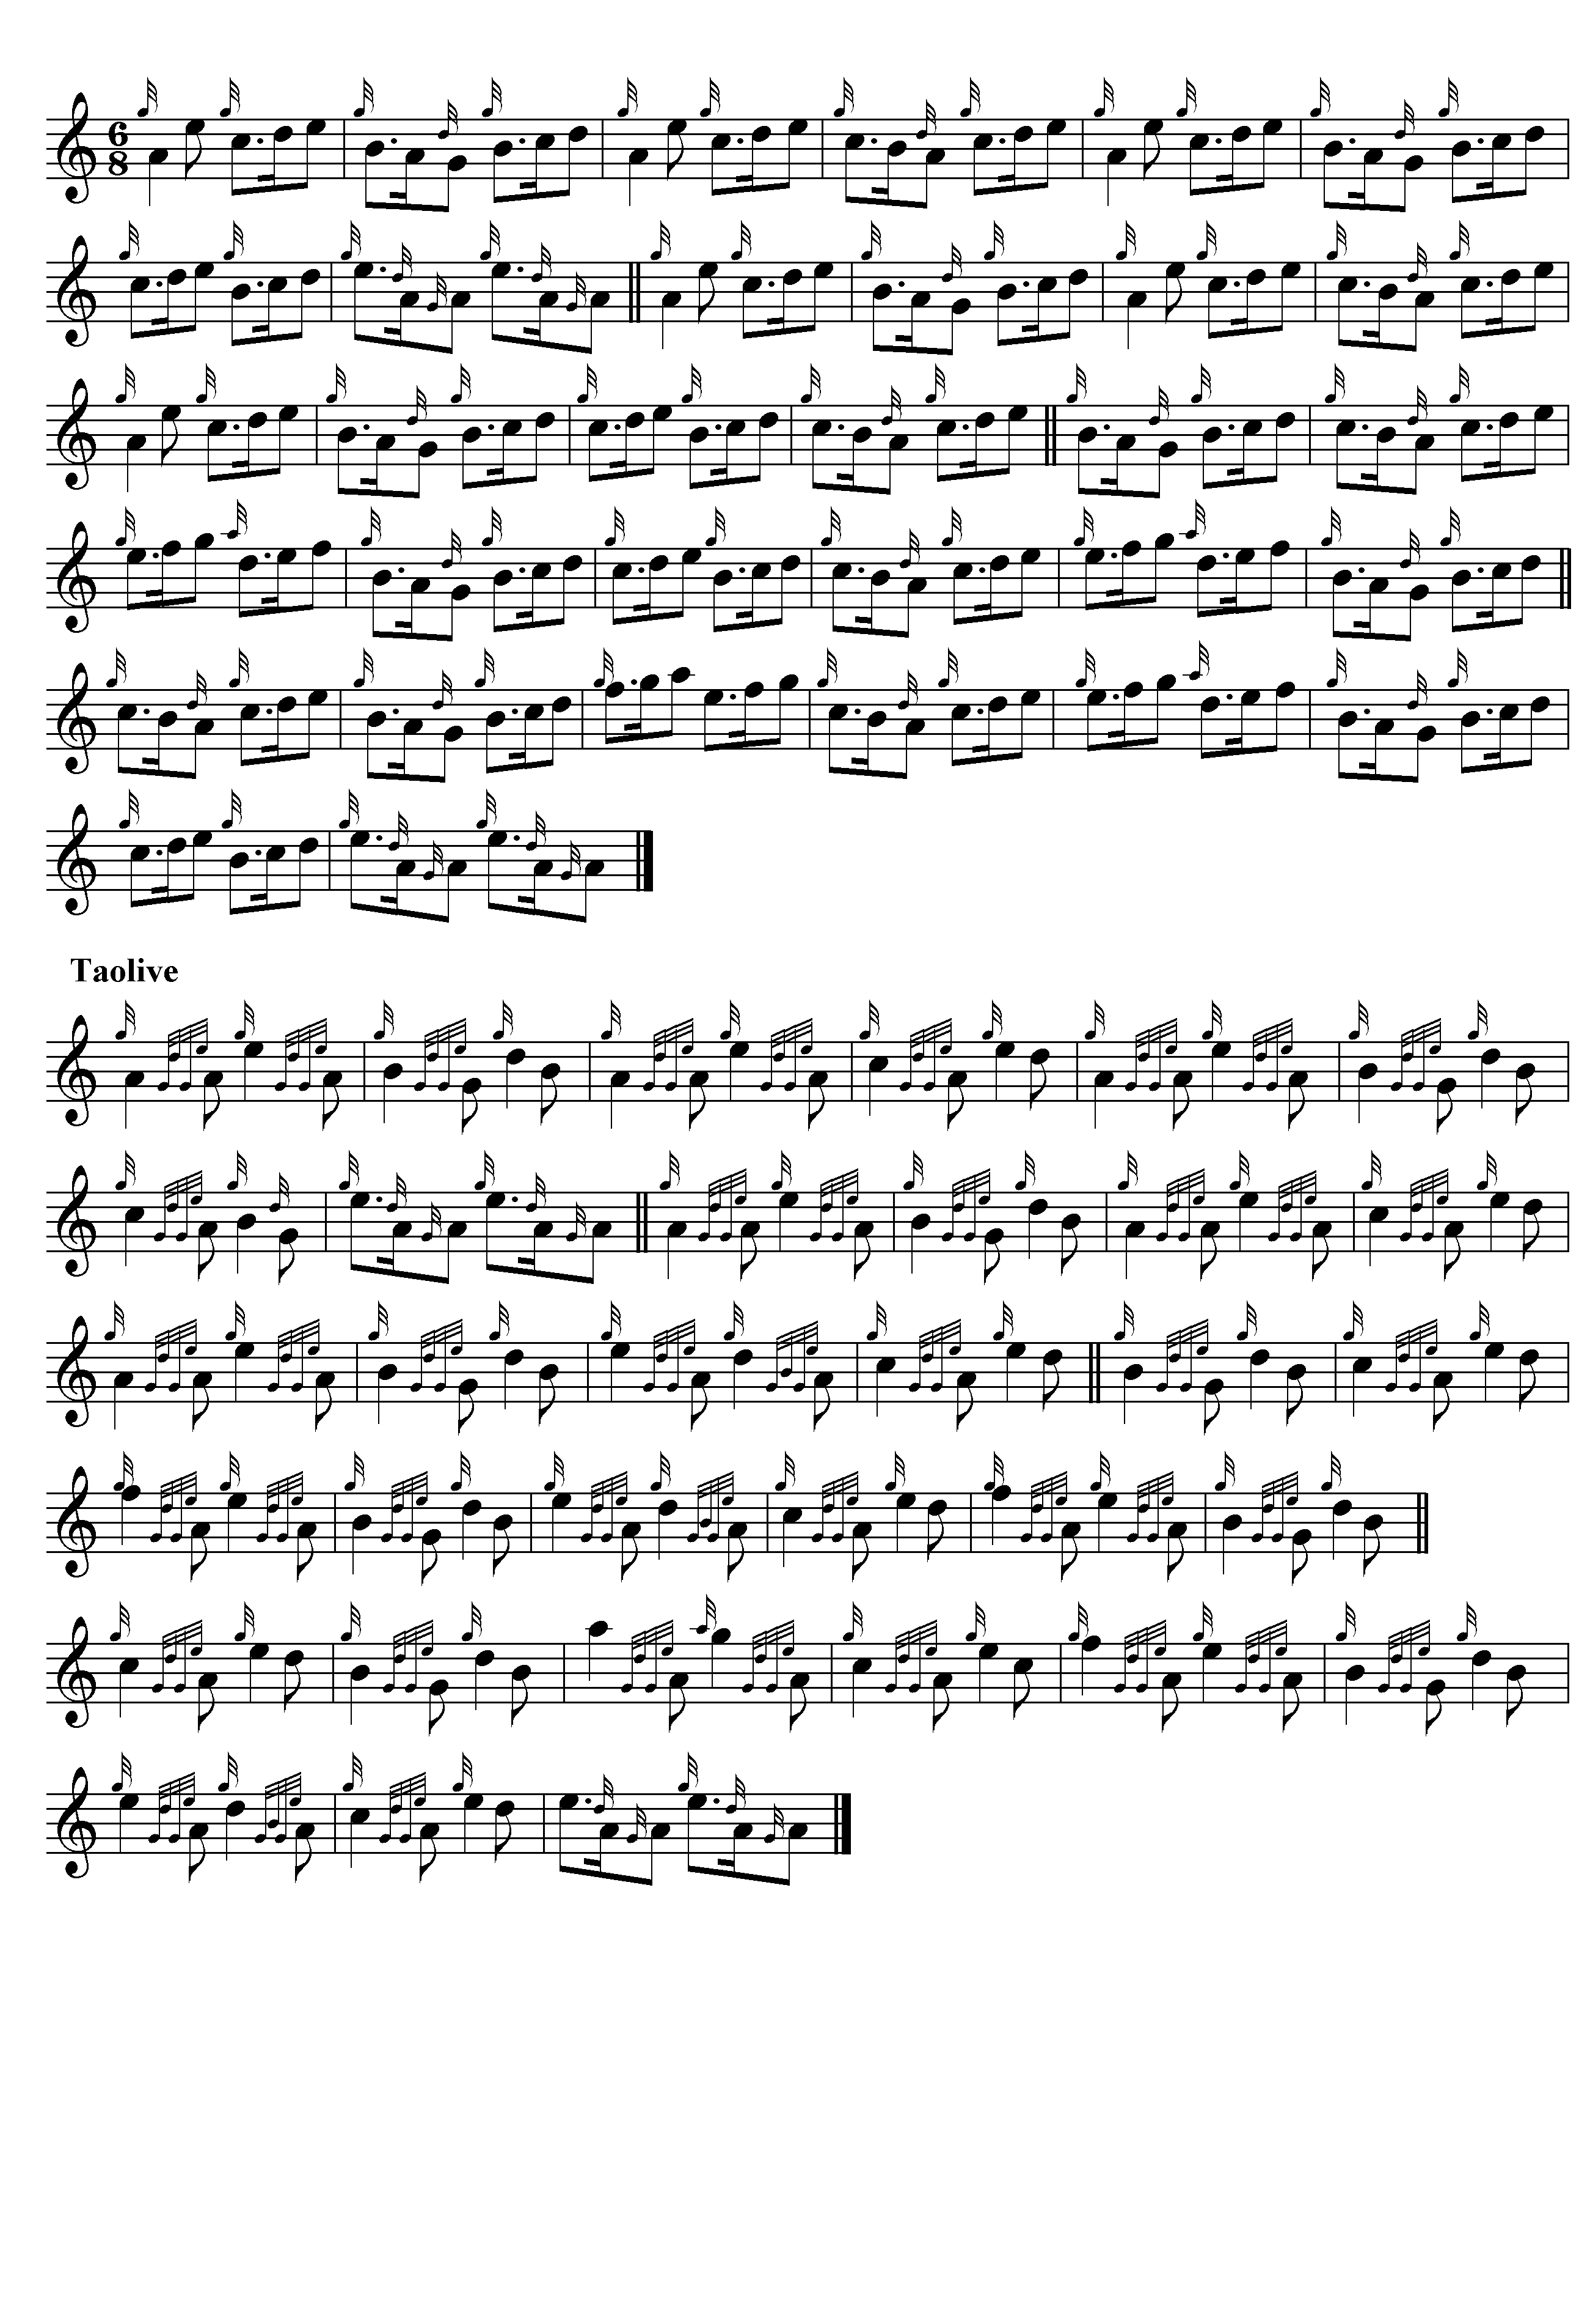

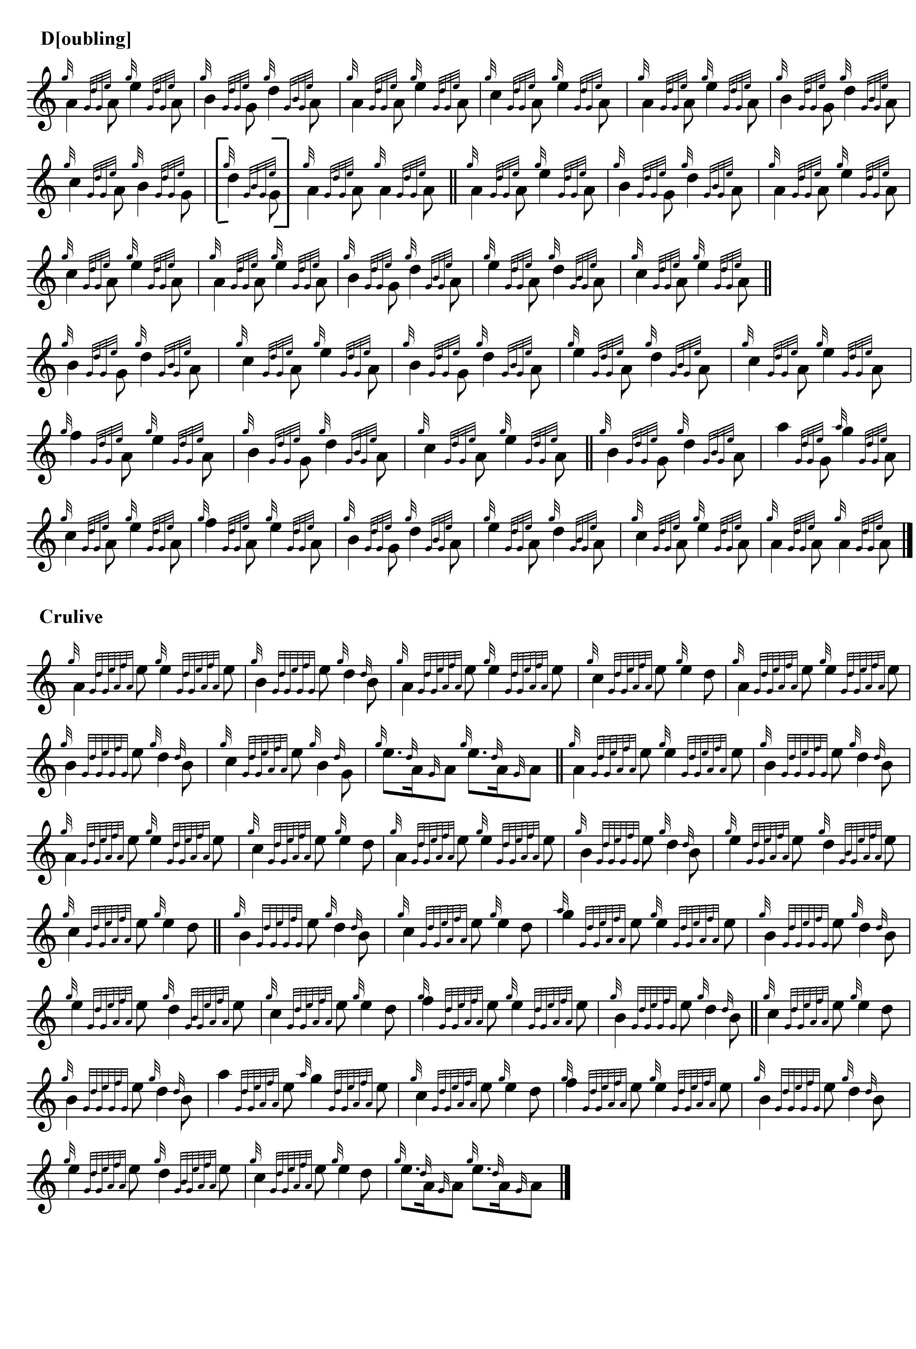

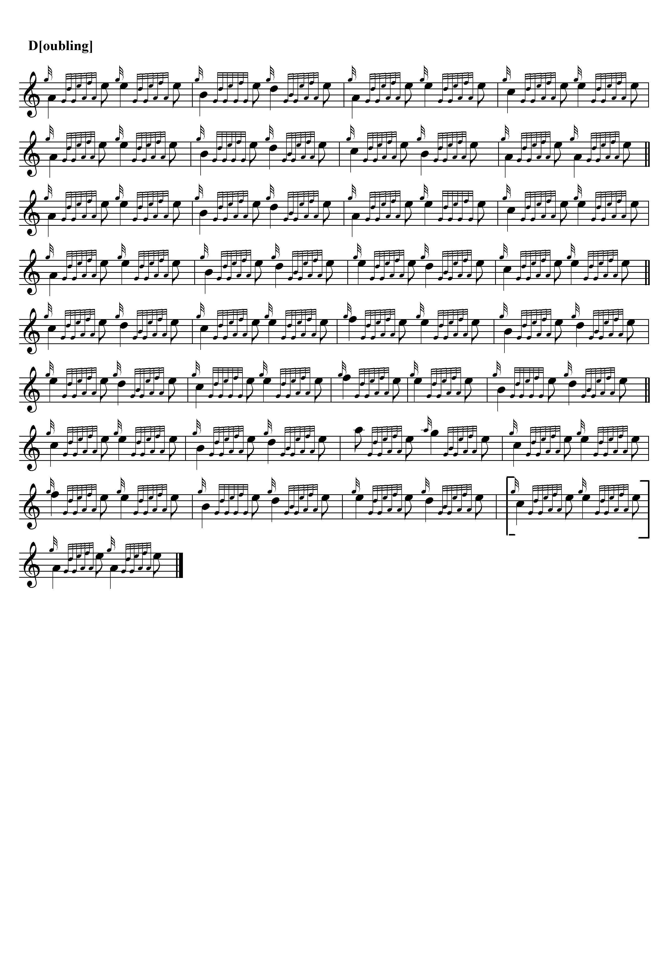

The Gaelic title means something pretty close to “here’s a health on your return…” so There may be a degree of musical onomatopoeia involved here with the playful returns of motif reinforcing the sentiment of this salute.

Angus MacKay sets the tune like this:

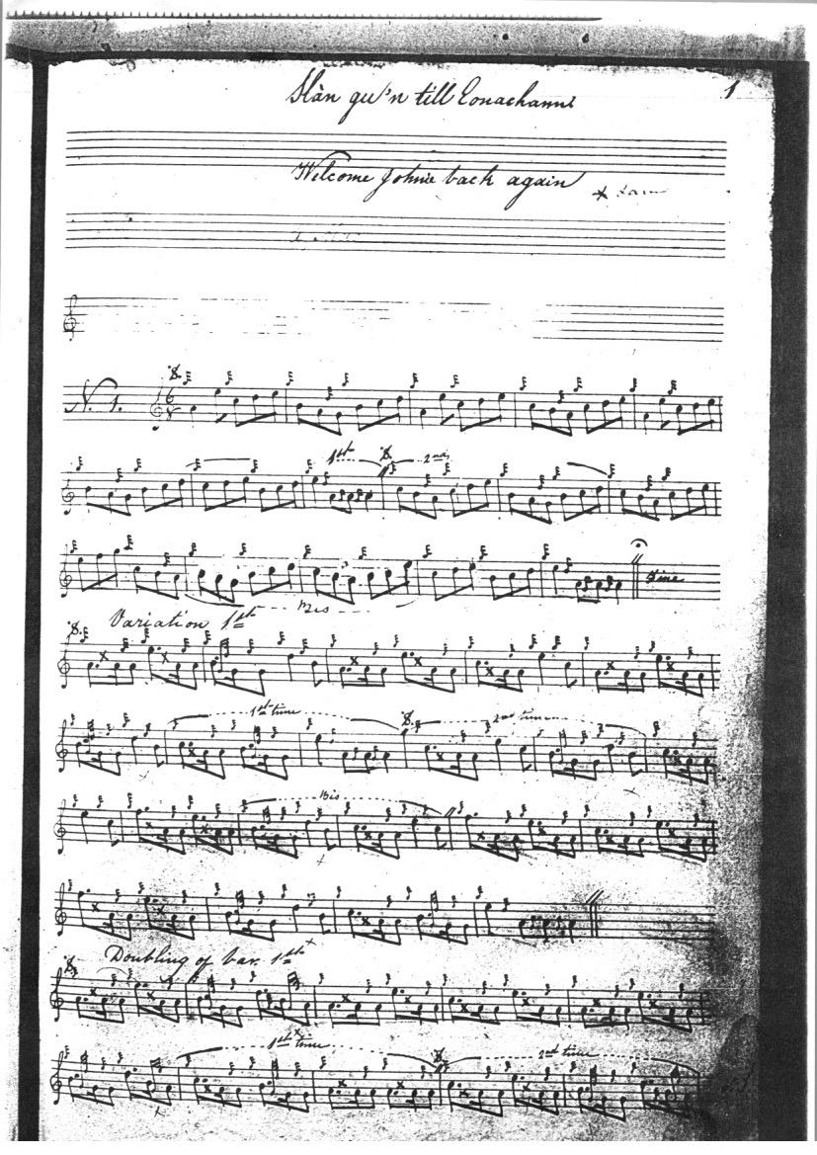
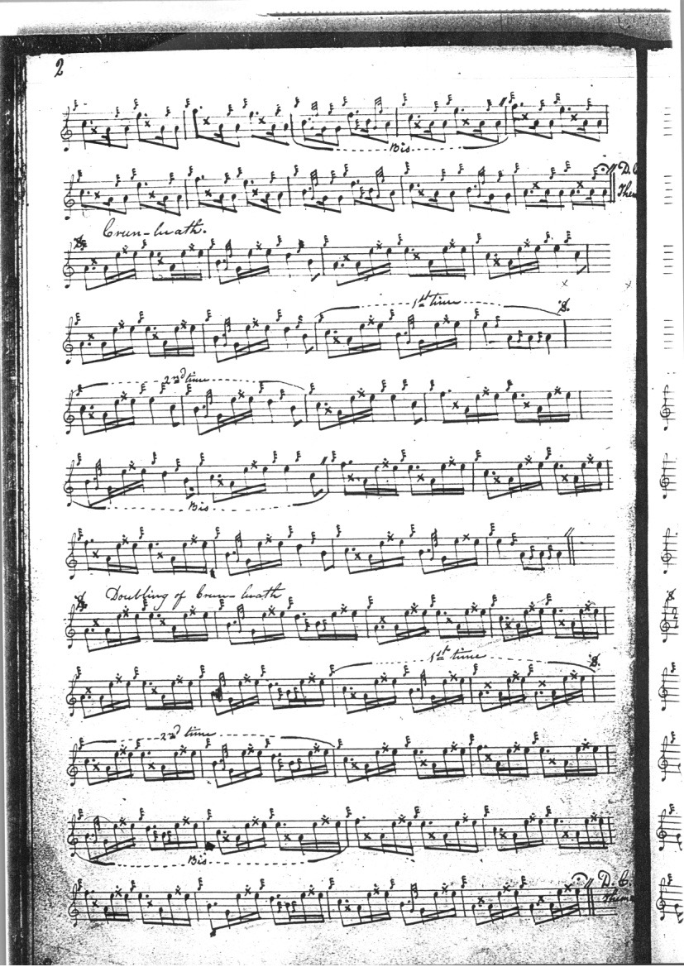
MacKay’s setting has three lines of eight bars each, 8 8 8, in the ground, but the variations stretch to four lines, the last showing something of the playful elaboration we see in Colin Mór Campbell. We note that the word “Campbell” is jotted down following the title in the English index of the manuscript (although not the Gaelic one). The score in the so-called “Kintarbert” MS is an outline one only and is not reproduced here. There is a further MacKay setting of this tune in the Seaforth MS, as follows:

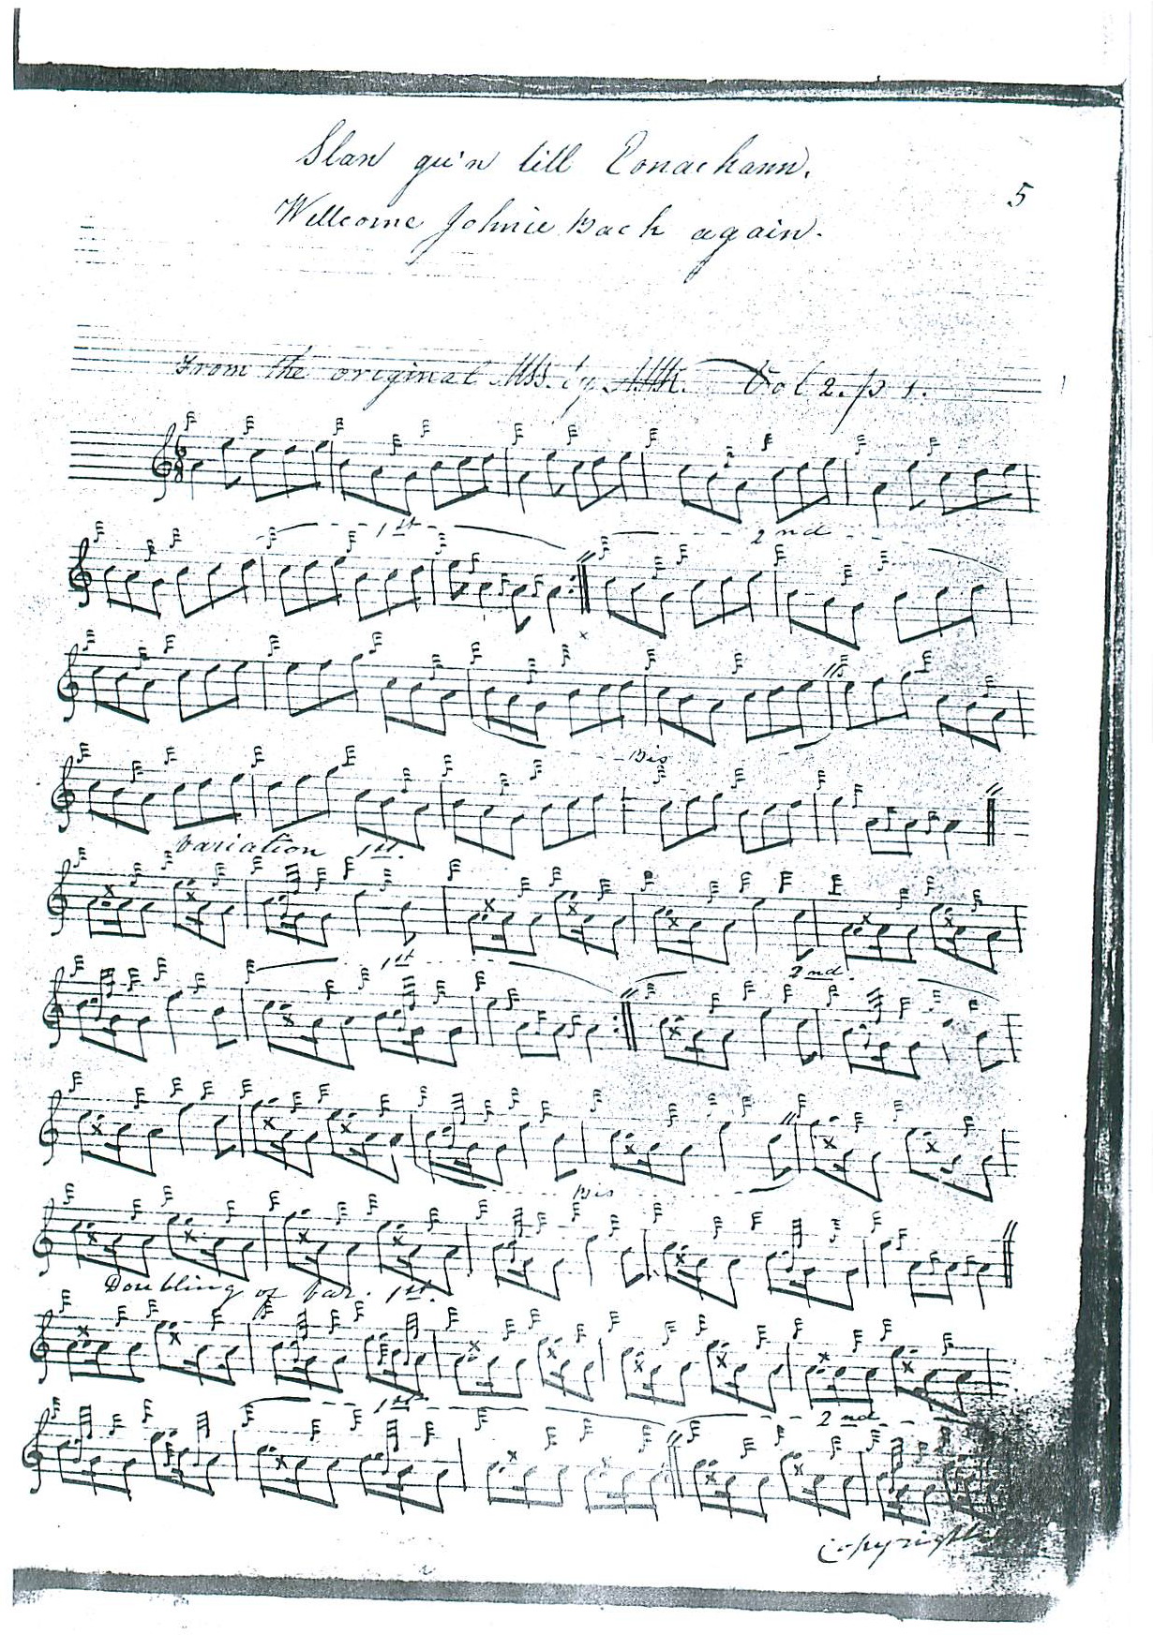

And so on. Here we see the tune made up to four lines 8: 6 6, presumably to square more precisely with the variations. The Seaforth Manuscript came into the possession of Donald Cameron and his sons, and it is interesting to see it clearly reflected in the version preserved by John MacDougall Gillies, a leading Cameron pupil.

Duncan Campbell of Foss’s score is marked “from MacGregor”, but the music follows the score in MacKay’s main manuscript closely. It adds nothing of significance to the tune and is not reproduced here. Uilleam Ross’s score probably has its source the “Kintarbert” MS or a transcript of it. This latter was the volume containing 88 tunes compiled by Angus MacKay (and probably intended as the second volume of his published collection) which came into the possession of Sir Charles Forbes (1803-1877) of Castle Newe, Strathdon, whose piper was Duncan Campbell of Foss. On the basis of a single word “Kintarbert” scrawled casually in the end leaf, probably indicating a loan, it was later designated the “Kintarbert MS” although its connections are with Aberdeenshire rather than Argyle. If it spent time, as we might expect, in upland southern Aberdeenshire, then it may well have been directly accessible to Uilleam Ross who was periodically at Balmoral—Ross could probably have seen it in London as well. Neither score is reproduced here. John MacDougall Gillies’s score is along similar lines, but there are transcription issues and his score is not reproduced here. The setting in the McLennan papers is a rough partial transcript only and is not reproduced here.
David Glen follows MacKay’s main MS in the ground and we see him fascinatingly editing on the page:

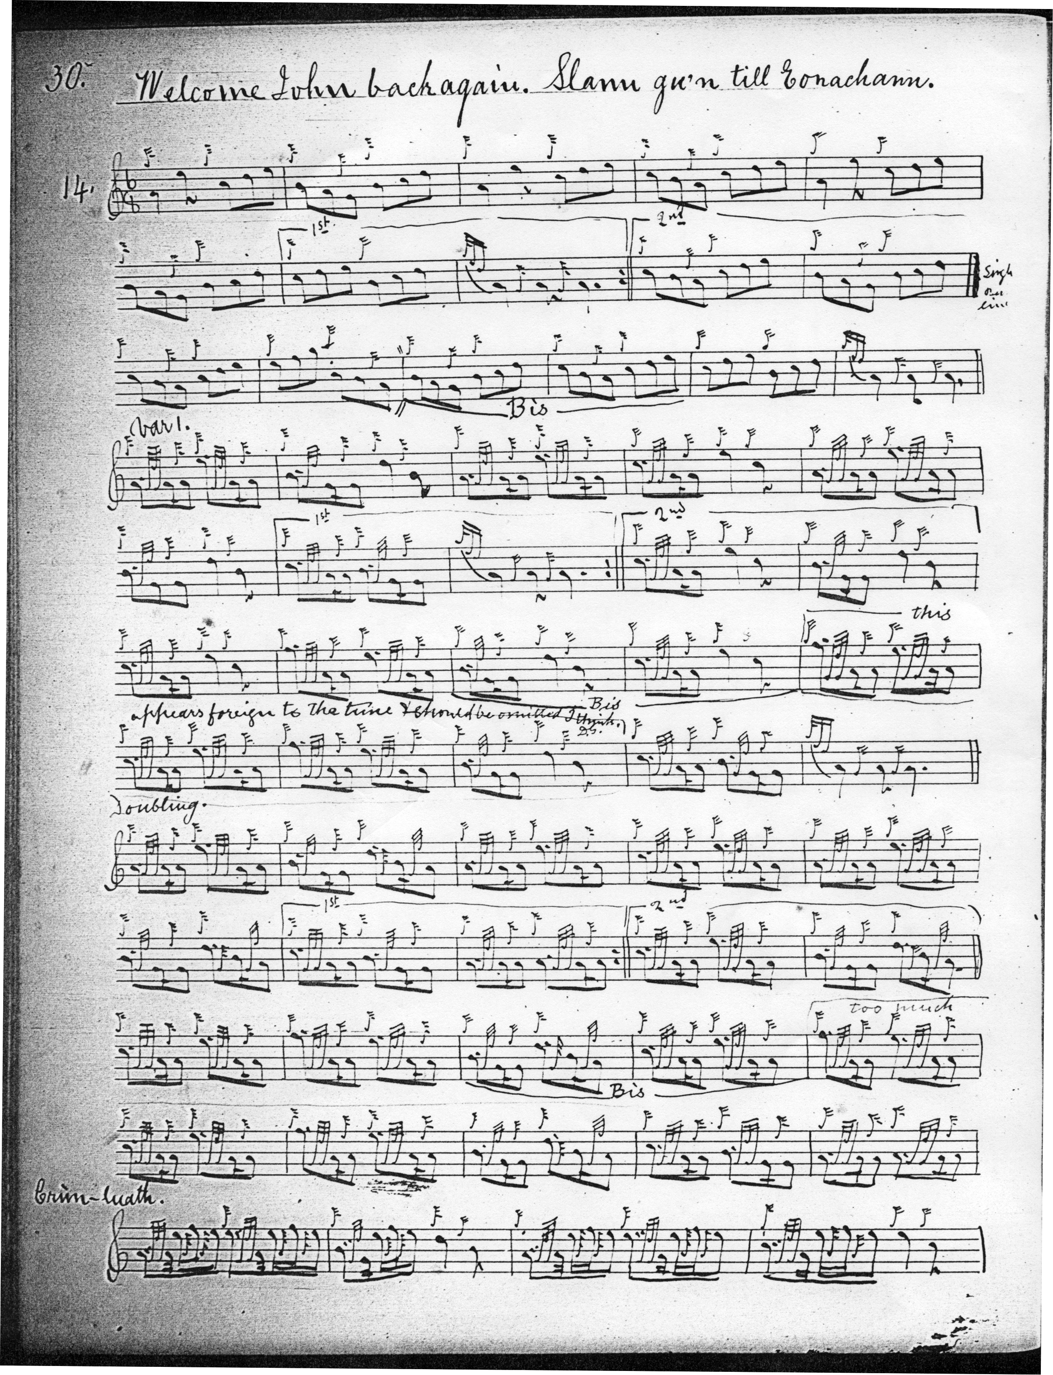
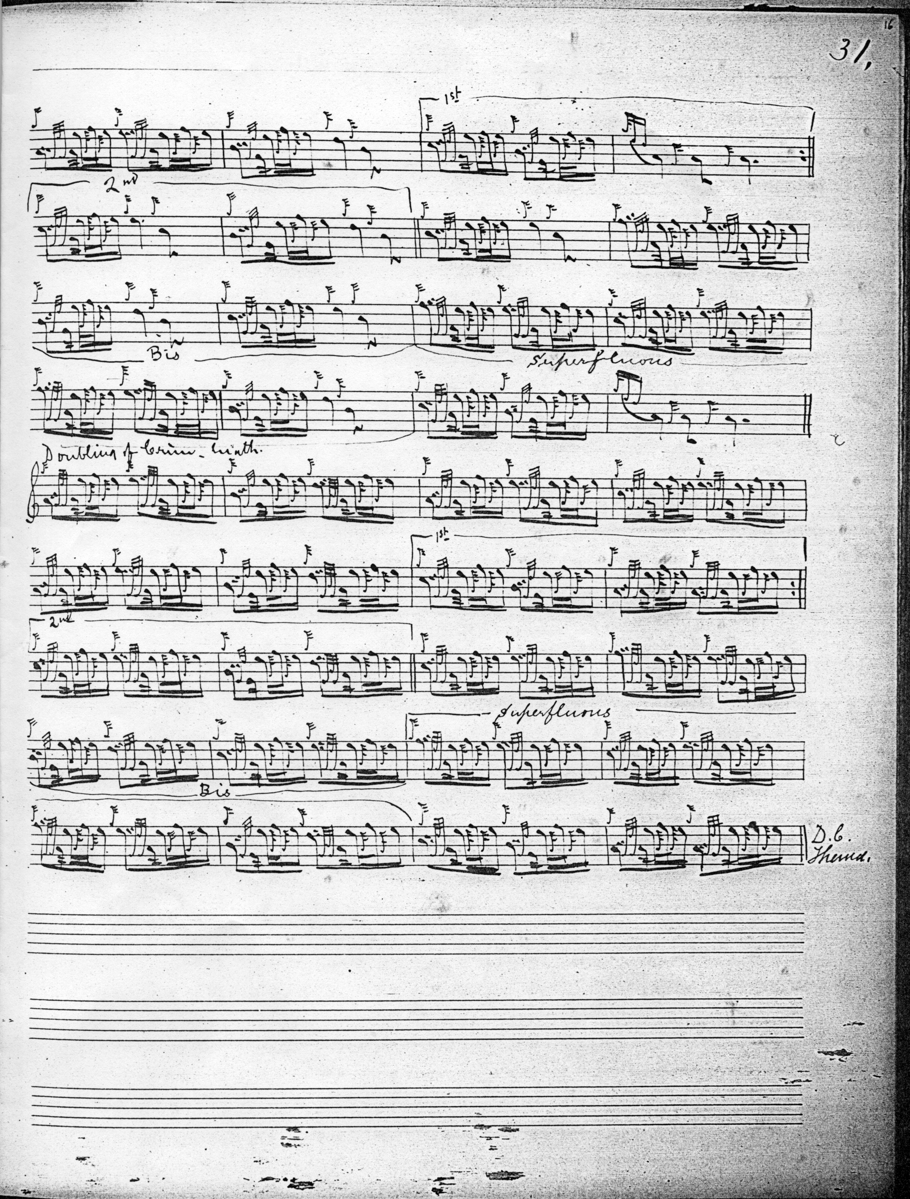

Glen indicates that bars seven to ten of his second part are in his judgment superfluous and should be dropped, sacrificing to “regularity” what some might regard as an appealing feature of the tune.

C. S. Thomason’s score, identifying Angus MacKay and John MacDougall Gillies as his sources shows a similarly revisionary tendency, reminding us that the editor had a number of late Victorian piper-editor informants which included both Glen and Gillies, although Thomason takes an interestingly different route to Glen in reducing the tune to contemporary notions of “regularity”:

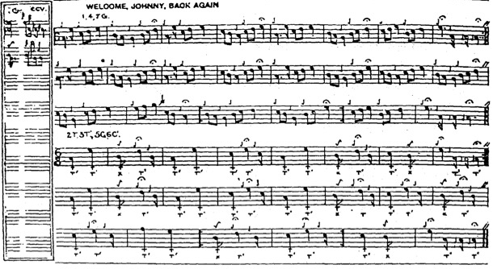

Commentary:

This tune offers a fine illustration of the variety of interpretations available to the performer in the older manuscript tradition, ranging from the free and expansive Nether Lorn version, to the stricter later Victorian scores, guided more narrowly by contemporary notions of “regularity”.

*

Electronic text © Dr. William Donaldson, Cambridge, Massachusetts, 15 December 2022.

