Young Neil’s Salute

There are settings of this tune in the following manuscript sources:
--Angus MacKay’s Manuscript, ii, 61-62;
--D. S. MacDonald’s Manuscript, i, 115-6;
--Peter Reid’s Manuscript, f.24 (with the title “Fuaim na tuine ri Duntróne”);
--David Glen’s Manuscript, ff.229-230;

and in the following published source:
--C. S. Thomason’s Ceol Mor, p.315.

Amongst the older records, Angus MacKay sets the tune like this:

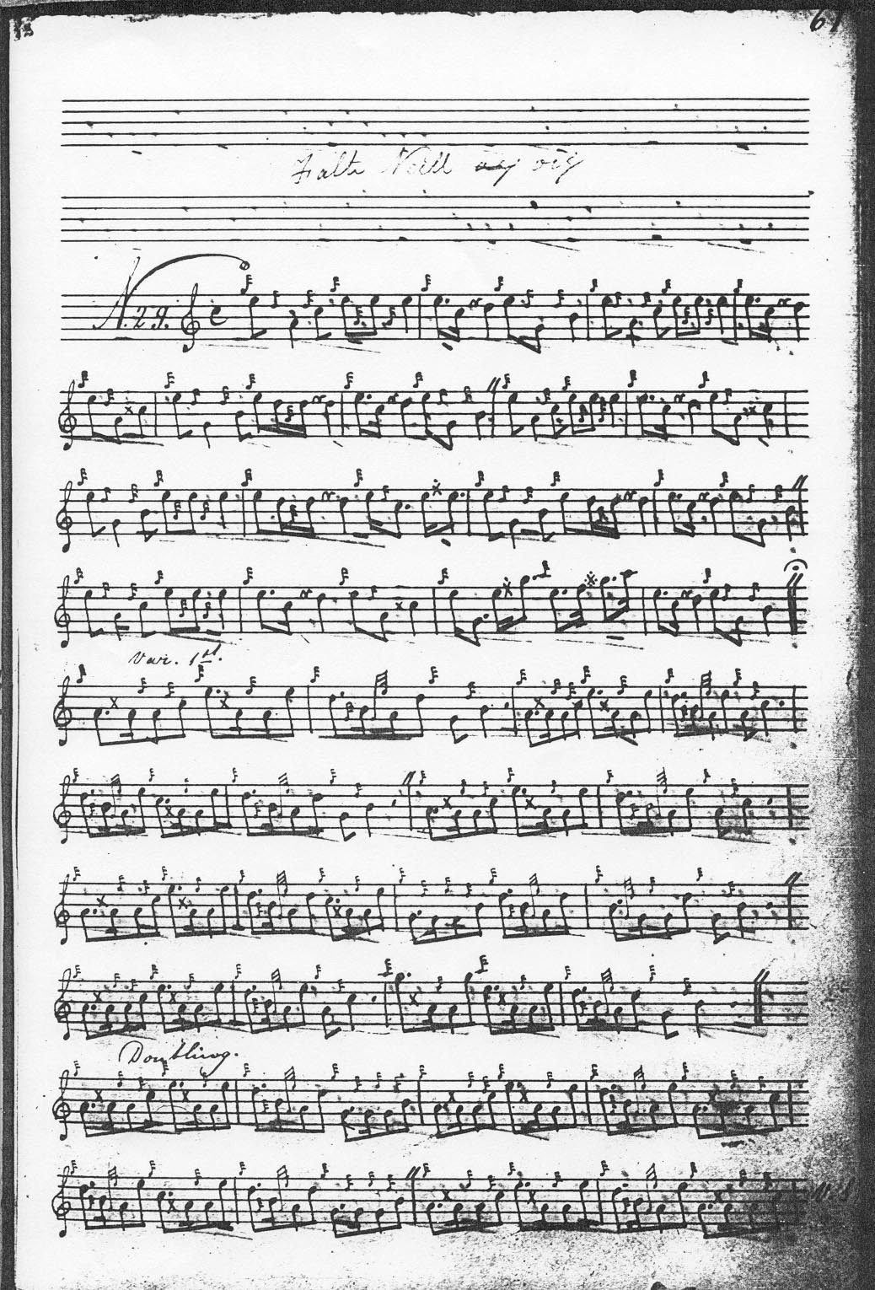
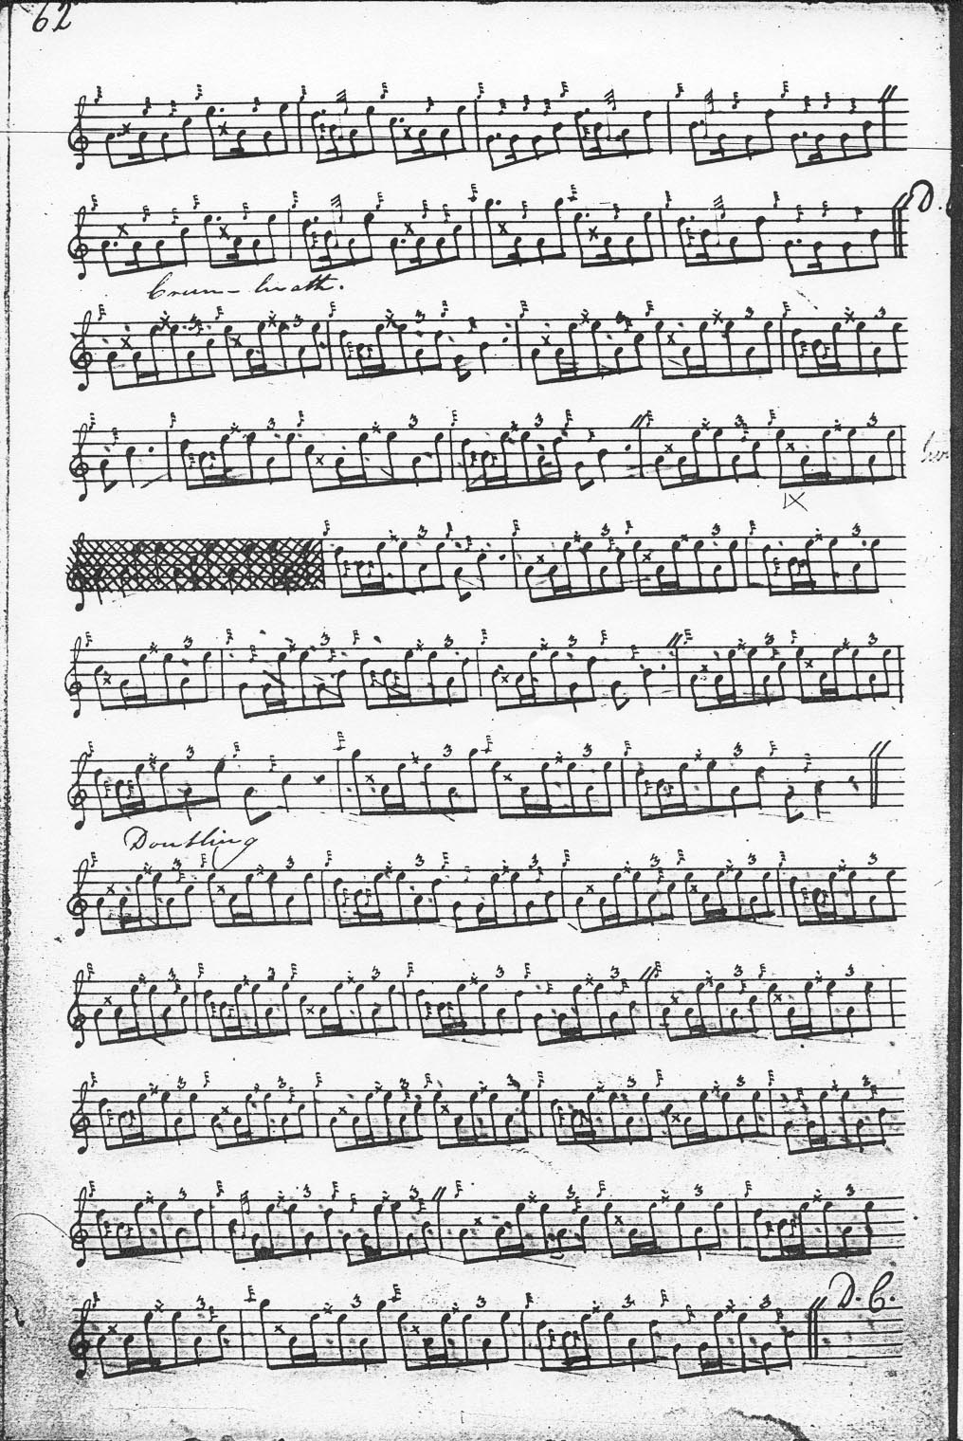
As it stands, this does not look like one of MacKay’s front-line repertory pieces—the absence of a title (later scratched in at the top) and its non-inclusion in the index to his manuscript, the transcription error elaborately ruled through in the crunluath singling, and the rhythmical unbalance of the ground at the cadence points, might suggest the tune as an obscure, or possibly recent, composition.

Peter Reid gives a partial setting, ground and taorluath singling only, and a title which links the piece with the extensive “Duntroon” tune-family:
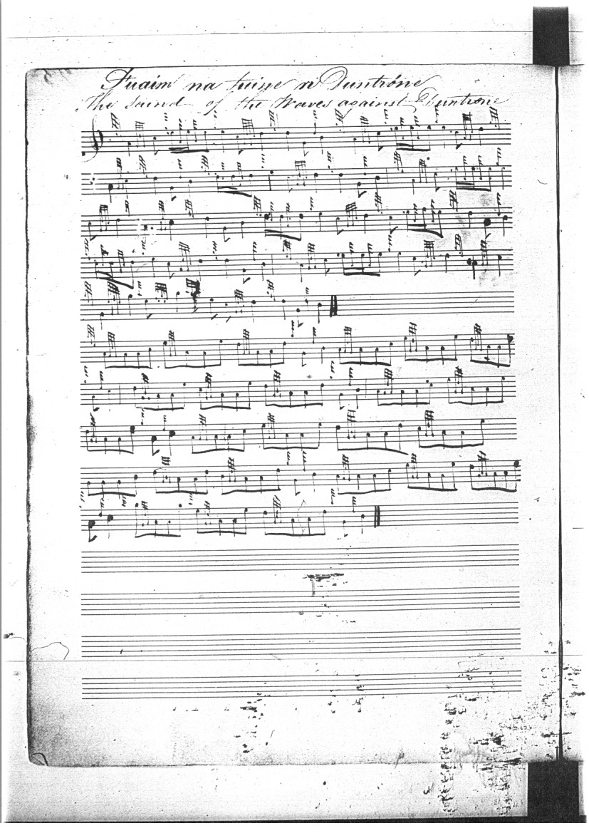

This is an interesting piece, with the potential to be developed in more than one way. For example, the tone row rather seems to invite a siubhal, and I have added one, singling and doubling, to David Glen’s setting in the m4a file. As it often happens that tunes are developed from the tone row of the later variations rather than the Ground. In the PDF file I give a set of later variations for the piece based on the siubhal.

C. S. Thomason’s recension of the tune cadences the ground in a pleasing and sensible way, and most players will probably prefer this version to MacKay’s, but he follows Mackay’s cadencing in the variations, which David Glen corrects. Glen emends Thomason’s score in a notational style probably more familiar to most readers and his score is given complete below. Glen drops Thomason’s repeat of line one in the ground and variations, but otherwise the settings are structurally and stylistically similar. Of the two, Glen’s will probably be preferred by most thoughtful players.

C. S. Thomason sets the tune as follows:

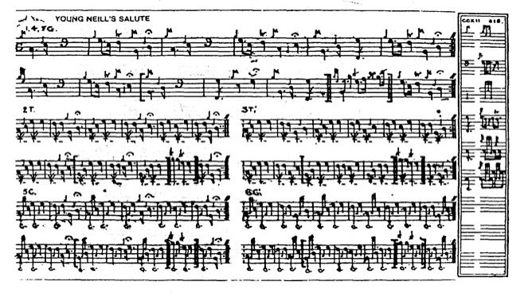

And David Glen like this:

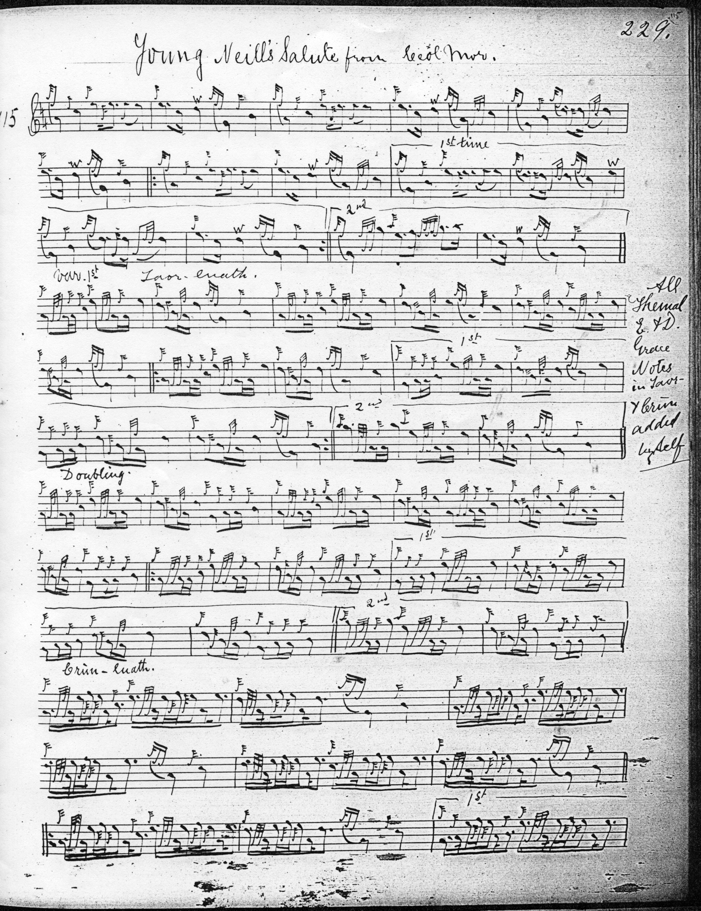

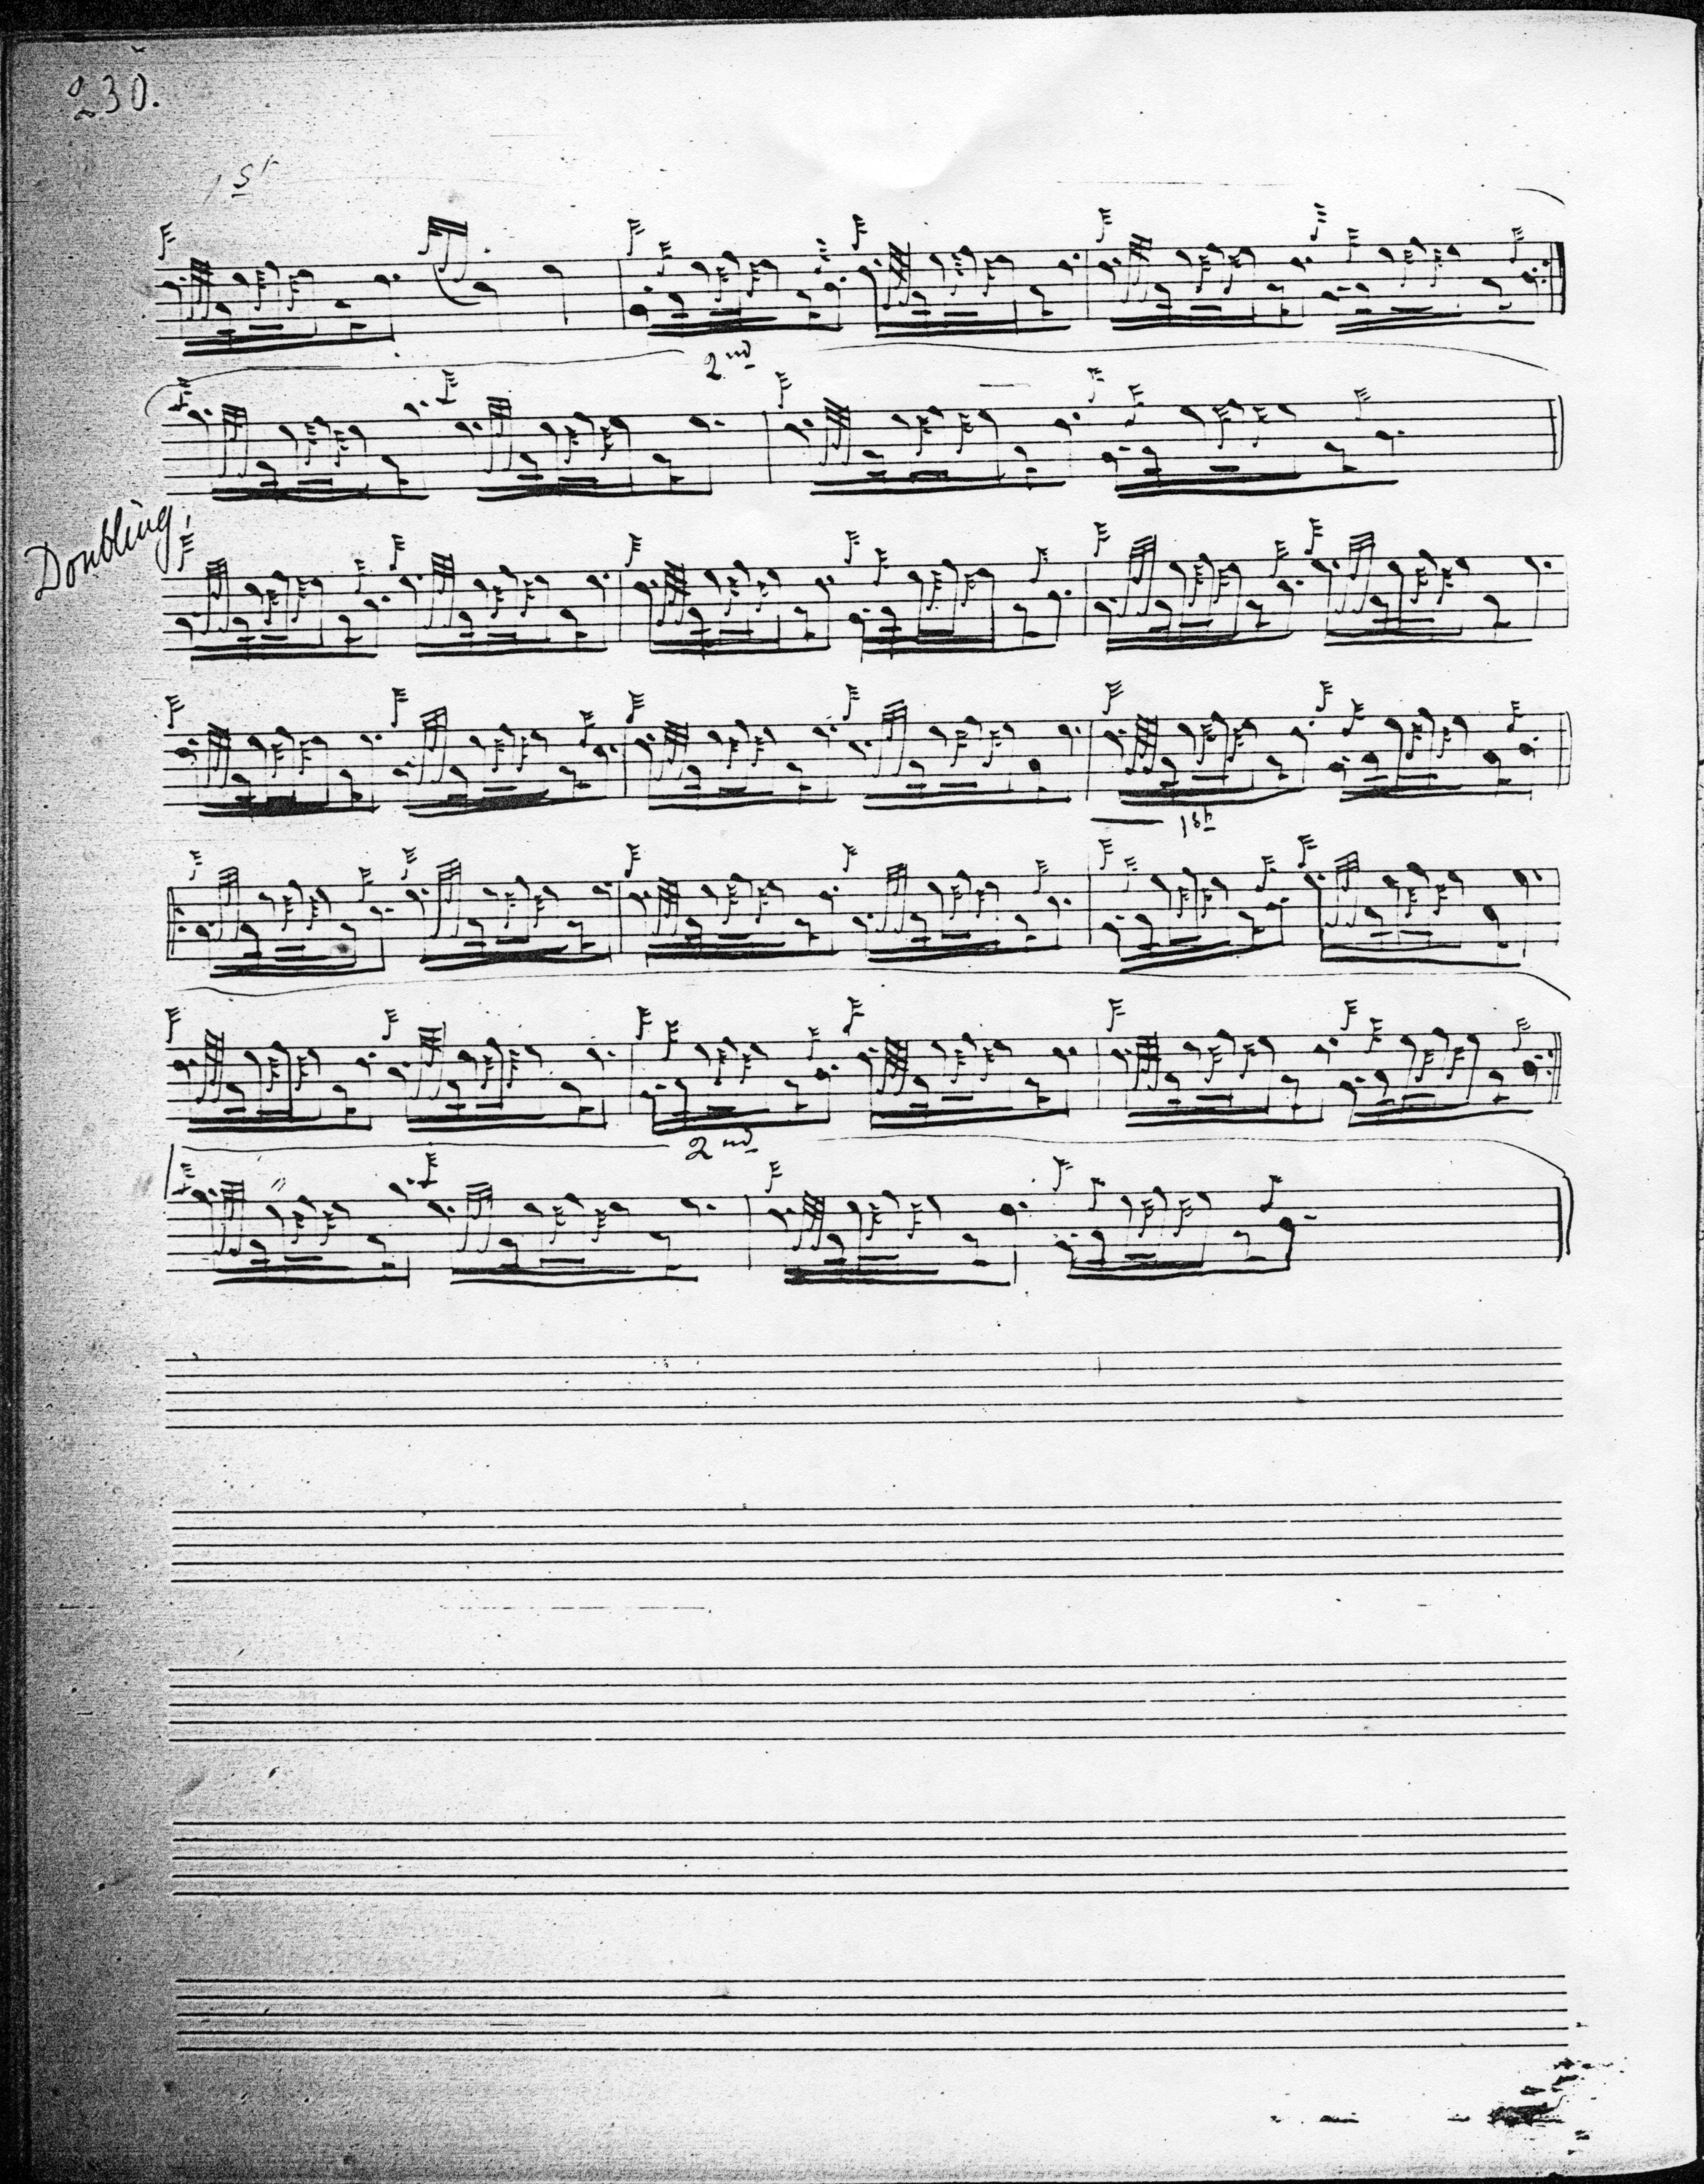

The score of the suggested siubhal and one possible route through the later variations based upon it follows here:

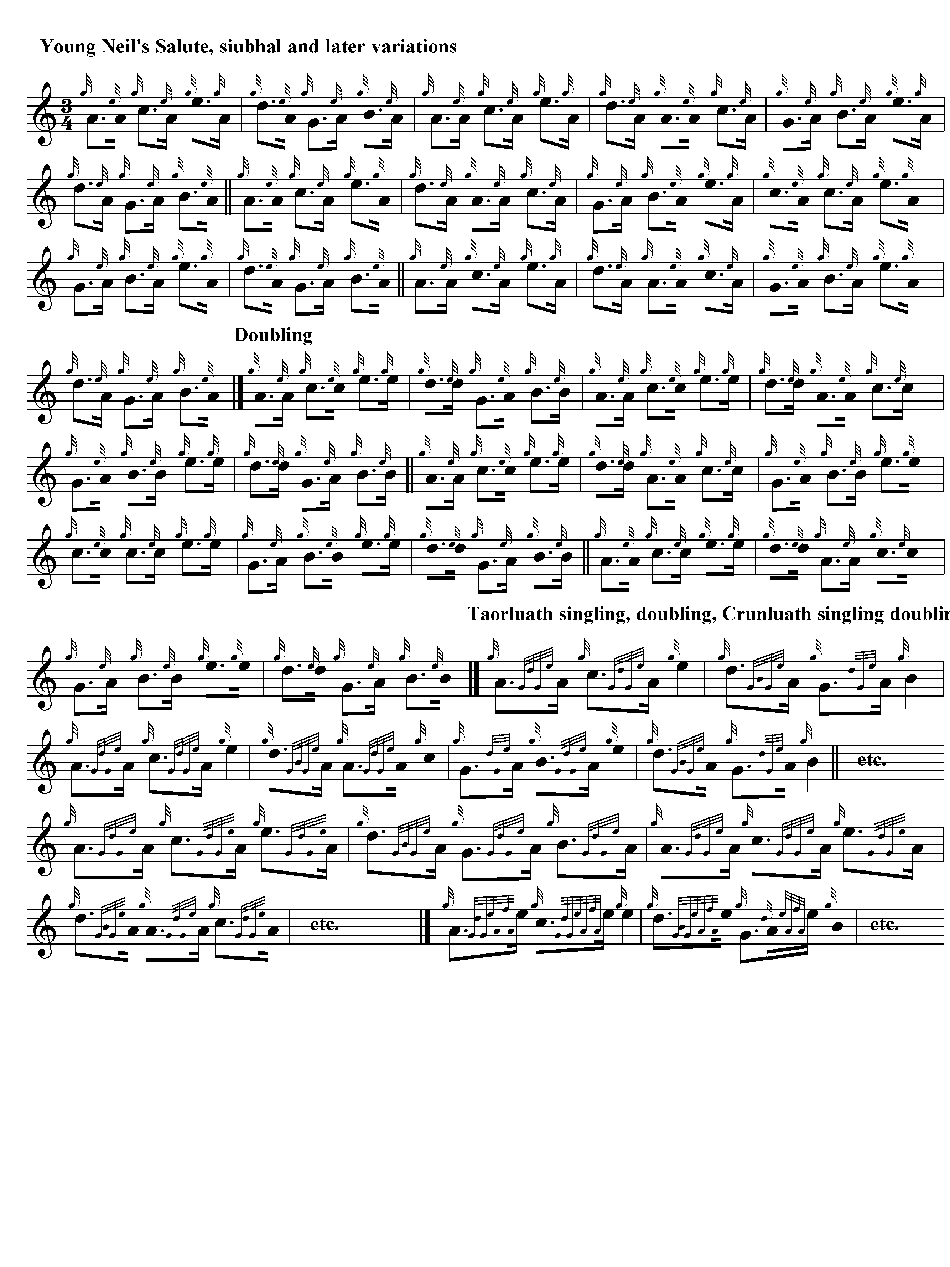

Commentary

“Young Neil’s Salute” is a little unusual in using an ungapped hexachordal scale, G-A-B-C-D-E to sustain a double tonic sequence, achieving contrast between the phrases by moving the emphasis within the scale, sometimes taking the flavour from the triad on A sometimes the one on the adjacent G.

It is an attractive piece, and may find its way into a good many people’s lists in the next few years.

*

Electronic text © Dr William Donaldson, Cambridge, Massachusetts, 8th November 2022

